Test Bank

Forecasting

1. Which simple forecasting method says the forecast is equal to the mean of the historical data?
2. Average Method
3. Naïve Method
4. Seasonal Naïve Method
5. Drift Method
6. Which simple forecasting method says the forecast is equal to the last observed value?
7. Average Method
8. Naïve Method
9. Seasonal Naïve Method
10. Drift Method
11. Which simple forecasting method says the forecast is equal to the last value from the same season?
12. Average Method
13. Naïve Method
14. Seasonal Naïve Method
15. Drift Method
16. Which simple forecasting method says the forecast is equal to the last value plus the average change?
17. Average Method
18. Naïve Method
19. Seasonal Naïve Method
20. Drift Method
21. Which simple forecasting method is a consequence of the efficient market hypothesis?
22. Average Method
23. Naïve Method
24. Seasonal Naïve Method
25. Drift Method
26. Which simple forecasting method is equivalent to extrapolating a line draw between the first and lost observations?
27. Average Method
28. Naïve Method
29. Seasonal Naïve Method
30. Drift Method
31. Which simple forecasting method uses the formula ?
32. Average Method
33. Naïve Method
34. Seasonal Naïve Method
35. Drift Method
36. Which simple forecasting method uses the formula ?
37. Average Method
38. Naïve Method
39. Seasonal Naïve Method
40. Drift Method
41. Which simple forecasting method uses the formula ?
42. Average Method
43. Naïve Method
44. Seasonal Naïve Method
45. Drift Method
46. Which simple forecasting method uses the formula ${\hat{y}}_{\left.T+h\right|T}=\frac{h}{T-1}(y_{T}-y_{1})?$
47. Average Method
48. Naïve Method
49. Seasonal Naïve Method
50. Drift Method
51. Which simple forecasting method uses the command meanf(x)?
52. Average Method
53. Naïve Method
54. Seasonal Naïve Method
55. Drift Method
56. Which simple forecasting method uses the command naive(x)?
57. Average Method
58. Naïve Method
59. Seasonal Naïve Method
60. Drift Method
61. Which simple forecasting method uses the command snaive(x)?
62. Average Method
63. Naïve Method
64. Seasonal Naïve Method
65. Drift Method
66. Which simple forecasting method uses the command rwf(x, drift=TRUE)?
67. Average Method
68. Naïve Method
69. Seasonal Naïve Method
70. Drift Method
71. Which of the following is an **assumption** made about forecasting residuals?
72. Residuals are normally distributed
73. Residuals are uncorrelated
74. Residuals have constant variance
75. None of the above
76. Which of the following is an **assumption** made about forecasting residuals?
77. Residuals have mean zero
78. Residuals are normally distributed
79. Residuals have constant variance
80. None of the above
81. Which of the following is **useful property** of forecasting residuals?
82. Residuals have mean zero
83. Residuals are uncorrelated
84. Residuals have constant variance
85. None of the above
86. Which of the following is **useful property** of forecasting residuals?
87. Residuals are normally distributed
88. Residuals are uncorrelated
89. Residuals have mean zero
90. None of the above
91. What is the consequence of forecasting residuals that are **not** uncorrelated?
92. Prediction intervals are difficult to calculate
93. Information is left in the residuals that should be used
94. Forecasts are biased
95. None of the above
96. What is the consequence of forecasting residuals that **don’t** have mean zero?
97. Prediction intervals are difficult to calculate
98. Information is left in the residuals that should be used
99. Forecasts are biased
100. None of the above
101. Which measure of forecast accuracy has the formula $T^{-1}\sum_{t=1}^{T}{\left|y_{t}-{\hat{y}}_{\left.t\right|t-1}\right|}$?
102. MAE
103. MSE
104. RMSE
105. MAPE
106. Which measure of forecast accuracy has the formula
107. MAE
108. MSE
109. RMSE
110. MAPE
111. Which measure of forecast accuracy has the formula
112. MAE
113. MSE
114. RMSE
115. MAPE
116. Which measure of forecast accuracy has the formula $\frac{100T^{-1}\sum_{t=1}^{T}{\left|y_{t}-{\hat{y}}_{\left.t\right|t-1}\right|}}{\left|y_{t}\right|}?$
117. MAE
118. MSE
119. RMSE
120. MAPE
121. Which measure of forecast accuracy is scale independent?
122. MAE
123. MSE
124. RMSE
125. MAPE
126. The training set should make up approximately what percent of the data?
127. 20%
128. 50%
129. 60%
130. 80%
131. The test set should make up approximately what percent of the data?
     1. 20%
     2. 50%
     3. 60%
     4. 80%
132. Which of the following is the command for making a time plot?
     1. plot(x)
     2. seasonplot(x)
     3. monthplot(x)
     4. Acf(x)
133. Calculation of forecasts is based on what?
     1. Test set
     2. Training set
     3. Both
     4. Neither
134. Forecast accuracy is based on what?
     1. Test set
     2. Training set
     3. Both
     4. Neeither
135. Which of the following is the command for making a seasonal plot?
     1. plot(x)
     2. seasonplot(x)
     3. monthplot(x)
     4. Acf(x)
136. Which of the following is the command for making a seasonal subseries plot?
     1. plot(x)
     2. seasonplot(x)
     3. monthplot(x)
     4. Acf(x)
137. Which of the following is the command for making a ACF plot?
     1. plot(x)
     2. seasonplot(x)
     3. monthplot(x)
     4. Acf(x)
138. Which of the following allows you to see departures from the seasonal pattern?
     1. Time plot
     2. Seasonal plot
     3. Seasonal subseries plot
     4. ACF plot
139. Which of the following allows you to see changes in seasonality over time?
     1. Time plot
     2. Seasonal plot
     3. Seasonal subseries plot
     4. ACF plot
140. A long term increase or decrease in the data is known as what?
     1. Trend
     2. Seasonal
     3. Cyclical
     4. White Noise
141. A series that is influenced by seasonal factors is known as what?
     1. Trend
     2. Seasonal
     3. Cyclical
     4. White Noise
142. Data that exhibits rises and falls that are not of a fixed period is known as what?
     1. Trend
     2. Seasonal
     3. Cyclical
     4. White Noise

39. Data that is uncorrelated over time is known as what?

1. Trend
2. Seasonal
3. Cyclical
4. White Noise
5. Which of the following is not a component of time series decomposition?
   1. Seasonal
   2. Trend-Cycle
   3. Autocorrelation
   4. Remainder
6. Which of the following time series decomposition models is appropriate when the magnitude of the seasonal fluctuations are **not** proportional to the level?
   1. Additive
   2. Multiplicative
   3. Both
   4. Neither
7. Which of the following time series decomposition models is appropriate when the magnitude of the seasonal fluctuations are proportional to the level?
   1. Additive
   2. Multiplicative
   3. Both
   4. Neither
8. Which of the following time series decomposition models is more prevalent with economic series?
   1. Additive
   2. Multiplicative
   3. Both
   4. Neither
9. What is the R command for doing classical decomposition?
   1. classical(x)
   2. decompose(x)
   3. stl(x)
   4. method(x)
10. What is the R command for doing STL decomposition?
    1. classical(x)
    2. decompose(x)
    3. stl(x)
    4. method(x)

Exhibit 1

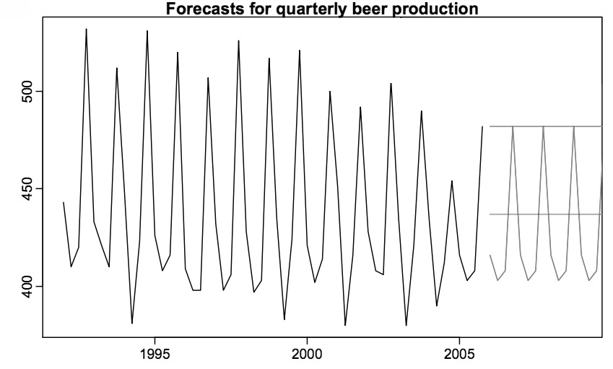

Line A

Line B

(Straight Line)

Line C

(Not Straight)

1. Refer to Exhibit 1. Line A is which simple forecasting method?
   1. Average Method
   2. Naïve Method
   3. Seasonal Naïve Method
   4. Drift Method
2. Refer to Exhibit 1. Line B is which simple forecasting method?
   1. Average Method
   2. Naïve Method
   3. Seasonal Naïve Method
   4. Drift Method
3. Refer to Exhibit 1. Line C is which simple forecasting method?
   1. Average Method
   2. Naïve Method
   3. Seasonal Naïve Method
   4. Drift Method

Figure 2

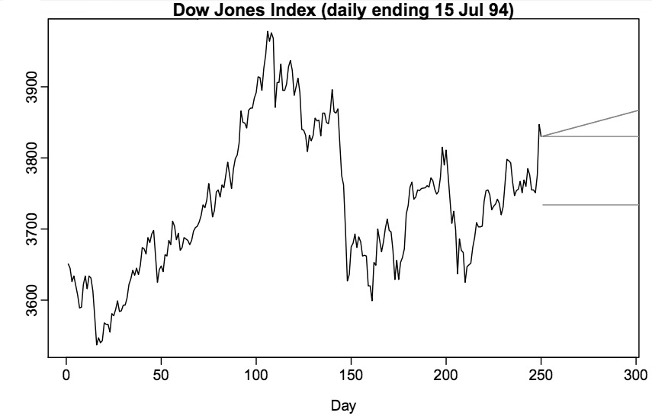

Line A

Line B

Line C

1. Refer to Exhibit 2. Line A is which simple forecasting method?
   1. Average Method
   2. Naïve Method
   3. Seasonal Naïve Method
   4. Drift Method
2. Refer to Exhibit 2. Line B is which simple forecasting method?
   1. Average Method
   2. Naïve Method
   3. Seasonal Naïve Method
   4. Drift Method
3. Refer to Exhibit 2. Line C is which simple forecasting method?
   1. Average Method
   2. Naïve Method
   3. Seasonal Naïve Method
   4. Drift Method

Figure 3

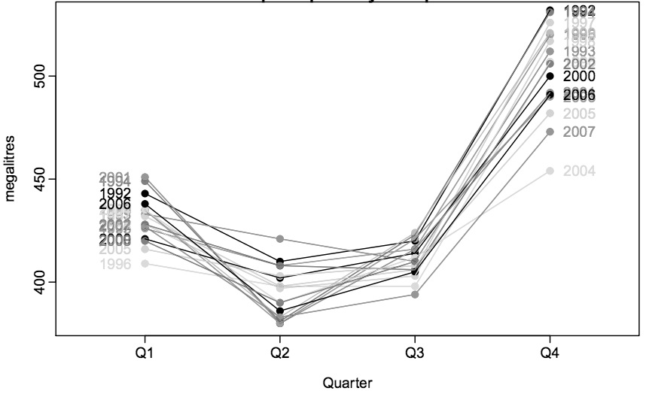

1. Refer to Exhibit 3. The peaks are in which quarter?
   1. Quarter 1
   2. Quarter 2
   3. Quarter 3
   4. Quarter 4
2. Refer to Exhibit 3. The trough are in which quarter?
   1. Quarter 1
   2. Quarter 2
   3. Quarter 3
   4. Quarter 4

Figure 4

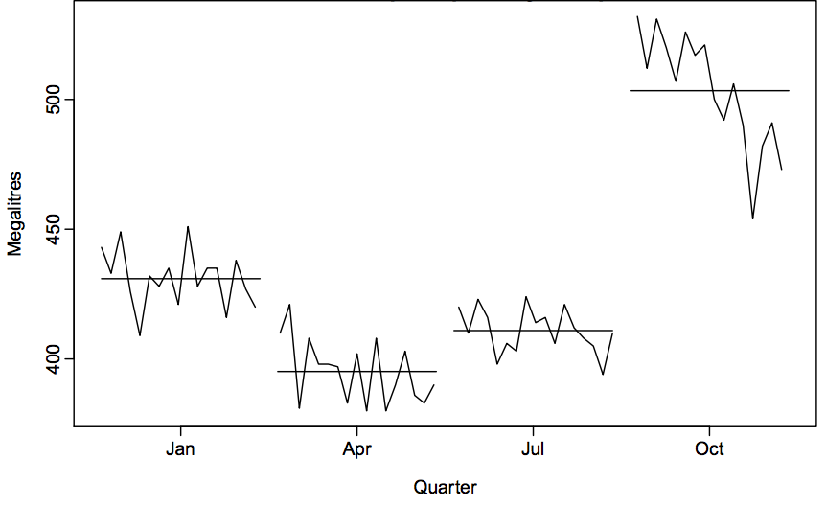

1. Refer to Exhibit 4. The peaks are in which quarter?
   1. Quarter 1
   2. Quarter 2
   3. Quarter 3
   4. Quarter 4
2. Refer to Exhibit 4. The trough are in which quarter?
   1. Quarter 1
   2. Quarter 2
   3. Quarter 3
   4. Quarter 4
3. Refer to Exhibit 4. In which quarter is there a decline in the seasonal affect?
   1. Quarter 1
   2. Quarter 2
   3. Quarter 3
   4. Quarter 4

Figure 5

|  |  |  |  |  |  |  |  |
| --- | --- | --- | --- | --- | --- | --- | --- |
| Year 1 | | | | Year 2 | | | |
| Q1 | Q2 | Q3 | Q4 | Q1 | Q2 | Q3 | Q4 |
| 10 | 6 | 8 | 12 | 11 | 7 | 9 | 13 |

1. Refer to Figure 5. Using the average method, what is the forecast of Quarter 2 of Year 3? (Don’t use a calculator.)
   1. 7
   2. 9.5
   3. 13.85
   4. 13
2. Refer to Figure 5. Using the naïve method, what is the forecast of Quarter 2 of Year 3? (Don’t use a calculator.)
   1. 7
   2. 9.5
   3. 13.85
   4. 13
3. Refer to Figure 5. Using the seasonal naïve method, what is the forecast of Quarter 2 of Year 3? (Don’t use a calculator.)
   1. 7
   2. 9.5
   3. 13.85
   4. 13
4. Refer to Figure 5. Using the drift method, what is the forecast of Quarter 2 of Year 3? (Don’t use a calculator.)
   1. 7
   2. 9.5
   3. 13.85
   4. 13