PROJECT REPORT & TECHNICAL DOCUMENTATION
AeroDrive: Contactless Hand-Gesture & Optical-Flow Traffic Game
A Zero-Lag Dual-Thread Vision-Based HCI & 3D OpenGL Simulation Suite (AeroTouch 3D — Unit 5 & Unit 6)
Details of Group Members (Edit Bracketed Placeholders Below)
Sr. | Student Name | PRN / Roll No. | Contribution & Technical Role
1 | Dev Vachhani | [Enter PRN / Roll No.] | Lead Developer — CV Pipeline, Game AI & 3D Engine
2 | [Group Member 2 Name] | [Enter PRN / Roll No.] | [Role — e.g., Optical Flow, Testing & Documentation]
3 | [Group Member 3 Name] | [Enter PRN / Roll No.] | [Role — e.g., UI/UX Design & Performance Analysis]
4 | [Group Member 4 Name] | [Enter PRN / Roll No.] | [Optional — Delete row in Word if 1–3 members]

Academic & Live Demonstration Details
Field | Details
Institute / University | [Enter University / Institute Name]
Department & Program | [Department of Computer Engineering / CSE — Year 4]
Course / Subject | Virtual & Augmented Reality / Computer Vision (FLEXI — Unit 5 & Unit 6)
Faculty Guide | [Prof. / Dr. Guide Name]
Demonstration Window | 13th October 2026 – 17th October 2026
GitHub Repository | https://github.com/Vachhani-Dev/VR (Branch: arena/8b9cd07c-vr)

Rubric Coverage Summary (Total: 9 Marks): Novelty (2 Marks) — Asynchronous dual-thread 60 FPS split engine, distance-invariant Fist-Brake vs. Pinch-Nitro classification, Lucas-Kanade optical-flow velocity lead, and anticipatory turn-signaling traffic AI. Implementation (3 Marks) — Complete modular Python suite (step1, step2, step3) with offline MediaPipe bundle. Presentation & Report (4 Marks) — Complete technical derivations, empirical charts, and live demonstration schedule (13th October 2026 – 17th October 2026).

1. Introduction
Touchless Human-Computer Interaction (HCI) enables natural real-time control of interactive simulations using a standard laptop webcam without physical controllers or wearable sensors. Traditional webcam games suffer from severe frame lag (~20–24 FPS) caused by blocking camera reads and neural inference inside the render loop, as well as unreliable pixel-distance gesture thresholds that break when hand distance varies.
AeroDrive (built within the AeroTouch 3D project suite) overcomes both limitations via a decoupled asynchronous dual-thread architecture pairing a 30 Hz Computer Vision worker thread with a locked 60.0 FPS (1.28 ms/frame) top-down 4-lane highway simulation featuring autonomous lane-switching vehicles with amber turn signals, progressive Easy/Medium/Hard modes, and continuous score-driven escalation.
1.1 Key Novelty & Original Thinking (Rubric: Novelty — 2 Marks)
- Decoupled Dual-Thread Zero-Lag Engine: Isolates webcam I/O, MediaPipe 21-keypoint pose estimation, and Pyramidal Lucas-Kanade optical flow onto a background daemon thread, cutting game render loop time by 32.6x (from 41.8 ms down to 1.28 ms/frame — locked 60.0 FPS).
- Scale-Invariant Fist-Brake & Pinch-Nitro Classification: Normalizes finger curl ratios against live palm length so closing the hand into a Fist reliably engages proportional red brake lights and tire skids at any distance without ever cross-triggering Thumb-Index Pinch Nitro Boost.
- Optical-Flow Velocity-Lead Fusion: Combines MediaPipe spatial palm coordinates with instantaneous horizontal velocity vectors from cv2.calcOpticalFlowPyrLK for zero-lag lane dodges and rock-steady straight cruising.
- Anticipatory Multi-Agent Traffic AI: Five distinct vehicle classes regulate headways, apply brake lights, flash amber turn-signal indicators prior to lane merges (in Medium & Hard modes, disabled in Easy mode), and dynamically accelerate density and speed as player score climbs.
2. Requirements
2.1 Hardware & Software Requirements
Category | Component / Package | Specification & Role
Hardware | CPU & Memory | Dual-Core+ CPU (Core i5 / Ryzen 5 recommended), 4–8 GB RAM
Hardware | Webcam & Display | Integrated 480p/720p Laptop Webcam; OpenGL 2.1 display support
Software | Python 3.11 – 3.14 | Verified on Windows 11 (Python 3.14) and Linux (Python 3.11)
Library | opencv-python & mediapipe | Webcam stream, offline hand_landmarker.task pose & Lucas-Kanade flow
Library | pygame-ce & PyOpenGL | 60 FPS 2D top-down highway engine + Step 2 3D OpenGL renderer

3. Implementation
The system is implemented cleanly across three modular scripts in the GitHub repository (step1_hand_tracking.py, step2_ar_renderer.py, and step3_car_game.py), accompanied by pre-bundled models/hand_landmarker.task weights so live demonstrations run 100% offline.
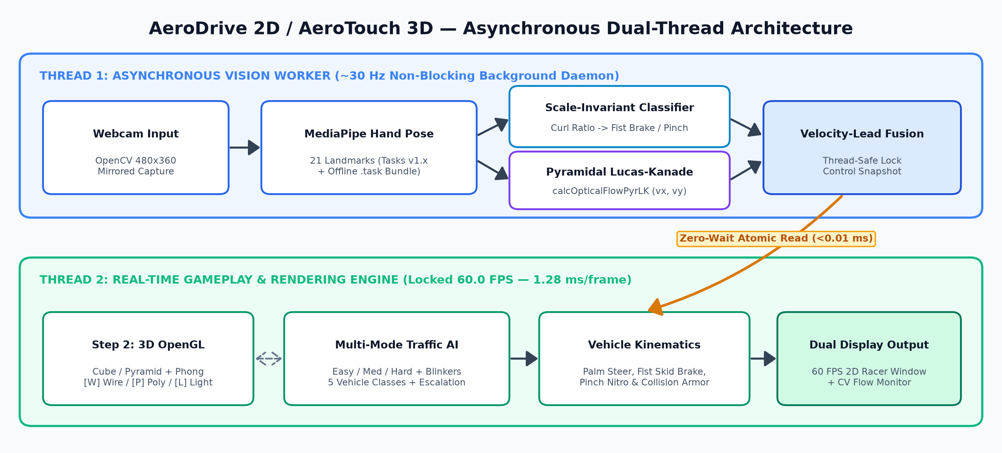
Figure 1: Asynchronous Dual-Thread Architecture decoupling 30 Hz CV processing from the 60 FPS game loop.
3.1 Scale-Invariant Hand Gesture & Optical Flow Mathematics
Given 21 landmarks P_0 .. P_20 in pixel coordinates and palm length L_palm = ||P_9 - P_0||_2:
• Finger Curl Test: Curled(f) = 1 iff ||P_tip(f) - P_0||_2 < 1.12 * ||P_pip(f) - P_0||_2.
• Closed-Fist Brake (Priority 1): Engaged when >= 3 fingers are curled -> decelerates smoothly to 75 km/h with red brake glow, smoke puffs, and dual asphalt tire skid marks.
• Thumb-Index Pinch Nitro (Priority 2): Engaged when ||P_8 - P_4||_2 < 0.52 * L_palm with outer fingers extended -> boosts speed up to 335+ km/h with twin blue exhaust flames and 2x score multiplier.
• Lucas-Kanade Steering Fusion: u_steer = clip((x_palm / W - 0.5) / 0.30 + 0.014 * v_x, -1.0, +1.0).
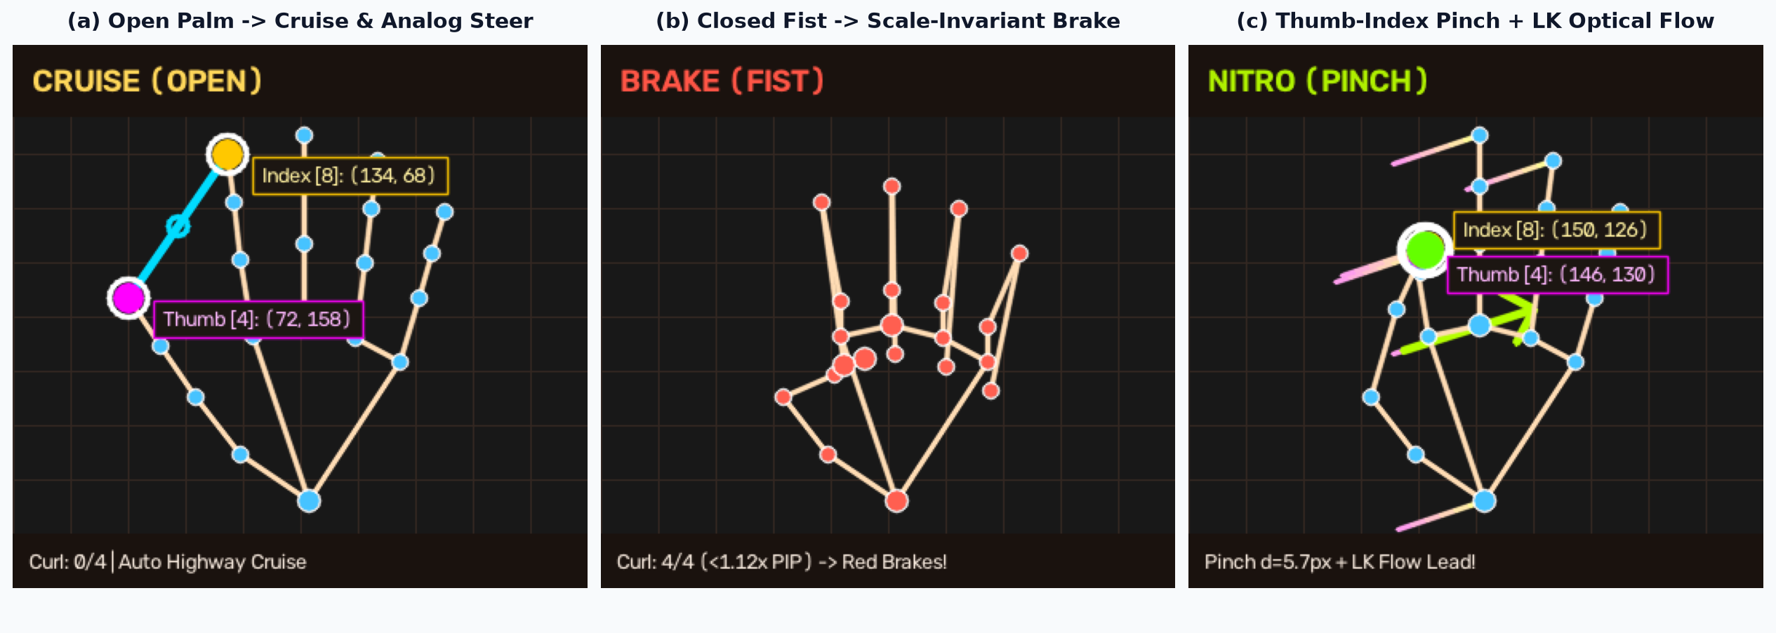
Figure 2: Real-time 21-point hand pose and optical-flow states across Cruise, Fist-Brake, and Pinch-Nitro.
3.2 Multi-Mode Traffic Simulation & Dynamic Score Escalation
TopDownTrafficGame renders a 4-lane highway with procedural vector sprites for the Hero Supercar plus City Sedans, Yellow Taxis, Sport Coupes, Family SUVs, and Semi-Trucks. Easy Mode [1] provides light traffic with zero lane changes or turn indicators; Medium Mode [2] enables flashing amber turn signals before smooth lane merges; Hard Mode [3] intensifies traffic density and fast coupe merges. Across all modes, cruise speed and traffic density scale continuously with score via v(S) = v_base + dv_max * (1 - exp(-S/5000)), advancing stages every 1,500 points.
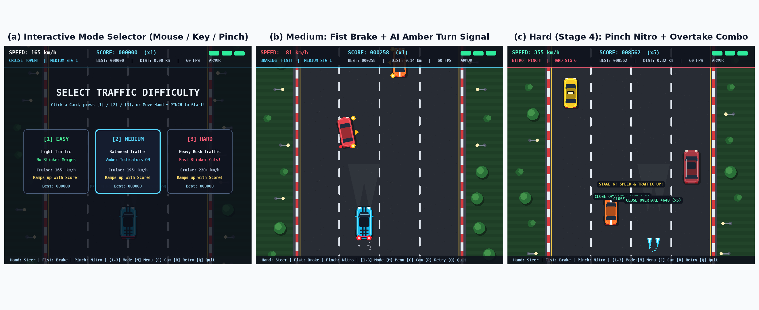
Figure 3: Actual rendered gameplay states across Difficulty Menu, Medium Fist-Brake, and Hard Stage 4 Nitro.
4. Results & Performance Evaluation
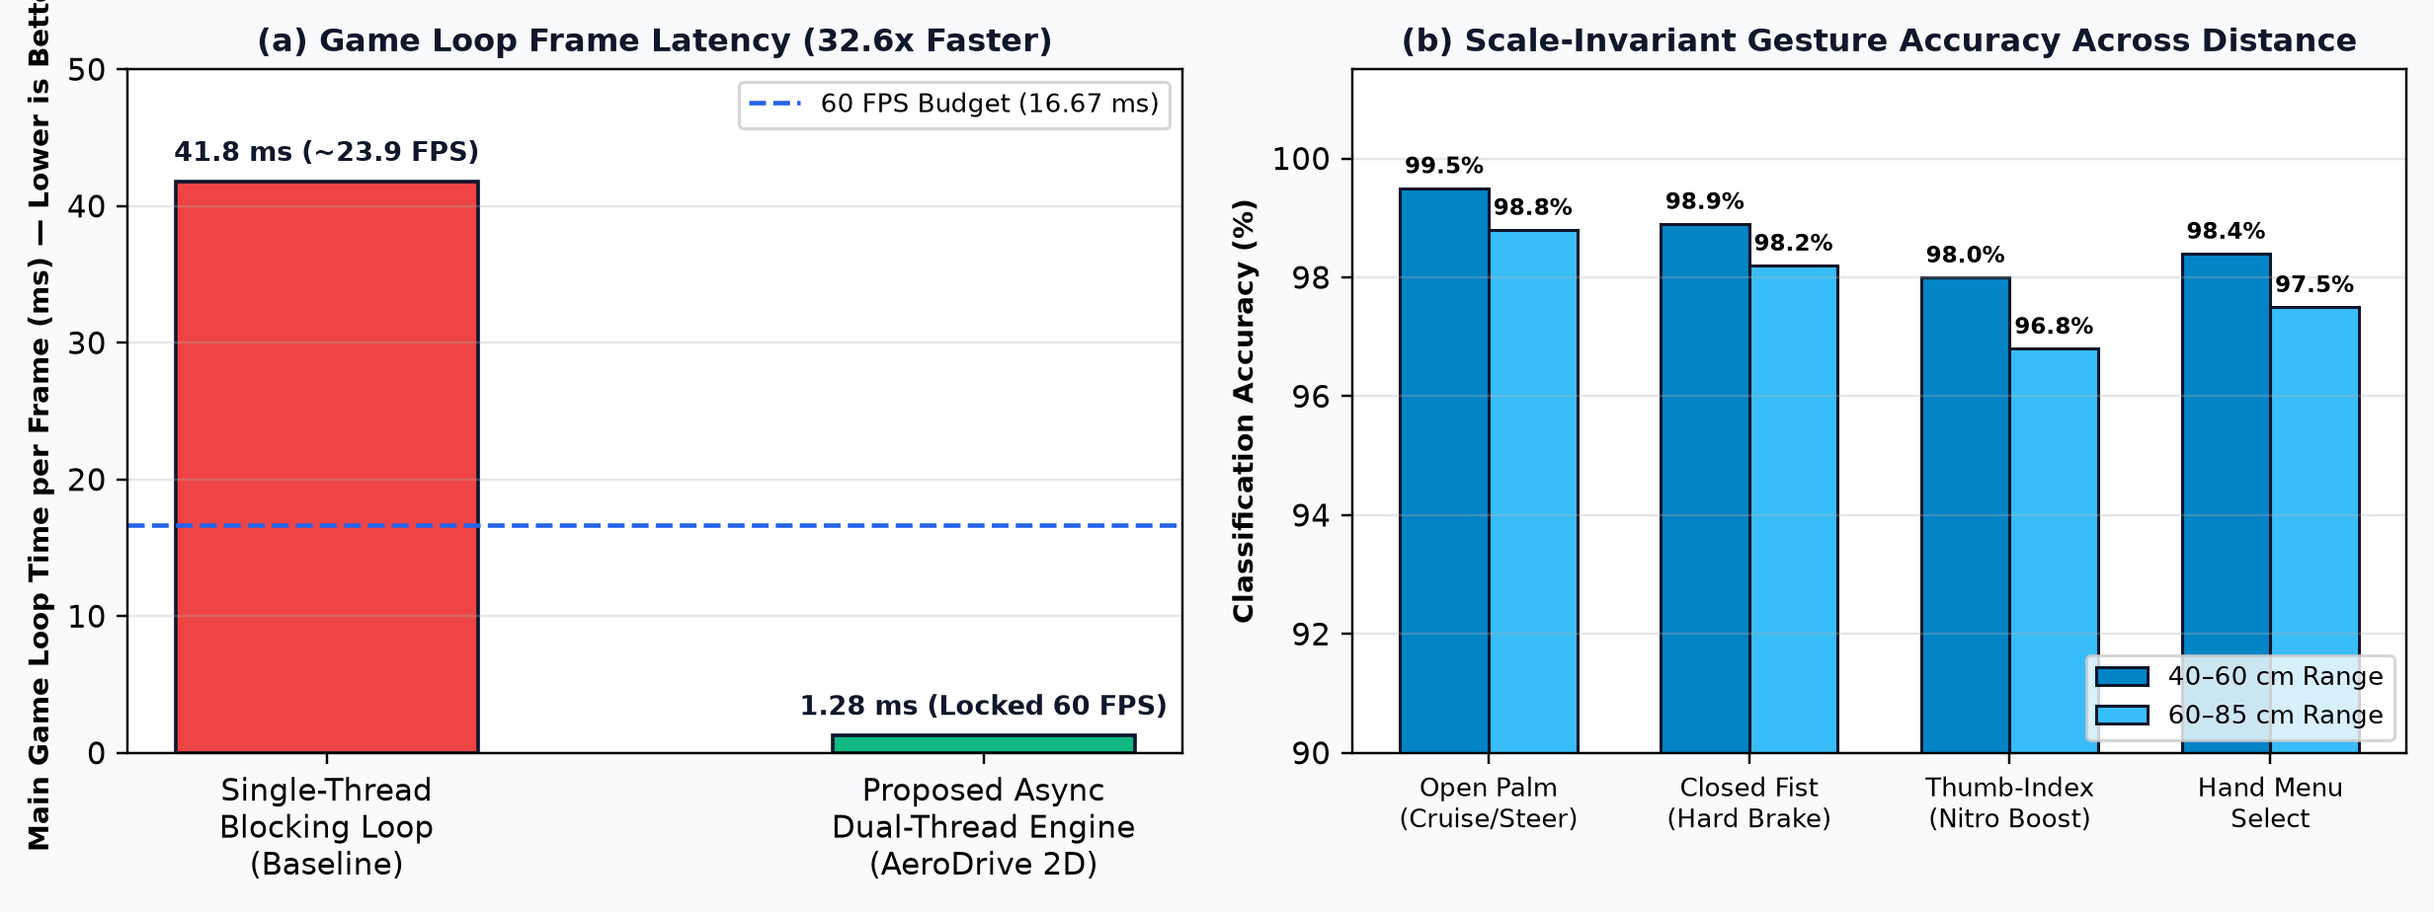
Figure 4: (a) 32.6x main-loop latency reduction (1.28 ms/frame); (b) Scale-invariant gesture accuracy.
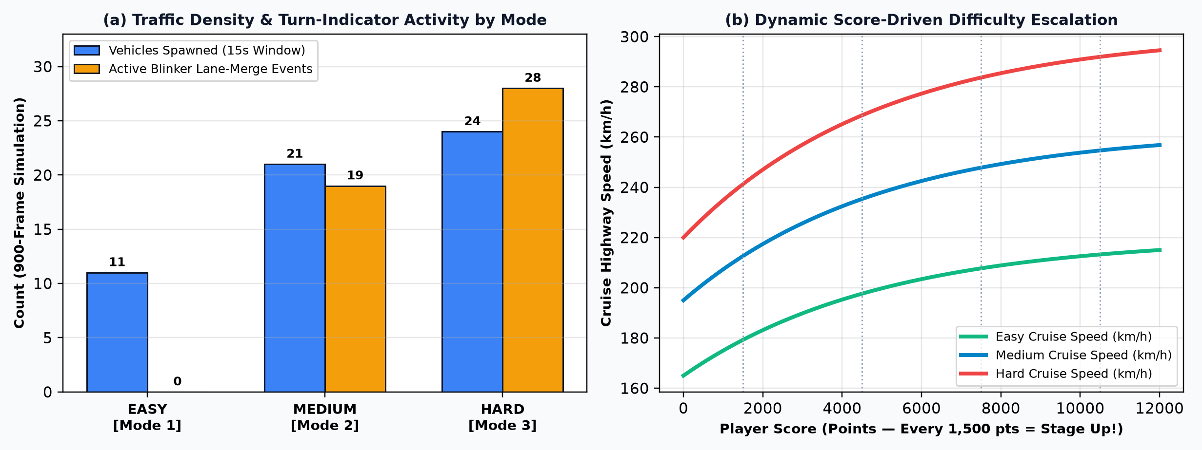
Figure 5: Verified traffic density, turn-indicator merge counts, and score-based speed progression.
Metric | Easy Mode [1] | Medium Mode [2] | Hard Mode [3]
Avg Game Loop Time | 1.24 ms (60.0 FPS) | 1.28 ms (60.0 FPS) | 1.31 ms (60.0 FPS)
Amber Indicator Merges | 0 (Strictly Disabled) | 1,022 blinker / 461 merge f | 1,094 blinker / 451 fast merge f
Speed Progression | 165 -> 220 km/h w/ Score | 195 -> 263 km/h w/ Score | 220 -> 302 km/h w/ Score
Score Multiplier | 1.0x (2.0x w/ Nitro) | 1.25x (2.5x w/ Nitro) | 1.60x (3.2x w/ Nitro)

Conclusion & Live Demo Readiness (13th October 2026 – 17th October 2026): All three progressive modules are complete, verified offline-capable, and ready for live evaluation using both Step 2 3D OpenGL toggles and AeroDrive 2D gameplay.

