**Work Breakdown Structure**

**My Coffee POS**

Version 1.0

Prepare by

Miss Vachira Mas-osot 5730213045<ProjectManager>

Miss Sutita Saraya 5730213009

Miss Tunyared Khaiwthong 5730213035

Mr. Passakorn Rattanaprapan 5730213067

Miss Savinee Jitjarak 5730213094

Table of Contents

1. **Revision History**

|  |  |  |  |
| --- | --- | --- | --- |
| **Name** | **Date** | **Description** | **Version** |
|  |  |  |  |

1. **Use Case Overview**

Use Case Diagram Level 0 : Coffee POS System

Coffee POS System

Employee

Use Case Diagram Level 1: Sale Management

Use Case Diagram Level 1: Material Management

Use Case Diagram Level 1: Food Management

Use Case Diagram Level 1: Employee Management

Use Case Diagram Level 1: System Management

1. System Structure

**My Coffee POS System**

Edit Data System

Delete Data System

Add Data System

View Data System

Delete Employee Data

Edit Employee Data

Add Employee Data

View Employee Data

Delete Material Data

Edit Material Data

Add Food Data

Add Material Data

View Material Data

Delete Food Data

Edit Food Data

View Food Data

View Sales Data

Delete Sale Data

Food Management

Employee Management

System Management

Material Management

Sales Management

Add Sale Data

Edit Sale Data

1. Static Structure and Data Analysis
   1. Model-View-Controller (MVC) Model
2. Sales Management
   1. View Sales Data

Receive Sale of Customer GUI Receive Sale of Customer to Model Sales

Sale of Customer Show Screen Receive Customer from Model

* 1. Add Sale Data

Add Sale of Customer GUI Add Sale of Customer to Model Sales

Sale of Customer Show Screen Receive Customer from Model

* 1. Edit Sale Data

Edit sale of Customer GUI Edit sale of Customer to Model Sales

Sale of Customer Show Screen Receive Customer from Model

* 1. Delete Sale Data

Delete sale of Customer GUI Delete sale of Customer to Model Sales

Sale of Customer Show Screen Receive Customer from Model

1. Food Management

3.1 View Data Food

View data of food to model

food

View data of food GUI

Receive food from model

Data of food report screen

3.2 Add data food

Add data of food to model

Add data of food GUI

food

Receive food from model

Data of food report screen

3.3 Edit Sale Data

Edit data of food to model

Edit data of food GUI

food

Receive food from model

Data of food report screen

3.4 Delete Sale Data

Delete data of food to model

Delete data of food GUI

food

Receive food from model

Data of food report screen

* 1. **Entity Class Model**

Coffee POS System

ในส่วนของทั้งระบบ (ใส่ตั้งไว้เฉยๆก่อน

1. Sale Management

Class ของ ดา

1. Material Management

ของ ฟาง

1. Food Management

|  |
| --- |
| Food |
| Type Price |

|  |
| --- |
| Drink |
| Product ID Product Name |
| +View() +Add() +Edit() +Delete() |

|  |
| --- |
| Dessert |
| Product ID Product Name |
| +View() +Add() +Edit() +Delete() |

|  |
| --- |
| Meat dish |
| Product ID Product Name |
| +View() +Add() +Edit() +Delete() |

1. Employee Management

ของ นาย

5. System Management

ของ สาว

**5. System Behaviour Model**

**Sequence Diagram**

3. Food management

3.1 View data food

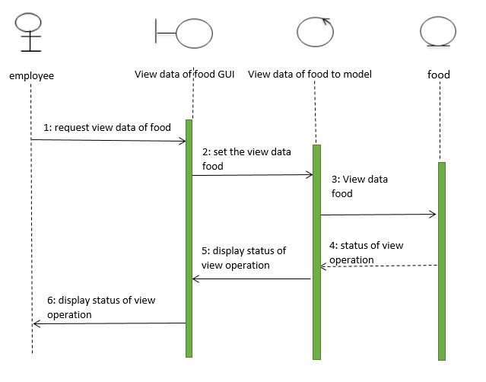

3.2 Add data food

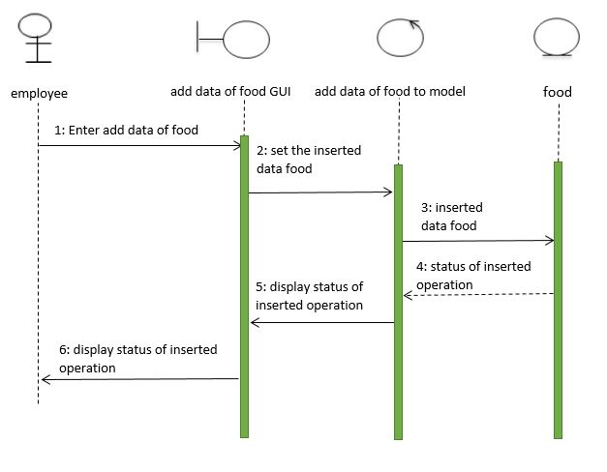

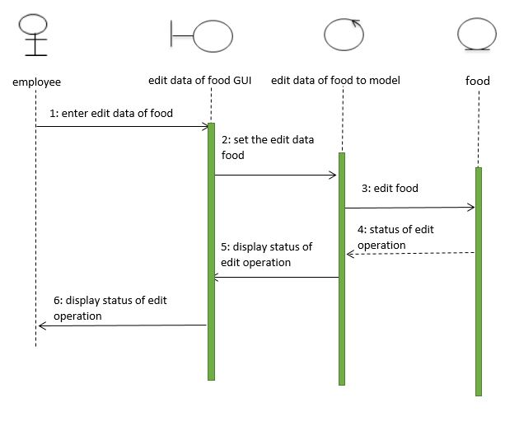

3.3 Edit data food

3.4 Delete data food

