9.1 For our simple robot model, describe the set of points that can be reached by the tip of the upper arm: 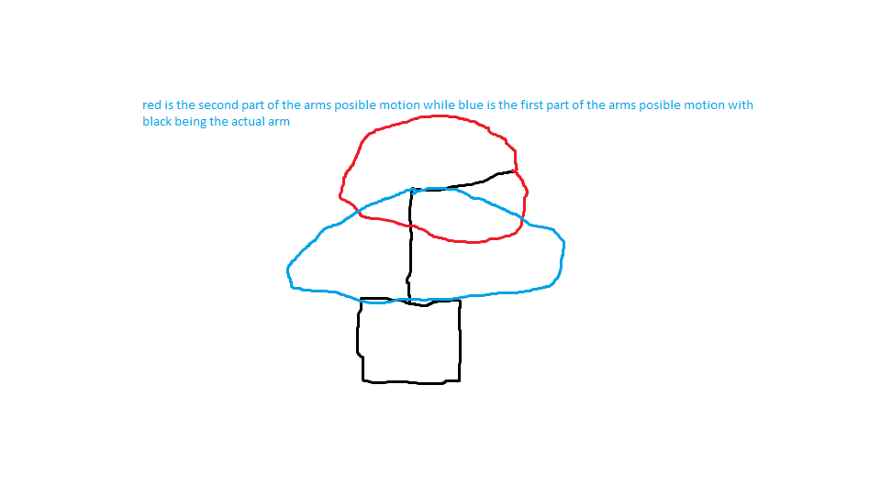

**The poorly drawn image above shows the rang eof movement that a simple robot model can take. So, it can be seen that upper arm can reach all the points surrounding it as it can reach all 360 degrees of rotation, but the lower arm can only rotate about 180 degrees. So the set of points are all of the 360 degree points of the upper arm coming off the 180 degree points of the lower arm.**

9.2 Find equations (concatenation of transformation matrices) for the position of any point on the simple robot in terms of the joint angles.

**M = RotateY(theta(base)) -> rotate on y by theta depending on base**

**X**

**Translate(0,heightFirstObject,0)**

**X**

**RotateZ(theta(lowerArm))**

**X**

**Translate(0,heightSecondObject,0)**

**X**

**RotateX(theta(upperArm))**

**Where X is multiplication**

9.10 Why is ray tracing a good strategy for rendering a scene described by a CSG tree?

**It is as simple as solving a scalar quadratic equation, so it is a much simpler process**

9.11 Show how quadtrees can be used to draw an image at different resolutions

**you can have a low resolution image by going up a level and so have less nodes. For example, could start by having 16 pixels and then go up a level so that there are only 4. Going up a level makes the r,g,b,A values the average of the 4 nodes in the level below it**

9.13 Is it possible to design a scene graph structure that is independent of the traversal algorithm?

**To do this you need to set each point to have an absolute position instead of a relative position.**