**«ІНСТИТУТ ПРИКЛАДНОГО СИСТЕМНОГО АНАЛІЗУ»**

**НАЦІОНАЛЬНОГО ТЕХНІЧНОГО УНІВЕРСИТЕТУ УКРАЇНИ «КПІ»**

**КАФЕДРА МАТЕМАТИЧНИХ МЕТОДІВ СИСТЕМНОГО АНАЛІЗУ**

**Лабораторна робота №6**

**з курсу «Бази даних»**

**тема: «Формирование SQL-запросов к созданной базе данных.»**

**Виконала: студентка 3 курсу**

**групи КА-83**

**Бень М. В.**

**Прийняв: Мухін В. Є.**

**Київ – 2020р.**

**ЭТАПЫ РАБОТЫ**

1. Создание схемы с базами данных.
2. Преобразование базы в SQL код.
3. Генереция SQL-запросов к таблицам.

**Создание схемы с базами данных.**

Таблица doctors:

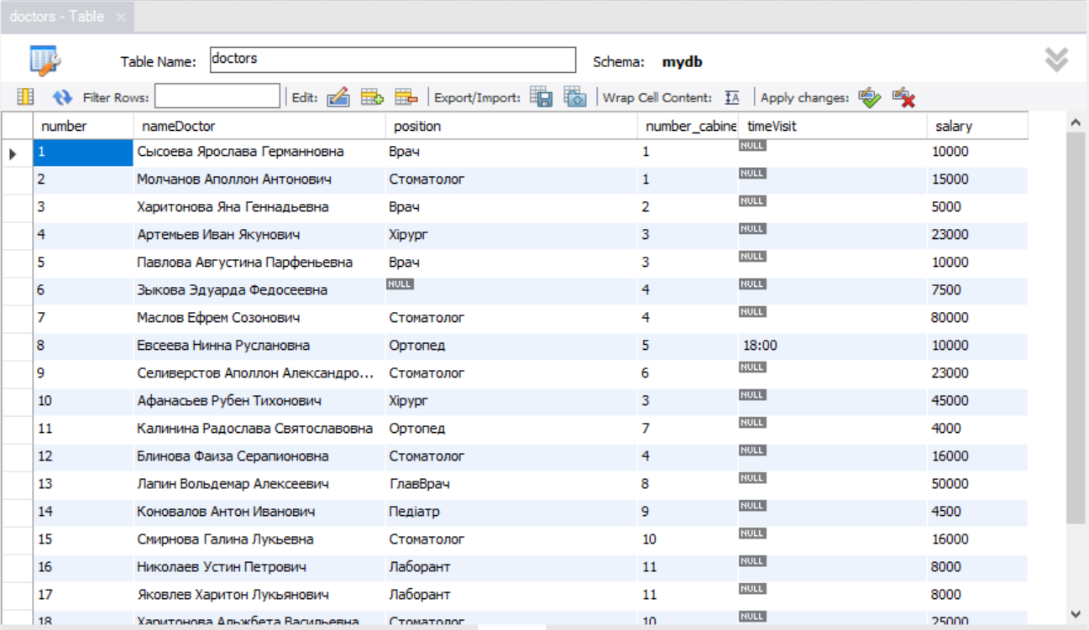

Таблица patients:

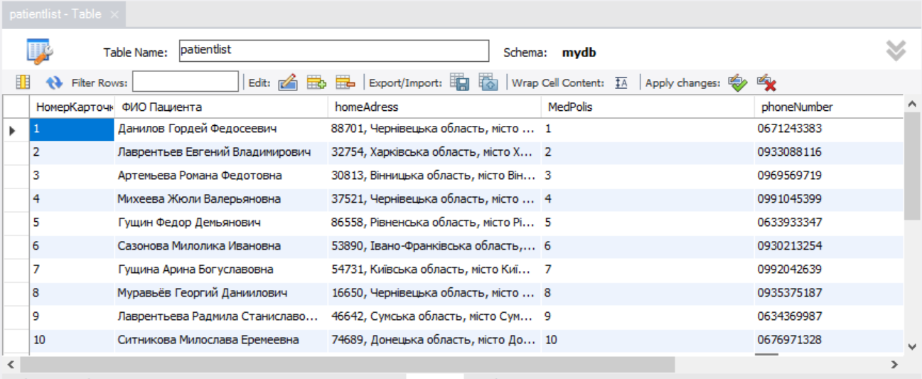

Таблица log:

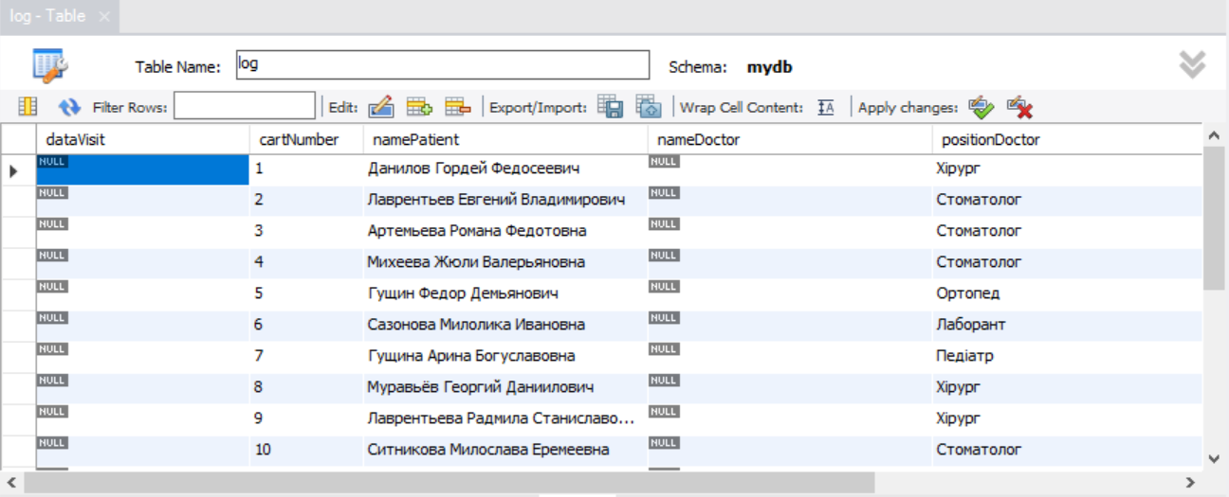

Таблица services_list:

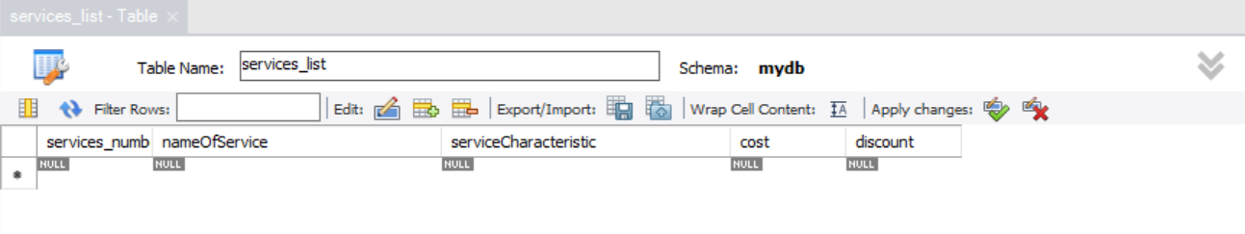

Преобразование базы в SQL код (дополнение 1)

Генерация SQL-запросов к таблицам.

1. select *

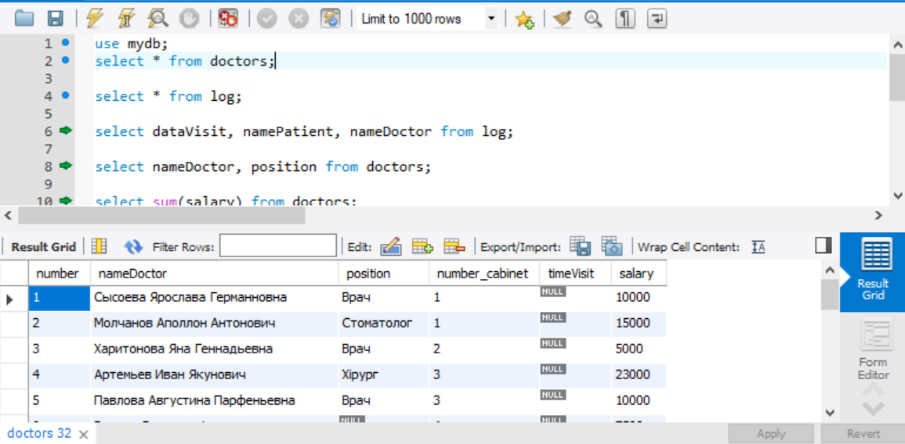

1. select some fields (count- кількість)

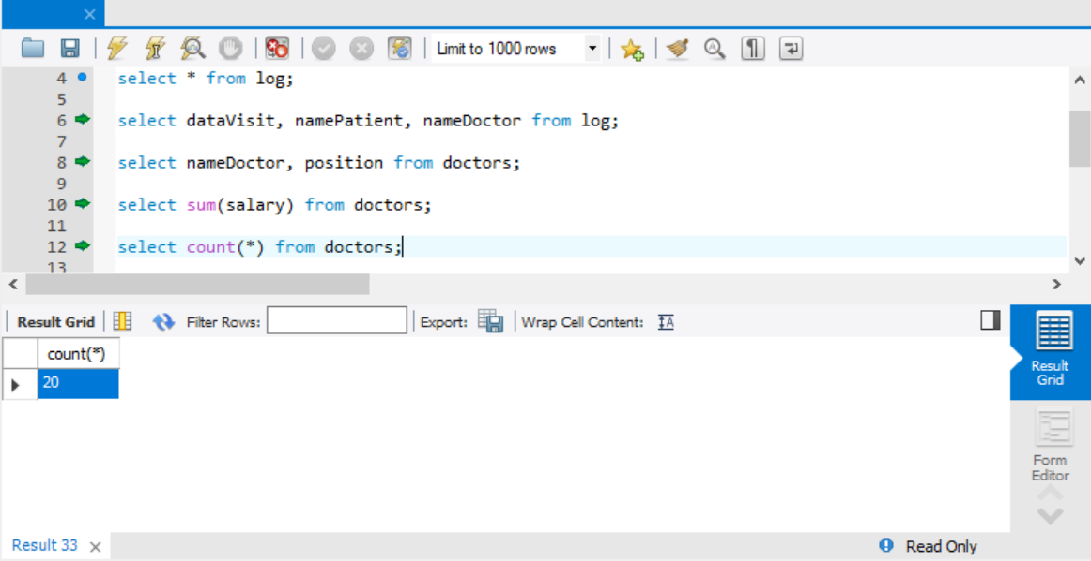

1. Selection condition (where, or, in, between, like)

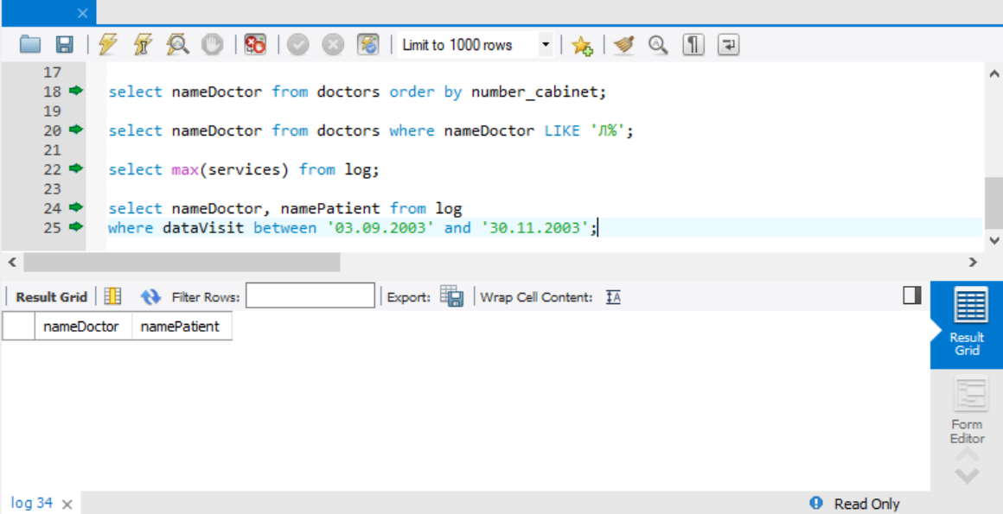

1. Aggregation function (sum, count, max, min, avg)

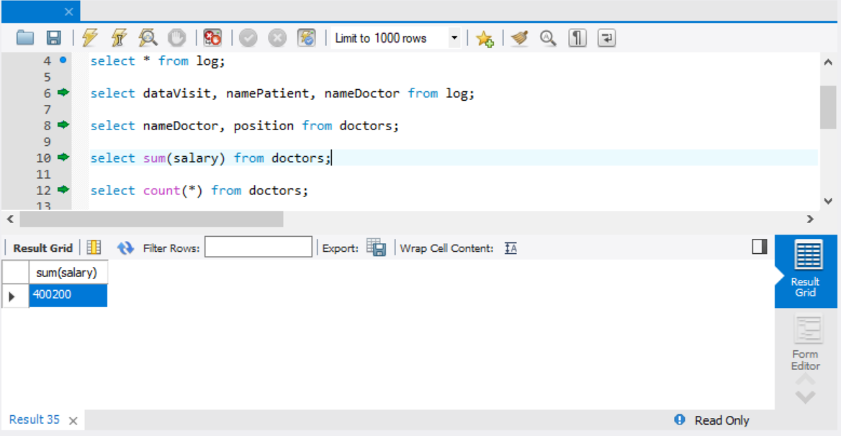

1. Sorting (order by limit)

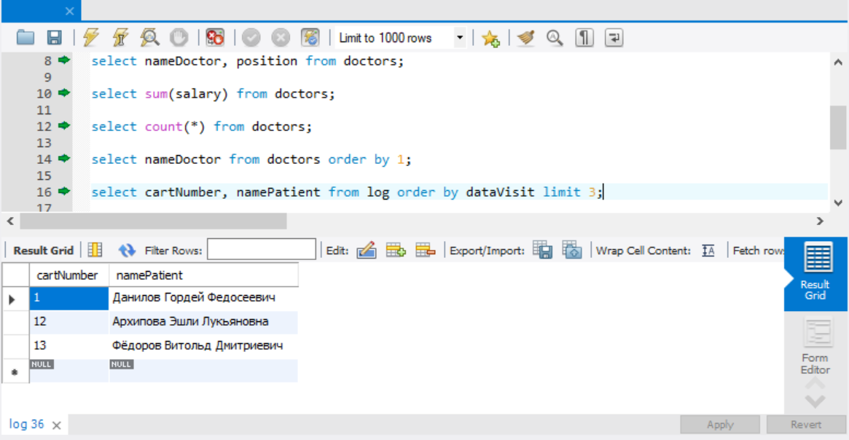

**Выводы:**

Для извлечения данных из базы данных используется язык SQL. SQL — это язык программирования, который очень напоминает английский, но предназначен для программ управления базами данных. SQL используется в каждом запросе в Access.

Понимание принципов работы SQL помогает создавать более точные запросы и упрощает исправление запросов, которые возвращают неправильные результаты.

Дополнение 1

-- MySQL Script generated by MySQL Workbench

-- Mon Nov 20 20:23:49 2017

-- Model: New Model Version: 1.0

-- MySQL Workbench Forward Engineering

SET @OLD_UNIQUE_CHECKS=@@UNIQUE_CHECKS, UNIQUE_CHECKS=0;

SET @OLD_FOREIGN_KEY_CHECKS=@@FOREIGN_KEY_CHECKS, FOREIGN_KEY_CHECKS=0;

SET @OLD_SQL_MODE=@@SQL_MODE, SQL_MODE='TRADITIONAL,ALLOW_INVALID_DATES';

-- -----------------------------------------------------

-- Schema mydb6

-- -----------------------------------------------------

-- -----------------------------------------------------

-- Schema mydb6

-- -----------------------------------------------------

CREATE SCHEMA IF NOT EXISTS `mydb6` DEFAULT CHARACTER SET utf8 ;

USE `mydb6` ;

-- -----------------------------------------------------

-- Table `mydb6`.`doctors`

-- -----------------------------------------------------

CREATE TABLE IF NOT EXISTS `mydb6`.`doctors` (

`iddoctors` INT NOT NULL,

`Full_name` VARCHAR(45) NOT NULL,

`Position` VARCHAR(45) NOT NULL,

`Cabinet_number` SMALLINT NOT NULL,

`Appointment_time` TIME NOT NULL,

`Type_of_service` VARCHAR(45) NOT NULL,

`Salary` DECIMAL(10,2) NOT NULL,

PRIMARY KEY (`iddoctors`))

ENGINE = InnoDB;

-- -----------------------------------------------------

-- Table `mydb6`.`patients`

-- -----------------------------------------------------

CREATE TABLE IF NOT EXISTS `mydb6`.`patients` (

`idpatients` INT NOT NULL,

`Full_name` VARCHAR(45) NULL,

`Home_adress` VARCHAR(45) NULL,

`Medical_policy` VARCHAR(45) NULL,

`Phone_number` VARCHAR(45) NULL,

`Gender` VARCHAR(45) NULL,

PRIMARY KEY (`idpatients`))

ENGINE = InnoDB;

-- -----------------------------------------------------

-- Table `mydb6`.`list_of_services`

-- -----------------------------------------------------

CREATE TABLE IF NOT EXISTS `mydb6`.`list_of_services` (

`idlist_of_services` INT NOT NULL,

`Name_of_service` VARCHAR(45) NULL,

`Characteristic_of_service` VARCHAR(45) NULL,

`Cost` DECIMAL(10,2) NULL,

`Discount` DECIMAL(5,2) NULL,

PRIMARY KEY (`idlist_of_services`))

ENGINE = InnoDB;

-- -----------------------------------------------------

-- Table `mydb6`.`journal`

-- -----------------------------------------------------

CREATE TABLE IF NOT EXISTS `mydb6`.`journal` (

`Appointment_date` TIMESTAMP NULL,

`Card_number` INT NULL,

`Patient_full_name` VARCHAR(45) NULL,

`Doctor_full_name` VARCHAR(45) NULL,

`Doctor's_position` VARCHAR(45) NULL,

`Service` VARCHAR(45) NULL,

`Quantity` SMALLINT(100) NULL)

ENGINE = InnoDB;

SET SQL_MODE=@OLD_SQL_MODE;

SET FOREIGN_KEY_CHECKS=@OLD_FOREIGN_KEY_CHECKS;

SET UNIQUE_CHECKS=@OLD_UNIQUE_CHECKS;

-- -----------------------------------------------------

-- Data for table `mydb6`.`doctors`

-- -----------------------------------------------------

START TRANSACTION;

USE `mydb6`;

INSERT INTO `mydb6`.`doctors` (`iddoctors`, `Full_name`, `Position`, `Cabinet_number`, `Appointment_time`, `Type_of_service`, `Salary`) VALUES (1, 'Lue', 'head physician', 100, '7:00', 'therapeutic', 2000);

INSERT INTO `mydb6`.`doctors` (`iddoctors`, `Full_name`, `Position`, `Cabinet_number`, `Appointment_time`, `Type_of_service`, `Salary`) VALUES (2, 'James', 'surgeon', 201, '7:00', 'surgical', 3800);

INSERT INTO `mydb6`.`doctors` (`iddoctors`, `Full_name`, `Position`, `Cabinet_number`, `Appointment_time`, `Type_of_service`, `Salary`) VALUES (3, 'Love', 'surgeon', 202, '15:00', 'surgical', 3000);

INSERT INTO `mydb6`.`doctors` (`iddoctors`, `Full_name`, `Position`, `Cabinet_number`, `Appointment_time`, `Type_of_service`, `Salary`) VALUES (4, 'Frye', 'surgeon', 203, '7:00', 'surgical', 500);

INSERT INTO `mydb6`.`doctors` (`iddoctors`, `Full_name`, `Position`, `Cabinet_number`, `Appointment_time`, `Type_of_service`, `Salary`) VALUES (5, 'Wade', 'surgeon', 204, '15:00', 'surgical', 200);

INSERT INTO `mydb6`.`doctors` (`iddoctors`, `Full_name`, `Position`, `Cabinet_number`, `Appointment_time`, `Type_of_service`, `Salary`) VALUES (6, 'Crowder', 'therapist', 301, '7:00', 'therapeutic', 1200);

INSERT INTO `mydb6`.`doctors` (`iddoctors`, `Full_name`, `Position`, `Cabinet_number`, `Appointment_time`, `Type_of_service`, `Salary`) VALUES (7, 'Thompson', 'therapist', 302, '15:00', 'therapeutic', 1800);

INSERT INTO `mydb6`.`doctors` (`iddoctors`, `Full_name`, `Position`, `Cabinet_number`, `Appointment_time`, `Type_of_service`, `Salary`) VALUES (8, 'Shumpert', 'therapist', 303, '7:00', 'therapeutic', 1500);

INSERT INTO `mydb6`.`doctors` (`iddoctors`, `Full_name`, `Position`, `Cabinet_number`, `Appointment_time`, `Type_of_service`, `Salary`) VALUES (9, 'Cleveland', 'dentist', 401, '15:00', 'stomatologic', 100);

INSERT INTO `mydb6`.`doctors` (`iddoctors`, `Full_name`, `Position`, `Cabinet_number`, `Appointment_time`, `Type_of_service`, `Salary`) VALUES (10, 'Korver', 'dentist', 402, '7:00', 'stomatologic', 800);

INSERT INTO `mydb6`.`doctors` (`iddoctors`, `Full_name`, `Position`, `Cabinet_number`, `Appointment_time`, `Type_of_service`, `Salary`) VALUES (11, 'Rose', 'dentist', 403, '15:00', 'stomatologic', 500);

COMMIT;

-- -----------------------------------------------------

-- Data for table `mydb6`.`patients`

-- -----------------------------------------------------

START TRANSACTION;

USE `mydb6`;

INSERT INTO `mydb6`.`patients` (`idpatients`, `Full_name`, `Home_adress`, `Medical_policy`, `Phone_number`, `Gender`) VALUES (100, 'Kerr', 'Washington DC', 'AA-1123', '741852963', 'Male');

INSERT INTO `mydb6`.`patients` (`idpatients`, `Full_name`, `Home_adress`, `Medical_policy`, `Phone_number`, `Gender`) VALUES (101, 'Curry', 'Oakland', 'BB-1235', '85296341', 'Male');

INSERT INTO `mydb6`.`patients` (`idpatients`, `Full_name`, `Home_adress`, `Medical_policy`, `Phone_number`, `Gender`) VALUES (102, 'Durant', 'Ohio', 'CC-2358', '963852741', 'Female');

INSERT INTO `mydb6`.`patients` (`idpatients`, `Full_name`, `Home_adress`, `Medical_policy`, `Phone_number`, `Gender`) VALUES (103, 'Green', 'Utah', 'DD-5813', '369258147', 'Male');

INSERT INTO `mydb6`.`patients` (`idpatients`, `Full_name`, `Home_adress`, `Medical_policy`, `Phone_number`, `Gender`) VALUES (104, 'Thompson', 'Carolina', 'EE-1321', '258147369', 'Male');

INSERT INTO `mydb6`.`patients` (`idpatients`, `Full_name`, `Home_adress`, `Medical_policy`, `Phone_number`, `Gender`) VALUES (105, 'Young', 'New Jersey', 'FF-2134', '147258369', 'Female');

INSERT INTO `mydb6`.`patients` (`idpatients`, `Full_name`, `Home_adress`, `Medical_policy`, `Phone_number`, `Gender`) VALUES (106, 'Pachulia', 'Brooklyn', 'GG-3455', '789456123', 'Male');

INSERT INTO `mydb6`.`patients` (`idpatients`, `Full_name`, `Home_adress`, `Medical_policy`, `Phone_number`, `Gender`) VALUES (107, 'McGee', 'Georgia', 'HH-5589', '456123789', 'Male');

INSERT INTO `mydb6`.`patients` (`idpatients`, `Full_name`, `Home_adress`, `Medical_policy`, `Phone_number`, `Gender`) VALUES (108, 'Livingston', 'Virginia', 'II-1235', '789456123', 'Female');

INSERT INTO `mydb6`.`patients` (`idpatients`, `Full_name`, `Home_adress`, `Medical_policy`, `Phone_number`, `Gender`) VALUES (109, 'Igoudala', 'Florida', 'JJ-2357', '123456789', 'Male');

INSERT INTO `mydb6`.`patients` (`idpatients`, `Full_name`, `Home_adress`, `Medical_policy`, `Phone_number`, `Gender`) VALUES (110, 'Bell', 'California', 'KK-5711', '951843762', 'Male');

COMMIT;

-- -----------------------------------------------------

-- Data for table `mydb6`.`list_of_services`

-- -----------------------------------------------------

START TRANSACTION;

USE `mydb6`;

INSERT INTO `mydb6`.`list_of_services` (`idlist_of_services`, `Name_of_service`, `Characteristic_of_service`, `Cost`, `Discount`) VALUES (1000, 'Survey', 'therapeutic', 1000, 10);

INSERT INTO `mydb6`.`list_of_services` (`idlist_of_services`, `Name_of_service`, `Characteristic_of_service`, `Cost`, `Discount`) VALUES (1001, 'Removal of a tooth', 'stomatologic', 1500, 5);

INSERT INTO `mydb6`.`list_of_services` (`idlist_of_services`, `Name_of_service`, `Characteristic_of_service`, `Cost`, `Discount`) VALUES (1002, 'Heart surgery', 'surgical', 9000, 15);

INSERT INTO `mydb6`.`list_of_services` (`idlist_of_services`, `Name_of_service`, `Characteristic_of_service`, `Cost`, `Discount`) VALUES (1003, 'Teeth whitening', 'stomatologic', 2000, 20);

INSERT INTO `mydb6`.`list_of_services` (`idlist_of_services`, `Name_of_service`, `Characteristic_of_service`, `Cost`, `Discount`) VALUES (1004, 'Appendectomy', 'surgical', 2300, 25);

COMMIT;

-- -----------------------------------------------------

-- Data for table `mydb6`.`journal`

-- -----------------------------------------------------

START TRANSACTION;

USE `mydb6`;

INSERT INTO `mydb6`.`journal` (`Appointment_date`, `Card_number`, `Patient_full_name`, `Doctor_full_name`, `Doctor's_position`, `Service`, `Quantity`) VALUES ('18.11.2017', 100, 'Kerr', 'Lue', 'head physician', 'Survey', 3);

INSERT INTO `mydb6`.`journal` (`Appointment_date`, `Card_number`, `Patient_full_name`, `Doctor_full_name`, `Doctor's_position`, `Service`, `Quantity`) VALUES ('18.11.2017', 102, 'Durant', 'James', 'surgeon', 'Appendectomy', 5);

INSERT INTO `mydb6`.`journal` (`Appointment_date`, `Card_number`, `Patient_full_name`, `Doctor_full_name`, `Doctor's_position`, `Service`, `Quantity`) VALUES ('18.11.2017', 101, 'Curry', 'Korver', 'dentist', 'Removal of a tooth', 1);

INSERT INTO `mydb6`.`journal` (`Appointment_date`, `Card_number`, `Patient_full_name`, `Doctor_full_name`, `Doctor's_position`, `Service`, `Quantity`) VALUES ('19.11.2017', 100, 'Kerr', 'Lue', 'head physician', 'Survey', 2);

INSERT INTO `mydb6`.`journal` (`Appointment_date`, `Card_number`, `Patient_full_name`, `Doctor_full_name`, `Doctor's_position`, `Service`, `Quantity`) VALUES ('19.11.2017', 102, 'Durant', 'James', 'surgeon', 'Appendectomy', 4);

INSERT INTO `mydb6`.`journal` (`Appointment_date`, `Card_number`, `Patient_full_name`, `Doctor_full_name`, `Doctor's_position`, `Service`, `Quantity`) VALUES ('20.11.2017', 103, 'Green', 'Cleveland', 'dentist', 'Teeth whitening', 1);

INSERT INTO `mydb6`.`journal` (`Appointment_date`, `Card_number`, `Patient_full_name`, `Doctor_full_name`, `Doctor's_position`, `Service`, `Quantity`) VALUES ('20.11.2017', 103, 'Green', 'Rose', 'dentist', 'Removal of a tooth', 1);

INSERT INTO `mydb6`.`journal` (`Appointment_date`, `Card_number`, `Patient_full_name`, `Doctor_full_name`, `Doctor's_position`, `Service`, `Quantity`) VALUES ('22.11.2017', 102, 'Durant', 'James', 'surgeon', 'Appendectomy', 3);

INSERT INTO `mydb6`.`journal` (`Appointment_date`, `Card_number`, `Patient_full_name`, `Doctor_full_name`, `Doctor's_position`, `Service`, `Quantity`) VALUES ('22.11.2017', 106, 'Pachulia', 'Wade', 'surgeon', 'Heart surgery', 3);

INSERT INTO `mydb6`.`journal` (`Appointment_date`, `Card_number`, `Patient_full_name`, `Doctor_full_name`, `Doctor's_position`, `Service`, `Quantity`) VALUES ('22.11.2017', 104, 'Thompson', 'Rose', 'dentist', 'Teeth whitening', 1);

INSERT INTO `mydb6`.`journal` (`Appointment_date`, `Card_number`, `Patient_full_name`, `Doctor_full_name`, `Doctor's_position`, `Service`, `Quantity`) VALUES ('22.11.2017', 110, 'Bell', 'Cleveland', 'dentist', 'Teeth whitening', 2);

INSERT INTO `mydb6`.`journal` (`Appointment_date`, `Card_number`, `Patient_full_name`, `Doctor_full_name`, `Doctor's_position`, `Service`, `Quantity`) VALUES ('23.11.2017', 109, 'Igoudala', 'Rose', 'dentist', 'Removal of a tooth', 1);

INSERT INTO `mydb6`.`journal` (`Appointment_date`, `Card_number`, `Patient_full_name`, `Doctor_full_name`, `Doctor's_position`, `Service`, `Quantity`) VALUES ('23.11.2017', 105, 'Young', 'Crowder', 'surgeon', 'Heart surgery', 1);

INSERT INTO `mydb6`.`journal` (`Appointment_date`, `Card_number`, `Patient_full_name`, `Doctor_full_name`, `Doctor's_position`, `Service`, `Quantity`) VALUES ('24.11.2017', 102, 'Durant', 'James', 'surgeon', 'Appendectomy', 2);

INSERT INTO `mydb6`.`journal` (`Appointment_date`, `Card_number`, `Patient_full_name`, `Doctor_full_name`, `Doctor's_position`, `Service`, `Quantity`) VALUES ('25.11.2017', 100, 'Kerr', 'Shumpert', 'therapist', 'Survey', 1);

INSERT INTO `mydb6`.`journal` (`Appointment_date`, `Card_number`, `Patient_full_name`, `Doctor_full_name`, `Doctor's_position`, `Service`, `Quantity`) VALUES ('25.11.2017', 102, 'Durant', 'James', 'surgeon', 'Appendectomy', 1);

COMMIT;