Stage 1 – ADLS Gen2 Setup In this stage, raw data storage layer is created using ADLS Gen2.
Created Containers such as raw-data/transactions, raw-data/customers, raw-data/atm, and raw-data/upi are provisioned. This provides secure, scalable, and hierarchical storage for all incoming banking datasets.
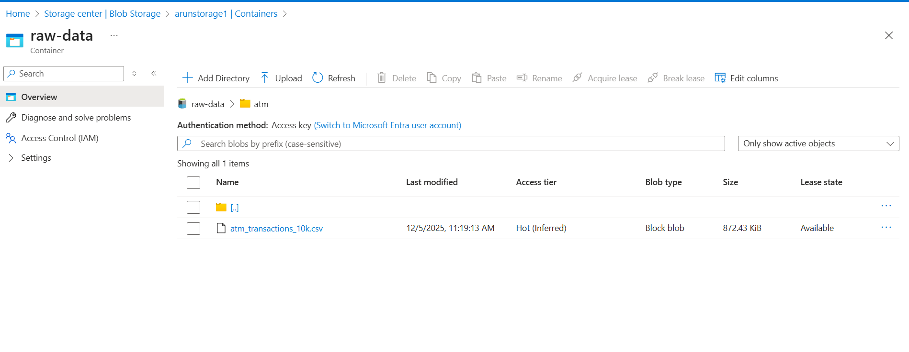

Stage 2 – Event Grid Configuration
Event Grid is enabled on selected Blob containers to detect new file uploads instantly. Each event automatically notifies downstream services, enabling real-time data ingestion without manual intervention.
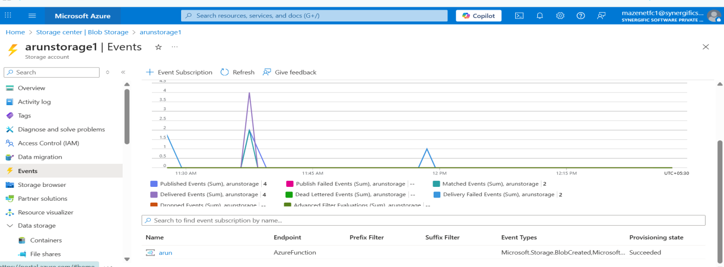

Stage 3 – Queue Service Setup
A Queue or Topic is created to handle high-volume ingestion events generated by Event Grid. This ensures reliable message delivered and smooth handling of variable workloads.

Stage 4 – Python Function (Event Grid Trigger)
An Azure Function with an Event Grid Trigger is developed to validate file metadata and routing rules. After validation, the function pushes an ingestion request message into the queue for processing.
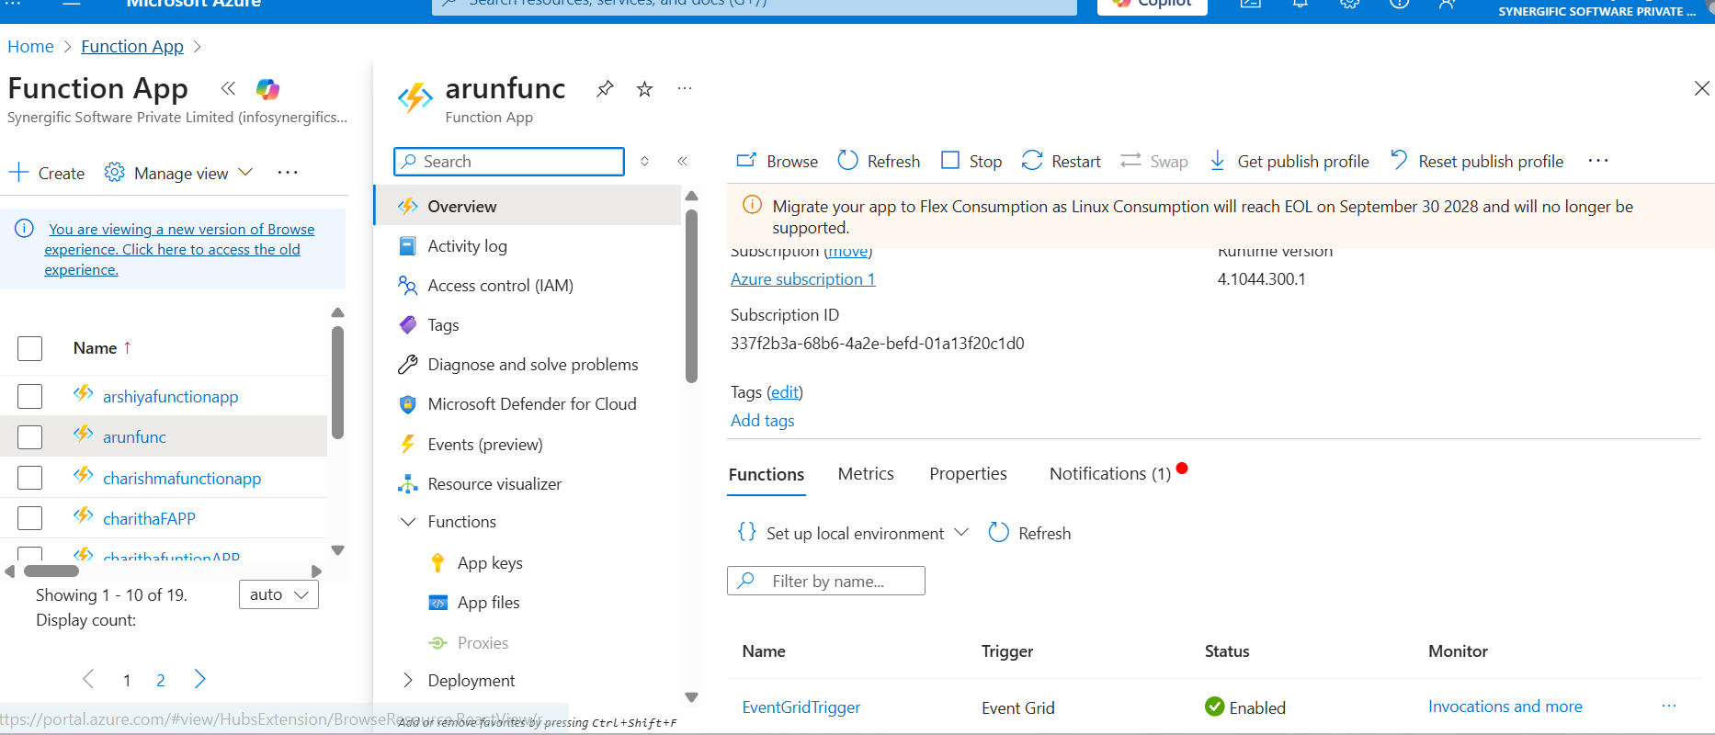
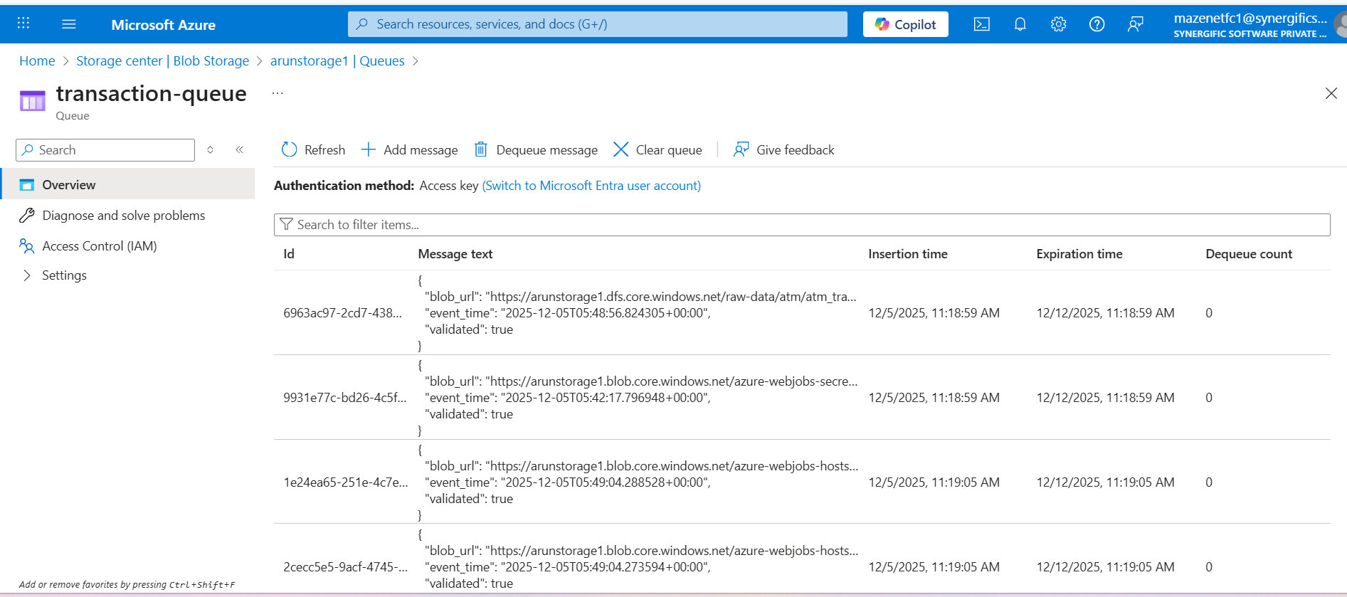
End day-1

