Employment Equity Data: Analysis
Analyst assignment | EEA2 submissions, 500 employers, 2013-2024

Summary
The dataset covers 500 South African employers over 12 years, reported across seven occupational levels. After cleaning and combining the two files, five findings stand out:
- One employer dominates. KwaZulu-Natal Provincial Department of Education makes up 35% of all reported headcount (31% to 47% depending on the year). Every comparison below is in percentage shares and is shown without this employer. Including it changes top-management shares by 0.3 percentage points at most.
- Top management is slowly diversifying. White share fell from 65.6% to 54.4% between 2013 and 2024; African share rose from 17.5% to 23.8%.
- The gap to the workforce is still large. In 2024, white employees are 9.8% of the workforce but 54.4% of top management. African employees are 72.7% of the workforce but 23.8% of top management.
- Women are under-represented most at the top. Women are 42.2% of the workforce but 24.7% of top management. Since 2013 the top gained 6.9 points, less than unskilled (+8.7) and professionally qualified (+7.8) roles.
- Employer classifications are unstable. The industry sector changes between years for 31% of employers, so sector trends need careful handling.

1. Data preparation
The profile file has 42,000 rows (500 employers x 12 years x 7 occupational levels, a complete panel with no duplicate keys). The meta file has one row per employer with 73 columns, because each attribute is repeated for every year. Issues found and how they were handled:
Issue | Where | Fix
Inconsistent column case | Profile: African_Female, AFRICAN_male, coloured_MALE | Lower-cased all names
Typo in column name | Profile: foriegn_male | Renamed to foreign_male
Same level, two labels | "Temporary" (2024 only, 500 rows) vs "Temporary employees" | Merged into "Temporary employees"; now 7 levels x 6,000 rows
Wide layout | Meta: attribute_year columns (73 columns) | Reshaped to one row per employer-year (6,000 rows)
Messy text | Meta: spacing and case in names and sectors | Trimmed and upper-cased
Combining the files | Key: ee_ref + submission_year | Left join; all 42,000 profile rows matched
Extreme values | Up to 73,872 African women in one cell | Traced to one real employer (see Finding 1); kept, analysed separately

For analysis, the race-by-gender columns were reshaped into long format (race and gender as columns), so shares can be computed for any grouping.

2. Findings

Finding 1: One provincial education department is over a third of the data
The largest values in the profile file are not typos. They all belong to a single employer, KwaZulu-Natal Provincial Department of Education, and recur in every year. It accounts for 31.7% of reported headcount in 2013, peaking at 47.1% in 2022 and standing at 36.5% in 2024. The next largest employer is about 7%.
Why it matters: any raw total or average is largely a statement about this one employer. All results here use percentage shares, and each headline is also computed with the employer excluded. For top-management race shares the two versions differ by 0.3 percentage points at most (for example 2024 white: 54.4% excluding vs 54.2% including), so the conclusions do not depend on this choice.

Finding 2: Top management has shifted gradually away from white representation
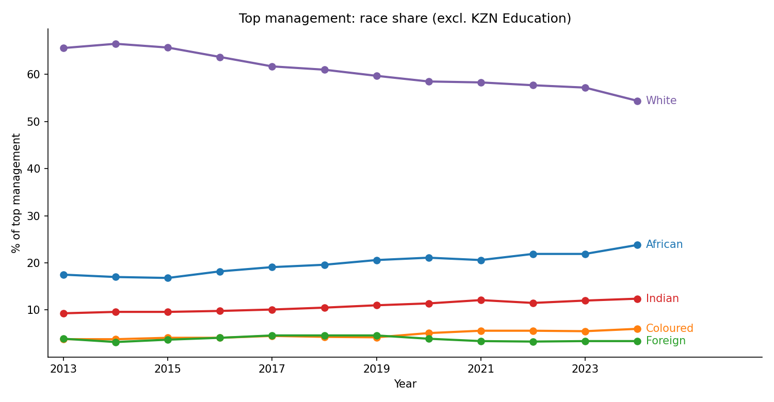
Figure 1. Race composition of top management, 2013 to 2024, excluding KZN Education.
Share of top management | 2013 | 2024 | Change (pp)
White | 65.6% | 54.4% | -11.2
African | 17.5% | 23.8% | +6.3
Indian | 9.3% | 12.4% | +3.1
Coloured | 3.8% | 6.0% | +2.2
Foreign nationals | 3.9% | 3.4% | -0.5

The shift is steady rather than abrupt, with a faster drop in the last year. White representation is still a clear majority of top management, and foreign nationals have not gained share.

Finding 3: Top management still looks very different from the workforce
2024, excluding KZN Education | Whole workforce | Top management | Gap (pp)
African | 72.7% | 23.8% | -48.9
White | 9.8% | 54.4% | +44.6
Indian | 4.8% | 12.4% | +7.6
Coloured | 11.0% | 6.0% | -5.0
Foreign nationals | 1.7% | 3.4% | +1.7

Progress in Finding 2 is real but small relative to the gap. African share of top management rose about 0.6 percentage points a year between 2013 and 2024. At that pace it would take decades to approach the workforce share. This is a simple extrapolation, not a forecast.

Finding 4: Women are under-represented most at the top
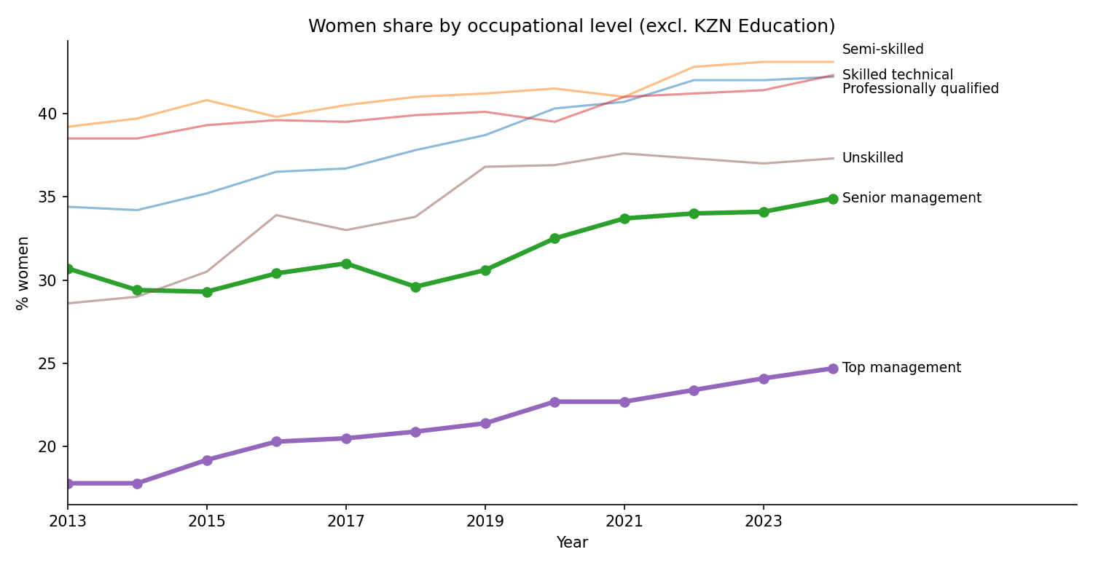
Figure 2. Women as a share of each occupational level, excluding KZN Education. Temporary employees omitted from the chart for readability (volatile year to year); included in the table.
Women share by level | 2013 | 2018 | 2024
Top management | 17.8% | 20.9% | 24.7%
Senior management | 30.7% | 29.6% | 34.9%
Professionally qualified | 34.4% | 37.8% | 42.2%
Skilled technical | 38.5% | 39.9% | 42.3%
Semi-skilled | 39.2% | 41.0% | 43.1%
Unskilled | 28.6% | 33.8% | 37.3%
Temporary employees | 44.1% | 50.0% | 50.0%

Women made up 36.8% of the workforce in 2013 and 42.2% in 2024. Top management rose 6.9 points over the period and unskilled roles rose 8.7 points, and professionally qualified roles rose 7.8, so the top has not been catching up faster than the middle and bottom of the pyramid. Senior management dipped in 2018 before recovering. The gap between the share of women in top management and in the workforce overall is about 17.5 points in 2024.

Finding 5: The same employer can change sector from year to year
Industry sector changes between years for 157 of 500 employers (31%), business type for 36 (7%), and province for 22 (4%). The dominant employer itself switches between "Arts, Entertainment and Recreation" and "Public Administration" and between "Educational Institution" and "Non-profit Organization". The registered name is also missing for 8% of employer-years, and spelling varies across years.
Implication: industry-level trends over time mix real change with relabelling, so they were not used for the findings above. A stable analysis by sector would need the labels harmonised first, for example by fixing each employer to its most frequent sector.

3. Assumptions and limitations
- The 500 employers are a sample of EEA2 submitters, not the whole labour market. Results describe these employers only.
- Foreign nationals are a separate category in the source data and are kept separate; they are not allocated to a population group.
- The dominant employer is retained in the cleaned data and excluded only from reported shares, as a robustness choice. Including it does not change the conclusions.
- Top management in 2024 is 1,508 people (1,650 in 2013) excluding KZN Education. That is a small base, so year-to-year moves of a few tenths of a point should not be over-read.
- The data show who is employed at each level, not why. They cannot say anything about hiring, promotion or pay on their own.
- "Temporary" and "Temporary employees" were treated as the same category.

4. Code
All steps (cleaning, reshaping, merging, checks, tables and charts) are in the accompanying notebook, EE_analysis_clean.ipynb. It runs top to bottom from the two CSV files and writes the two charts and two tables used here.

