Systems Analysis and Design
Stock Trading System
Nathan Able, Christy Bibb, Steeve Tankeu
Ira A. Fulton Schools of Engineering, Arizona State University
IFT 401: Information Tech Capstone (2026 Fall C)
Professor Michael Walsh
September 13, 2026

Table of Contents

Background 4
Problem Statement 4
Technology Solution 4
Process Maps 6
Requirements 15
Functional Requirements 15
Customer Account and Authentication 15
Simulated Cash Management 15
Stock Search and Price Display 16
Buy and Sell Orders 16
Pending Orders and Cancellation 17
Portfolio and Transaction History 17
Administrator Stock Management 17
Administrator Market Scheduling 18
Nonfunctional Requirements 18
Business Rules 20
User Interface 21
Wireframe 1: Account Registration and Sign In 22
Wireframe 2: Cash Management 23
Wireframe 3: Market Search and Trade Ticket 24
Wireframe 4: Pending Orders 25
Wireframe 5: Portfolio and Transaction History 26
Wireframe 6: Administrator Stock Management 26
Wireframe 7: Administrator Market Schedule 27
Infrastructure Architecture 28
Infrastructure Topology 28
Information Architecture 30
Entity Relationship Diagram 30
Relationships 31
Security and Privacy Architecture 32
Privacy Boundaries 33
Programming 33
Programing Languages 33
Framework and Development Tools 34
References 35

Background

Problem Statement
People who are learning the basic mechanics of stock trading need a safe environment in which they can practice without risking money or providing real financial information. Existing brokerage platforms are designed for actual investment activity and may introduce unnecessary complexity, financial risk, and privacy concerns for a beginning learner. A training system must therefore reproduce the essential activities involved in managing an investment portfolio while clearly separating the simulation from real-world trading.
The proposed Stock Trading System will address this need by giving customers a centralized web application for managing simulated cash, locating available stocks, viewing generated stock prices, submitting buy and sell orders, reviewing pending orders, tracking holdings, and examining transaction history. The system must maintain accurate relationships among cash balances, stock holdings, orders, prices, and transaction records so that one action does not leave the simulated account in an inconsistent state. It must also support administrators who manage the available stock list and establish the market schedule used to determine whether an order executes immediately or remains pending. The application will not execute real trades or collect banking information, brokerage credentials, payment information, or other data associated with real financial accounts.

Technology Solution
The team will develop a browser-based stock trading simulation as a single Django web application. Python and Django will provide the server-side application logic, authentication, authorization, form processing, validation, database models, migrations, and automated testing. Django includes an object-relational mapper that allows relational models and their connections to be defined in Python, along with migration tools for creating and updating the corresponding database structure (Django Software Foundation, n.d.-a). These capabilities support the project’s need to keep customer accounts, simulated cash activity, orders, holdings, stock prices, and market schedules consistent.
The user interface will use server-rendered Django templates with HTML, CSS, Bootstrap, and limited JavaScript. This approach provides responsive webpages without requiring a separate frontend application or application programming interface. A custom random stock-price generator will produce simulated market values and preserve the price information required for portfolio calculations and transaction records. SQLite will support straightforward local development, while MySQL will serve as the relational system of record for the deployed application.
The completed system will be hosted on PythonAnywhere, which supports deployment of existing Django projects and the configuration of Python environments, web applications, static files, and databases (PythonAnywhere, 2016). Users will access the application through a web browser over HTTPS. Git and GitHub will provide source control and team collaboration through branches, pull requests, and code review, but they will remain outside the live application request path. This consolidated architecture is appropriate for a three-person capstone team because it supports the required business functions while limiting unnecessary infrastructure and integration overhead.

Process Maps
The following process maps define the major customer and administrator workflows supported by the Stock Trading System. Each map begins with one Start point, ends with one End point, uses rectangles for actions, diamonds for decisions, and arrows to show the flow of control. Successful and unsuccessful outcomes are shown where validation or business rules affect the workflow. The maps establish the behavioral steps that the functional requirements and interface mockups must support.
Function: Customer account registration and validation.
Purpose: This process shows how a new customer enters the information required to create an account. The system validates that all required fields are complete and that the email address and username are unique. Invalid information produces a validation message and returns the customer to the entry step. Valid information results in the creation of a customer account and an authenticated session.
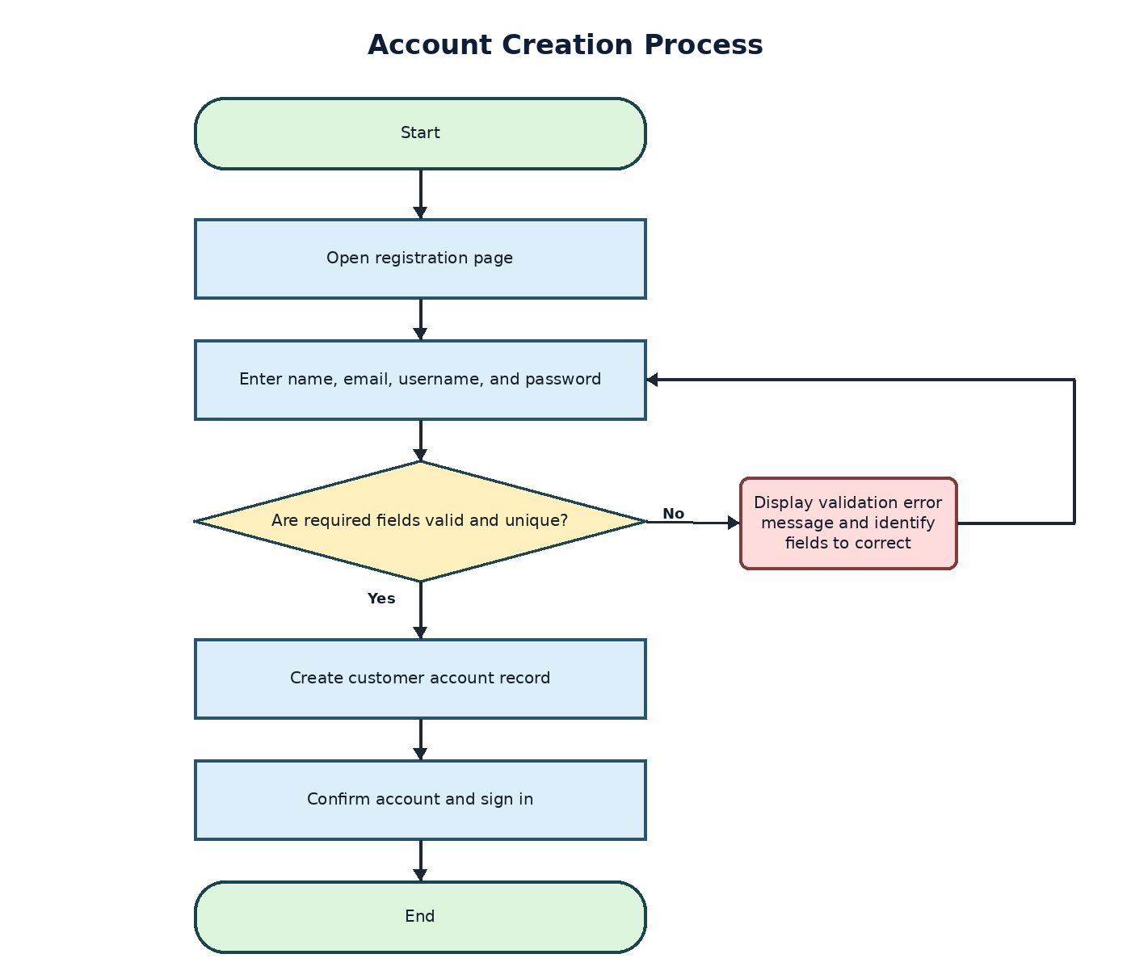
Function: Deposit simulated cash into a customer account.
Purpose: This process shows how a customer submits a simulated cash deposit. The system verifies that the amount is positive and within the permitted simulation limit. An invalid amount produces a validation message, while an accepted amount creates a cash-transaction record and increases the customer’s available simulated balance.
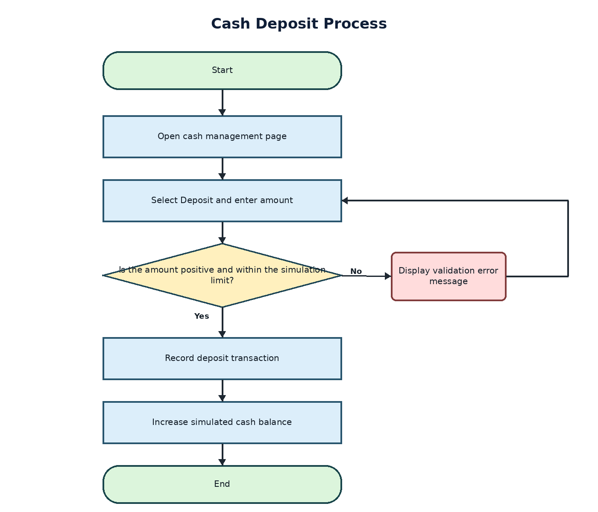

Function: Withdraw simulated cash from a customer account.
Purpose: This process shows how a customer requests a simulated cash withdrawal. The system verifies that the amount is positive and does not exceed the customer’s available cash. An invalid or overdrawn request produces a validation message. An accepted request creates a withdrawal record and decreases the simulated cash balance.
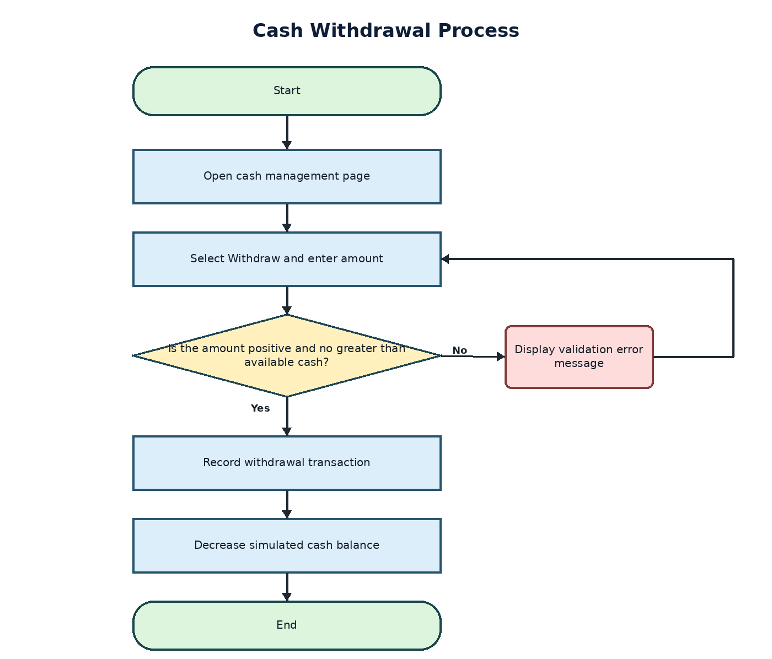

Function: Submit and process a simulated stock purchase.
Purpose: This process shows how a customer selects a stock, enters a positive whole-number quantity, and reviews the current simulated price. The system validates the quantity and confirms that sufficient simulated cash is available. If the market is open, the order executes and the system updates the customer’s cash, holdings, order status, and transaction history. If the market is closed, the system records the order as pending for later execution.
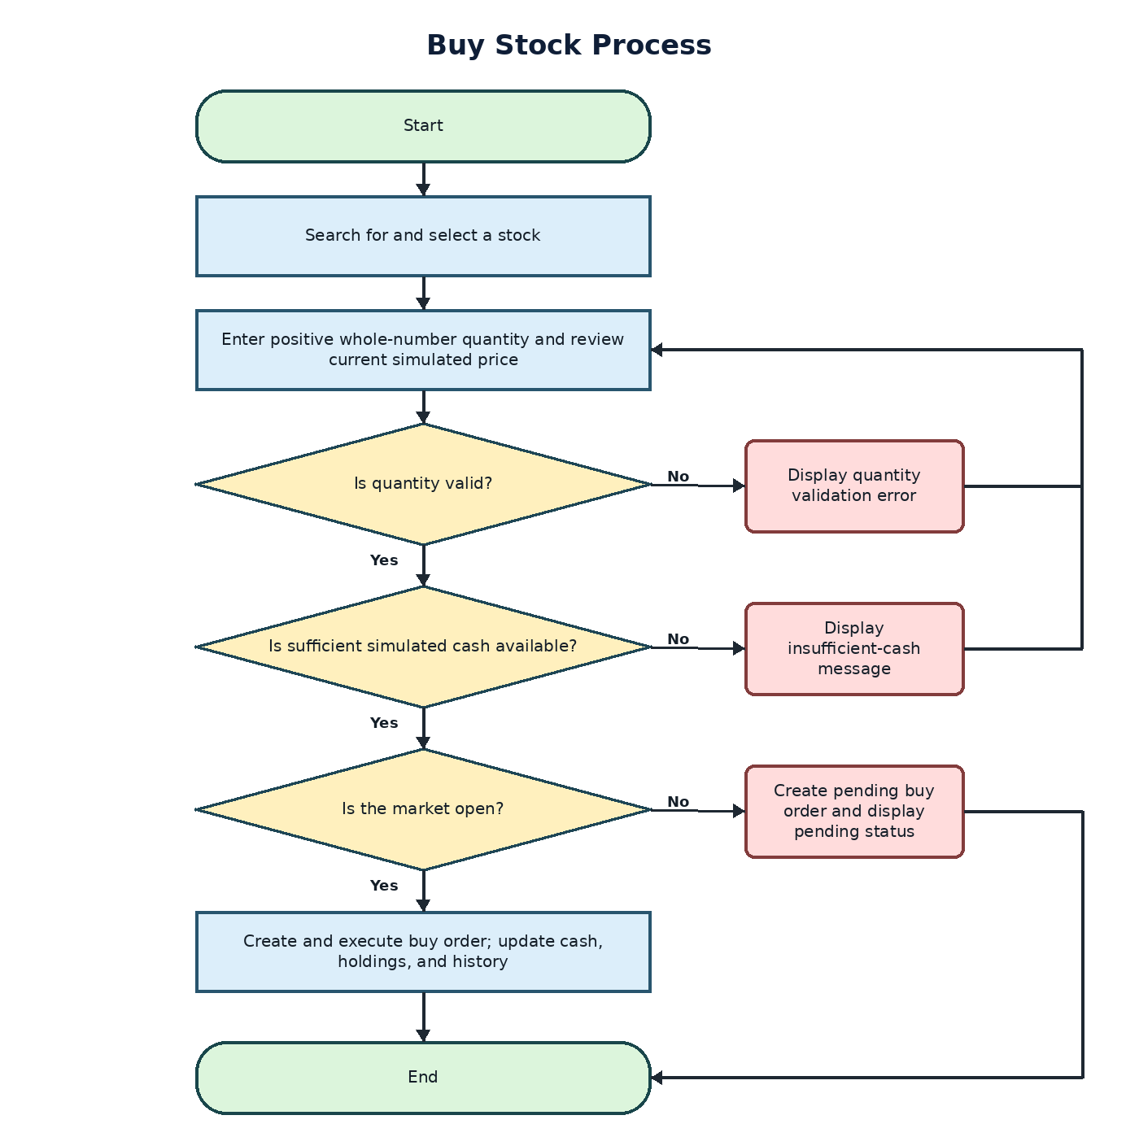
Function: Submit and process a simulated stock sale.
Purpose: This process shows how a customer selects an existing holding and enters the number of shares to sell. The system verifies that the quantity is positive and does not exceed the customer’s available shares. If the market is open, the order executes and updates the customer’s cash, holdings, order status, and transaction history. If the market is closed, the system records the order as pending.
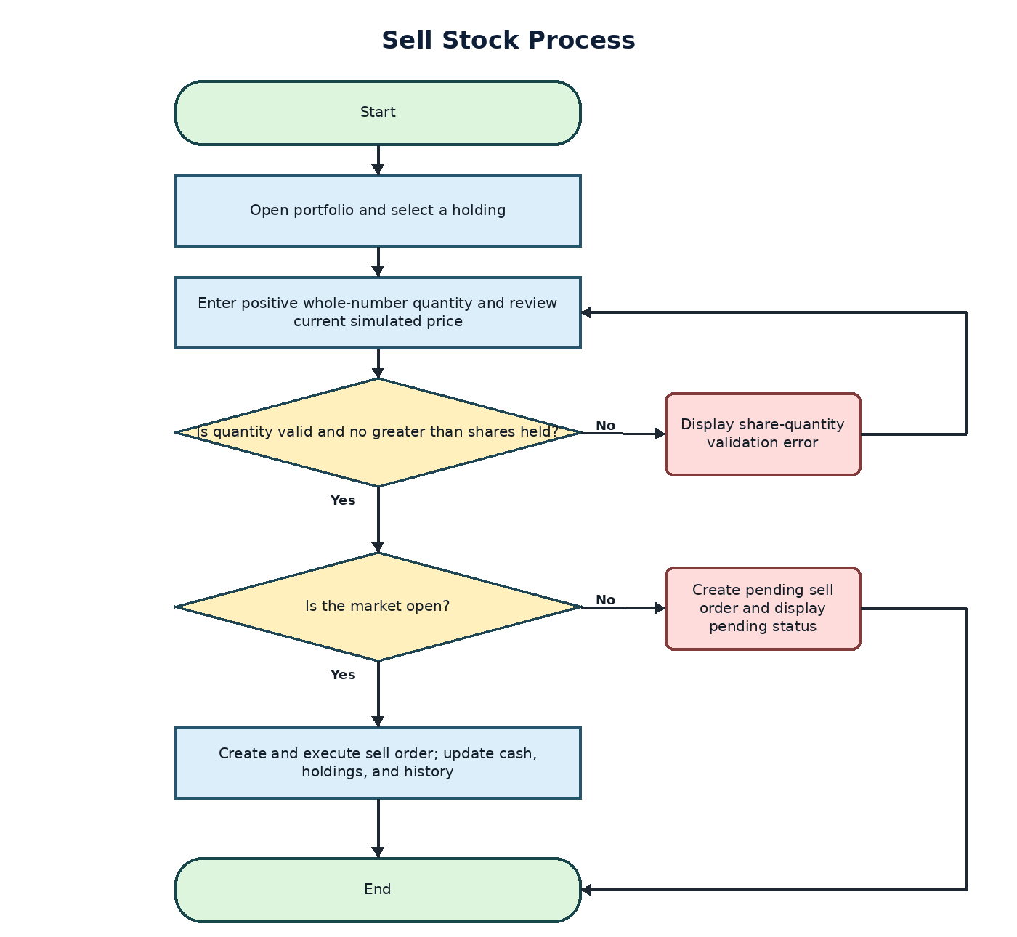
Function: Cancel an eligible pending order.
Purpose: This process shows how a customer selects an order and requests cancellation. The system verifies that the selected order still belongs to the customer and remains pending. An order that has already executed or been cancelled cannot be cancelled again. An eligible cancellation changes the order status to cancelled, releases any simulated cash or shares committed to the order, preserves the order record, and displays confirmation.
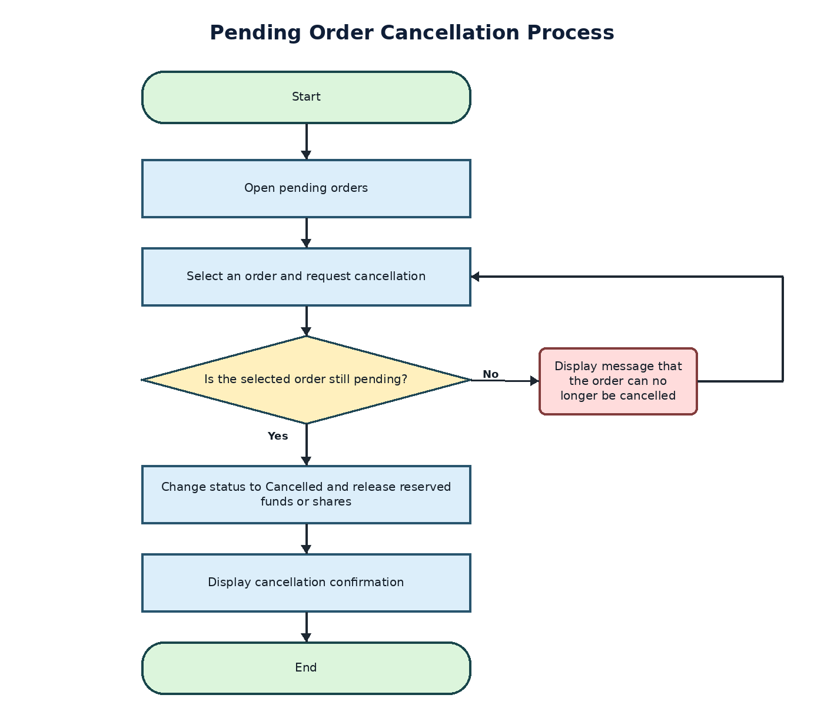

Function: Review portfolio values, holdings, and transaction history.
Purpose: This process shows how the system loads a customer’s simulated cash, holdings, and current stock prices to calculate individual position values and total portfolio value. The customer can continue viewing the portfolio summary or request transaction history. Transaction-history results can be filtered by transaction type and date range.
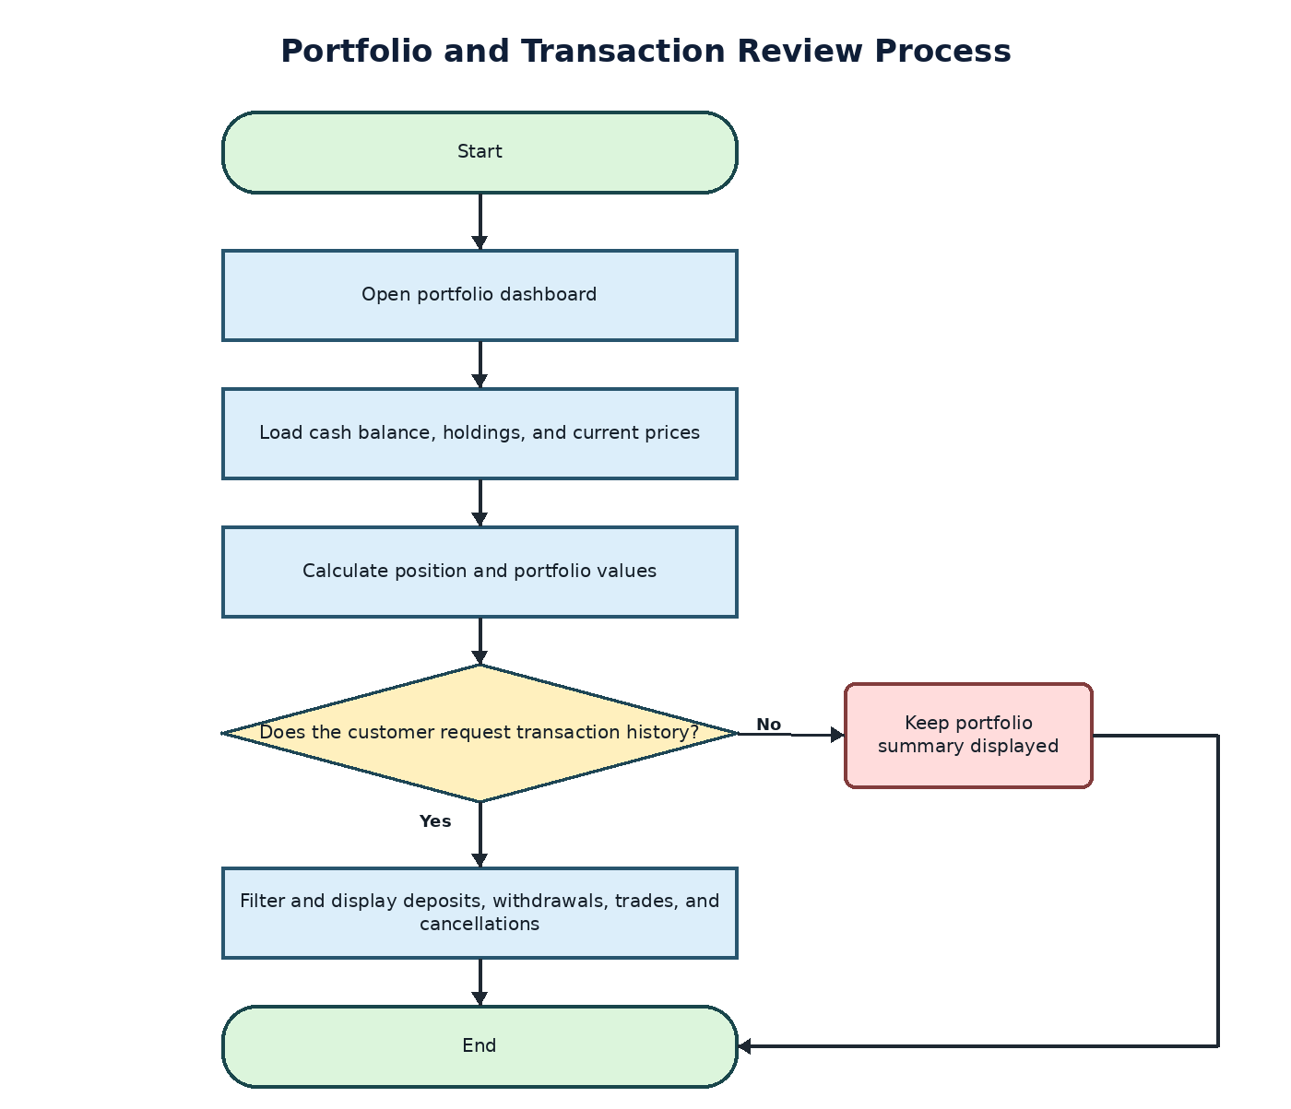

Function: Add a stock to the simulated market.
Purpose: This process shows how an administrator creates a stock by entering a symbol, company name, positive opening price, and active status. The system verifies that the values are valid and that the symbol is unique. Accepted information creates the stock and its initial price record, making the active stock available in the simulated market listing.
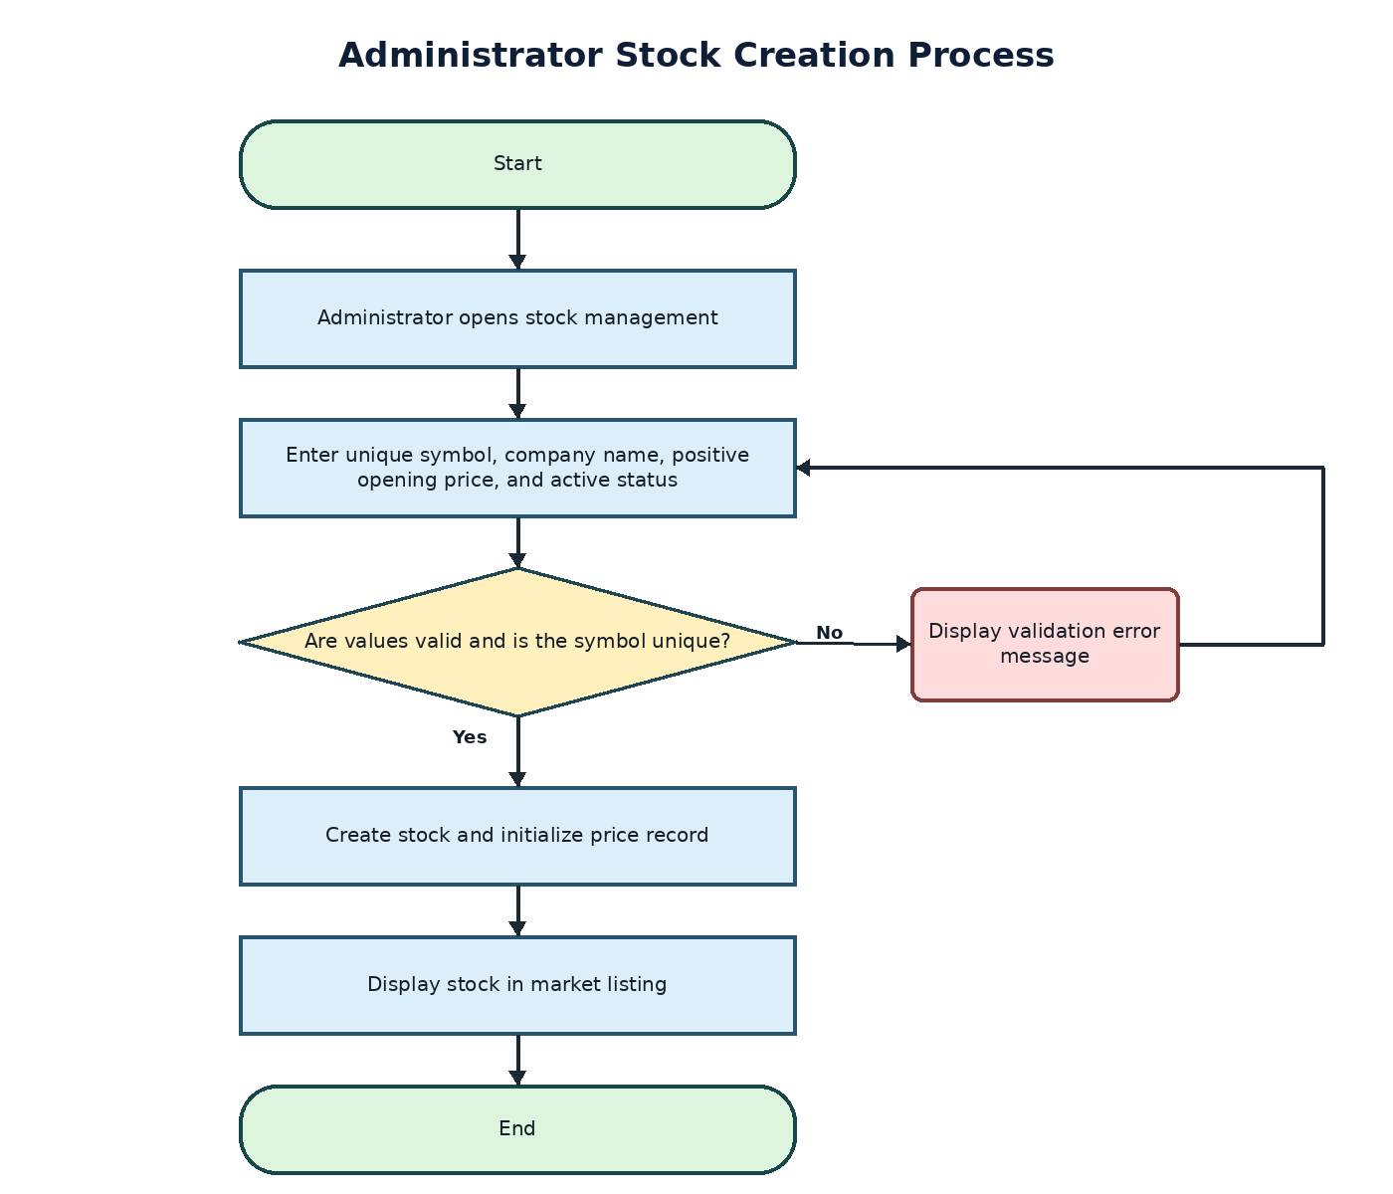

Function: Configure the simulated market schedule.
Purpose: This process shows how an administrator establishes the market’s opening time, closing time, trading days, timezone, and exception dates. The system rejects invalid or overlapping schedules. A valid schedule becomes active and controls whether subsequently submitted orders execute immediately or remain pending.
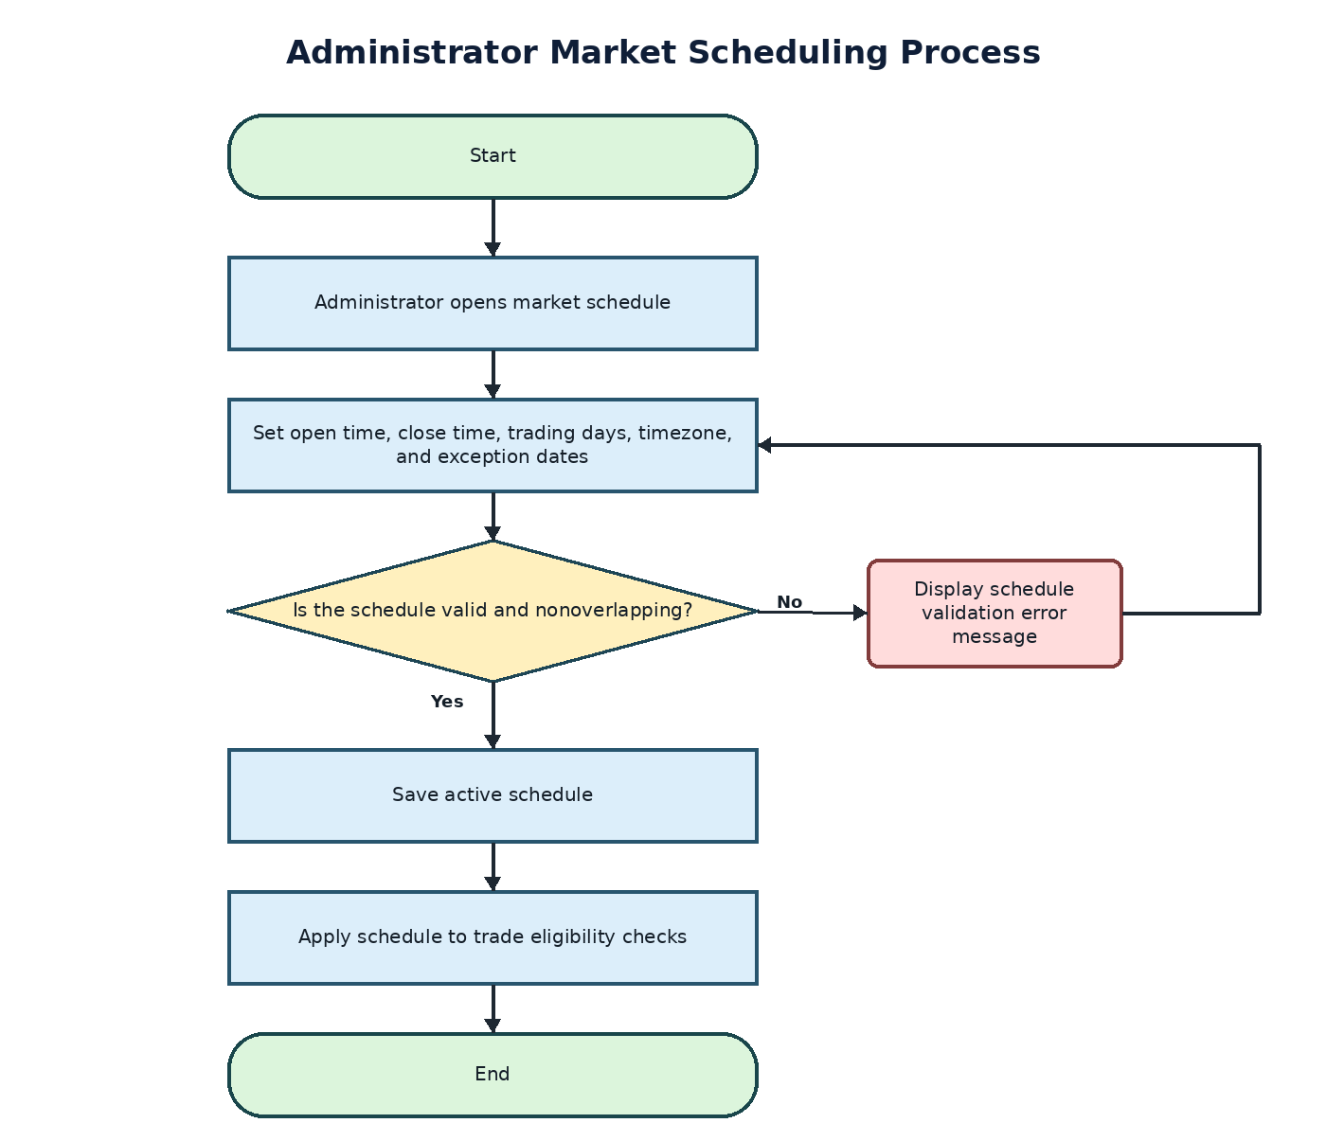

Requirements

Functional Requirements

Customer Account and Authentication
- FR-01: The system shall allow a new customer to create an account by providing a name, unique email address, unique username, and password.
- FR-02: The system shall validate required registration fields and reject duplicate usernames or email addresses.
- FR-03: The system shall store passwords using Django’s password-hashing functions and shall never display or store plaintext passwords.
- FR-04: The system shall authenticate registered customers and administrators before granting access to protected functions.
- FR-05: The system shall terminate the authenticated session when a customer or administrator signs out.

Simulated Cash Management
- FR-06: The system shall display the customer’s available simulated cash balance.
- FR-07: The system shall allow a customer to deposit a positive simulated amount within configured limits.
- FR-08: The system shall allow a customer to withdraw a positive simulated amount that does not exceed available cash.
- FR-09: The system shall record each deposit and withdrawal with its transaction type, amount, date and time, resulting balance, and associated customer account.
- FR-10: The system shall reject zero, negative, nonnumeric, overdrawn, or otherwise invalid cash transactions and display a clear validation message.

Stock Search and Price Display
- FR-11: The system shall allow customers to search active stocks by symbol or company name.
- FR-12: The system shall display each matching stock’s symbol, company name, current simulated market price, and price change.
- FR-13: The system shall use the custom random stock-price generator to update simulated prices and preserve the price records required for portfolio calculations and demonstrations.
- FR-14: The system shall clearly identify displayed stock prices, cash balances, portfolio values, and trading activity as simulated.

Buy and Sell Orders
- FR-15: The system shall allow an authenticated customer to submit a market buy order for a positive whole-number quantity of an active stock.
- FR-16: The system shall prevent a buy order from executing or becoming pending when the customer lacks sufficient available simulated cash.
- FR-17: The system shall allow an authenticated customer to submit a market sell order only when the customer holds the requested number of available shares.
- FR-18: The system shall use the current simulated stock price when an eligible market order executes.
- FR-19: The system shall update cash activity, holdings, order status, and transaction history as one atomic database transaction when an order executes.
- FR-20: The system shall record an otherwise valid order as pending when it is submitted outside configured market hours.

Pending Orders and Cancellation
- FR-21: The system shall display each customer’s pending orders with the creation time, stock, order side, quantity, estimated value, and current status.
- FR-22: The system shall allow a customer to request cancellation only for an order that belongs to that customer and remains pending.
- FR-23: The system shall release simulated cash or shares committed to an order when that pending order is successfully cancelled.
- FR-24: The system shall retain cancelled orders in transaction history with a cancelled status.

Portfolio and Transaction History
- FR-25: The system shall display each customer’s holdings with the stock symbol, quantity, average cost, current simulated price, current value, and simulated gain or loss.
- FR-26: The system shall calculate the customer’s total portfolio value from available simulated cash and the current value of all holdings.
- FR-27: The system shall display transaction history for deposits, withdrawals, purchases, sales, and cancellations.
- FR-28: The system shall allow customers to filter transaction history by transaction type and date range.

Administrator Stock Management
- FR-29: The system shall allow an authenticated administrator to create a stock with a unique symbol, company name, positive opening price, and active status.
- FR-30: The system shall reject duplicate stock symbols and invalid stock values.
- FR-31: The system shall allow an administrator to edit a stock’s company name and active status without changing its historical price, order, holding, or transaction records.
- FR-32: The system shall prevent customers and unauthenticated users from accessing administrator stock-management functions.

Administrator Market Scheduling
- FR-33: The system shall allow an authenticated administrator to configure the market opening time, closing time, trading days, and timezone.
- FR-34: The system shall allow an administrator to create exception dates for simulated market closures or modified trading hours.
- FR-35: The system shall reject schedules in which the closing time does not follow the opening time or active schedules improperly overlap.
- FR-36: The system shall use the active market schedule to determine whether a valid order executes immediately or remains pending.
- FR-37: The system shall prevent customers and unauthenticated users from changing the market schedule.

Nonfunctional Requirements
- NFR-01 Security: The system shall enforce role-based authorization for customer and administrator functions and apply Django protections for cross-site request forgery, session handling, password storage, and common injection attacks.
- NFR-02 Privacy: The system shall collect only the account information needed for the training simulation and shall not request banking information, brokerage credentials, payment information, or real financial-account data.
- NFR-03 Data Integrity: Database constraints and atomic transactions shall prevent negative balances, negative holdings, duplicate stock symbols, and partially completed trades.
- NFR-04 Availability: The hosted application shall provide a clear error or maintenance response when a service is unavailable and shall use recoverable database backups appropriate to the course deployment.
- NFR-05 Performance: Under normal classroom demonstration loads, primary pages and stock searches should return within two seconds, excluding network conditions outside the application’s control.
- NFR-06 Usability: Customer and administrator pages shall use consistent navigation, readable labels, visible validation messages, and confirmation before destructive actions.
- NFR-07 Accessibility: Application pages shall support keyboard navigation, programmatically associated form labels, sufficient color contrast, and information that does not depend on color alone.
- NFR-08 Compatibility: The application shall support current desktop versions of Chrome, Edge, and Firefox and shall remain usable at common tablet and mobile display widths.
- NFR-09 Maintainability: The Django project shall separate models, forms, views, templates, tests, and configuration according to a documented and consistent project structure.
- NFR-10 Testability: Automated Django tests shall cover authentication, authorization, validation, cash and holding rules, order execution, cancellation, price generation, and market scheduling.
- NFR-11 Auditability: The system shall timestamp account-changing events and retain order, cash-transaction, and price records needed to review simulation results during testing and demonstrations.
- NFR-12 Simulation Boundary: Every page that displays cash, portfolio values, stock prices, or trades shall identify them as simulated and shall not present the application as a real brokerage service.

Business Rules
- BR-01: Each newly created customer account shall begin with $25,000 in simulated cash.
- BR-02: Each customer account shall have one simulated portfolio.
- BR-03: Customers and administrators shall use the same underlying Django user-account structure, with permissions distinguishing the two roles.
- BR-04: Administrator accounts shall be created through controlled Django administrative tools and shall not be available through public registration.
- BR-05: Simulated prices shall be updated by the custom random-price generator when the application requests or evaluates a current price. The system shall not require a continuously running trading service.
- BR-06: Available simulated cash shall exclude funds committed to pending buy orders.
- BR-07: Available shares shall exclude shares committed to pending sell orders.
- BR-08: An order shall use one record that progresses through pending, executed, or cancelled status. The system shall not require a separate execution entity.
- BR-09: Deactivating a stock shall prevent new orders for that stock while preserving existing holdings, prices, orders, and transaction history.
- BR-10: Cash changes caused by deposits, withdrawals, purchases, sales, reservations, and releases shall be recorded or calculated from auditable system records.
- BR-11: A valid pending order shall be evaluated against the active market schedule and current simulated price before execution.
- BR-12: The regular market schedule shall use a defined timezone and may be modified by administrator-created exception dates.

User Interface
The Stock Trading System will use server-rendered webpages designed for customers and administrators. The interface will provide consistent navigation, readable labels, visible validation messages, and clear identification of all money, prices, holdings, and transactions as simulated. Bootstrap will support consistent styling and responsive layouts across current desktop browsers and common tablet and mobile widths.
Customer and administrator functions will remain visually and logically separated. Customers will have access to registration, cash management, market search, trading, pending orders, portfolios, and transaction history. Administrators will have protected interfaces for managing stocks and market schedules. Authorization will be enforced by the Django application rather than relying only on hidden links or interface controls.
The mockups establish the required content and organization of each page. Exact colors, spacing, and minor presentation details may evolve during implementation, but the functions and information represented in each mockup must remain available.

Wireframe 1: Account Registration and Sign In
Description: This mockup combines the two entry points used to access the system. New customers can create an account by entering their name, email address, username, password, and password confirmation. Existing customers and administrators can sign in through a separate form without navigating away from the page.
The registration form will identify missing or invalid fields and reject duplicate usernames or email addresses. Passwords will be processed using Django’s authentication system and will never be displayed or stored as plaintext. Successful registration creates the customer account and signs the customer into the application. Successful sign-in directs the authenticated user to the appropriate customer or administrator interface.
This mockup supports FR-01 through FR-05.
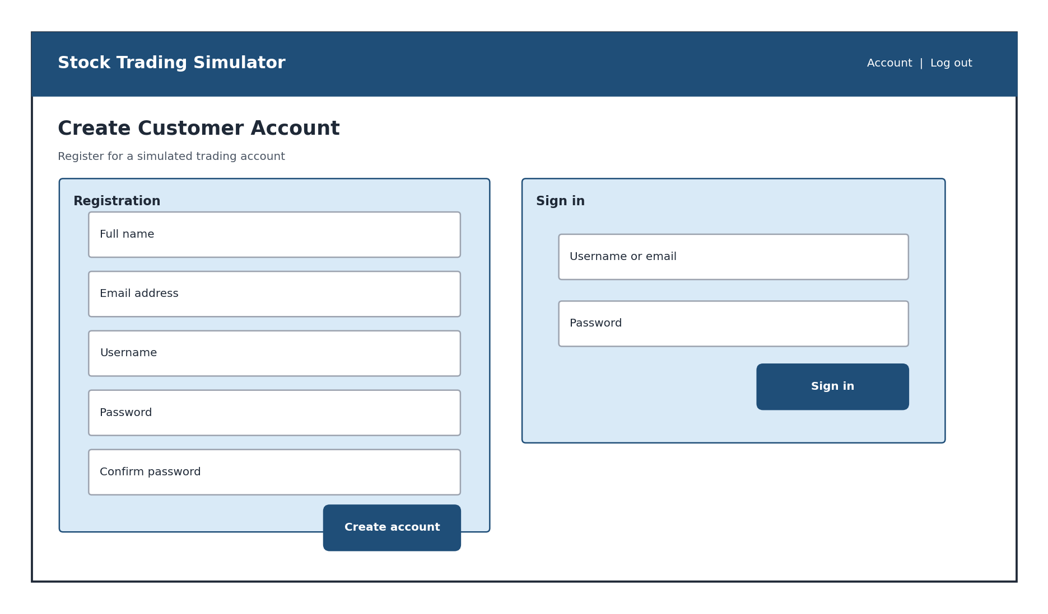

Wireframe 2: Cash Management
Description: This mockup provides a summary of the customer’s available simulated cash, funds committed to pending orders, and resulting buying power. Deposit and withdrawal controls appear below the summary so the customer can enter an amount and select the intended transaction type.
The interface will reject zero, negative, nonnumeric, over-limit, or overdrawn requests and display a message explaining the correction required. Accepted transactions update the displayed balance and appear in recent cash activity. All values will be visibly identified as simulated.
This mockup supports FR-06 through FR-10.
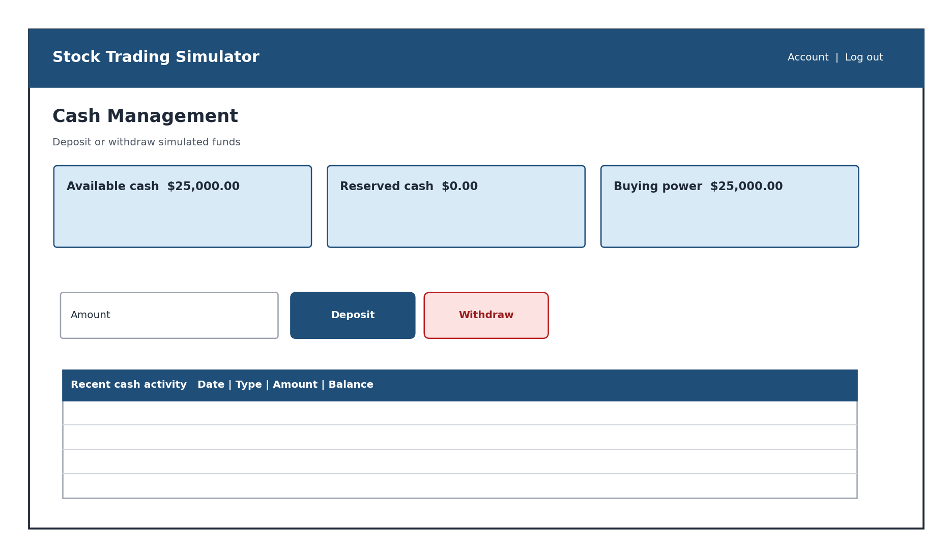

Wireframe 3: Market Search and Trade Ticket
Description: This mockup allows a customer to search active stocks by symbol or company name. Search results display the stock symbol, company name, current simulated price, and price change. Selecting a stock opens a trade ticket without requiring the customer to leave the market-search page.
The trade ticket allows the customer to select Buy or Sell, enter a positive whole-number quantity, review the current simulated price, and view an estimated order total before submission. The application will validate available cash or shares, depending on the order type. The submitted order will either execute at the current simulated price or display a pending status depending on the market schedule.
This mockup supports FR-11 through FR-20.
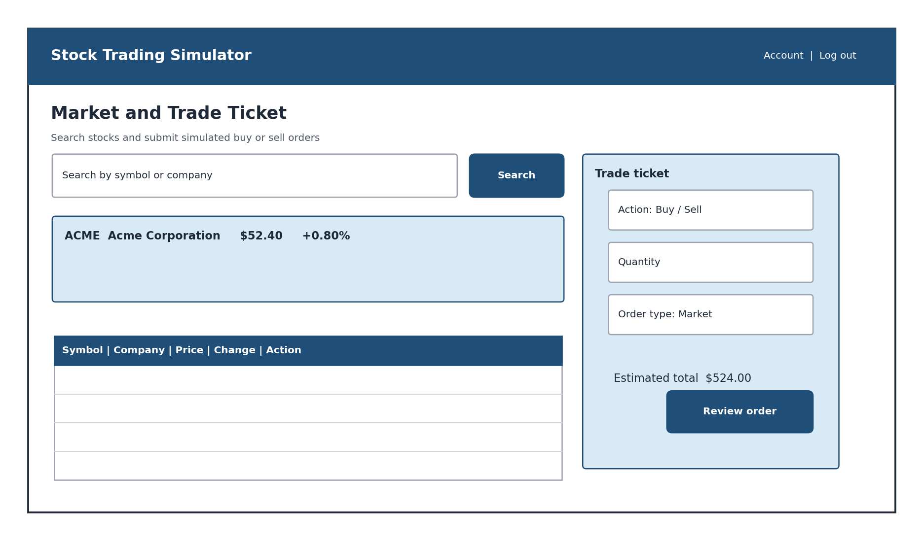

Wireframe 4: Pending Orders
Description: This mockup displays the customer’s pending orders in a table containing the creation time, stock symbol, order side, quantity, estimated value, status, and available action. Cancellation is available only for an order that belongs to the authenticated customer and remains pending.
Selecting the cancellation control will display a confirmation prompt before the order status changes. A successful cancellation releases any committed simulated cash or shares and retains the order in transaction history with a cancelled status. If the order is no longer pending, the interface will explain that it cannot be cancelled.
This mockup supports FR-21 through FR-24.
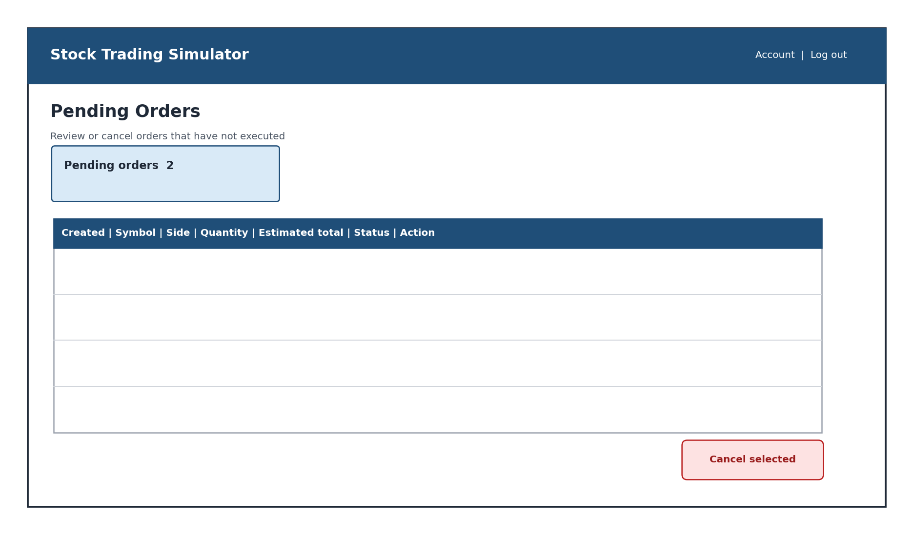

Wireframe 5: Portfolio and Transaction History
Description: This mockup presents the customer’s total simulated portfolio value, available cash, and overall gain or loss. The holdings table displays each stock symbol, quantity, average cost, current simulated price, current value, and calculated gain or loss.
Transaction history appears below the holdings summary and includes deposits, withdrawals, purchases, sales, and cancellations. The completed interface will provide transaction-type and date-range filters above the history table so customers can narrow the displayed activity.
This mockup supports FR-25 through FR-28.
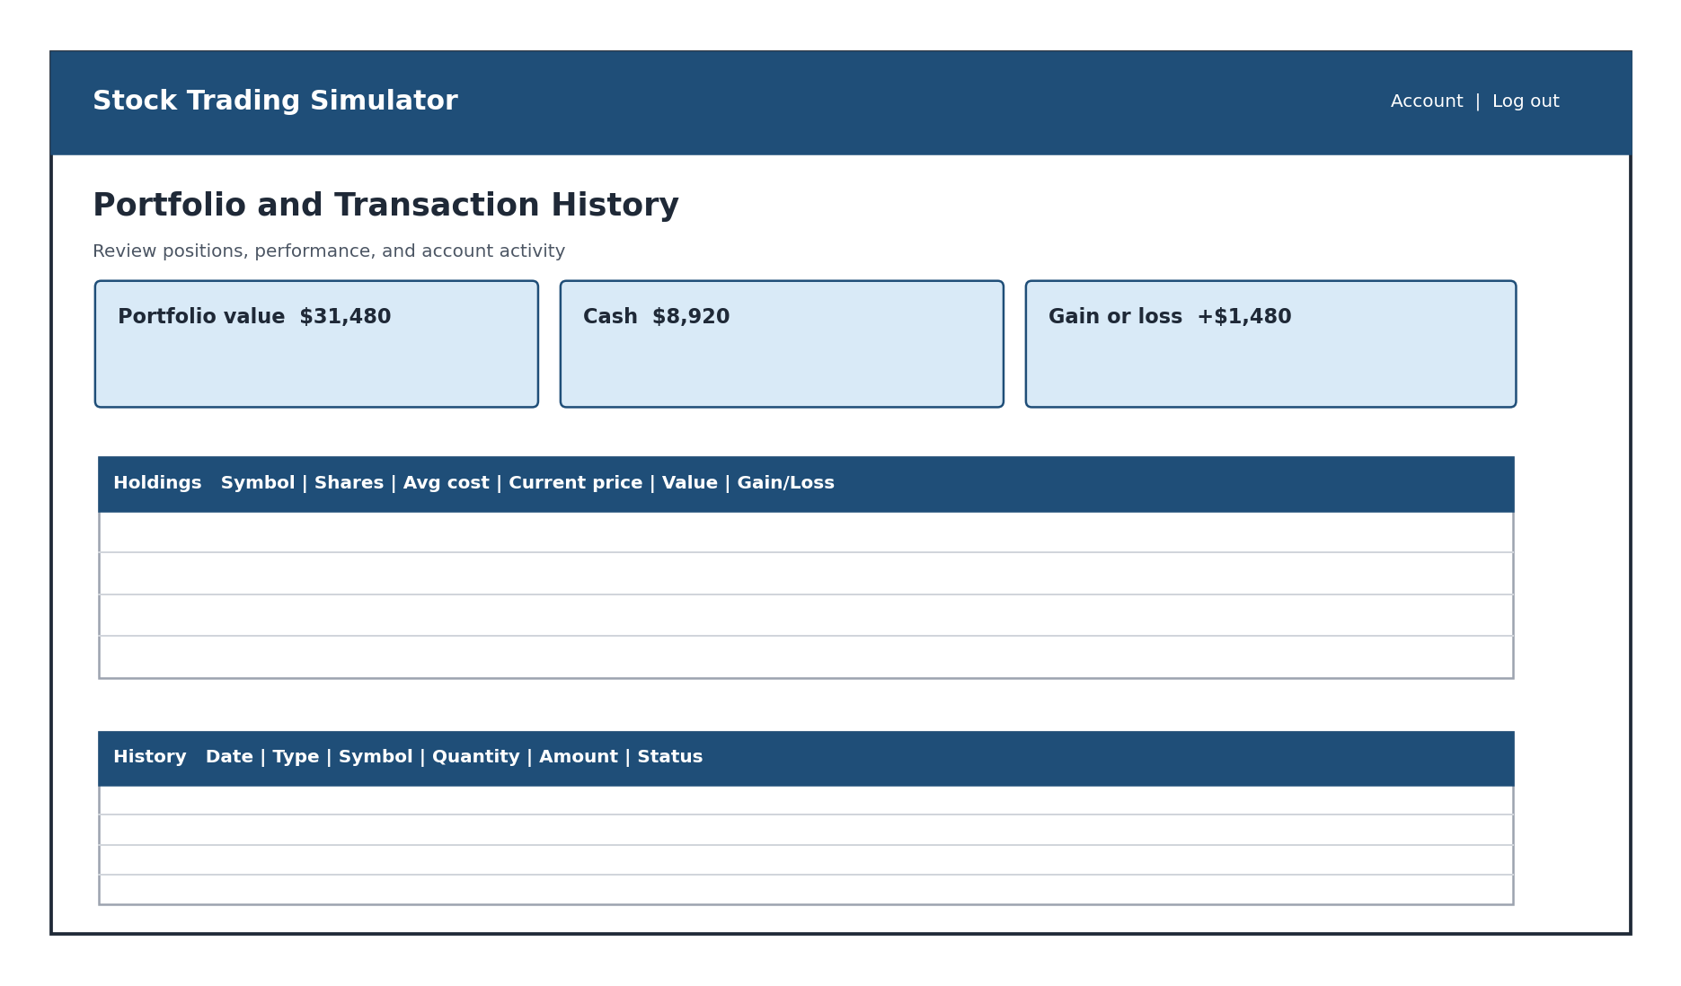

Wireframe 6: Administrator Stock Management
Description: This protected mockup allows an administrator to create and maintain stocks used by the simulation. The creation form collects a stock symbol, company name, positive opening price, and active status. The adjacent table displays existing stocks and provides an editing action.
The interface will reject duplicate symbols and invalid opening prices. Deactivating a stock prevents new orders without deleting existing holdings, price history, orders, or transaction records. Customers and unauthenticated users will not be permitted to access this page.
This mockup supports FR-29 through FR-32.
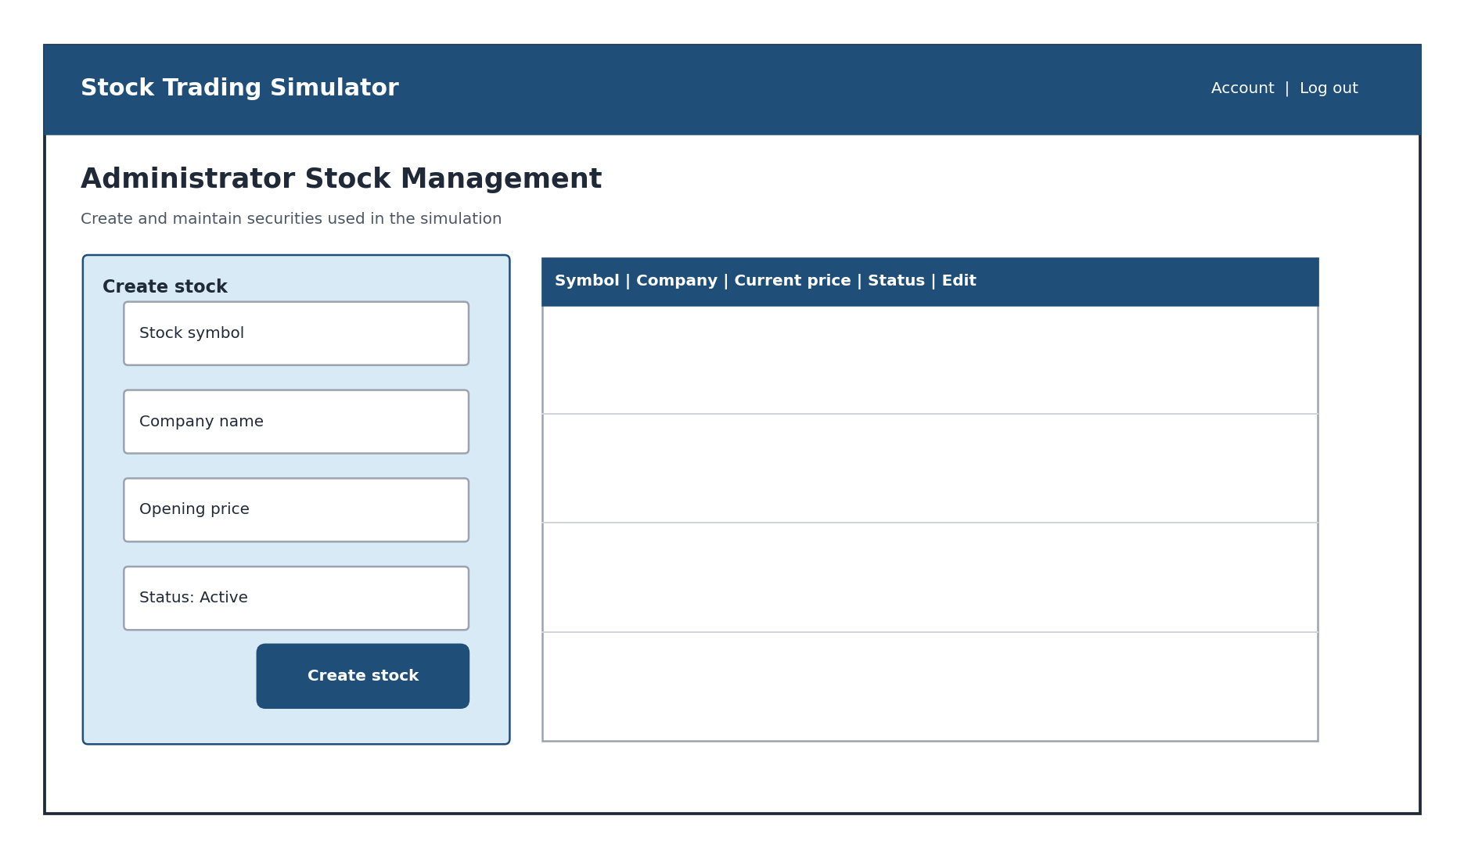

Wireframe 7: Administrator Market Schedule
Description: This protected mockup allows an administrator to configure regular market hours by specifying the opening time, closing time, trading days, and time zone. A separate area lists exception dates for closures or modified hours, keeping normal schedules distinct from one-time changes.
The interface will reject closing times that do not follow opening times and schedules that improperly overlap. Once saved, the active schedule determines whether an eligible order executes immediately or remains pending. Customers and unauthenticated users will not be permitted to modify these settings.
This mockup supports FR-33 through FR-37.
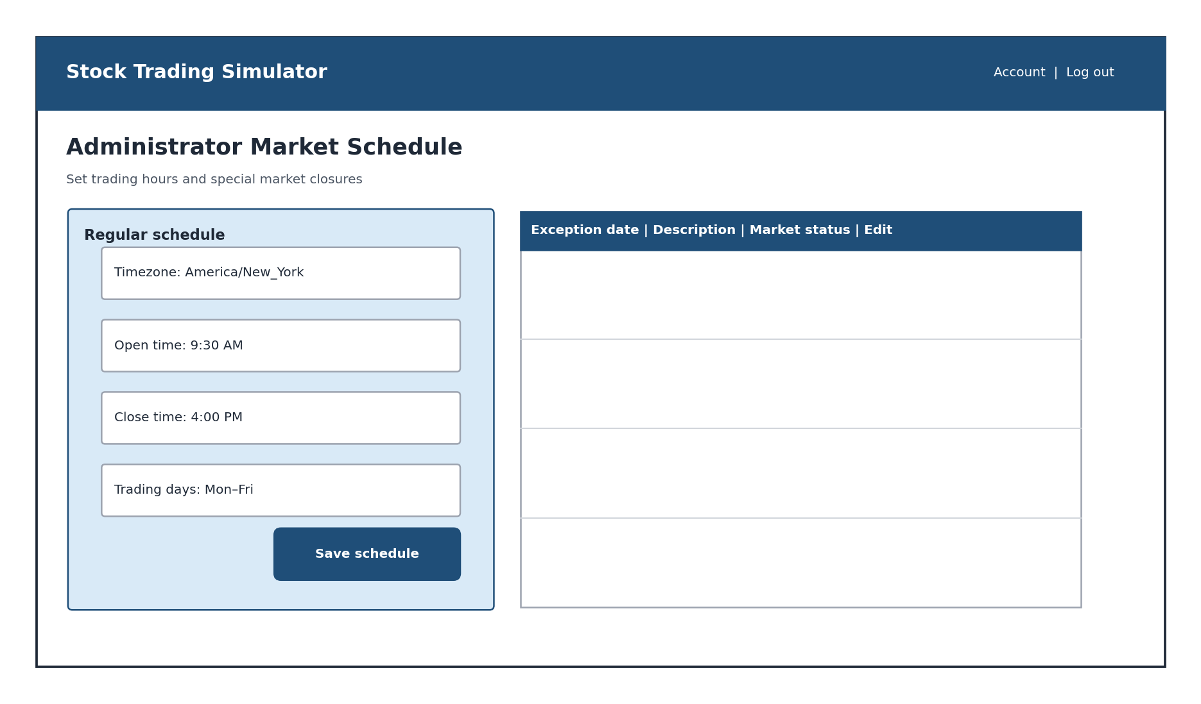

Infrastructure Architecture

Infrastructure Topology
The Stock Trading System will use a centralized web architecture consisting of a user’s device and web browser, a Django application hosted on PythonAnywhere, and a hosted MySQL database. PythonAnywhere provides the application-hosting environment and supports deployment of existing Django projects (PythonAnywhere, 2016).
Customers and administrators will access the application through a web browser over HTTPS. The browser will communicate with the Django application, which will handle authentication, validation, business logic, and webpage generation. Django will access the hosted MySQL database through its object-relational mapper. The browser will not connect directly to the database.
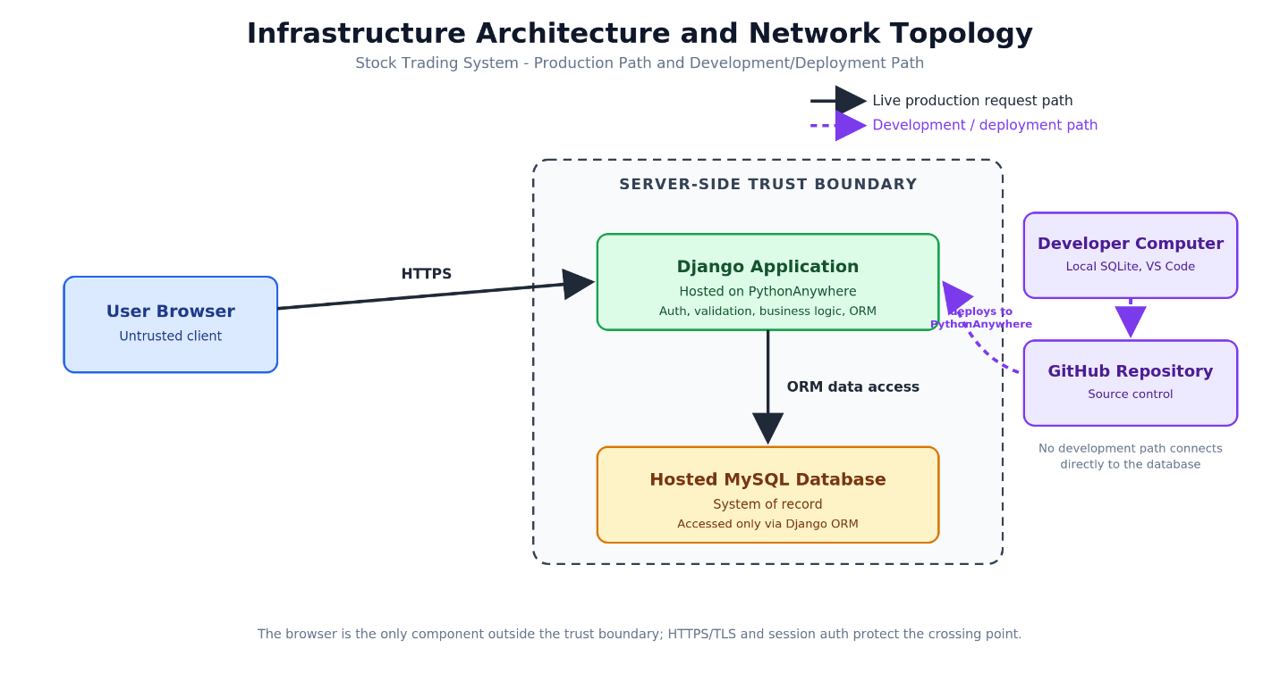
The production request path is:
User browser → HTTPS → Django application → MySQL database
Development will occur on the team members’ computers using Visual Studio Code, Python, Django, and local SQLite databases. Git and GitHub will provide version control, branches, pull requests, and code review. Approved code from the main branch will be deployed to PythonAnywhere. GitHub and the local development databases are not part of the live customer request path and will not connect directly to the production database.
The infrastructure is intentionally limited to the components required for this capstone application. The system does not require multiple application servers, a load balancer, a replicated database, or separate application services.

Information Architecture

Entity Relationship Diagram
The information architecture defines the data required to support customer accounts, simulated cash activity, stock prices, orders, holdings, and market scheduling. Figure 18 presents the system’s logical entity-relationship model, including the principal entities, attributes, primary keys, foreign keys, and relationships. Django models and migrations will later translate this logical model into the physical SQLite and MySQL database structures.
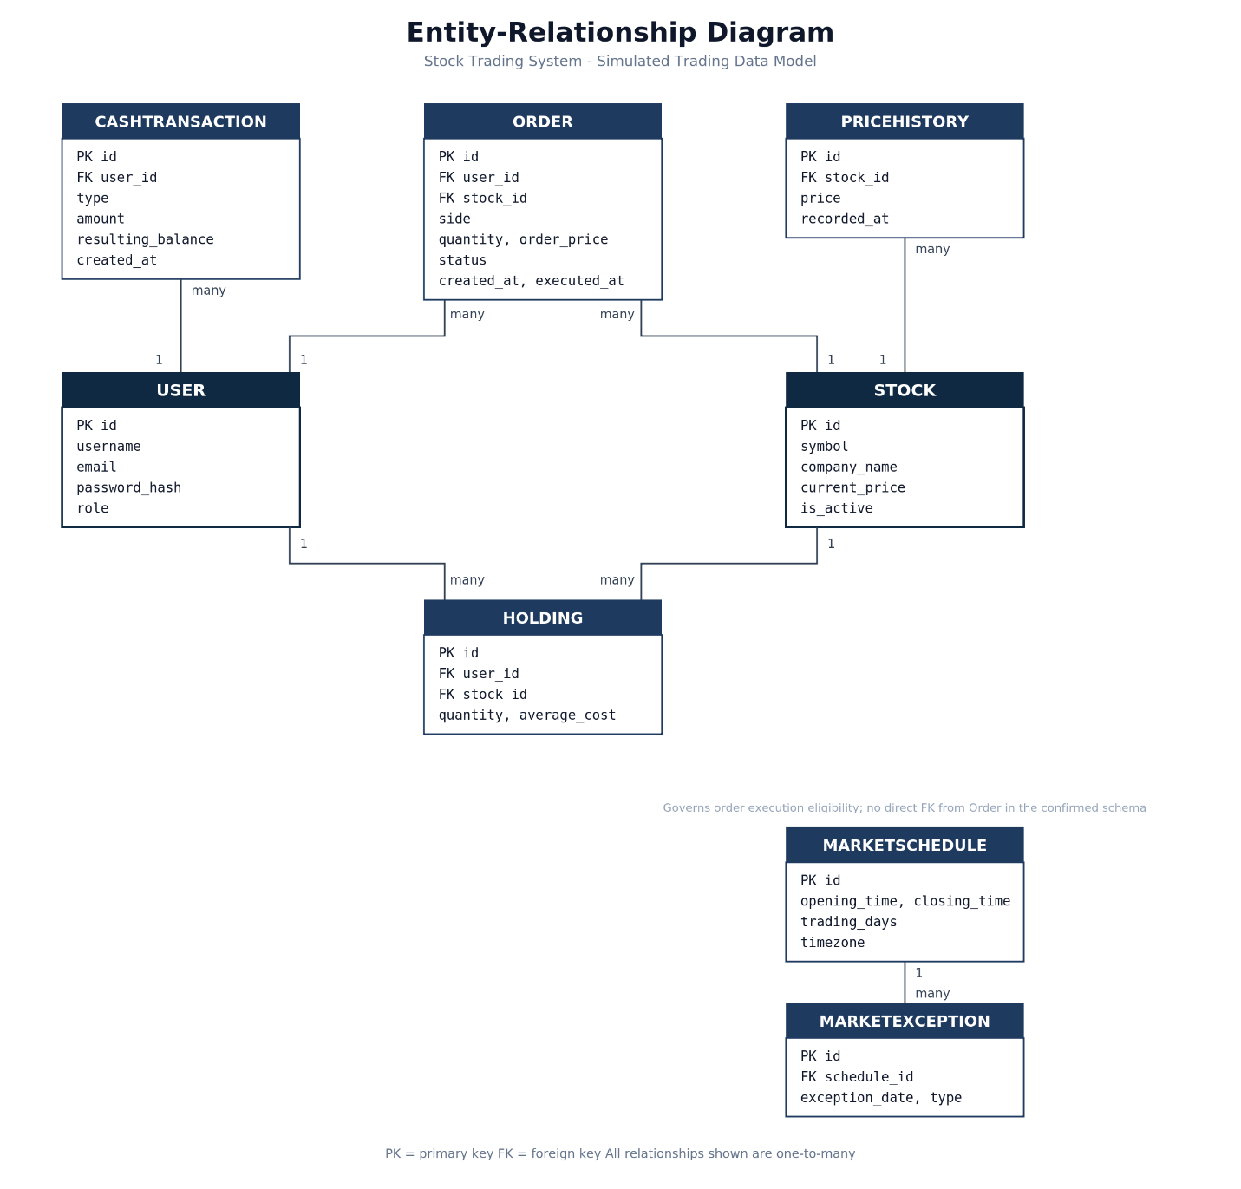
Entity | Purpose
User | Stores customer and administrator account information. The role attribute distinguishes customers from administrators.
CashTransaction | Records simulated cash activity, including the transaction type, amount, resulting balance, and creation time.
Stock | Stores each simulated stock’s unique symbol, company name, current price, and active status.
PriceHistory | Preserves generated prices associated with a stock and the time each price was recorded.
Order | Records buy and sell orders, including the customer, stock, quantity, price, status, creation time, and execution time.
Holding | Stores the quantity and average cost of each stock currently held by a customer.
MarketSchedule | Defines regular opening and closing times, trading days, and the applicable timezone.
MarketException | Defines closures or modified market behavior for specific dates associated with a market schedule.

Relationships
A User can have many cash transactions, orders, and holdings. Each CashTransaction belongs to one User, and each Order belongs to one User and references one Stock. A User and Stock combination identifies a customer’s Holding, allowing the system to maintain the quantity and average cost of each owned stock.
A Stock can appear in many orders, holdings, and price-history records. These relationships allow the system to preserve trading history and recalculate portfolio values when simulated stock prices change. A MarketSchedule can have multiple MarketException records for holidays, closures, or modified hours. The active schedule governs order-execution eligibility, but an individual order does not require a direct foreign-key relationship to the schedule.
Primary and foreign keys will enforce the defined relationships. Additional uniqueness and validation constraints will prevent duplicate usernames, email addresses, stock symbols, and duplicate holdings for the same user and stock. The application will calculate available simulated cash from recorded cash activity and executed orders while subtracting funds committed to pending buy orders. Available shares will likewise exclude shares committed to pending sell orders.

Security and Privacy Architecture
The security and privacy architecture addresses one risk in each element of the confidentiality, integrity, and availability model. Controls will be implemented through Django, HTTPS, database constraints, role-based authorization, and PythonAnywhere-appropriate operational procedures. Django provides built-in protections for password handling, cross-site request forgery, session security, and other common web-application threats (Django Software Foundation, n.d.-b).
Security area | Risk | Controls
Confidentiality | An unauthorized person could access another customer’s account information, simulated trading activity, or administrator-only functions. | Django authentication and password hashing; HTTPS for information in transit; server-side authorization for every protected function; separation of customer and administrator permissions; collection limited to information required for the simulation.
Integrity | Invalid or unauthorized activity could alter simulated cash, holdings, orders, stock prices, or transaction history and produce inconsistent records. | Server-side validation; Django CSRF protection; database constraints; unique identifiers; Django ORM data access; and atomic transactions that update cash activity, holdings, order status, and history together.
Availability | A hosting failure, application error, or database corruption could make the classroom demonstration unavailable or cause the loss of simulation data. | Application logging and error handling; database backups; a documented restoration procedure; dependency and configuration records; and pre-demonstration testing of the hosted application.

Privacy Boundaries
The Stock Trading System is an educational simulation and will not collect banking information, brokerage credentials, payment-card information, government identification numbers, or real investment-account data. Customer information will be limited to the name, email address, username, password credential, and simulated account activity required to operate the application.
Passwords will be stored using Django’s password-hashing system rather than as readable text. Customers will have access only to their own simulated accounts and activity. Administrator access will be limited to authorized accounts created through controlled Django administrative tools. Production credentials and secret configuration values will not be stored in the public GitHub repository or delivered to the user’s browser.

Programming
The Stock Trading System will use a Python and Django development stack selected to support the required web interface, business logic, relational data, testing, collaboration, and deployment. The project will remain a single server-rendered Django application to reduce unnecessary integration work.

Programing Languages
Language | Project use and rationale
Python | Implements Django models, forms, views, validation, authentication integration, price generation, order processing, and automated tests. Python is familiar to all three team members and is supported by PythonAnywhere.
HTML | Defines the structure and content of the server-rendered webpages.
CSS | Provides page styling, spacing, responsive presentation, and accessibility-related visual formatting.
JavaScript | Supports limited browser-side interactions, such as confirmations and interface updates that do not require a complete page reload. Core validation will remain on the server.
SQL | Represents the relational database technology underlying SQLite and MySQL. Most database operations will be performed through the Django ORM rather than manually written SQL.

Framework and Development Tools
Tool or framework | Project use and rationale
Django | Provides the application structure, authentication, authorization, forms, validation, templates, ORM, migrations, administration, security protections, and testing framework in one integrated platform (Django Software Foundation, n.d.-a).
Bootstrap | Provides consistent and responsive interface components without requiring the team to create every layout and style from the beginning.
Visual Studio Code | Serves as the primary editor for Python, HTML, CSS, JavaScript, configuration files, and documentation.
Git | Tracks changes locally and supports branching, commits, and version history.
GitHub | Provides the shared repository, pull requests, code review, issue tracking, and collaboration workflow.
GitHub Desktop | Gives team members a graphical option for common Git operations while they develop familiarity with collaborative source control.
SQLite | Supports local development and testing without requiring each team member to configure a separate database server.
MySQL | Serves as the hosted relational database and production system of record.
Django test framework | Supports automated testing of authentication, authorization, validation, cash rules, orders, holdings, market scheduling, and administrator functions.
PythonAnywhere | Hosts the Django application and production MySQL database in an environment designed to support Python web applications (PythonAnywhere, 2016).

References
Django Software Foundation. (n.d.-a). Django at a glance: Django documentation. Django Project. https://docs.djangoproject.com/en/5.2/intro/overview/
Django Software Foundation. (n.d.-b). Security in Django: Django documentation. Django Project. https://docs.djangoproject.com/en/5.2/topics/security/
PythonAnywhere. (2016, February 10). Deploying an existing Django project on PythonAnywhere. PythonAnywhere Help. https://help.pythonanywhere.com/pages/DeployExistingDjangoProject/

