Markdown to DOCX Supported Examples
This document exercises the Markdown features currently supported by the converter. It favours examples that should render intentionally in DOCX rather than raw conformance edge cases that only make sense when comparing Markdown to HTML.
Paragraphs and line breaks
This is a normal paragraph with plain text. It should wrap naturally in Word without manual line breaks.
This is a second paragraph after a blank line.
This line is followed by a soft line break in the source
and should remain part of the same paragraph.
This line ends with two spaces for a hard break.
The next line should appear below it.
This line ends with a backslash hard break.
The next line should also appear below it.
Escaped punctuation should remain literal: *asterisks*, _underscores_, [brackets], `backticks`, and \ backslash.

Headings
Heading Level 1
Heading Level 2
Heading Level 3
Heading Level 4
Heading Level 5
Heading Level 6
Setext Heading Level 1
Setext Heading Level 2
Heading with bold, italic, code, and a link

Inline formatting
Plain inline styles: bold, italic, bold italic, inline code, and strikethrough.
Nested inline styles: bold with italic inside, italic with bold inside, and bold with inline code inside.
Inline code preserves Markdown-looking text: **not bold**, [not a link](https://example.com), a < b && c > d, and A | B.
Formatting beside punctuation: bold, italic, code, strike.

Links
Direct link: Example.
Direct link with title: Example with title.
Reference-style link: CommonMark spec.
Collapsed reference link: CommonMark.
Repeated reference link: the same spec.
Autolink URL: https://example.com/autolink.
Autolink email: person@example.com.

Blockquotes
Single paragraph quote:
A simple quoted paragraph.
Multi-paragraph quote:
First quoted paragraph.
Second quoted paragraph with bold, italic, code, and link.
Nested quote:
Outer quote.
Back to the outer quote.
Quote containing a list:
- Quoted bullet one
- Quoted bullet two
- Quoted number one
- Quoted number two
Quote containing a heading and code:

Unordered lists
Hyphen list:
- First item.
- Second item with bold and code.
- Third item.
Asterisk list:
- Alpha
- Beta
- Gamma
Plus list:
- One
- Two
- Three
Nested unordered list:
- Parent A
  - Child A1
    - Grandchild A1a
  - Child A2
- Parent B
Loose unordered list:
- First loose item.
Continuation paragraph for the first item.
- Second loose item.
Continuation paragraph with a link.

Ordered lists
Normal ordered list:
- First step.
- Second step.
- Third step.
Ordered list starting at 3:
- Start from three.
- Then four.
- Then five.
Ordered list starting at 10:
- Ten.
- Eleven.
- Twelve.
Nested ordered list:
- Parent one
  - Child one
  - Child two
- Parent two
  - Child three
    - Grandchild three-a
    - Grandchild three-b
Ordered list with nested bullets:
- First parent
  - Sub bullet A
  - Sub bullet B
- Second parent
  - Sub bullet C
Bullet list with nested ordered items:
- Parent one
  - Nested ordered A
  - Nested ordered B
- Parent two
  - Nested ordered C

Task lists
- [ ] Unchecked task.
- [x] Checked task.
- [x] Checked task with uppercase marker.
- [ ] Task with bold, italic, code, and link.
  - [ ] Nested unchecked task.
  - [x] Nested checked task.

Multi-block list items
List item with continuation paragraph:
- Item with an opening paragraph.
Continuation paragraph inside the same item.
- Next item.
List item with indented code:
- Item before code.
code line one
code line two
- Item after code.
List item with fenced code:
- Fenced code item:
code inside a list
second code line
- Item after fenced code.

Code blocks
Indented code block:
def hello():
print("Hello, world.")
Fenced code block without language:
plain fenced code
with multiple lines
Fenced C# code block:
public void Method()
{
return;
}
Fenced JSON code block:
{
"key": "value",
"markdown": "**not bold inside code**",
"pipe": "A | B"
}
Fenced Markdown-looking code:
# Not a heading inside code
- Not a list inside code
[Not a link](https://example.com)

Mermaid diagrams
Flowchart, standard backtick fence:
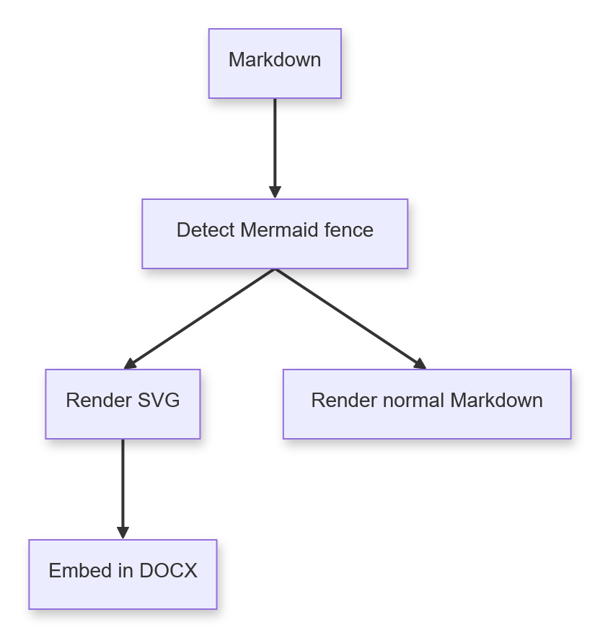
Sequence diagram, colon fence:
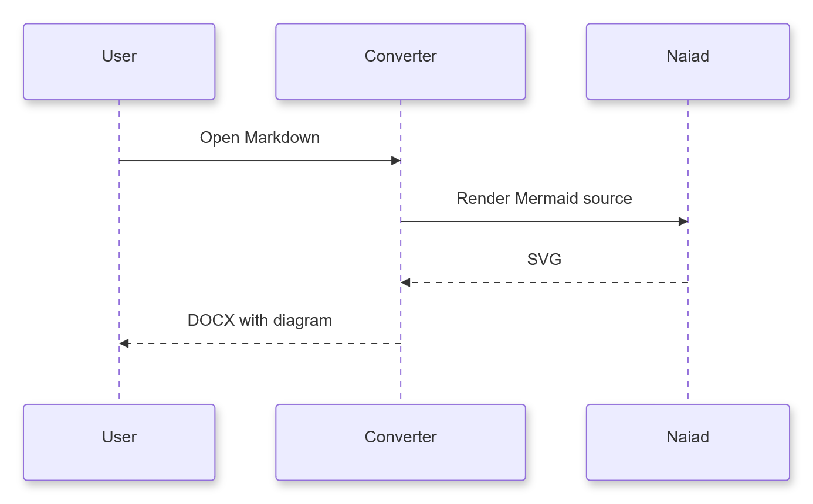
Class diagram:
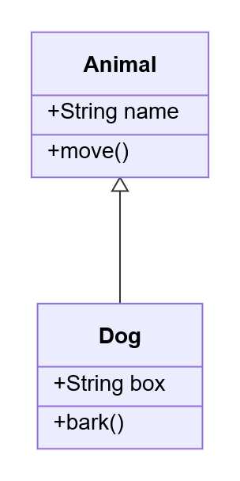
State diagram:
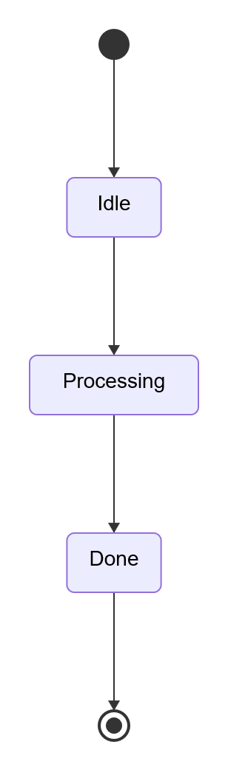
Entity relationship diagram:
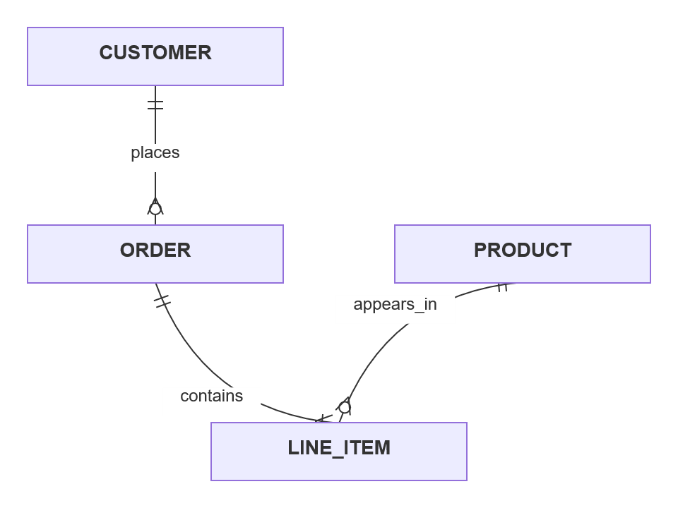
Gantt chart:
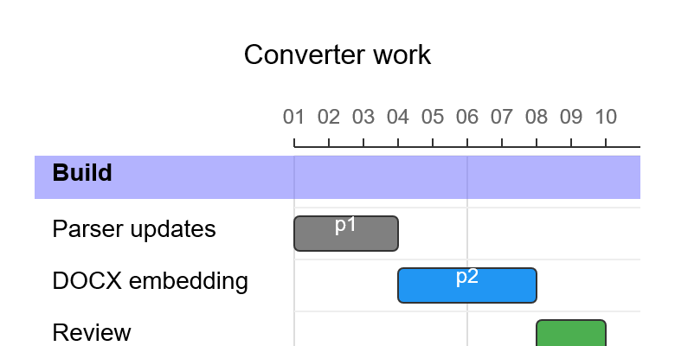
Pie chart:
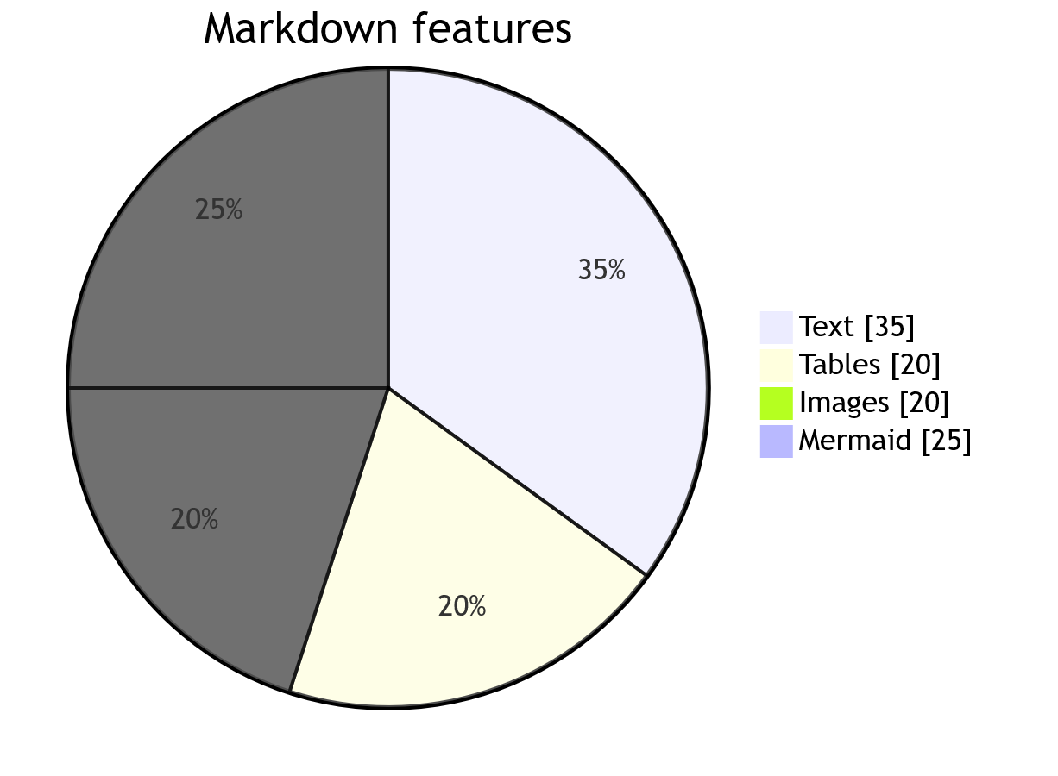
Git graph:
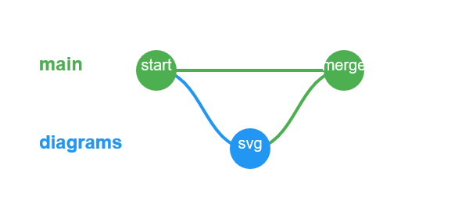
Mindmap:
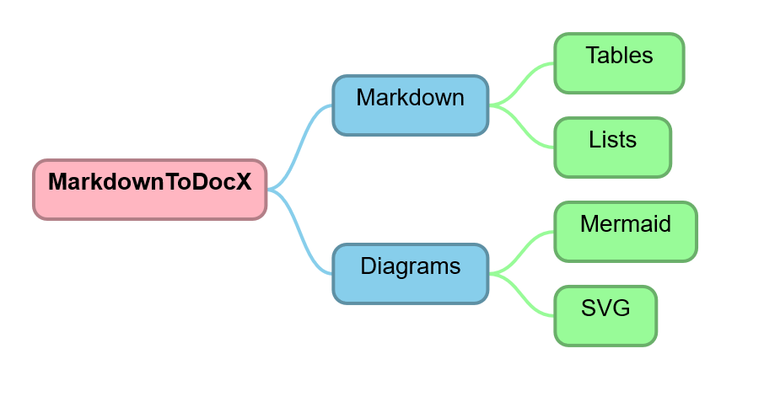
Timeline:
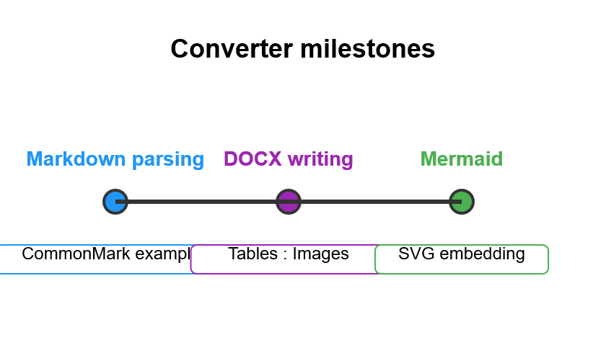
User journey:
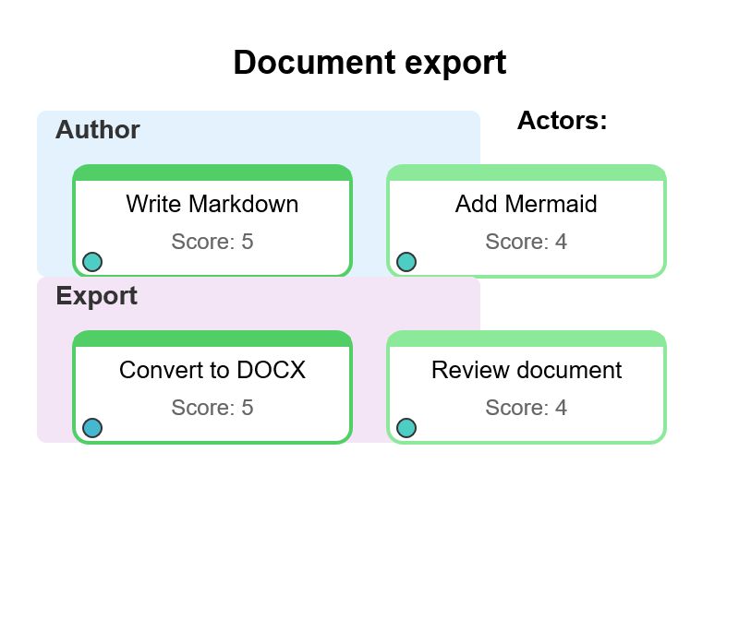
Quadrant chart:
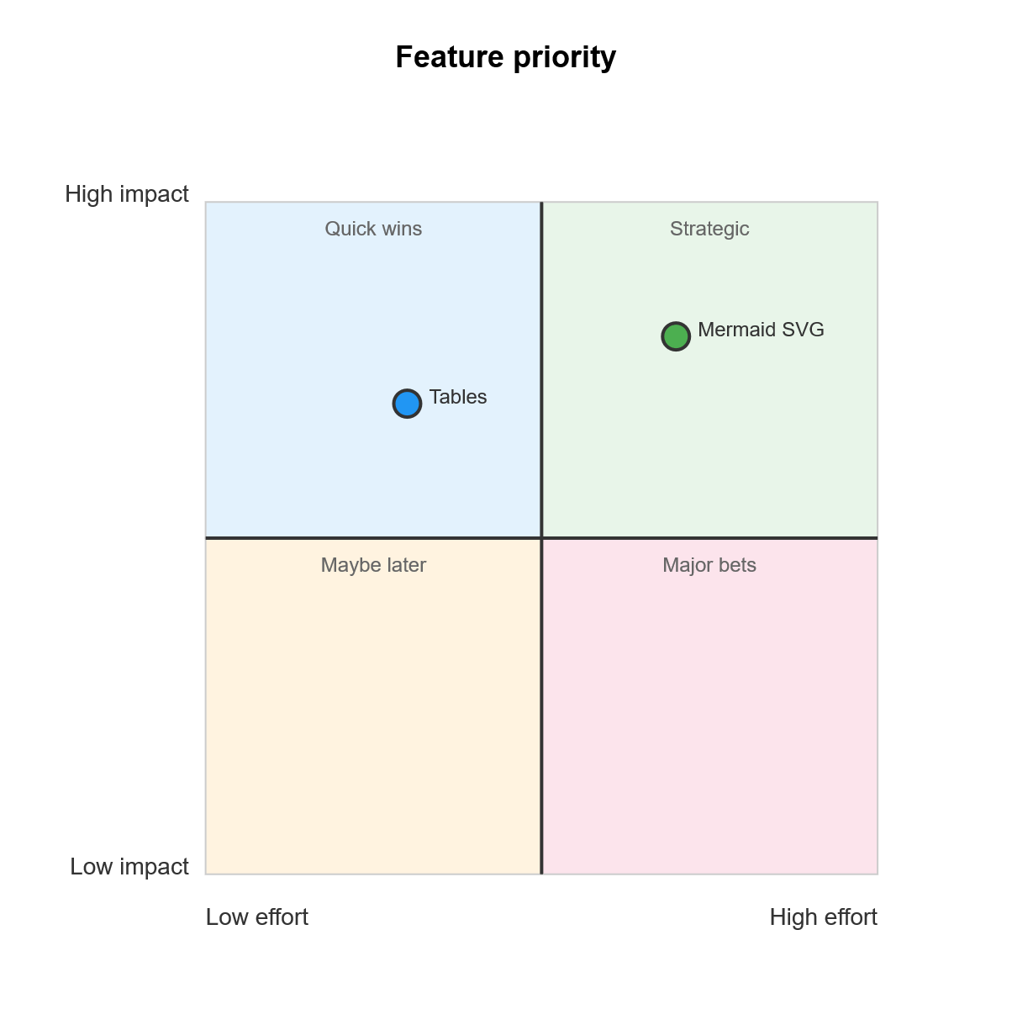
Requirement diagram:
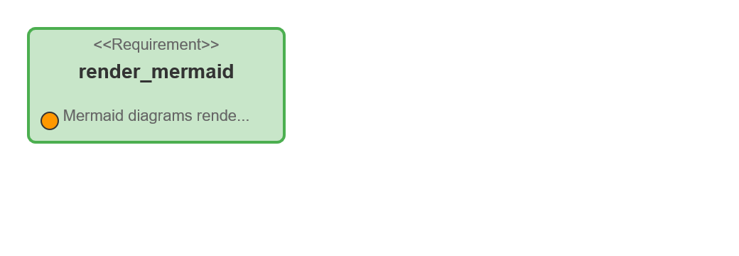
C4 diagram:
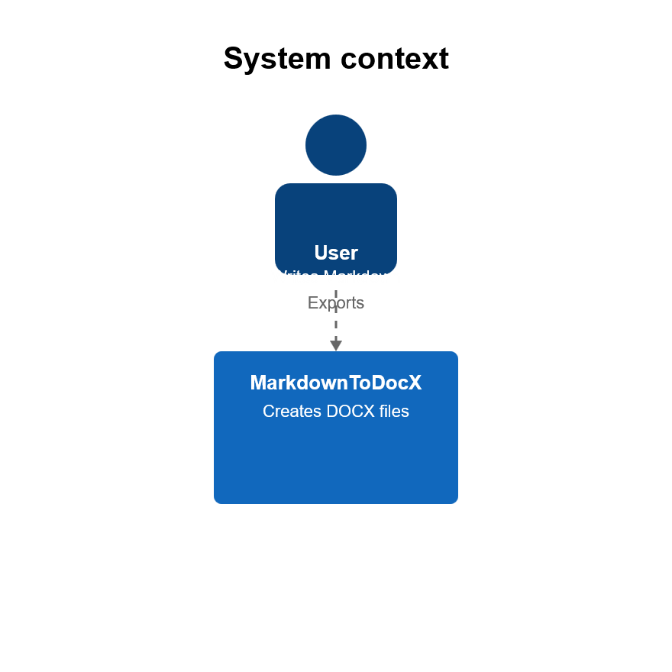
Kanban:
Block diagram:
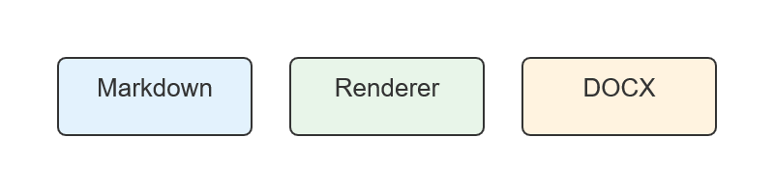
Packet diagram:
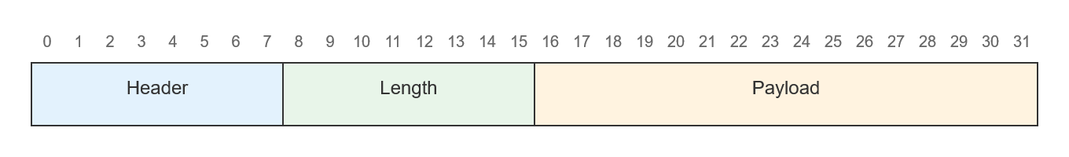
Architecture diagram:
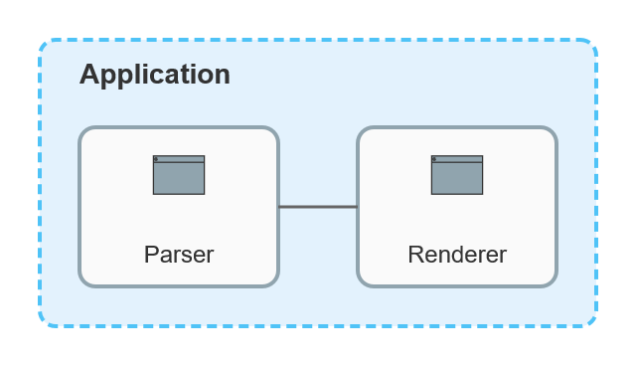
Radar chart:
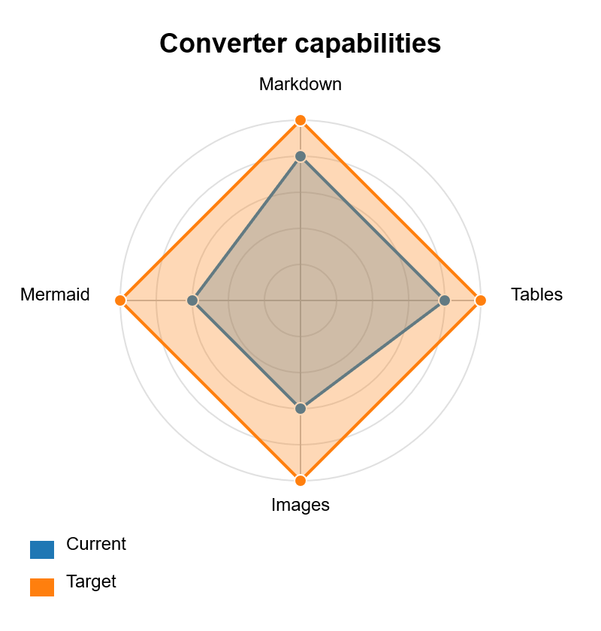
Sankey diagram:
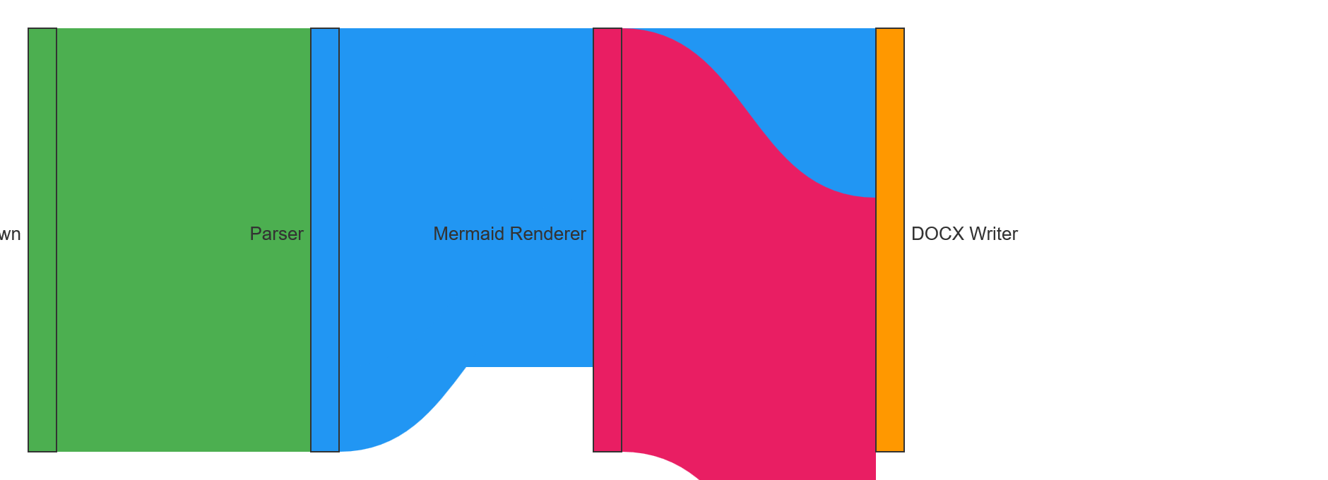

Tables
Header row only:
A | B | C
Table with body:
Name | Value | Notes
Foo | 1 | First
Bar | 2 | Second
Baz | 3 | Third
Table with explicit alignment:
Left | Center | Right
L1 | C1 | R1
L2 | C2 | R2
Table with empty cells:
Col A | Col B | Col C
A1 |  | C1
A2 | B2
Table with inline formatting:
Bold header | Italic header | Code header
Cell with link | Cell with code | Plain cell
Strong cell | Emphasis cell | Strike cell
Table with escaped pipe:
Label | Value
Literal pipe | A | B
Table with image in a cell:
Description | Preview
Logo | 
Missing icon | [Missing image: Icon]

Images
Local image with alt text:
Local image with title:
Reference-style local image:
Missing local image placeholder:
[Missing image: Missing local image]
Remote image placeholder:
[Missing image: Remote image]

Footnotes
Footnote markers are supported as preserved document text.
Another paragraph can refer to the same area of the document with a second note.

Horizontal rules
Hyphen rule:

Asterisk rule:

Underscore rule:

Mixed supported nesting
Blockquote containing tasks:
- [ ] Quoted unchecked task
- [x] Quoted checked task
Blockquote containing nested ordered content:
- First quoted step
  - Sub bullet in quote
- Second quoted step
Ordered item with continuation and nested bullet:
- Numbered item with continuation.
Continuation paragraph belongs to the first item.
  - Nested bullet in continuation.
- Second numbered item.
Table near the end:
Feature | Expected DOCX behaviour
Links | Real Word hyperlinks
Lists | Native Word numbering or bullets
Code | Monospace shaded paragraphs
Images | Embedded when local file exists
End of supported examples.
First footnote body text.
Second footnote body with formatting and code.

