Welcome to the Router program.

Aim:

The aim of this program is to provide the unit with an easy to use signals distribution system.

Use:

- Select the appropriate file from the list provided,
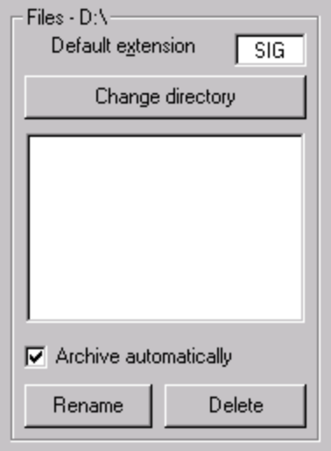

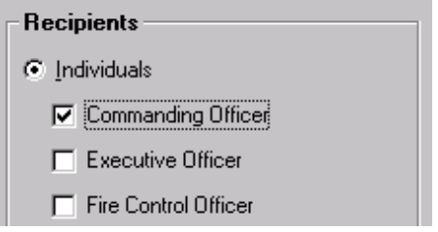
- Select the individual(s) and/or group(s) to receive the file, and
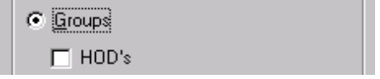

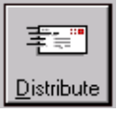
- Press the distribute button.

