Systems Management Server Version 2.0
Scalable Management for Windows® Based Systems

Collecting Asset Information with Systems Management Server 2.0
Technical Paper
Abstract
You can use Microsoft® Systems Management Server (SMS) to collect personal computer asset information and store this information in the SMS site database. This technical paper describes a new collection method that takes advantage of changes in the Microsoft Windows Management Instrumentation (WMI) code.

© 2001 Microsoft Corporation. All rights reserved.
The information contained in this document represents the current view of Microsoft Corporation on the issues discussed as of the date of publication. Because Microsoft must respond to changing market conditions, it should not be interpreted to be a commitment on the part of Microsoft, and Microsoft cannot guarantee the accuracy of any information presented after the date of publication.
This white paper is for informational purposes only. MICROSOFT MAKES NO WARRANTIES, EXPRESS OR IMPLIED, IN THIS DOCUMENT.
Microsoft, Windows, and Windows NT are either registered trademarks or trademarks of Microsoft Corporation in the United States and/or other countries.
Other product and company names mentioned herein may be the trademarks of their respective owners.
Microsoft Corporation • One Microsoft Way • Redmond, WA 98052-6399 • USA
January 2000

Introduction 1
Contents
Overview of the Key Verification Steps 2
How to Determine if a Personal Computer is SMBIOS-Compliant 2
Running Smbios2.exe 3
How to Download and Install the New WMI Code 5
How to Use WBEM Tools to View Asset Data 6
Running Wbemdump.exe 6
How to View and Modify the SMS_def.mof File 7
How to Configure the SMS_def.mof File 8
How to View the Updated SMS_def.mof File by Using the MOF Manager Tool 13
Checking the SMS Inventory 14
SMBIOS-to-CIM Version 2.0 Mapping Sheet (this is a subset) 15
For More Information 17

You can collect personal computer asset information and store this information in the Microsoft Systems Management Server (SMS) database. The NOIDMIF method that SMS 1.2 uses still works with SMS 2.0. When you use the NOIDMIF method, you usually need a manufacturer-specific tool to read the asset information and generate the Management Information Format (MIF) file on the SMS client. It can require a fair amount of effort to install these manufacturer-specific tools. This technical paper describes a new method that you can use to collect asset information from personal computers. This new method takes advantage of enhancements made to the Microsoft Windows Management Instrumentation (WMI) code, which is the Microsoft implementation of Web Based Enterprise Management (WBEM).

Introduction
Microsoft Windows 2000 includes a new version of WMI code. The new WMI code is System Management BIOS (SMBIOS) aware, so you can configure the SMS Hardware Inventory Agent to read the serial number and asset information for Windows 2000–based computers that are compliant with the SMBIOS specification. To do this, you must enable the appropriate classes and properties on the SMS_def.mof file. You can use the MOF Manager tool to verify that the appropriate classes are configured in the SMS_def.mof file, which is described in the “How to View and Modify the SMS_def.mof File” section of this technical paper.
The SMS_def.mof file included with SMS reads the serial number from the Type 1 structure in the BIOS. However, some computer manufacturers write serial number information in the Type 2 or Type 3 structure of the BIOS. To configure SMS to capture the serial number on computers that write serial number information in the Type 2 or Type 3 structure, refer to the “How to Configure the SMS_def.mof File” section of this technical paper.
The new WMI code is available for Microsoft Windows 95, Microsoft Windows 98, and Microsoft Windows NT® 4.0 clients at the following Microsoft Web site:
http://msdn.microsoft.com/downloads/sdks/wmi/download.asp
To collect asset information from the BIOS, computers running Windows 2000, Windows 95, or Windows 98 require SMBIOS version 2.0 or later, and computers running Windows NT 4.0 require SMBIOS version 2.1 or later. It is important to note that you need SMS 2.0 Service Pack 2 (SP2) to support the new version of WMI (also known as WMI version 1.5 or 1085.005).
This technical paper describes the following verification steps:

Overview of the Key Verification Steps
- How to determine if computers are SMBIOS-compliant (does not require SMS)
- How to download and install the new WMI code (for Windows 95, Windows 98, or Windows NT 4.0)
- How to use WBEM tools to view asset data (does not require SMS)
- How to view and modify the SMS_def.mof file (requires SMS)
- How to check the SMS inventory (requires SMS)

How to Determine if a Personal Computer is SMBIOS-Compliant
SMBIOS was developed from a portion of Desktop Management Interface (DMI). For detailed information about the function calls that are used to obtain SMBIOS information, in addition to a pointer to the SMBIOS specifications, refer to the following Intel Web site:
http://developer.intel.com/ial/WfM/wfm20/design/smbios/smbstep.htm
There are a number of tools you can use to identify the SMBIOS (DMI BIOS) version. You can download Smbios2.exe from the following IBM Web site:
http://www.ibm.com/products/surepath/documents/utilities.html
If Smbios2.exe is unable to output the serial number information, you probably cannot import the serial number into SMS.
Note There is one exception to this behavior. Smbios2.exe strictly follows SMBIOS standards. However, during the development of the SMBIOS standards, some BIOS manufacturers and original equipment manufacturers (OEMs) did not strictly follow the SMBIOS standards. WMI makes allowances for ambiguous situations like this. For example, SMBIOS 2.1 and later requires that an “_SMBIOS_” string be present at a 16-byte offset within 64 KB of real-mode address space (F000:0). At the next 16-byte address from this string, the “_DMI_” string must be present. Following these two strings (at the next 16-byte address) is a data structure. This data structure has a pointer to where the actual SMBIOS data is stored. This pointer address can be greater than 1 MB. WMI allows the second “_DMI_” string to be missing. In short, Smbios2.exe may not work, but WMI might still receive SMBIOS data.

Running Smbios2.exe
Example 1: Run Smbios2.exe on an older computer that is not SMBIOS-compliant, by typing the following command at a command prompt:

smbios2 /G

After you type this command, output similar to the following example is displayed:

SMBIOS (aka DMIBIOS) Version 2.3.1 (Build 37) Display Utility - Jul 2 1999
-----------------------------------------------------------------
The following software is copyrighted material of the IBM Corporation and is provided AS IS without warranty of any kind, either express or implied <Remaining licensing agreement/disclaimer removed for readability>
Send comments/bugs to smbcheck@us.ibm.com.
DMI BIOS Function 50h, Get DMI Information (Return code: 81h - Unknown Function)

DMI BIOS Get DMI Structures via Function 51h:

Error: Unknown Function

Example 2: Run Smbios2.exe on a SMBIOS-compliant computer (for example, Compaq Presario), by typing the following command at a command prompt:

smbios2 /G

After you type the command, output similar to the following example is displayed:
Note The key fields are displayed in bold type.
SMBIOS (aka DMIBIOS) Version 2.3.1 (Build 37) Display Utility - Jul 2 1999
------------------------------------------------------------------------
The following software is copyrighted material of the IBM Corporation and is provided AS IS without warranty of any kind, either express or implied <Remaining licensing agreement/disclaimer removed for readability>

Send comments/bugs to smbcheck@us.ibm.com.
continued

SMBIOS 2.1 Structure Table Entry Point Structure (at FC85h:0000h):
Anchor String = _SM_
Checksum = 77h
Entry Point Structure Length = 1Fh bytes
SMBIOS Revision = 2.1
Maximum Structure Size = 519 (decimal) bytes
Entry Point Revision = 0
Formated Area:
Reserved = 0 0 0 0 0
DMI BIOS Structure Entry Point Structure (at FC86h:0000h):
Header = _DMI_
Checksum = 1Ch
Length = 0398h (920 decimal) bytes
BIOS Structure Table Address = 000FC4B0h
Number of Structures = 13
DMI BIOS Revision = 2.1

DMI BIOS Get DMI Structures from the Structure Table:
Structure: BIOS Information (Type 0)
Type: 0
Length: 13h
Handle: 0000h (0t)
BIOS Vendor: 'Compaq'
BIOS Version: '686U2'
Starting Addr Seg: F000h
BIOS Release Date: 05/25/99
BIOS ROM Size: 256K
BIOS Characteristics: 7DC8DE90h 00000000h
ISA Supported: Yes
MCA Supported: No
EISA Supported: No
PCI Supported: Yes
PCMCIA Supported: No
PnP Supported: Yes
APM Supported: Yes
Flashable BIOS: Yes
BIOS shadowing: Yes
VL-VESA Supported: No
ESCD Supported: Yes
CD-Boot Supported: Yes
Selectable Boot: No
BIOS ROM Socketed: No
PC Card Bootable: No
Enhanced Disk Drive: Yes
BIOS Characteristics Extension Byte 1: 17h
ACPI Supported: Yes
USB Legacy Supported: Yes
AGP Supported: Yes
I2O Boot Supported: No
LS-120 Boot Supported: Yes
ATAPI Zip Boot Supported: No
1394 Boot Supported: No
Smart Battery BIOS: No

continued
Structure: System Information (Type 1)
Type: 1
Length: 19h
Handle: 0001h (1t)
Manufacturer: 'Compaq'
Product Name: 'Compaq PC'
Version: 'N/A'
Serial Number: '1X97CLY2X22F'
UUID:
0000h : 31 58 39 37 43 4C 59 32-58 32 32 46 00 43 44 45 1X97CLY2X22F CDE
Wake-up Type: Unknown

Structure: Baseboard Information (Type 2)
Type: 2
Length: 08h
Handle: 0002h (2t)
Manufacturer: 'Compaq'
Product: '05E4h'
Version: 'None'
Serial Number: 'None'

Structure: System Enclosure (Type 3)
Type: 3
Length: 0Dh
Handle: 0003h (3t)
Manufacturer: 'Compaq'
Type: Mini Tower, Chassis Lock: Not Present or Unknown
Version: 'N/A'
Serial Number: 'None'
Asset Tag Number: 'No Asset Tag'
Bootup State: Unknown
Power Supply State: Unknown
Thermal State: Unknown
Security Status: Unknown
Structure: Processor Information (Type 4)

Note The remainder of the output was deleted for readability.
After you view the output from Smbios2.exe, you need to look at the same data using WBEM (WMI).

How to Download and Install the New WMI Code
Windows 2000 includes WMI version 1.5 (1085.005), which is SMBIOS aware. If your clients are running Windows 95, Windows 98, or Windows NT 4.0, you need to download WMI version 1.5 from the following Microsoft Web site:
http://msdn.microsoft.com/downloads/sdks/wmi/download.asp
A future release of SMS will include the new version of WMI. For now, you can deploy the new WMI version as an SMS package using a command line such as Wmint4.exe /s.

How to Use WBEM Tools to View Asset Data
You can use the Wbemtest and Wbemdump tools to view the asset data. Wbemtest is a graphical user interface (GUI) tool located in the SystemRoot\System32\Wbem folder, and Wbemdump is a command-line tool located in the Microsoft Platform Software Development Kit (SDK). The examples in the following section are based on the Wbemdump tool, but the Wbemtest tool works just as well.

Running Wbemdump.exe
Example 1: The following example involves a Windows 98-based computer (Compaq Presario) and uses the old WMI code. Type the following command at a command prompt:

wbemdump root\cimv2 win32_bios

After you type the command, output similar to the following example is displayed:

<ROOT\CIMV2>
Win32_BIOS
BuildNumber (CIM_STRING/string) = <null>
Caption (CIM_STRING/string) = “Compaq”
CodeSet (CIM_STRING/string) = <null>
Description (CIM_STRING/string) = “Compaq”
IdentificationCode (CIM_STRING/string) = <null>
InstallDate (CIM_DATETIME/datetime) = <null>
LanguageEdition (CIM_STRING/string) = <null>
Manufacturer (CIM_STRING/string) = <null>
Name (CIM_STRING/string)* = “Compaq”
OtherTargetOS (CIM_STRING/string) = “N/A”
PrimaryBIOS (CIM_BOOLEAN/boolean) = TRUE
ReleaseDate (CIM_DATETIME/datetime) = “19990406000000.000000-000”
SerialNumber (CIM_STRING/string) = <null>
SoftwareElementID (CIM_STRING/string)* = “Compaq”
SoftwareElementState (CIM_UINT16/uint16)* = 3 (0x3)
Status (CIM_STRING/string) = “OK”
TargetOperatingSystem (CIM_UINT16/uint16)* = 2 (0x2)
Version (CIM_STRING/string)* = ““

Note No serial number is shown in this example because the old WMI code is not SMBIOS aware. You need to install the new WMI code on the client running Windows 98.
Example 2: The following example involves the same Windows 98-based computer (Compaq Presario) as in Example 1, but with the new WMI code. Type the following command at a command prompt:

wbemdump root\cimv2 win32_bios

After you type the command, output similar to the following example is displayed:

<ROOT\CIMV2>
Win32_BIOS
BiosCharacteristics (CIM_UINT16 | CIM_FLAG_ARRAY/uint16) = 4,7,9,10,11,12,14,15,19,22,23,24,26,27,28,29,30,32,33,34,36
BuildNumber (CIM_STRING/string) = <null>
Caption (CIM_STRING/string) = “Compaq”
CodeSet (CIM_STRING/string) = <null>
CurrentLanguage (CIM_STRING/string) = <null>
Description (CIM_STRING/string) = “Compaq”
IdentificationCode (CIM_STRING/string) = <null>
InstallableLanguages (CIM_UINT16/uint16) = <null>
InstallDate (CIM_DATETIME/datetime) = <null>
LanguageEdition (CIM_STRING/string) = <null>
ListOfLanguages (CIM_STRING | CIM_FLAG_ARRAY/string) = <null>
Manufacturer (CIM_STRING/string) = “Compaq”
Name (CIM_STRING/string)* = “Compaq”
OtherTargetOS (CIM_STRING/string) = <null>
PrimaryBIOS (CIM_BOOLEAN/boolean) = TRUE
ReleaseDate (CIM_DATETIME/datetime) = “19990406******.******+***”
SerialNumber (CIM_STRING/string) = “1X97CLY2X22F”
SMBIOSBIOSVersion (CIM_STRING/string) = “686U2”
SMBIOSMajorVersion (CIM_UINT16/uint16) = 2 (0x2)
SMBIOSMinorVersion (CIM_UINT16/uint16) = 1 (0x1)
SMBIOSPresent (CIM_BOOLEAN/boolean) = TRUE
SoftwareElementID (CIM_STRING/string)* = “Compaq”
SoftwareElementState (CIM_UINT16/uint16)* = 3 (0x3)
Status (CIM_STRING/string) = “OK”
TargetOperatingSystem (CIM_UINT16/uint16)* = 0 (0x0)
Version (CIM_STRING/string)* = ““

Note The serial number and other properties are now available because the new version of WMI (1085.005) is installed.

How to View and Modify the SMS_def.mof File
The verification steps so far have not required you to use SMS. The SMBIOS and WBEM tools do not require you to install SMS. This section describes how to use the MOF Manager tool to verify that the SMS_def.mof file is configured to collect serial number information from SMBIOS-compliant computers. For more information about the MOF Manager tool, see article Q202538, “SMS:Editing MOF’s with the MOF Manager” in the Microsoft Knowledge Base. This section also includes an example of how to augment the SMS_def.mof file to collect the computer asset tag. (The SMS_def.mof file does not currently have this capability, but this functionality can be added to the SMS_def.mof file.)
You can use the MOF Manager tool to view and modify classes and properties in the SMS_def.mof file, as shown in the following figure.
Note The following screenshot contains the Win32_BIOS class, on which the SerialNumber property is enabled.
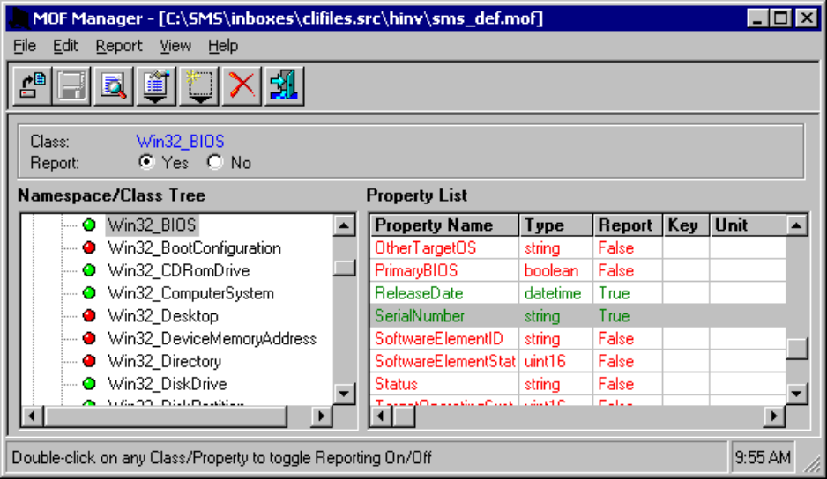

How to Configure the SMS_def.mof File
According to the SMBIOS specification, a computer manufacturer can store other information in the BIOS, in addition to the serial number. One useful piece of information is the asset tag. The SMS_def.mof file does not currently contain the information required to collect the asset tag from an SMBIOS-compliant computer, but you can configure the SMS_def.mof file to do so. The asset tag is in the SMBIOS Type 3 structure, which maps to the Win32_SystemEnclosure class. You should first use the Wbemdump tool to verify that WMI can read the asset tag.
To verify that WMI can read the asset tag, type the following command at a command prompt:

wbemdump root\cimv2 win32_systemenclosure

After you type this command, output similar to the following example is displayed:

<ROOT\CIMV2>
Win32_SystemEnclosure
AudibleAlarm (CIM_BOOLEAN/boolean) = <null>
BreachDescription (CIM_STRING/string) = <null>
CableManagementStrategy (CIM_STRING/string) = <null>
Caption (CIM_STRING/string) = “System Enclosure”
ChassisTypes (CIM_UINT16 | CIM_FLAG_ARRAY/uint16) = 10
CreationClassName (CIM_STRING/string) = “Win32_SystemEnclosure”
CurrentRequiredOrProduced (CIM_SINT16/sint16) = <null>
Depth (CIM_REAL32/real32) = <null>
Description (CIM_STRING/string) = “System Enclosure”
HeatGeneration (CIM_UINT16/uint16) = <null>
Height (CIM_REAL32/real32) = <null>
HotSwappable (CIM_BOOLEAN/boolean) = <null>
InstallDate (CIM_DATETIME/datetime) = <null>
LockPresent (CIM_BOOLEAN/boolean) = FALSE
Manufacturer (CIM_STRING/string) = “TOSHIBA”
Model (CIM_STRING/string) = <null>
Name (CIM_STRING/string) = “System Enclosure”
NumberOfPowerCords (CIM_UINT16/uint16) = <null>
OtherIdentifyingInfo (CIM_STRING/string) = <null>
PartNumber (CIM_STRING/string) = <null>
PoweredOn (CIM_BOOLEAN/boolean) = <null>
Removable (CIM_BOOLEAN/boolean) = <null>
Replaceable (CIM_BOOLEAN/boolean) = <null>
SecurityBreach (CIM_UINT16/uint16) = <null>
SecurityStatus (CIM_UINT16/uint16) = 3 (0x3)
SerialNumber (CIM_STRING/string) = “00000000”
ServiceDescriptions (CIM_STRING “| CIM_FLAG_ARRAY/string) = <null>
ServicePhilosophy (CIM_UINT16 |

continued

CIM_FLAG_ARRAY/uint16) = <null>
SKU (CIM_STRING/string) = <null>
SMBIOSAsset Tag (CIM_STRING/string) = “A444788
Status (CIM_STRING/string) = <null>
Tag (CIM_STRING/string)* = “System Enclosure 0”
TypeDescriptions (CIM_STRING | CIM_FLAG_ARRAY/string) = <null>
Version (CIM_STRING/string) = “Version 1.0”
VisibleAlarm (CIM_BOOLEAN/boolean) = <null>
Weight (CIM_REAL32/real32) = <null>
Width (CIM_REAL32/real32) = <null>

Note This test was performed on a Toshiba Protege 3110CT.
After you verify that Wbemdump can output the asset tag, SMS stores the asset tag information in the database only if the SMS_def.mof file contains the required information. You can use the following sample code to collect the SMBIOSAssetTag property and a few other selected properties from the Win32_SystemEnclosure class. Note that the sample includes the serial number attribute, so adding the following code to SMS_def.mof allows SMS to capture serial numbers from computers that store serial numbers in the Type 3 structure.
You can copy the following sample code directly onto the end of the SMS\Inboxes\Clifiles.src\Hinv\SMS_def.mof file:

[SMS_Report(TRUE),
SMS_Group_Name("System Enclosure"),
SMS_Class_ID("MICROSOFT|System_Enclosure|1.0")]
class Win32_SystemEnclosure : SMS_Class_Template
{
[SMS_Report(TRUE), key]
string Tag;
[SMS_Report(FALSE)]
string Caption;
[SMS_Report(FALSE)]
string Description;
[SMS_Report(TRUE)]
string Manufacturer;
[SMS_Report(TRUE)]
string Name;
[SMS_Report(TRUE)]
string SerialNumber;
[SMS_Report(TRUE)]
string SMBIOSAssetTag;
[SMS_Report(TRUE)]
string Version;
};

SMS automatically propagates this updated SMS_def.mof file to the client access points (CAPs), and clients inherit the updated SMS_def.mof file on the next maintenance cycle. The SMS Hardware Inventory Agent detects that the SMS_def.mof file has changed, based on the cyclical redundancy check (CRC), and compiles the new SMS_def.mof file into the Common Information Model (CIM) repository.
Some computer manufacturers store asset information in the Type 2 structure in the BIOS. To verify that WMI can read the information in the Type 2 structure, type the following command at a command prompt:

wbemdump root\cimv2 win32_baseboard

After you type this command, output similar to the following example is displayed:

<ROOT\CIMV2>
Win32_BaseBoard
Caption (CIM_STRING/string) = "Base Board"
ConfigOptions (CIM_STRING | CIM_FLAG_ARRAY/string) = "TOSHIBA"
CreationClassName (CIM_STRING/string) = "Win32_BaseBoard"
Depth (CIM_REAL32/real32) = <null>
Description (CIM_STRING/string) = "Base Board"
Height (CIM_REAL32/real32) = <null>
HostingBoard (CIM_BOOLEAN/boolean) = TRUE
HotSwappable (CIM_BOOLEAN/boolean) = <null>
InstallDate (CIM_DATETIME/datetime) = <null>
Manufacturer (CIM_STRING/string) = "TOSHIBA"
Model (CIM_STRING/string) = <null>
Name (CIM_STRING/string) = "Base Board"
OtherIdentifyingInfo (CIM_STRING/string) = <null>
PartNumber (CIM_STRING/string) = <null>
PoweredOn (CIM_BOOLEAN/boolean) = TRUE
Product (CIM_STRING/string) = "Portable PC"
Removable (CIM_BOOLEAN/boolean) = <null>
Replaceable (CIM_BOOLEAN/boolean) = <null>
RequirementsDescription (CIM_STRING/string) = <null>
RequiresDaughterBoard (CIM_BOOLEAN/boolean) = <null>
SerialNumber (CIM_STRING/string) = "00000000"
SKU (CIM_STRING/string) = <null>
SlotLayout (CIM_STRING/string) = <null>
SpecialRequirements (CIM_BOOLEAN/boolean) = <null>
Status (CIM_STRING/string) = <null>
Tag (CIM_STRING/string)* = "Base Board"
Version (CIM_STRING/string) = "Version A0"
Weight (CIM_REAL32/real32) = <null>
Width (CIM_REAL32/real32) = <null>

Note This test was performed on a Toshiba Protege 3110CT.
After you verify that Wbemdump can display data from the Type 2 structure, add the following code to the SMS_def.mof file if you want SMS to collect this information.
You can copy the following sample code directly onto the end of the SMS\Inboxes\Clifiles.src\Hinv\SMS_def.mof file:

[SMS_Report(TRUE),
SMS_Group_Name("Baseboard"),
SMS_Class_ID("MICROSOFT|Baseboard|1.0")]
class Win32_Baseboard : SMS_Class_Template
{
[SMS_Report(TRUE), key]
string Tag;
[SMS_Report(FALSE)]
string ConfigOptions;
[SMS_Report(FALSE)]
string Depth;
[SMS_Report(FALSE)]
string Description;
[SMS_Report(FALSE)]
string Height;
[SMS_Report(FALSE)]
string HostingBoard;
[SMS_Report(FALSE)]
string HotSwappable;
[SMS_Report(FALSE)]
string InstallDate;
[SMS_Report(TRUE)]
string Manufacturer;
[SMS_Report(TRUE)]
string Model;
[SMS_Report(FALSE)]
string Name;
[SMS_Report(FALSE)]
string OtherIdentifyingInfo;
[SMS_Report(FALSE)]
string PartNumber;
[SMS_Report(FALSE)]
string PoweredOn;
[SMS_Report(TRUE)]
string Product;
[SMS_Report(FALSE)]
string Removable;
[SMS_Report(FALSE)]
string Replaceable;
[SMS_Report(FALSE)]
string RequirementsDescription;
[SMS_Report(FALSE)]
string RequiresDaughterBoard;
[SMS_Report(TRUE)]
string SerialNumber;
[SMS_Report(FALSE)]
string SKU;
[SMS_Report(FALSE)]
string SlotLayout;
[SMS_Report(FALSE)]
string SpecialRequirements;
[SMS_Report(FALSE)]
string Status;
[SMS_Report(FALSE)]
string Version;
[SMS_Report(FALSE)]
string Weight;
[SMS_Report(FALSE)]
string Width;
};
To summarize, not all personal computer manufacturers store their serial numbers in the Type 1 structure. Some personal computer manufacturers store serial number information in the Type 2 or Type 3 structure. SMS does not capture information out of the Type 2 or Type 3 structures unless you configure the SMS_def.mof file to include the Win32_BaseBoard (Type 2) or Win32_SystemEnclosure (Type 3) class. Also note that because many organizations have an assortment of personal computers that store serial number information in Type 1, Type 2, and Type 3 structures, serial number information in the SMS database may be stored in three different tables. To combine all serial number information, you must design queries accordingly.

How to View the Updated SMS_def.mof File by Using the MOF Manager Tool
The following figure shows the Win32_SystemEnclosure class in the left pane, and the SMBIOSAssetTag property is displayed in the right pane.
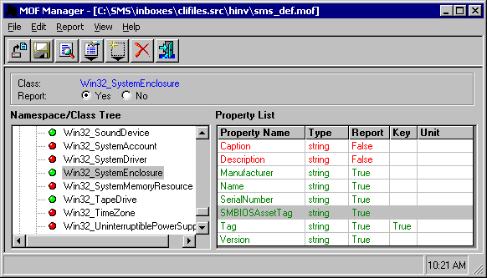

Checking the SMS Inventory
The following figure shows that the asset tag information exists in the SMS site database.
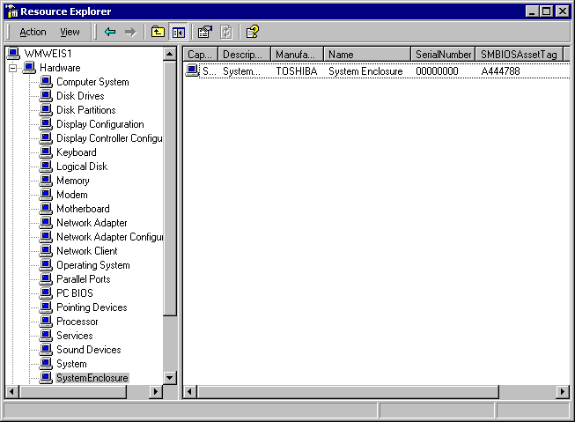

SMBIOS-to-CIM Version 2.0 Mapping Sheet (this is a subset)
Type | Structure | Version | Field | CIMV2 Class | CIMV2 Property
0 | BIOS information | 2.0 | Type | NONE | NONE
 |  | 2.0 | Length | NONE | NONE
 |  | 2.0 | Handle | NONE | NONE
 |  | 2.0 | BIOS Version | NONE | NONE
 |  | 2.0 | BIOS Start Address Segment | NONE | NONE
 |  | 2.0 | BIOS Release Date | NONE | NONE
 |  | 2.0 | BIOS ROM Size | NONE | NONE
 |  | 2.0 | BIOS Characteristics | Win32_BIOS | BIOSCharacteristics[]
 |  |  | OEM-defined | Win32_OEMBucket | Type0_BIOSVendorBits
 |  |  | OEM-defined | Win32_OEMBucket | Type0_SystemVendorBits
 |  | 2.1 | BIOS Characteristics Ex[] | Win32_BIOS | BIOSCharacteristics[]
1 | System information | 2.0 | Type | NONE | NONE
 |  | 2.0 | Length | NONE | NONE
 |  | 2.0 | Handle | NONE | NONE
 |  | 2.0 | Manufacturer | Win32_ComputerSystemProduct | Vendor
 |  | 2.0 | Product Name | Win32_ComputerSystemProduct | Name
 |  | 2.0 | Version | Win32_ComputerSystemProduct | Version
 |  | 2.0 | Serial Number | Win32_BIOS | SerialNumber
 |  | 2.1 | UUID | Win32_ComputerSystemProduct | UUID
 |  |  | UUID (continued) | Win32_ComputerSystemProduct | IdentifyingNumber
continued
Type | Structure | Version | Field | CIMV2 Class | CIMV2 Property
 |  | 2.1 | Wakeup Type | Win32_ComputerSystem | WakeUpType
2 | Base board information | 2.0 | Type | NONE | NONE
 |  | 2.0 | Length | NONE | NONE
 |  | 2.0 | Handle | NONE | NONE
 |  | 2.0 | Manufacturer | Win32_BaseBoard | Manufacturer
 |  | 2.0 | Product Name | Win32_BaseBoard | ProductName
 |  | 2.0 | Version | Win32_BaseBoard | Version
 |  | 2.0 | Serial Number | Win32_BaseBoard | SerialNumber
3 | System enclosure | 2.0 | Type | NONE | NONE
 |  | 2.0 | Length | NONE | NONE
 |  | 2.0 | Handle | NONE | NONE
 |  | 2.0 | Manufacturer | Win32_SystemEnclosure | Manufacturer
 |  | 2.0 | Type (Chassis Type) | Win32_SystemEnclosure | ChassisType
 |  | 2.0 | Type (Lock Present) | Win32_SystemEnclosure | LockPresent
 |  | 2.0 | Version | Win32_SystemEnclosure | Version
 |  | 2.0 | Serial Number | Win32_SystemEnclosure | SerialNumber
 |  | 2.0 | Asset Tag Number | Win32_SystemEnclosure | AssetTag
 |  | 2.1 | Bootup State | Win32_ComputerSystem | BootupState
 |  | 2.1 | Power Supply State | Win32_ComputerSystem | PowerSupplyState
 |  | 2.1 | Thermal State | Win32_ComputerSystem | ThermalState
 |  | 2.1 | Security Status | Win32_SystemEnclosure | SecurityStatus
 |  | 2.3 | OEM-defined | Win32_OEMBucket | Type3_OEMDefined

For more information about SMS, visit our Web site at http://www.microsoft.com/smsmgmt/default.asp

For More Information

