Task-1

# **Steps to complete your Git Repository**

**Step 1:-** Create new account in Git-hub by entering your college email.

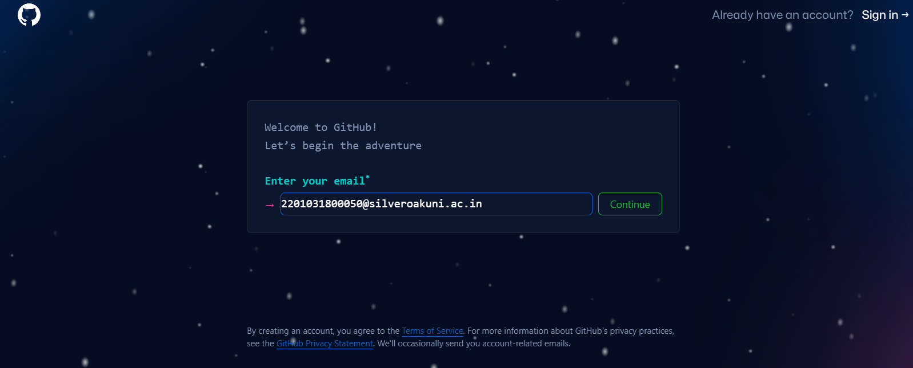

**Step 2:-** Enter your Password.

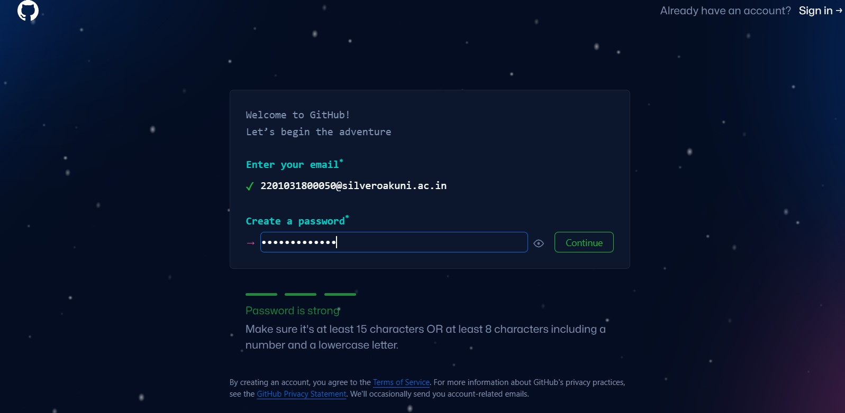

**Step 3:-** Enter your username for your account.

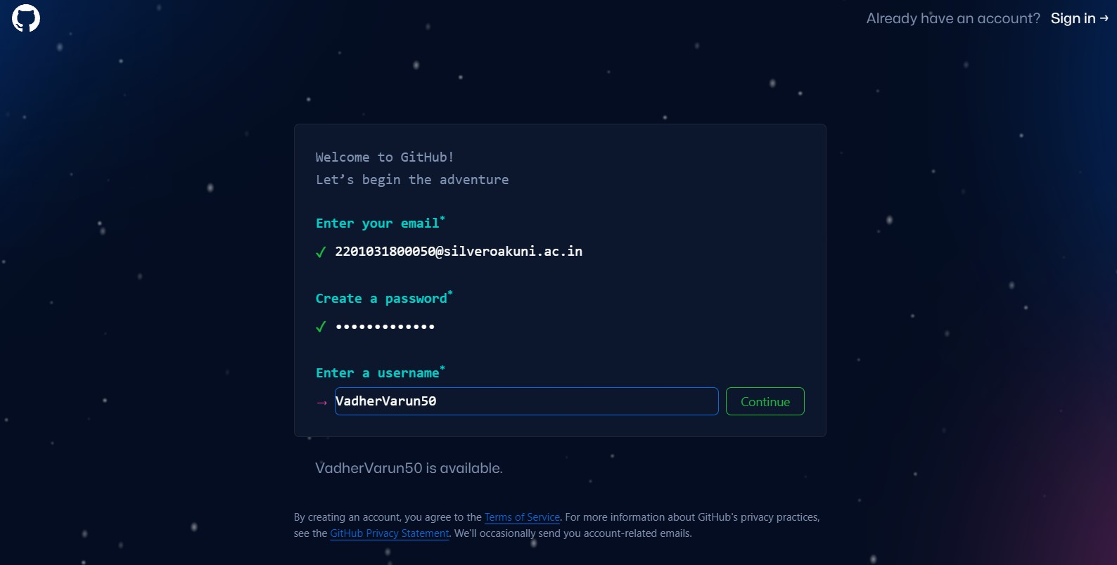

**Step 4:-** After completing your verification, click on create account.

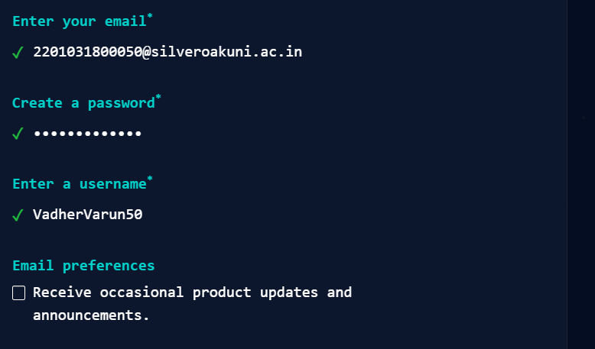

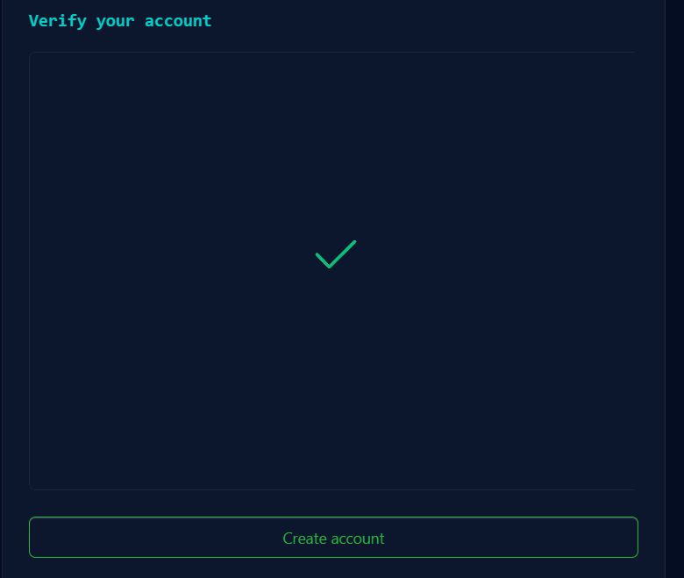

**Step 5:-** Now your account has been created, after this you can complete account personalisation

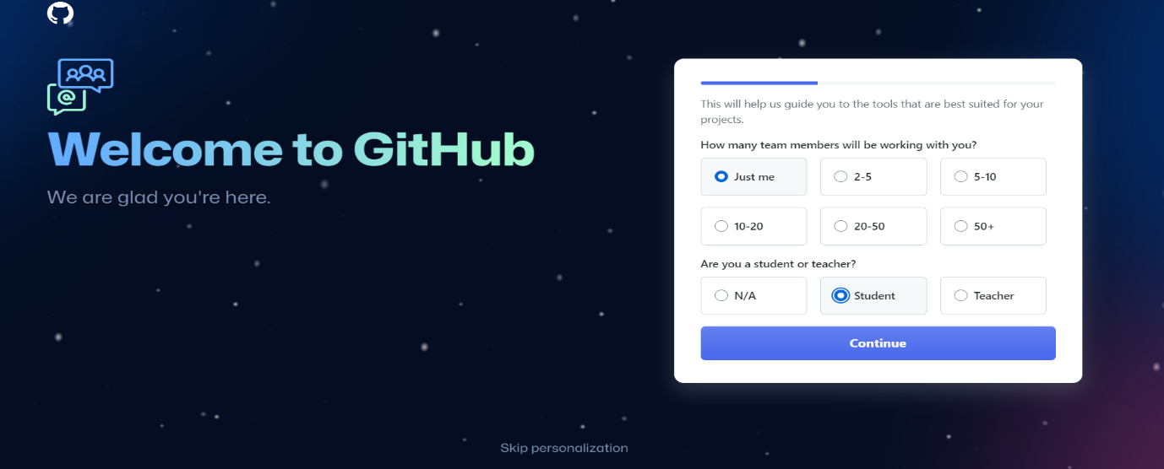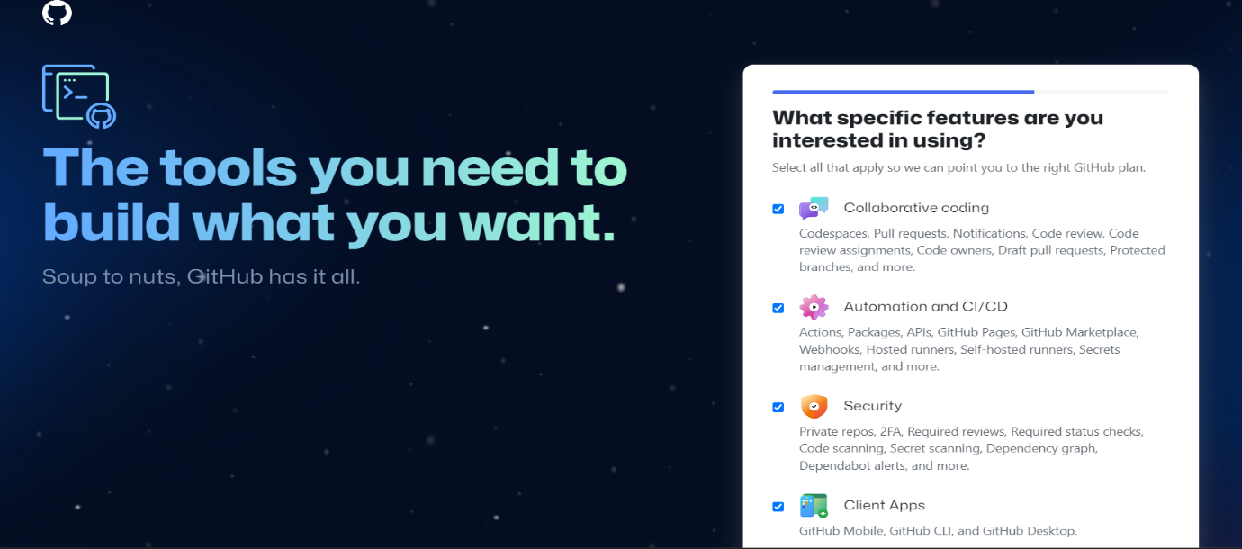

**Step 6:-** Ater creating your account and completing personalization click on create new repository.

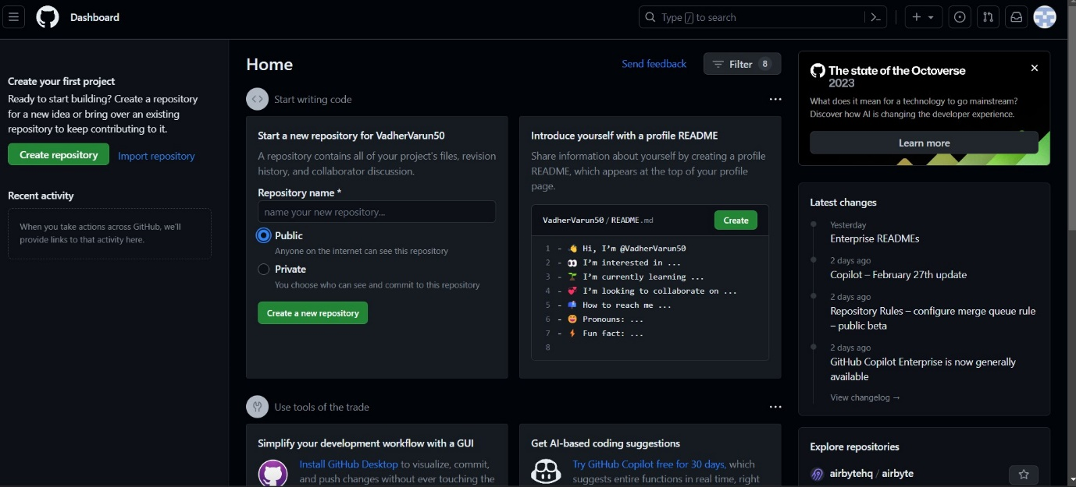

**Step 7:-** Name your Repository after your college enrollment number.

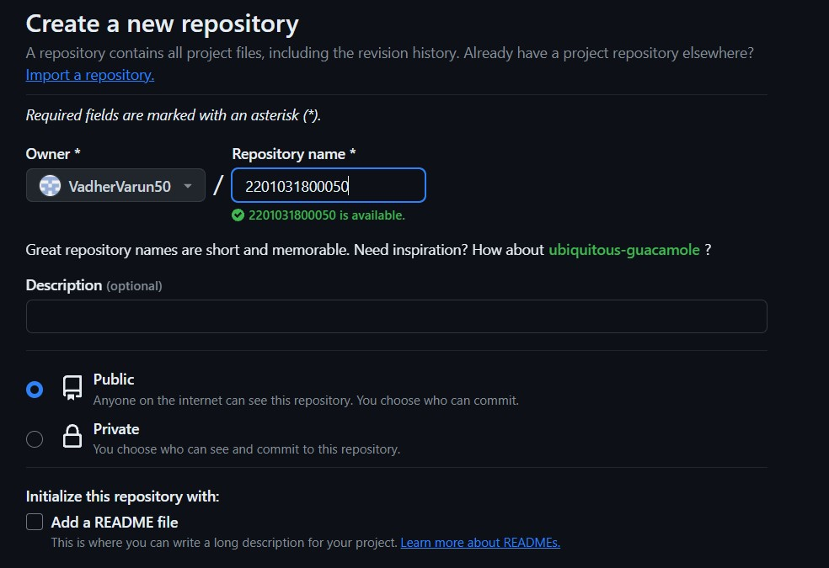

**Step 8:-** Now click on ‘Add file’ option to create a folder in the repository. We are required to create 2 folders here in our repository, named as ‘Assignment_1’ and ‘Assignment_2’.

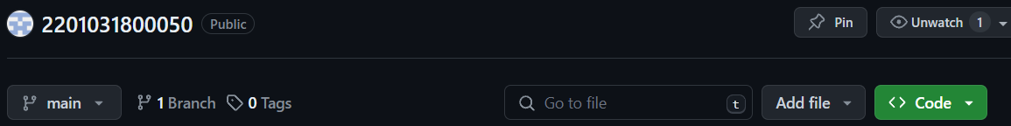

**Step 9:-** Write your folder name in the specified area(Assignment_1 and Assignment_2).

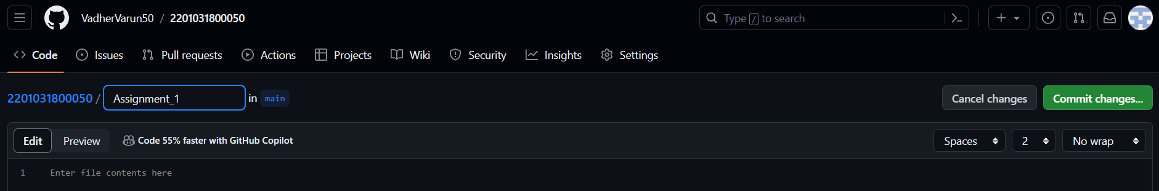

**Step 10:-** Now move forward by clicking on Commit Changes option.



**Step 11:-** Same way like this create folder named Assignment_2

**Step 12:-** Now you’ll be able to see two folders that you created in your repository.

