|  |  |  |  |  |  |  |  |  |
| --- | --- | --- | --- | --- | --- | --- | --- | --- |
| **GPIO** | **Input** | **Output** | **Notes** |  | **GPIO** | **Input** | **Output** | **Notes** |
| **0** | **Pulled up** | **OK** | Outputs PWM signal at boot |  | **16** | **OK** | **OK** |  |
| **1** | **TX pin** | **OK** | Debug output at boot |  | **17** | **OK** | **OK** |  |
| **2** | **OK** | **OK** | Connected to on-board LED |  | **18** | **OK** | **OK** |  |
| **3** | **OK** | **RX pin** | HIGH at boot |  | **19** | **OK** | **OK** |  |
| **4** | **OK** | **OK** |  |  | **21** | **OK** | **OK** |  |
| **5** | **OK** | **OK** | Outputs PWM signal at boot |  | **22** | **OK** | **OK** |  |
| **6** | **x** | **x** | Connected to the integrated SPI flash |  | **23** | **OK** | **OK** |  |
| **7** | **x** | **x** | Connected to the integrated SPI flash |  | **25** | **OK** | **OK** |  |
| **8** | **x** | **x** | Connected to the integrated SPI flash |  | **26** | **OK** | **OK** |  |
| **9** | **x** | **x** | Connected to the integrated SPI flash |  | **27** | **OK** | **OK** |  |
| **10** | **x** | **x** | Connected to the integrated SPI flash |  | **32** | **OK** | **OK** |  |
| **11** | **x** | **x** | Connected to the integrated SPI flash |  | **33** | **OK** | **OK** |  |
| **12** | **OK** | **OK** | Boot fail if pulled high |  | **34** | **OK** |  | **input only** |
| **13** | **OK** | **OK** |  |  | **35** | **OK** |  | **input only** |
| **14** | **OK** | **OK** | Outputs PWM signal at boot |  | **36** | **OK** |  | **input only** |
| **15** | **OK** | **OK** | Outputs PWM signal at boot |  | **39** | **OK** |  | **input only** |

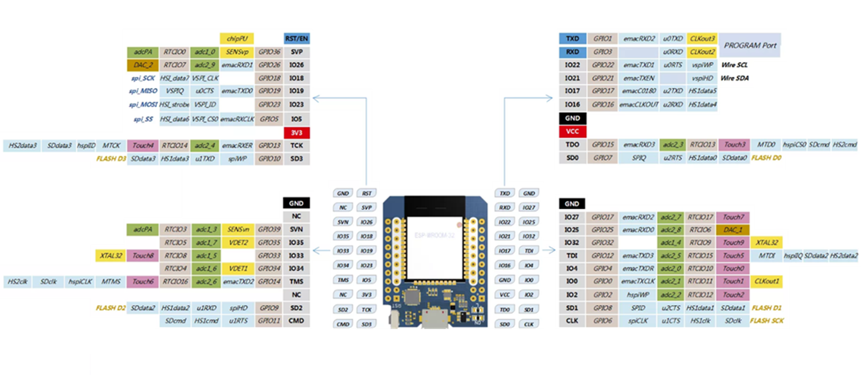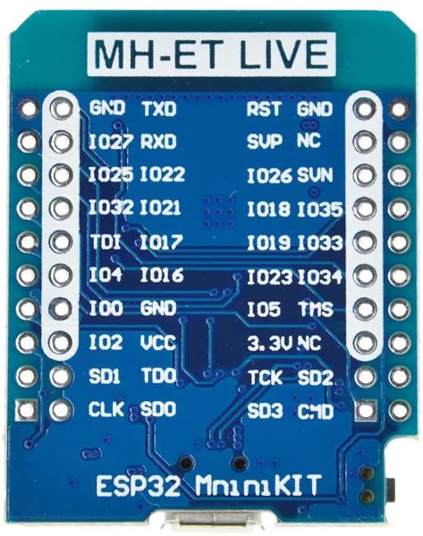

**Wire пины по умолчанию**

**GPIO22 Wire SCL**

**GPIO21 Wire SDA**