GPIO | Input | Output | Notes |  | GPIO | Input | Output | Notes
0 | Pulled up | OK | Outputs PWM signal at boot |  | 16 | OK | OK
1 | TX pin | OK | Debug output at boot |  | 17 | OK | OK
2 | OK | OK | Connected to on-board LED |  | 18 | OK | OK
3 | OK | RX pin | HIGH at boot |  | 19 | OK | OK
4 | OK | OK |  |  | 21 | OK | OK
5 | OK | OK | Outputs PWM signal at boot |  | 22 | OK | OK
6 | x | x | Connected to the integrated SPI flash |  | 23 | OK | OK
7 | x | x | Connected to the integrated SPI flash |  | 25 | OK | OK
8 | x | x | Connected to the integrated SPI flash |  | 26 | OK | OK
9 | x | x | Connected to the integrated SPI flash |  | 27 | OK | OK
10 | x | x | Connected to the integrated SPI flash |  | 32 | OK | OK
11 | x | x | Connected to the integrated SPI flash |  | 33 | OK | OK
12 | OK | OK | Boot fail if pulled high |  | 34 | OK |  | input only
13 | OK | OK |  |  | 35 | OK |  | input only
14 | OK | OK | Outputs PWM signal at boot |  | 36 | OK |  | input only
15 | OK | OK | Outputs PWM signal at boot |  | 39 | OK |  | input only
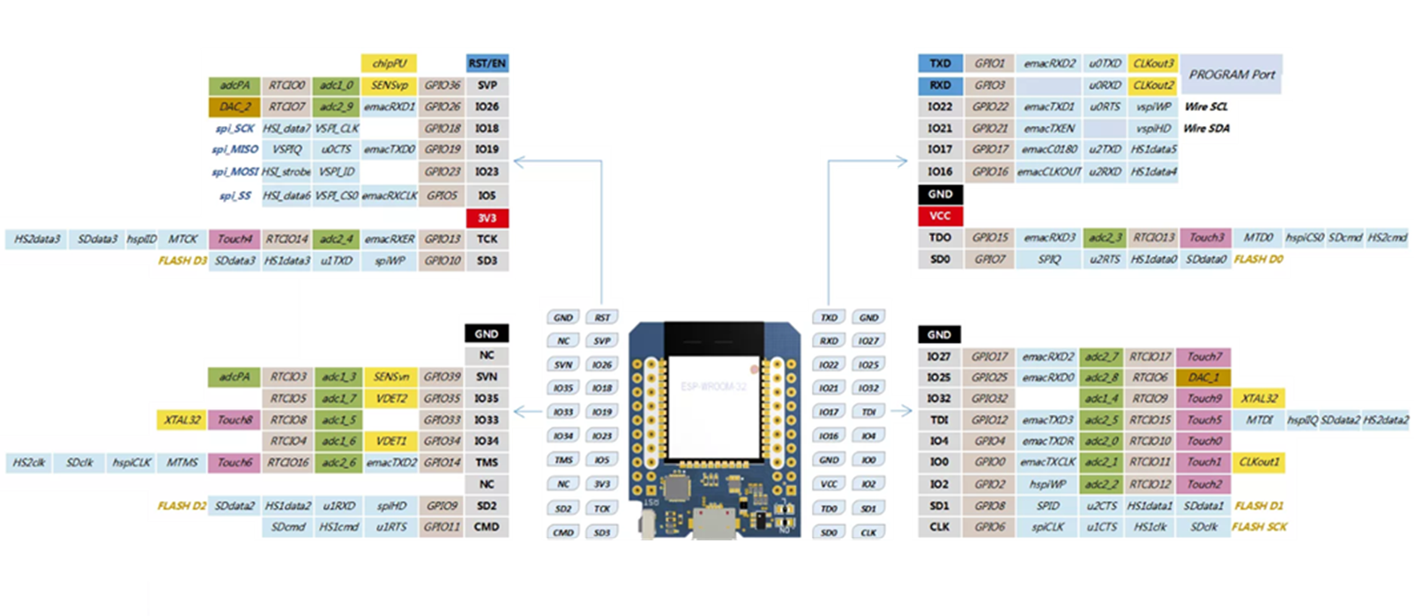
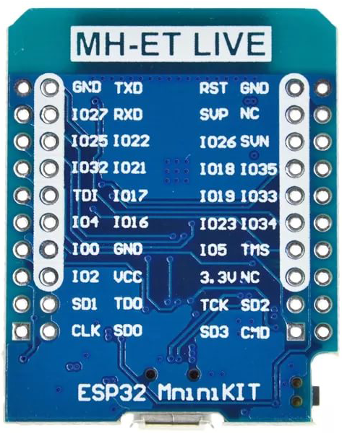
Wire пины по умолчанию
GPIO22 Wire SCL
GPIO21 Wire SDA

