Module 4 Linux Essentials   
TASK 4.3

After you have logged into the system, do the following.   
1.Invoke pwd to see your current working directory (there should be your home directory).

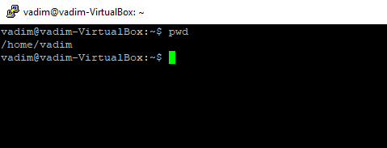  
2. Collect output of these commands   
ls -l / -- Listing the contents of the root directory with use a long listing format

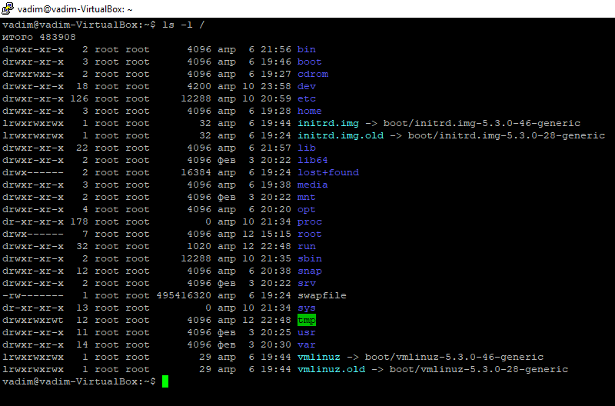

ls -- just listing the contents of the current directory

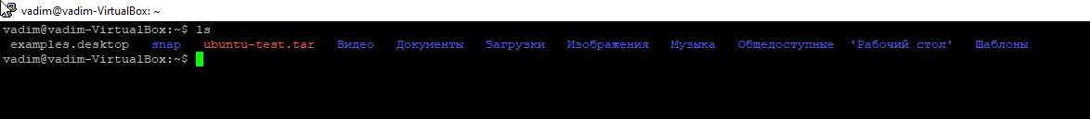

ls ~ -- listing the contents of the home directory user which login in system

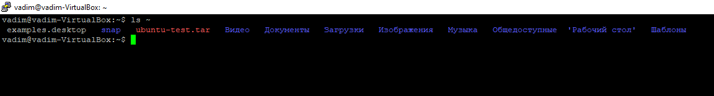

ls -l -- listing the contents of the current directory with use a long listing format

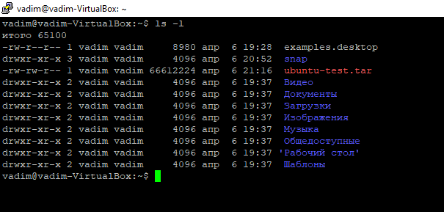

ls –a -- listing the contents of the current directory and do not ignore entries starting with **.**



ls -la -- listing the contents of the current directory with use a long listing format and do not ignore entries starting with **.**

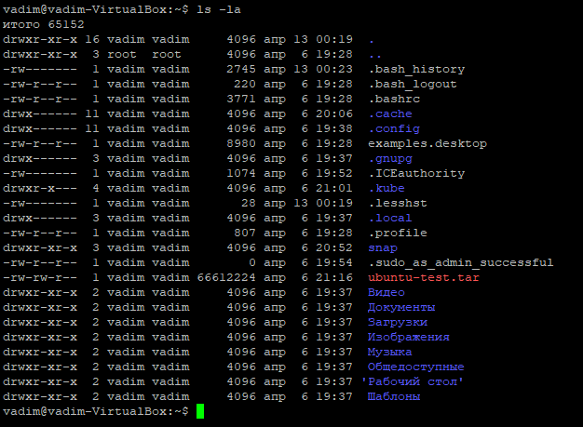

ls -lda ~ -- listing the contents of the home directory user which login in system with use a long listing format, do not ignore entries starting with **.** and list directories themselves, not their contents.

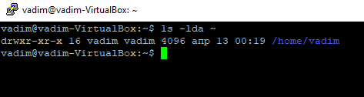

Note differences between produced outputs. Describe (in few words) purposes of these commands.

3. Execute and describe the following commands (store the output, if any):   
mkdir test – create directory **test** in home work directory which user login  
cd test -- change current directory to child  
pwd – this command to seehow use directory is now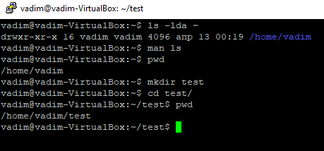

touch test.txt – create file test.txt in directory /home/Vadim/test  
ls -l test.txt -- listing the contents of the file test.txt

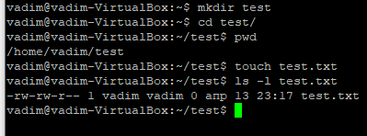  
mkdir test2 -- create directory **test2** in path /home/Vadim/test/  
mv test.txt test2 – rename(or move) file test.txt to test2  
cd test2 – do not execute because **test2** is file

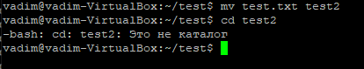

ls -- just listing the contents of the current directory - /home/Vadim/test

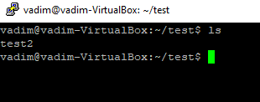mv test.txt test2.txt – do not execute rename(or move) file test.txt to test2.txt because we don`t have file test.txt in current direcrory /../../test/

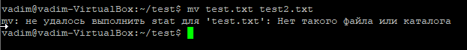  
ls -- just listing the contents of the current directory

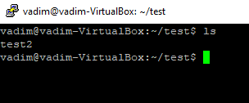cp test2.txt .. -- do not execute copy file to parent directory because we don`t have file test.txt in current directory.

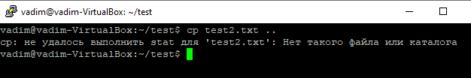  
cd .. – change to parent directory   
ls -- listing the contents of the current directory

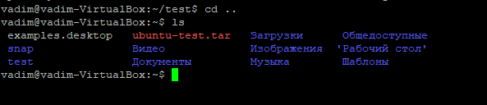

rm test2.txt -- do not execute remove file test.txt because we don`t have this file in current directory

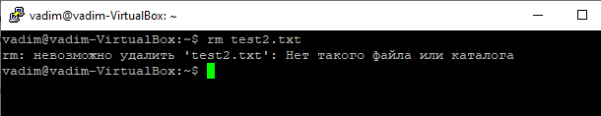  
rmdir test2 -- do not execute command remove directory because we don`t have child directory in current directory.

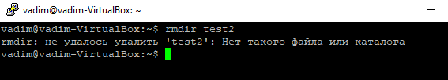  
4. Execute and describe the difference   
cat /etc/fstab – just concatenate files and print on the standard output

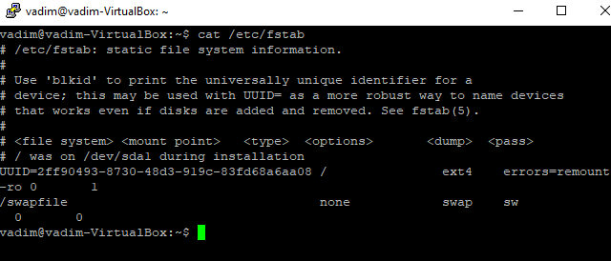

less /etc/fstab – this command is an a pager program in Unix and improved then more command. Support scrolling and searching in output file.

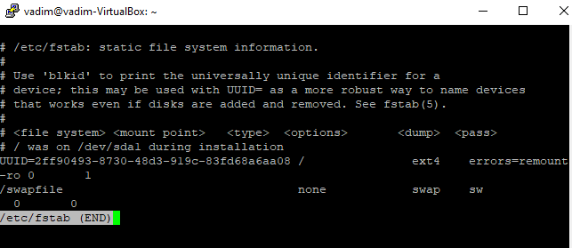

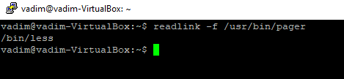  
more /etc/fstab – this command is an file perusal filter for crt viewing pager. Older then less program.

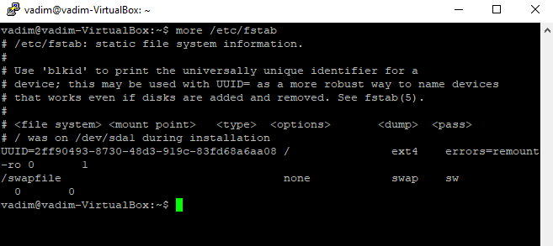

5. Add to archive all ‘test’ directories.

a. to the pure ‘tar’;

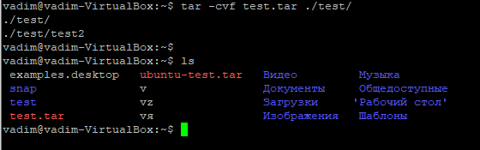

b. to the zipped ‘tar’ with only tar command;

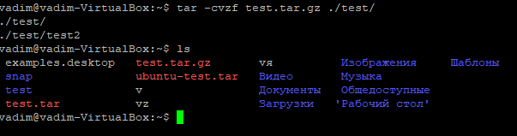

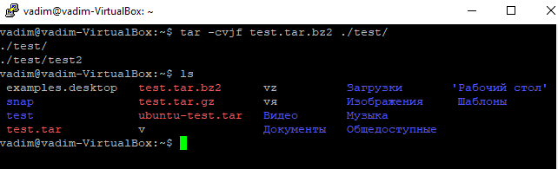

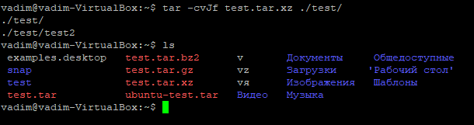

c. to the zipped ‘tar’ with gzip command;

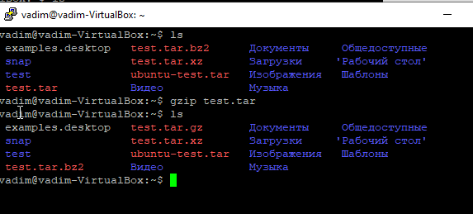

extract from archives all above.

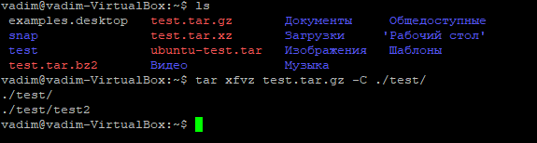

5. Look through man pages of the listed above commands.

