Instruction

**After cloning the repository, you need to do a few things:**

1. In the Package Manager Console execute the command.

Update-Package Microsoft.CodeDom.Providers.DotNetCompilerPlatform –r

1. Add folder App_Data to CommentTask

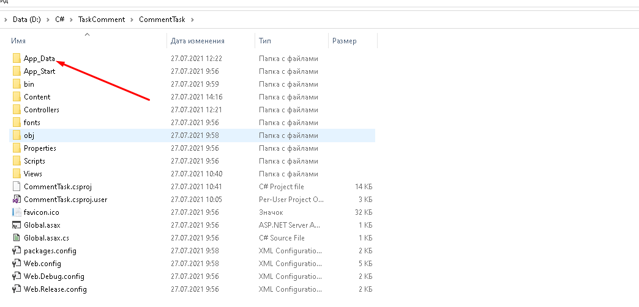

1. Choose to run project CommentTask.

