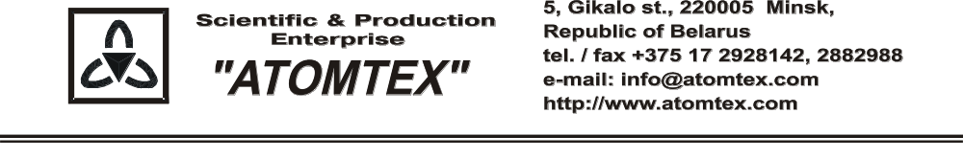
CALIBRATION CERTIFICATE
Date of calibration 21.03.2019

Type BDKN-05 detection unit

S/N 480,005

Measurement limits:
Detection unit BDKN-05: Flux density: n 0.1 – 10⁴ s⁻¹⋅cm⁻²;
Dose rate: n 0.1 μSv/h – 10 mSv/h

Measurement error:
Detection unit BDKN-05: ± 20 %

Operating conditions:

Air temperature +21°C
Atmospheric pressure 101 kPa
Relative humidity 65 %

The detection unit is calibrated with collimated beams of neutrons on the standard facility UPN-AT140 № 001 with the set of Pu - α - Be neutron radiation sources. Certificate of compliance № 210-1508/18 issued by VNIIM, St. Petersburg, Russia (uncertainty ±4 %.

Calibration data

Detection unit BDKN-05 (n)

Intrinsic background level of spectrometer with neutron radiation detection unit
Detection unit type | Intrinsic background level, s⁻¹
BDKN-05 | 0.180

Sensitivity to neutron radiation
Detection unit type | Sensitivity, counts·cm²/neutron  in the direct beam Pu-Be neutron source
BDKN-05 | 8.63

Calibrated by: V. Pisarenko _____________

Technical control: N. Kurbatova _____________

