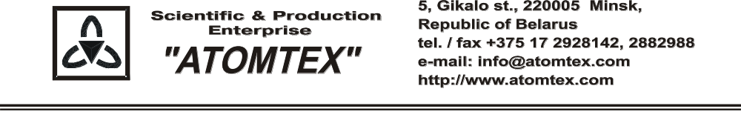
CALIBRATION CERTIFICATE
Date of calibration 21.08.2019

Type BDKN-05 detection unit

S/N 480,004

Sensitivity to Pu-α-Be neutron source radiation: ≥8 impulses·cm2/neutron

Operating conditions:

Air temperature +21°C
Atmospheric pressure 101 kPa
Relative humidity 65 %

The detection unit is calibrated with collimated beams of neutrons on the standard facility UPN-AT140 № 001 with the set of Pu - α - Be neutron radiation sources. Certificate of compliance № 210-1508/18 issued by VNIIM, St. Petersburg, Russia (uncertainty ±4 %).

Calibration data

Detection unit BDKN-05 (n)

Intrinsic background level of spectrometer with neutron radiation detection unit
Detection unit type | Intrinsic background level, s⁻¹ | Maximum background level, s⁻¹
BDKN-05 | 0.160 | 0,23

Sensitivity to neutron radiation
Detection unit type | Sensitivity, counts·cm²/neutron  in the direct beam Pu-Be neutron source, impulses·cm2/neutron | Minimal detectable sensitivity, impulses·cm2/neutron
BDKN-05 | 9,99 | 8,0

Calibrated by: V. Pisarenko _____________

Technical control: N. Kurbatova _____________

