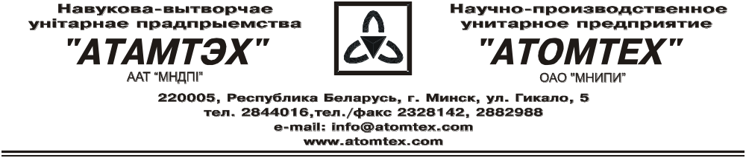

CALIBRATION CERTIFICATE

Date of calibration: 25.01.2018

Type The detection unit BDKG-25:

S/N: №420.001

Measurement limits:
BDKG-25: γ 0,1 μGy/h – 1,0 Gy/h;

Measurement error:
BDKG-25: ± 30 %

Operating conditions:

Air temperature +19°C
Atmospheric pressure 97,8 kPa
Relative humidity 71%

The instrument is calibrated on the standard dosimetry facility AT-130, N 015, error ±4% (the Certificate of Compliance N 210-1099/15 on 23.10.2015. issued by FGUP "D.I.Mendeleyev VNIIM", St. Petersburg, Russia) and the instrument is c alibrated on the standard dosimetry facility AT-110, N 013, error ±5% (the Certificate of Compliance N 210-1098/15 on 23.10.2015. issued by FGUP "D.I.Mendeleyev VNIIM", St. Petersburg, Russia).

BDKG-25(γ)

Conventionally true value (CTV) of kerma rate,  | Calibration data,
70,0 μGy/h | 70,3 μGy/h
700 μGy/h | 701 μGy/h
70,0 mGy/h | 74,7 mGy/h
200 mGy/h | 207 mGy/h
700 mGy/h | 669 mGy/h
1,0 Gy/h | 0,9 Gy/h

Calibrated by: V. Galushko _____________
(signature)

Technical control: N. Kurbatova _____________
(signature)

