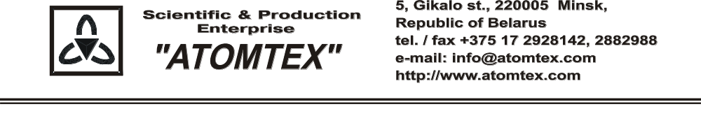
CALIBRATION CERTIFICATE
Date of calibration 19.03.2019

Type BDKN-02 detection unit

S/N 460,003

Measurement limits:
Detection unit BDKN-02: Flux density: n 0.1 – 10⁴ s⁻¹⋅cm⁻²;
Dose rate: n 0.1 μSv/h – 10 mSv/h

Measurement error:
Detection unit BDKN-02: ± 20 %

Operating conditions:

Air temperature +21°C
Atmospheric pressure 101 kPa
Relative humidity 65 %

The detection unit is calibrated with collimated beams of neutrons on the standard facility UPN-AT140
№ 001 with the set of Pu - α - Be neutron radiation sources (certificates of Compliance№ 210-1508/18 issued by VNIIM, St. Petersburg, Russia), error of ± 5 %.

Calibration data

Detection unit BDKN-02 (n)

Flux density
Conventionally true value (CTV) of flux density,  ϕ_{oi}, 1/cm²⋅s | Calibration data,  ϕ_{i}, 1/cm²⋅s
1019 | 1003.9
235 | 220.1
57.0 | 53.6
5.90 | 5.8

Dose rate
Conventionally true value (CTV) of dose rate,  H₀*(10), µSv/h | Calibration data,  H*(10), µSv/h
1434 | 1308.1

Calibrated by: V. Pisarenko _____________

Technical control: N. Kurbatova _____________

