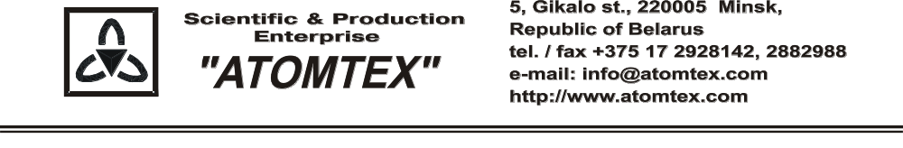
CALIBRATION CERTIFICATE
Date of calibration: 24.07.2017

Type: Detection unit BDKG-01

S/N: 16645

Measurement limits:
BDKG-01: γ 0.1 μSv/h – 10 Sv/h;

Measurement error:
BDKG-01: ± 20 %

Operating conditions:

Air temperature +20°C
Atmospheric pressure 99,1 kPa
Relative humidity 78 %

The instrument is calibrated on the standard dosimetry facility AT-130, N 015, error ±4% (the Certificate of Compliance N 210-1427/18 on 23.10.2018 issued by FGUP "D.I.Mendeleyev VNIIM", St. Petersburg, Russia); AT-110, N 013, error ±5% (the Certificate of Compliance N 210-1426/18 on 22.10.2018 issued by FGUP "D.I.Mendeleyev VNIIM", St. Petersburg, Russia).

Calibration data

BDKG-01 (γ)
Conventionally true value (CTV) of dose rate, 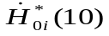 | Calibration data,  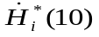
0.70 µSv/h | 0.71 µSv/h
7.0 µSv/h | 7.1 µSv/h
70.0 μSv/h | 73.0 μSv/h
0.70 mSv/h | 0.69 mSv/h
7.0 mSv/h | 6.9 mSv/h
70.0 mSv/h | 69.0 mSv/h
0.7 Sv/h | 0.70 Sv/h
7.0 Sv/h | 6.9 Sv/h

Calibrated by: V. Pisarenko _____________
(signature)

Technical control: N. Kurbatova _____________
(signature)

