**What is Lambda in AWS ?**

* In AWS (Amazon Web Services), Lambda is a serverless computing service that lets you run code without provisioning or managing servers. You simply upload your code, and AWS Lambda handles everything required to run and scale it with high availability.3

Lab Steps

1. **Task 1: Sign in to AWS Management Console**

1.Click on the Open Console button, and you will get redirected to AWS Console in a new browser tab.

On the AWS sign-in page,

Leave the Account ID as default. Never edit/remove the 12-digit Account ID present in the AWS Console. Otherwise, you cannot proceed with the lab.

Now copy your Username and Password in the Lab Console to the IAM Username and Password in AWS Console and click on the Sign-in button.

Once Signed In to the AWS Management Console, make the default AWS Region as US East (N. Virginia) us-east-

**Task 2: Creating a lambda function**

1. Go to AWS management console and search for “lambda” in the search bar
2. Click on create function

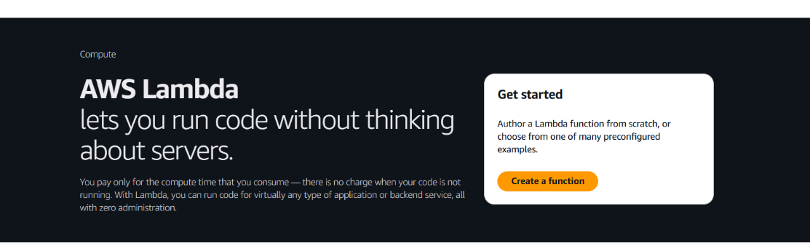

1. Select “author for scratch” as the function creation method.
2. Enter a name for your function.
3. In the Runtime section, choose the programming language – select pythab3.13

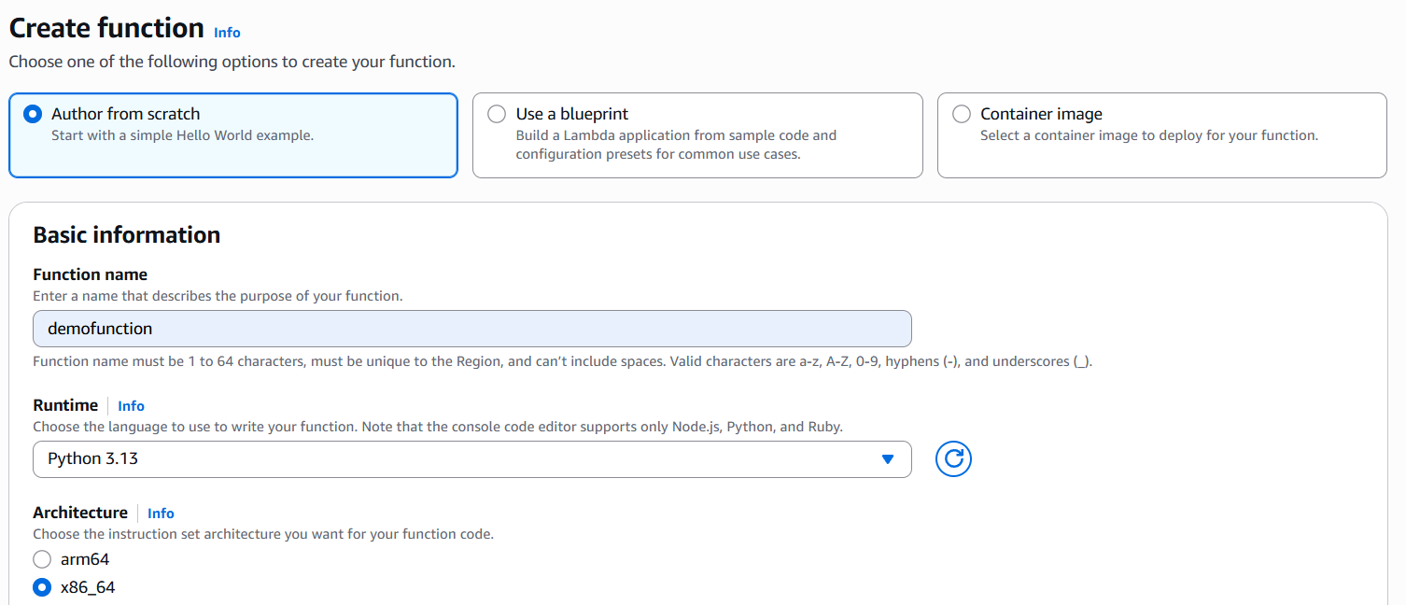

6.Click on create function

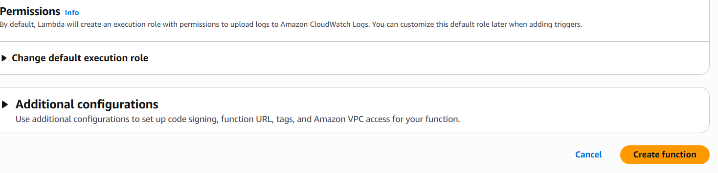

Function is created

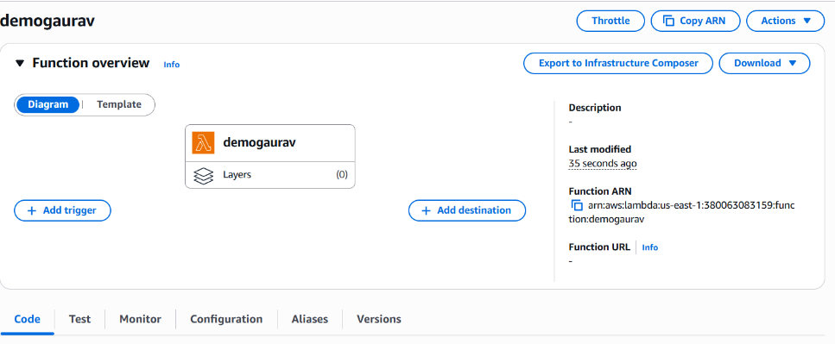

**Task 2: Testing the lambda function**

Step1. After creating the lambda function, scroll down the screen will display a default sample code .

Step 2. Click on the “test” button .

Step 3.In the event configuration window(Event JSON), remove all pre-written code expect curly braces { } .

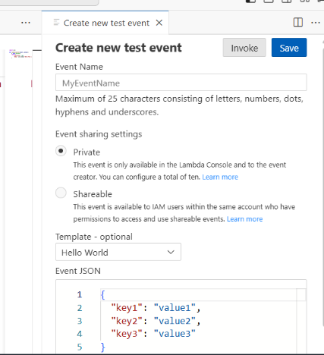

Step 4.click on test button . This execute a lambda function

Step 5.after execution click on details , The result of execution will be display

To Modify Lambda function

Step6. Go to code tab

Step7. Make the desired change to the code

Step8. Click on deploy button to apply the update changes

Step9. Go to test tab

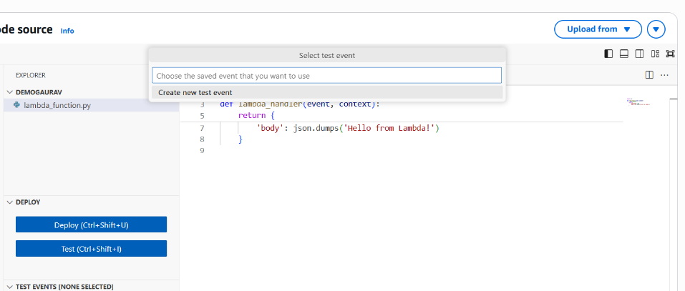

Step10. click on test button . This execute a lambda function

Step11. After the code executes, click on the Details section to view the result.

Step12. You will see the new output of your updated code

**Adding trigger S3 function**

Step1: create a lambda function

Step2: Create a new S3 bucket

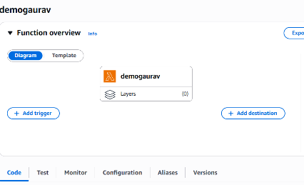

* After modification in code click on Deploy

Step3: In Lambda console, Click on “Add trigger”.

Step4: From the list available trigger, select “S3”.

Step5: Enter the name of the S3 bucket you created.

Step6: In the “Event type” select “All object create event”.

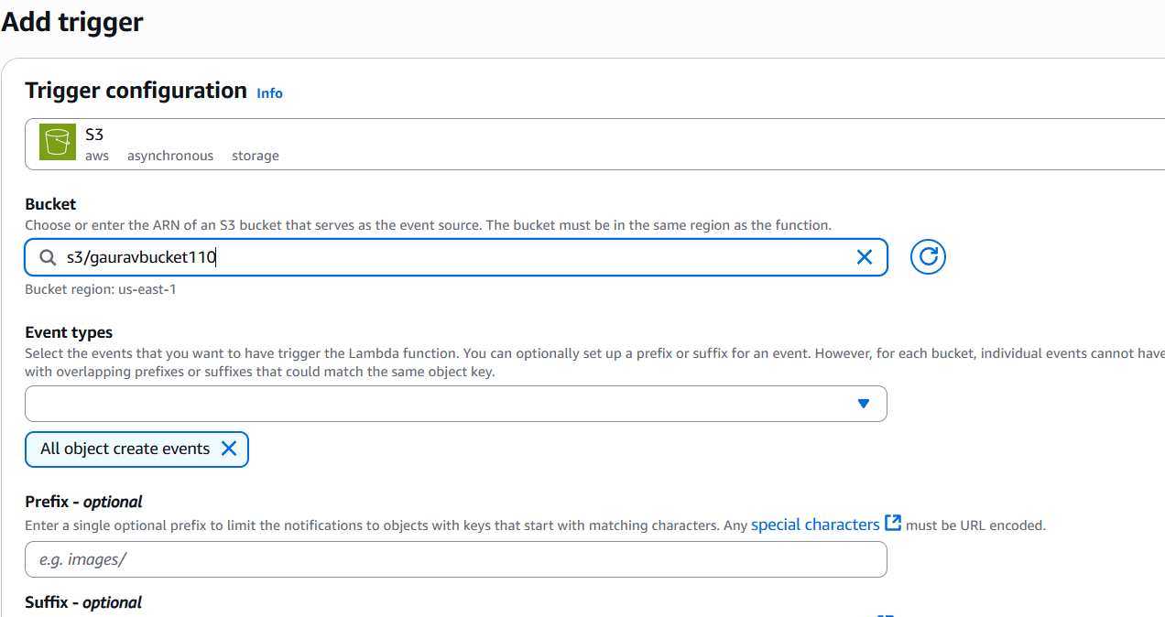

Step7: Tick the checkbox to acknowledge the permissions settings .

Step8: click on “Add” the S3 bucket added to your lambda function.

Step9: Go to the S3 bucket and upload a file

step10: Open the lambda console and go to the “Monitor” tab.

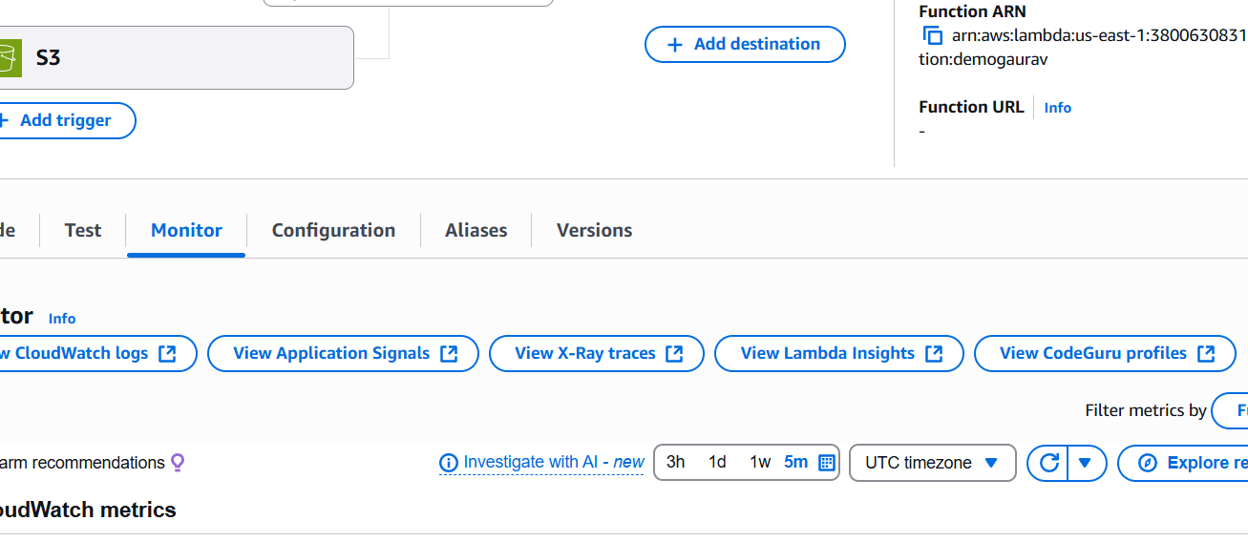

Step11: Click on “View cloudWatch logs”.

Step12: In the log streams sections, click on the latest log entry or first one.

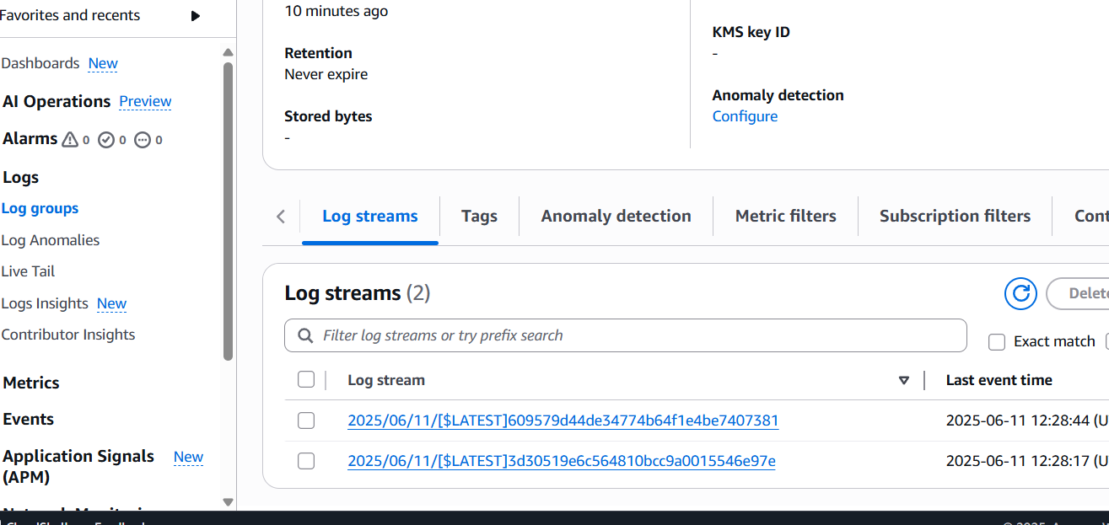

Step13: You will be able to see the Lambda functions execution details and confirm the trigger work successfully.

