Data Extraction

Research: Regarding Australia Bushfire, several open source websites are looked to find out the data, in order to corelate with our requirement.

Links :

<https://data.sa.gov.au/data/dataset?tags=bushfire>

<https://earthdata.nasa.gov/>

<https://data.nsw.gov.au/bushfire-data-quick-links>

After studying, through NASA an open source data was extracted. The data obtained from satellite is called as Visible Infrared Imaging Radiometer Suite (VIIRS) which provides a higher resolution images of the Earth surface. The VIIRS satellite is globally used to fetch all the fire locations in near-real time (NRT). The fire prone activity is estimated based on a variable called Fire Radioactive Power (FRP). All the details collected of the fire prone areas is based on longitude and latitude.

Below is the reference for all the attributes for the data set:

Links: <https://earthdata.nasa.gov/earth-observation-data/near-real-time/firms/v1-vnp14imgt#ed-viirs-375m-attributes>

Below link is the reference for the data available for all countries using VIIRS:

Link: <https://nrt4.modaps.eosdis.nasa.gov/archive/FIRMS/viirs/>

Data Sourcing:

Data extraction was done Australia and New Zealand from 04-Dec-2019 to 20-April-2020.

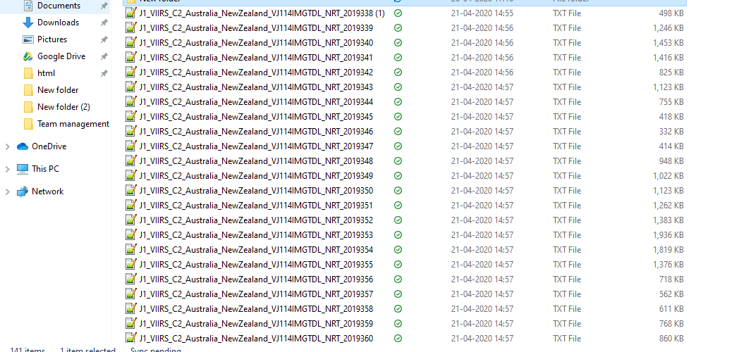

Naming convention of all the data sets:

**J1_VIIRS_C2_Australia_NewZealand_VJ114IMGTDL_NRT_YYYYDDD**

After extracting data on day to day for all the months. All the data were merged using python and final output was prepared.

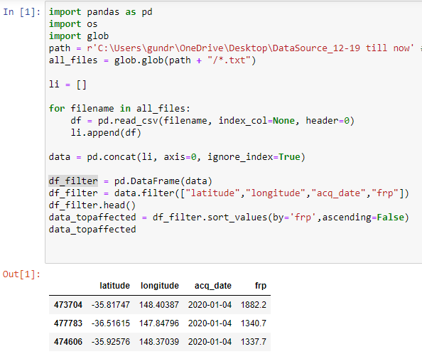

All the data were extracted. Using longitude and latitude, trying to reverse geo all the location for all the records.

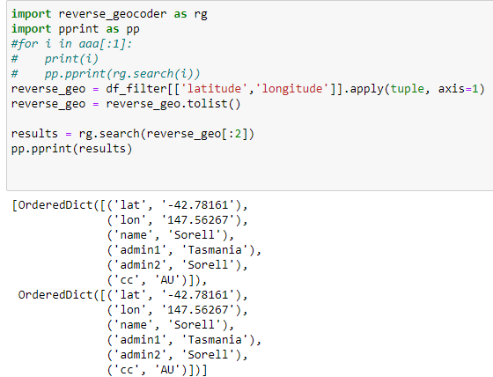

Note: Above output just shows 2 output.

After completing reverse geo location for all the data. It is written into a csv formatted file.

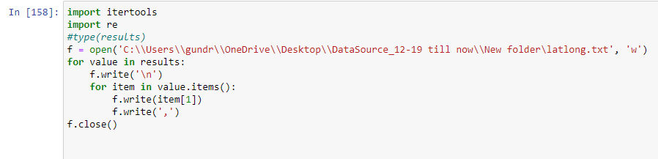

Finally, VIIRS data and reverse geo files are merged.

**Data Cleaning;**

As most of the data was already cleaned and it did not have NULL values.

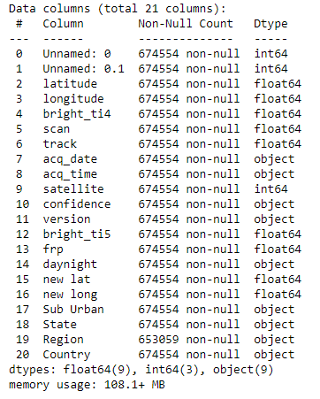

But the data extracted have other country records, so only Australia records were extracted.

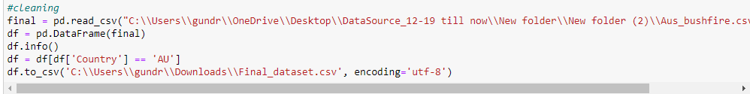

**Weather Data**

Research: After looking into various open source for weather data, access of data extraction is limited per API.

Collecting weather Data Collection is in still going on.

Links of the weather data which were referred:

<https://www.worldweatheronline.com>

<http://api.openweathermap.org>

<https://www.weatherbit.io/api>

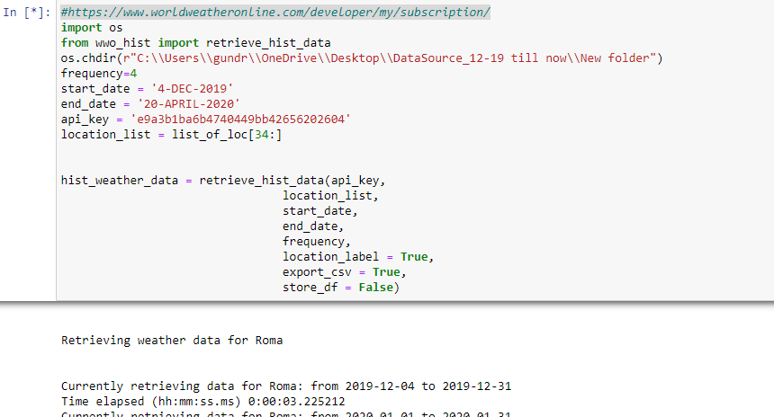

Visualisation:

Research: Various websites were referred to understand visualisation using matplotlib, seaborn, folium.

Work:

1.)

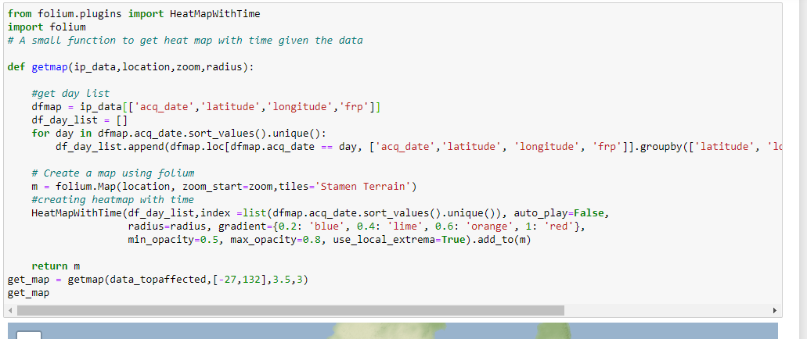

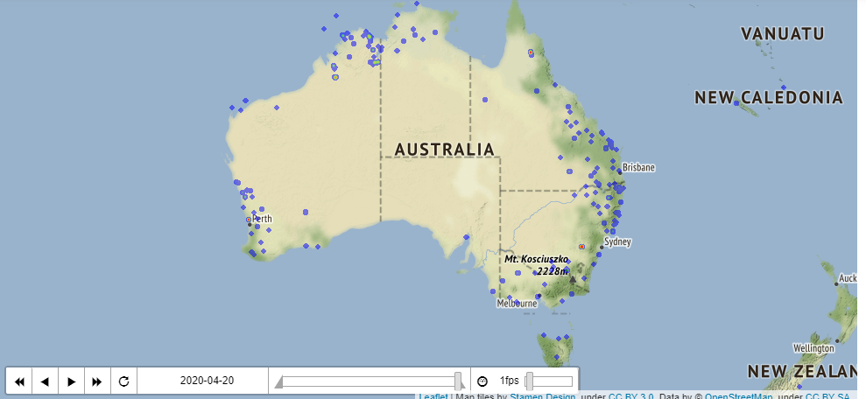

2.) 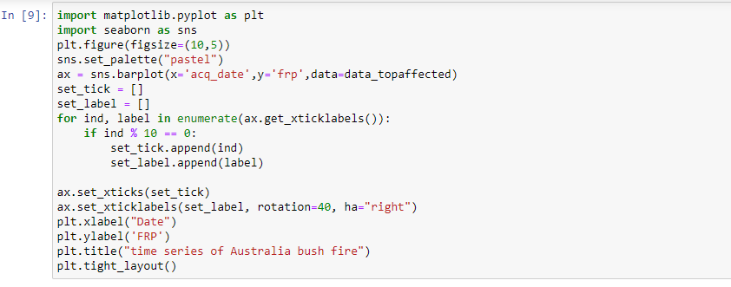

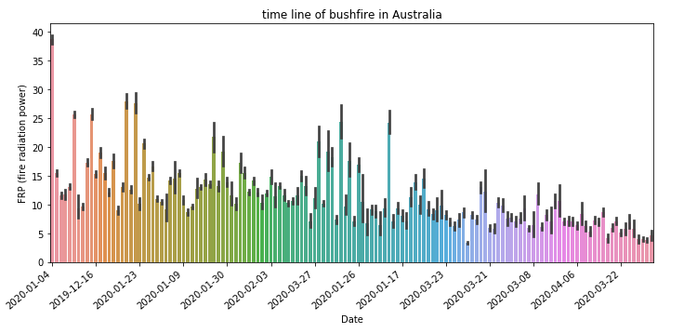

Extra Efforts:

Trying to understand for front end application.

Did a document on web application prototype.

Link:

https://teams.microsoft.com/l/file/F918F4DC-156A-412A-B11F-81EDAE976420?tenantId=d02378ec-1688-46d5-8540-1c28b5f470f6&fileType=docx&objectUrl=https%3A%2F%2Fdeakin365.sharepoint.com%2Fsites%2FData2IntelligenceConsulting%2FShared%20Documents%2FD2I%20(Emergency%20Management)%2FWireFrame.docx&baseUrl=https%3A%2F%2Fdeakin365.sharepoint.com%2Fsites%2FData2IntelligenceConsulting&serviceName=teams&threadId=19:5e24cce19aaa43a4b4f31094a2cc040d@thread.tacv2&groupId=10567a03-e6be-45e6-b917-f7b8920e9c9b