**WIREFRAMES**

|  |  |  |
| --- | --- | --- |
| Fire Incidents & Warnings | Plan &Preparation | About Us |



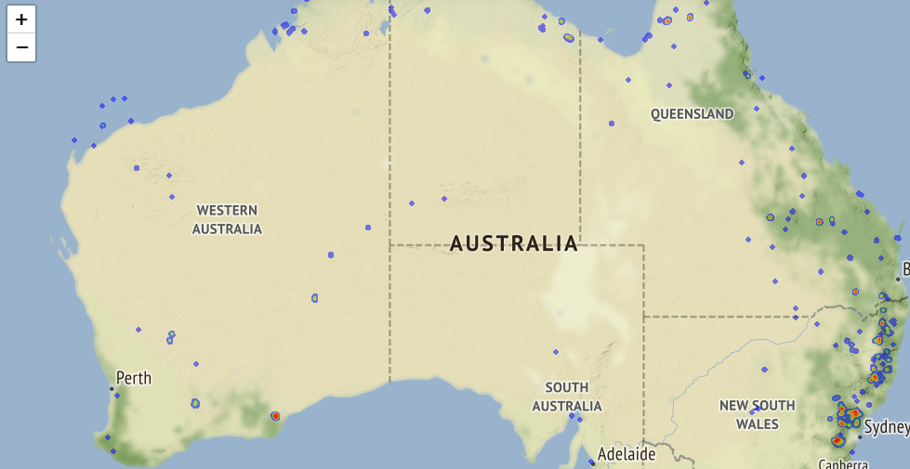

*Fire Incidents & *Plan & Prepare *About Us  
 Warnings   
->Fire near me ->Fire Safety Measure ->Contact Us   
->Fire Updates ->Survival Plan ->Fire Control Central  
->Report a Fire

*Alert Level *Icon Explained  
->Under Control ->Warning  
->Out of Control ->Advice  
 ->Emergency