`Минобрнауки России
Юго-Западный государственный университет

Кафедра программной инженерии

ЛАБОРАТОРНАЯ РАБОТА
по дисциплине «Компьютерная графика»
по теме:
«Программа для формирования изображений»

Выполнили: студенты группы ПО-31б
Василевский В.Я.
Пирогов Д.Ю.

Проверил: старший преподаватель
Ефремов В.В.

Курск 2025 г.
Вариант – 4

Цель работы– Изучить математические методы и выполнить программную реализацию построения кривых и поверхностей.
Задание:
Создать приложение, дающее возможность:
1) реализовывать построение квадратичной кривой Безье;
а) возможность задания произвольного количества вершин;
б) поэтапное выполнение с расчетом промежуточных вершин;
в) выбор параметра разбиения
3) реализовывать построение кривой Чайкина;
5) реализовывать построение поверхности Ду-Сабина:
а) возможность задания произвольного количества вершин;
б) поэтапное выполнение с расчетом точек грани;
6) реализовать возможность отображения:
а) точек исходного контрольного полигона;
б) вершин уточненного контрольного полигона;
в) выбора количества разбиений.
Ссылка на репозиторий:
https://github.com/Vados-rb26/CompGraphLabs

Программа на python:
import tkinter as tk
from tkinter import ttk, messagebox
import math

class Point:
def __init__(self, x, y):
self.x = x
self.y = y

def __add__(self, other):
return Point(self.x + other.x, self.y + other.y)

def __mul__(self, scalar):
return Point(self.x * scalar, self.y * scalar)

def __rmul__(self, scalar):
return self.__mul__(scalar)

def __truediv__(self, scalar):
return Point(self.x / scalar, self.y / scalar)

def to_tuple(self):
return (self.x, self.y)

class BezierQuadraticTab:
def __init__(self, notebook):
self.frame = ttk.Frame(notebook)
notebook.add(self.frame, text="Квадратичная кривая Безье")

self.canvas = tk.Canvas(self.frame, width=600, height=500, bg="white")
self.canvas.grid(row=0, column=0, columnspan=5, padx=5, pady=5)

ttk.Label(self.frame, text="Параметр t (0-1):").grid(row=1, column=0, padx=5, pady=5)
self.t_var = tk.DoubleVar(value=0.5)
self.t_slider = tk.Scale(self.frame, from_=0, to=1, resolution=0.01,
orient=tk.HORIZONTAL, variable=self.t_var,
command=self.update_curve)
self.t_slider.grid(row=1, column=1, padx=5, pady=5)

ttk.Label(self.frame, text="Количество разбиений:").grid(row=2, column=0, padx=5, pady=5)
self.subdivisions_var = tk.IntVar(value=3)
self.subdivisions_slider = tk.Scale(self.frame, from_=1, to=10,
orient=tk.HORIZONTAL, variable=self.subdivisions_var,
command=self.update_curve)
self.subdivisions_slider.grid(row=2, column=1, padx=5, pady=5)

ttk.Label(self.frame, text="Количество сегментов:").grid(row=3, column=0, padx=5, pady=5)
self.segments_var = tk.IntVar(value=1)
self.segments_combo = ttk.Combobox(self.frame, textvariable=self.segments_var,
values=[1, 2, 3, 4, 5], state="readonly")
self.segments_combo.grid(row=3, column=1, padx=5, pady=5)
self.segments_combo.bind("<<ComboboxSelected>>", self.update_segments)

ttk.Button(self.frame, text="Добавить точку", command=self.add_point_mode).grid(row=1, column=2, padx=5, pady=5)
ttk.Button(self.frame, text="Очистить", command=self.clear).grid(row=1, column=3, padx=5, pady=5)
ttk.Button(self.frame, text="Пример", command=self.load_example).grid(row=1, column=4, padx=5, pady=5)
ttk.Button(self.frame, text="Построить кривую", command=self.draw_curve).grid(row=2, column=2, padx=5, pady=5)
ttk.Button(self.frame, text="Пошагово", command=self.step_by_step).grid(row=2, column=3, padx=5, pady=5)
ttk.Button(self.frame, text="Следующий шаг", command=self.next_step).grid(row=2, column=4, padx=5, pady=5)

self.control_points = []
self.curve_points = []
self.intermediate_points = []
self.segments = []
self.adding_points = False
self.show_intermediate = tk.BooleanVar(value=True)
self.current_step = 0
self.max_steps = 0

ttk.Checkbutton(self.frame, text="Показывать промежуточные точки",
variable=self.show_intermediate, command=self.update_curve).grid(row=3, column=2, columnspan=3)

self.canvas.bind("<Button-1>", self.canvas_click)

def add_point_mode(self):
self.adding_points = True

def canvas_click(self, event):
if not self.adding_points:
return

point = Point(event.x, event.y)
self.control_points.append(point)

self.canvas.create_oval(event.x-3, event.y-3, event.x+3, event.y+3,
fill="red", outline="red", tags="control_point")
self.canvas.create_text(event.x, event.y-10, text=str(len(self.control_points)-1),
fill="black", tags="control_label")

self.update_segments()

def update_segments(self, event=None):
if len(self.control_points) >= 3:
num_segments = max(1, len(self.control_points) - 2)
self.segments_var.set(num_segments)
self.segments_combo['values'] = list(range(1, num_segments + 1))

def clear(self):
self.canvas.delete("all")
self.control_points = []
self.curve_points = []
self.intermediate_points = []
self.segments = []
self.current_step = 0
self.max_steps = 0

def load_example(self):
self.clear()
self.control_points = [
Point(100, 400),
Point(200, 100),
Point(300, 400),
Point(400, 100),
Point(500, 400)
]

for i, p in enumerate(self.control_points):
self.canvas.create_oval(p.x-3, p.y-3, p.x+3, p.y+3,
fill="red", outline="red", tags="control_point")
self.canvas.create_text(p.x, p.y-10, text=str(i),
fill="black", tags="control_label")

self.update_segments()
self.draw_curve()

def bezier_quadratic(self, p0, p1, p2, t):
return (1-t)**2 * p0 + 2*(1-t)*t * p1 + t**2 * p2

def recursive_subdivide(self, p0, p1, p2, t, depth, max_depth):
if depth >= max_depth:
return []

p01 = (1-t) * p0 + t * p1
p12 = (1-t) * p1 + t * p2
p012 = (1-t) * p01 + t * p12

if depth == self.current_step:
self.intermediate_points.append((p0, p1, p2, p01, p12, p012))

left = self.recursive_subdivide(p0, p01, p012, t, depth+1, max_depth)
right = self.recursive_subdivide(p012, p12, p2, t, depth+1, max_depth)

return left + [p012] + right

def split_into_segments(self):
self.segments = []
num_segments = self.segments_var.get()

if len(self.control_points) < 3:
return []

for i in range(num_segments):
start_idx = i * (len(self.control_points) - 1) // num_segments
if i == num_segments - 1:
segment_points = self.control_points[-3:]
else:
segment_points = self.control_points[start_idx:start_idx+3]

if len(segment_points) == 3:
self.segments.append(segment_points)

def draw_curve(self):
if len(self.control_points) < 3:
return

self.canvas.delete("curve")
self.canvas.delete("intermediate")
self.curve_points = []
self.intermediate_points = []

t = self.t_var.get()
subdivisions = self.subdivisions_var.get()

self.split_into_segments()

if not self.segments:
return

for i in range(len(self.control_points)-1):
p1 = self.control_points[i]
p2 = self.control_points[i+1]
self.canvas.create_line(p1.x, p1.y, p2.x, p2.y,
fill="gray", dash=(4,2), tags="curve")

all_curve_points = []
for segment_idx, segment in enumerate(self.segments):
if len(segment) != 3:
continue

p0, p1, p2 = segment

segment_curve_pts = []
steps = 20
for i in range(steps + 1):
u = i / steps
pt = self.bezier_quadratic(p0, p1, p2, u)
segment_curve_pts.append(pt)

all_curve_points.extend(segment_curve_pts)

self.recursive_subdivide(p0, p1, p2, t, 0, subdivisions)

mid_point = self.bezier_quadratic(p0, p1, p2, 0.5)
self.canvas.create_text(mid_point.x, mid_point.y-15,
text=f"Сегмент {segment_idx+1}",
fill="blue", tags="curve")

if self.show_intermediate.get():
for points_tuple in self.intermediate_points:
p0, p1, p2, p01, p12, p012 = points_tuple

self.canvas.create_line(p01.x, p01.y, p12.x, p12.y,
fill="blue", width=1, tags="intermediate")
self.canvas.create_line(p0.x, p0.y, p01.x, p01.y,
fill="lightblue", width=1, dash=(2,2), tags="intermediate")
self.canvas.create_line(p1.x, p1.y, p12.x, p12.y,
fill="lightblue", width=1, dash=(2,2), tags="intermediate")

self.canvas.create_oval(p01.x-2, p01.y-2, p01.x+2, p01.y+2,
fill="blue", outline="blue", tags="intermediate")
self.canvas.create_oval(p12.x-2, p12.y-2, p12.x+2, p12.y+2,
fill="blue", outline="blue", tags="intermediate")
self.canvas.create_oval(p012.x-2, p012.y-2, p012.x+2, p012.y+2,
fill="green", outline="green", tags="intermediate")

for i in range(len(all_curve_points)-1):
p1 = all_curve_points[i]
p2 = all_curve_points[i+1]
self.canvas.create_line(p1.x, p1.y, p2.x, p2.y,
fill="red", width=2, tags="curve")

info_text = f"Контрольных точек: {len(self.control_points)}, Сегментов: {len(self.segments)}"
self.canvas.create_text(100, 20, text=info_text,
fill="black", font=("Arial", 10), tags="curve")

def step_by_step(self):
if len(self.control_points) < 3:
return

self.current_step = 0
self.max_steps = self.subdivisions_var.get()
self.update_step_display()

def next_step(self):
if self.max_steps == 0:
self.step_by_step()
return

if self.current_step < self.max_steps:
self.current_step += 1
self.update_step_display()

def update_step_display(self):
if len(self.control_points) < 3 or not self.segments:
return

self.canvas.delete("curve")
self.canvas.delete("intermediate")
self.intermediate_points = []

t = self.t_var.get()

for i in range(len(self.control_points)-1):
p1 = self.control_points[i]
p2 = self.control_points[i+1]
self.canvas.create_line(p1.x, p1.y, p2.x, p2.y,
fill="gray", dash=(4,2), tags="curve")

for segment in self.segments:
if len(segment) != 3:
continue

p0, p1, p2 = segment

self.recursive_subdivide(p0, p1, p2, t, 0, self.current_step)

if self.current_step == self.max_steps:
curve_pts = []
for i in range(21):
u = i / 20.0
pt = self.bezier_quadratic(p0, p1, p2, u)
curve_pts.append(pt)

for i in range(len(curve_pts)-1):
p1_pt = curve_pts[i]
p2_pt = curve_pts[i+1]
self.canvas.create_line(p1_pt.x, p1_pt.y, p2_pt.x, p2_pt.y,
fill="red", width=2, tags="curve")

for points_tuple in self.intermediate_points:
p0, p1, p2, p01, p12, p012 = points_tuple

self.canvas.create_line(p01.x, p01.y, p12.x, p12.y,
fill="blue", width=1, tags="intermediate")
self.canvas.create_line(p0.x, p0.y, p01.x, p01.y,
fill="lightblue", width=1, dash=(2,2), tags="intermediate")
self.canvas.create_line(p1.x, p1.y, p12.x, p12.y,
fill="lightblue", width=1, dash=(2,2), tags="intermediate")

self.canvas.create_oval(p01.x-2, p01.y-2, p01.x+2, p01.y+2,
fill="blue", outline="blue", tags="intermediate")
self.canvas.create_oval(p12.x-2, p12.y-2, p12.x+2, p12.y+2,
fill="blue", outline="blue", tags="intermediate")
self.canvas.create_oval(p012.x-2, p012.y-2, p012.x+2, p012.y+2,
fill="green", outline="green", tags="intermediate")

step_text = f"Шаг: {self.current_step}/{self.max_steps}"
self.canvas.create_text(500, 20, text=step_text,
fill="blue", font=("Arial", 10, "bold"), tags="curve")

def update_curve(self, *args):
if len(self.control_points) >= 3:
self.draw_curve()

class ChaikinCurveTab:
def __init__(self, notebook):
self.frame = ttk.Frame(notebook)
notebook.add(self.frame, text="Кривая Чайкина")

self.canvas = tk.Canvas(self.frame, width=600, height=500, bg="white")
self.canvas.grid(row=0, column=0, columnspan=4, padx=5, pady=5)

ttk.Label(self.frame, text="Количество итераций:").grid(row=1, column=0, padx=5, pady=5)
self.iterations_var = tk.IntVar(value=3)
self.iterations_slider = tk.Scale(self.frame, from_=0, to=7,
orient=tk.HORIZONTAL, variable=self.iterations_var,
command=self.update_curve)
self.iterations_slider.grid(row=1, column=1, padx=5, pady=5)

ttk.Button(self.frame, text="Добавить точку", command=self.add_point_mode).grid(row=2, column=0, padx=5, pady=5)
ttk.Button(self.frame, text="Очистить", command=self.clear).grid(row=2, column=1, padx=5, pady=5)
ttk.Button(self.frame, text="Пример", command=self.load_example).grid(row=2, column=2, padx=5, pady=5)
ttk.Button(self.frame, text="Построить кривую", command=self.draw_curve).grid(row=2, column=3, padx=5, pady=5)

self.control_points = []
self.chaikin_points = []
self.adding_points = False

self.canvas.bind("<Button-1>", self.canvas_click)

def add_point_mode(self):
self.adding_points = True

def canvas_click(self, event):
if not self.adding_points:
return

point = Point(event.x, event.y)
self.control_points.append(point)

self.canvas.create_oval(event.x-3, event.y-3, event.x+3, event.y+3,
fill="red", outline="red", tags="control_point")

if len(self.control_points) > 1:
last_point = self.control_points[-2]
self.canvas.create_line(last_point.x, last_point.y, event.x, event.y,
fill="gray", dash=(4,2), tags="control_polygon")

self.draw_curve()

def clear(self):
self.canvas.delete("all")
self.control_points = []
self.chaikin_points = []

def load_example(self):
self.clear()
self.control_points = [
Point(100, 300),
Point(200, 100),
Point(300, 400),
Point(400, 200),
Point(500, 300)
]

for p in self.control_points:
self.canvas.create_oval(p.x-3, p.y-3, p.x+3, p.y+3,
fill="red", outline="red", tags="control_point")

for i in range(len(self.control_points)-1):
p1 = self.control_points[i]
p2 = self.control_points[i+1]
self.canvas.create_line(p1.x, p1.y, p2.x, p2.y,
fill="gray", dash=(4,2), tags="control_polygon")

self.draw_curve()

def chaikin_subdivision(self, points, iterations):
if iterations == 0:
return points

new_points = []

for i in range(len(points) - 1):
p0 = points[i]
p1 = points[i+1]

q = 0.75 * p0 + 0.25 * p1
r = 0.25 * p0 + 0.75 * p1

new_points.append(q)
new_points.append(r)

return self.chaikin_subdivision(new_points, iterations-1)

def draw_curve(self):
if len(self.control_points) < 2:
return

self.canvas.delete("chaikin")
self.chaikin_points = []

iterations = self.iterations_var.get()

chaikin_pts = self.chaikin_subdivision(self.control_points, iterations)

if len(chaikin_pts) > 1:
for i in range(len(chaikin_pts)-1):
p1 = chaikin_pts[i]
p2 = chaikin_pts[i+1]
self.canvas.create_line(p1.x, p1.y, p2.x, p2.y,
fill="blue", width=2, tags="chaikin")

for pt in chaikin_pts:
self.canvas.create_oval(pt.x-2, pt.y-2, pt.x+2, pt.y+2,
fill="blue", outline="blue", tags="chaikin")

self.canvas.create_text(50, 20, text=f"Итерация: {iterations}",
fill="black", tags="chaikin")

def update_curve(self, *args):
if len(self.control_points) >= 2:
self.draw_curve()

class DooSabinSurfaceTab:
def __init__(self, notebook):
self.frame = ttk.Frame(notebook)
notebook.add(self.frame, text="Поверхность Ду-Сабина")

self.canvas = tk.Canvas(self.frame, width=600, height=500, bg="white")
self.canvas.grid(row=0, column=0, columnspan=4, padx=5, pady=5)

ttk.Label(self.frame, text="Количество итераций:").grid(row=1, column=0, padx=5, pady=5)
self.iterations_var = tk.IntVar(value=2)
self.iterations_slider = tk.Scale(self.frame, from_=0, to=5,
orient=tk.HORIZONTAL, variable=self.iterations_var,
command=self.update_surface)
self.iterations_slider.grid(row=1, column=1, padx=5, pady=5)

ttk.Label(self.frame, text="Тип поверхности:").grid(row=2, column=0, padx=5, pady=5)
self.surface_type = tk.StringVar(value="quad")

ttk.Radiobutton(self.frame, text="Четырехугольник", variable=self.surface_type,
value="quad", command=self.load_example).grid(row=2, column=1, padx=5, pady=5)
ttk.Radiobutton(self.frame, text="Треугольник", variable=self.surface_type,
value="triangle", command=self.load_example).grid(row=2, column=2, padx=5, pady=5)
ttk.Radiobutton(self.frame, text="Пятиугольник", variable=self.surface_type,
value="pentagon", command=self.load_example).grid(row=2, column=3, padx=5, pady=5)

ttk.Button(self.frame, text="Очистить", command=self.clear).grid(row=3, column=0, padx=5, pady=5)
ttk.Button(self.frame, text="Пример", command=self.load_example).grid(row=3, column=1, padx=5, pady=5)

self.vertices = []
self.faces = []
self.edges = []
self.face_points_history = []

def clear(self):
self.canvas.delete("all")
self.vertices = []
self.faces = []
self.edges = []
self.face_points_history = []

def load_example(self):
self.clear()

surface_type = self.surface_type.get()

if surface_type == "quad":
self.vertices = [
Point(200, 200),
Point(400, 200),
Point(400, 400),
Point(200, 400)
]
elif surface_type == "triangle":
self.vertices = [
Point(300, 150),
Point(450, 350),
Point(150, 350)
]
elif surface_type == "pentagon":
center = Point(300, 250)
radius = 150
for i in range(5):
angle = 2 * math.pi * i / 5
x = center.x + radius * math.cos(angle)
y = center.y + radius * math.sin(angle)
self.vertices.append(Point(x, y))

for i, v in enumerate(self.vertices):
self.canvas.create_oval(v.x-4, v.y-4, v.x+4, v.y+4,
fill="red", outline="red", tags="vertex")
self.canvas.create_text(v.x, v.y-10, text=str(i),
fill="black", tags="vertex_label")

self.faces = [list(range(len(self.vertices)))]
self.edges = []
for i in range(len(self.vertices)):
self.edges.append((i, (i+1) % len(self.vertices)))

self.draw_mesh()
self.update_surface()

def draw_mesh(self):
self.canvas.delete("mesh")

for edge in self.edges:
v1 = self.vertices[edge[0]]
v2 = self.vertices[edge[1]]
self.canvas.create_line(v1.x, v1.y, v2.x, v2.y,
fill="black", width=2, tags="mesh")

if self.faces and self.vertices:
for face in self.faces:
points = [self.vertices[i].to_tuple() for i in face]
if len(points) >= 3:
self.canvas.create_polygon(points, fill="lightblue",
outline="black", width=1, tags="mesh")

def doosabin_subdivision(self, vertices, faces, edges):
new_vertices = []
new_faces = []
new_edges = []
face_points = []

for face in faces:
avg = Point(0, 0)
for vertex_idx in face:
avg = avg + vertices[vertex_idx]
avg = avg / len(face)
face_points.append(avg)

edge_points = []
edge_to_faces = {}

for edge_idx, edge in enumerate(edges):
v1_idx, v2_idx = edge
v1 = vertices[v1_idx]
v2 = vertices[v2_idx]

adjacent_faces = []
for face_idx, face in enumerate(faces):
has_v1 = any(v == v1_idx for v in face)
has_v2 = any(v == v2_idx for v in face)

if has_v1 and has_v2:
idx1 = face.index(v1_idx)
idx2 = face.index(v2_idx)

if (abs(idx1 - idx2) == 1 or
(idx1 == 0 and idx2 == len(face)-1) or
(idx2 == 0 and idx1 == len(face)-1)):
adjacent_faces.append(face_idx)

if len(adjacent_faces) == 2:
edge_point = (v1 + v2 + face_points[adjacent_faces[0]] +
face_points[adjacent_faces[1]]) / 4
edge_points.append(edge_point)
edge_to_faces[edge_idx] = adjacent_faces

vertex_points = []
for vertex_idx, vertex in enumerate(vertices):
incident_edges = []
for edge_idx, edge in enumerate(edges):
if vertex_idx in edge:
incident_edges.append(edge_idx)

if incident_edges:
Q = Point(0, 0)
adjacent_faces_set = set()

for edge_idx in incident_edges:
if edge_idx in edge_to_faces:
for face_idx in edge_to_faces[edge_idx]:
adjacent_faces_set.add(face_idx)

for face_idx in adjacent_faces_set:
Q = Q + face_points[face_idx]

if adjacent_faces_set:
Q = Q / len(adjacent_faces_set)

R = Point(0, 0)
for edge_idx in incident_edges:
edge = edges[edge_idx]
v1 = vertices[edge[0]]
v2 = vertices[edge[1]]
mid = (v1 + v2) / 2
R = R + mid

R = R / len(incident_edges)

S = vertex
n = len(incident_edges)
new_vertex = (Q + 2*R + (n-3)*S) / n
vertex_points.append(new_vertex)

new_vertices = face_points + edge_points + vertex_points

for i in range(len(faces)):
new_faces.append([i])

for edge_idx, edge in enumerate(edges):
if edge_idx in edge_to_faces:
new_face = [
edge_idx + len(face_points),
edge_to_faces[edge_idx][0],
edge[0] + len(face_points) + len(edge_points),
edge_to_faces[edge_idx][1]
]
new_faces.append(new_face)

for vertex_idx in range(len(vertices)):
incident_edges_for_vertex = []
adjacent_faces_for_vertex = set()

for edge_idx, edge in enumerate(edges):
if vertex_idx in edge:
incident_edges_for_vertex.append(edge_idx)
if edge_idx in edge_to_faces:
for face_idx in edge_to_faces[edge_idx]:
adjacent_faces_for_vertex.add(face_idx)

new_face = [vertex_idx + len(face_points) + len(edge_points)]

for edge_idx in incident_edges_for_vertex:
new_face.append(edge_idx + len(face_points))

for face_idx in adjacent_faces_for_vertex:
new_face.append(face_idx)

new_faces.append(new_face)

for face in new_faces:
for i in range(len(face)):
v1 = face[i]
v2 = face[(i+1) % len(face)]
edge = (min(v1, v2), max(v1, v2))
if edge not in new_edges:
new_edges.append(edge)

return new_vertices, new_faces, new_edges, face_points

def draw_surface(self, vertices, faces, edges, iteration):
self.canvas.delete(f"surface_{iteration}")

for i, v in enumerate(vertices):
if i >= len(vertices):
continue
color = "green" if iteration > 0 else "red"
size = 3 if iteration > 0 else 4
self.canvas.create_oval(v.x-size, v.y-size, v.x+size, v.y+size,
fill=color, outline=color, tags=f"surface_{iteration}")

for edge in edges:
if edge[0] < len(vertices) and edge[1] < len(vertices):
v1 = vertices[edge[0]]
v2 = vertices[edge[1]]
color = "blue" if iteration > 0 else "black"
width = 1 if iteration > 0 else 2
self.canvas.create_line(v1.x, v1.y, v2.x, v2.y,
fill=color, width=width, tags=f"surface_{iteration}")

for face in faces:
if len(face) >= 3 and all(v < len(vertices) for v in face):
points = [vertices[i].to_tuple() for i in face]
fill_color = "#E0F7FA" if iteration > 0 else "lightblue"
self.canvas.create_polygon(points, fill=fill_color,
outline="blue", width=1, tags=f"surface_{iteration}")

def update_surface(self, *args):
if not self.faces:
return

for i in range(1, 6):
self.canvas.delete(f"surface_{i}")

iterations = self.iterations_var.get()

current_vertices = self.vertices.copy()
current_faces = self.faces.copy()
current_edges = self.edges.copy()
self.face_points_history = []

for i in range(iterations):
current_vertices, current_faces, current_edges, face_points = self.doosabin_subdivision(
current_vertices, current_faces, current_edges
)
self.face_points_history.append(face_points)
self.draw_surface(current_vertices, current_faces, current_edges, i+1)

info_text = f"Итерация: {iterations}, Вершин: {len(current_vertices)}, Граней: {len(current_faces)}"
self.canvas.create_text(300, 20, text=info_text,
fill="black", font=("Arial", 10), tags="info")

class MainApplication:
def __init__(self, root):
self.root = root
self.root.title("Алгоритмы построения кривых и поверхностей")
self.root.geometry("850x750")

self.notebook = ttk.Notebook(root)
self.notebook.pack(fill=tk.BOTH, expand=True, padx=5, pady=5)

self.bezier_tab = BezierQuadraticTab(self.notebook)
self.chaikin_tab = ChaikinCurveTab(self.notebook)
self.doosabin_tab = DooSabinSurfaceTab(self.notebook)

info_frame = ttk.Frame(root)
info_frame.pack(fill=tk.X, padx=5, pady=5)

info_text = """
Вариант 4. Реализованы алгоритмы:
1. Квадратичная кривая Безье (произвольное количество вершин, пошаговое выполнение, выбор параметра разбиения)
3. Кривая Чайкина
5. Поверхность Ду-Сабина
6. Отображение контрольных точек и уточненных полигонов
"""

ttk.Label(info_frame, text=info_text, justify=tk.LEFT).pack()

def main():
root = tk.Tk()
app = MainApplication(root)
root.mainloop()

if __name__ == "__main__":
main()

Порядок работы:
1.Запуск приложения
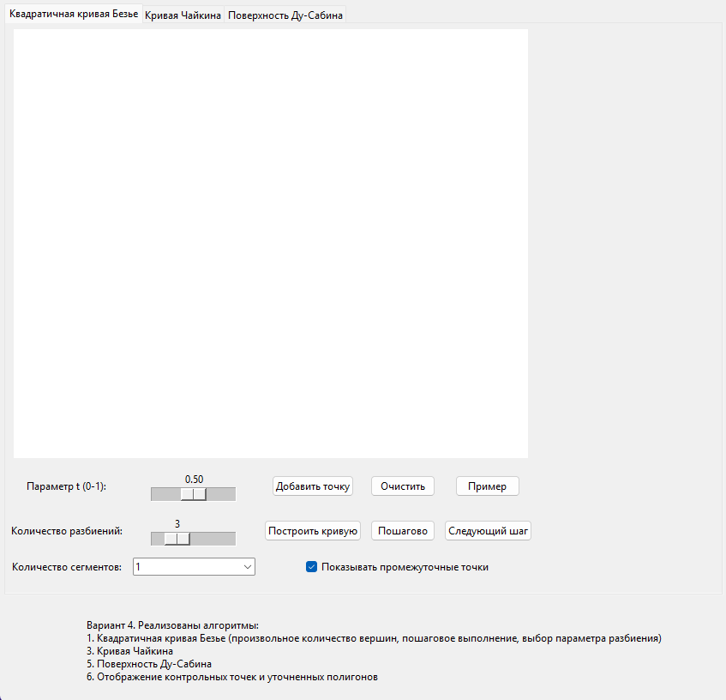
2.Квадратичная кривая Базье
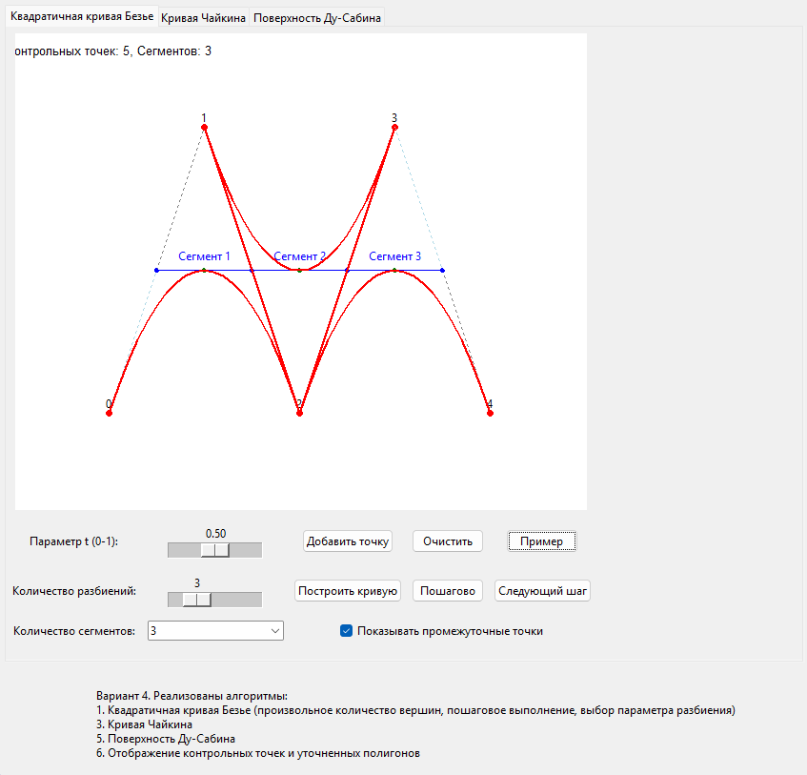
3.Кривая Чайкина
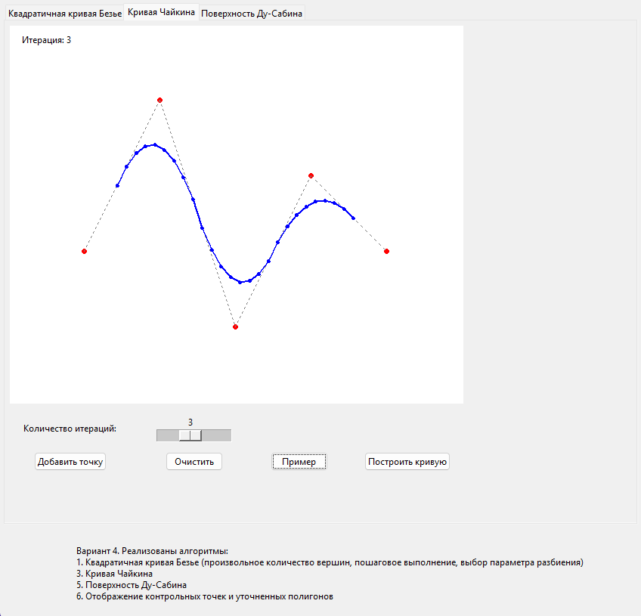
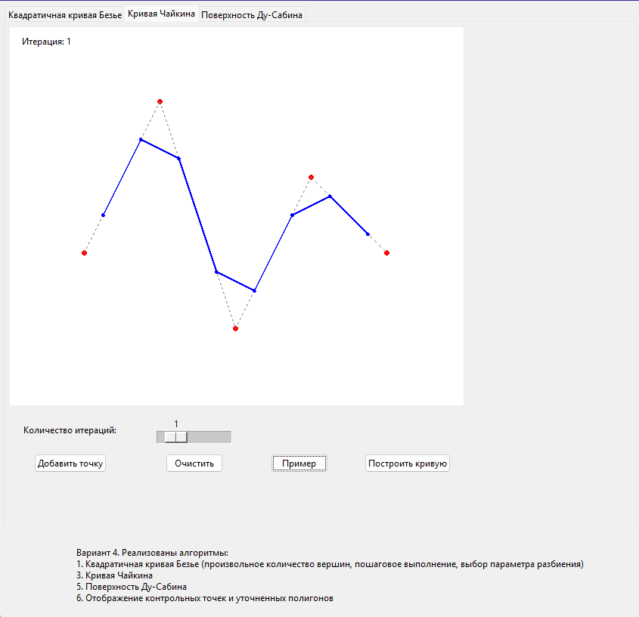
4.Поверхность Ду-Сабинина
