`Минобрнауки России
Юго-Западный государственный университет

Кафедра программной инженерии

ЛАБОРАТОРНАЯ РАБОТА
по дисциплине «Компьютерная графика»
по теме:
«Программа для формирования изображений»

Выполнили: студенты группы ПО-31б
Василевский В.Я.
Пирогов Д.Ю.

Проверил: старший преподаватель
Ефремов В.В.

Курск 2025 г.
Вариант – 4

Цель работы– Изучить математические методы и выполнить программную реализацию построения кривых и поверхностей.
Задание:создать приложение, реализующее построение кривых и поверхностей методами Безье, Чайкина, Ду-Сабина.
Создать приложение, дающее возможность:
1) реализовывать построение квадратичной кривой Безье;
а) возможность задания произвольного количества вершин;
б) поэтапное выполнение с расчетом промежуточных вершин;
в) выбор параметра разбиения.
2) реализовывать построение кубической кривой Безье;
а) возможность задания произвольного количества вершин;
б) поэтапное выполнение с расчетом промежуточных вершин;
в) выбор параметра разбиения;
3) реализовывать построение кривой Чайкина;
4) реализовывать построение поверхности Безье:
а) возможность задания произвольного количества массива исходных вершин;
б) выбор параметра разбиения;
5) реализовывать построение поверхности Ду-Сабина:
а) возможность задания произвольного количества вершин;
б) поэтапное выполнение с расчетом точек грани;
6) реализовать возможность отображения:
а) точек исходного контрольного полигона;
б) вершин уточненного контрольного полигона;
в) выбора количества разбиений.

Ссылка на репозиторий:
https://github.com/Vados-rb26/CompGraphLabs

Программа на python:
import tkinter as tk
from tkinter import ttk
import math

class Point3D:
def __init__(self, x, y, z):
self.x = x
self.y = y
self.z = z

def project(self, canvas_width, canvas_height, scale, offset_x, offset_y):
x_proj = self.x * scale + offset_x
y_proj = -self.y * scale + offset_y
return x_proj, y_proj

class Application:
def __init__(self, root):
self.root = root
self.root.title("Построение кривых и поверхностей")
self.root.geometry("1200x700")

self.canvas_width = 800
self.canvas_height = 600
self.scale = 50
self.offset_x = self.canvas_width // 2
self.offset_y = self.canvas_height // 2

self.current_method = "bezier_quad"
self.control_points = []
self.subdivisions = 3
self.t_parameter = 0.5
self.step_mode = False
self.current_step = 0

self.setup_styles()
self.setup_ui()

def setup_styles(self):
style = ttk.Style()
style.theme_use('clam')
style.configure('Title.TLabel', font=('Arial', 12, 'bold'))
style.configure('Method.TRadiobutton', font=('Arial', 10))
style.configure('Control.TButton', font=('Arial', 10))

def setup_ui(self):
main_frame = ttk.Frame(self.root)
main_frame.pack(fill=tk.BOTH, expand=True, padx=10, pady=10)

left_frame = ttk.LabelFrame(main_frame, text="Управление", padding=10)
left_frame.pack(side=tk.LEFT, fill=tk.Y, padx=(0, 10))

right_frame = ttk.Frame(main_frame)
right_frame.pack(side=tk.RIGHT, fill=tk.BOTH, expand=True)

self.setup_control_panel(left_frame)
self.setup_canvas(right_frame)
self.setup_points_table(left_frame)

def setup_control_panel(self, parent):
ttk.Label(parent, text="Выбор метода:", style='Title.TLabel').pack(anchor=tk.W, pady=(0, 10))

methods = [
("Квадратичная кривая Безье", "bezier_quad"),
("Кубическая кривая Безье", "bezier_cubic"),
("Кривая Чайкина", "chaikin"),
("Поверхность Безье", "bezier_surface"),
("Поверхность Ду-Сабина", "doo_sabin")
]

self.method_var = tk.StringVar(value=self.current_method)
for text, method in methods:
rb = ttk.Radiobutton(parent, text=text, variable=self.method_var,
value=method, command=self.change_method)
rb.pack(anchor=tk.W, pady=2)

ttk.Separator(parent, orient=tk.HORIZONTAL).pack(fill=tk.X, pady=10)

ttk.Label(parent, text="Параметры:", style='Title.TLabel').pack(anchor=tk.W, pady=(0, 10))

ttk.Label(parent, text="Разбиений:").pack(anchor=tk.W)
self.subdiv_slider = tk.Scale(parent, from_=1, to=10, orient=tk.HORIZONTAL,
length=200, command=self.update_subdivisions)
self.subdiv_slider.set(self.subdivisions)
self.subdiv_slider.pack(anchor=tk.W, pady=(0, 10))

ttk.Label(parent, text="Параметр t (0-1):").pack(anchor=tk.W)
self.t_slider = tk.Scale(parent, from_=0, to=100, orient=tk.HORIZONTAL,
length=200, command=self.update_t_parameter)
self.t_slider.set(50)
self.t_slider.pack(anchor=tk.W, pady=(0, 10))

ttk.Separator(parent, orient=tk.HORIZONTAL).pack(fill=tk.X, pady=10)

btn_frame = ttk.Frame(parent)
btn_frame.pack(fill=tk.X, pady=5)

ttk.Button(btn_frame, text="Добавить точку", command=self.add_random_point).pack(side=tk.LEFT, padx=2)
ttk.Button(btn_frame, text="Очистить", command=self.clear).pack(side=tk.LEFT, padx=2)

btn_frame2 = ttk.Frame(parent)
btn_frame2.pack(fill=tk.X, pady=5)

ttk.Button(btn_frame2, text="Построить", command=self.draw).pack(side=tk.LEFT, padx=2)
ttk.Button(btn_frame2, text="Шаг", command=self.step_build).pack(side=tk.LEFT, padx=2)

self.step_var = tk.BooleanVar(value=False)
ttk.Checkbutton(parent, text="Пошаговый режим", variable=self.step_var,
command=self.toggle_step_mode).pack(anchor=tk.W, pady=5)

self.info_label = ttk.Label(parent, text="Точек: 0")
self.info_label.pack(anchor=tk.W, pady=10)

def setup_points_table(self, parent):
frame = ttk.LabelFrame(parent, text="Точки управления", padding=5)
frame.pack(fill=tk.BOTH, expand=True, pady=(10, 0))

canvas = tk.Canvas(frame, height=150)
scrollbar = ttk.Scrollbar(frame, orient=tk.VERTICAL, command=canvas.yview)
scrollable_frame = ttk.Frame(canvas)

scrollable_frame.bind("<Configure>", lambda e: canvas.configure(scrollregion=canvas.bbox("all")))
canvas.create_window((0, 0), window=scrollable_frame, anchor="nw")
canvas.configure(yscrollcommand=scrollbar.set)

self.points_frame = scrollable_frame
canvas.pack(side=tk.LEFT, fill=tk.BOTH, expand=True)
scrollbar.pack(side=tk.RIGHT, fill=tk.Y)

def setup_canvas(self, parent):
canvas_frame = ttk.LabelFrame(parent, text="Визуализация", padding=10)
canvas_frame.pack(fill=tk.BOTH, expand=True)

self.canvas = tk.Canvas(canvas_frame, width=self.canvas_width,
height=self.canvas_height, bg="white", highlightthickness=1)
self.canvas.pack(fill=tk.BOTH, expand=True)
self.canvas.bind("<Button-1>", self.canvas_click)
self.canvas.bind("<B1-Motion>", self.canvas_drag)

self.draw_grid()

def draw_grid(self):
self.canvas.delete("grid")
for i in range(-10, 11):
x = i * self.scale + self.offset_x
self.canvas.create_line(x, 0, x, self.canvas_height, fill="#e0e0e0", tags="grid")
y = i * self.scale + self.offset_y
self.canvas.create_line(0, y, self.canvas_width, y, fill="#e0e0e0", tags="grid")

self.canvas.create_line(self.offset_x, 0, self.offset_x, self.canvas_height,
fill="#888", width=1, tags="grid")
self.canvas.create_line(0, self.offset_y, self.canvas_width, self.offset_y,
fill="#888", width=1, tags="grid")

for i in range(-10, 11):
x = i * self.scale + self.offset_x
self.canvas.create_text(x, self.offset_y + 15, text=str(i), fill="#666", font=("Arial", 8), tags="grid")
if i != 0:
y = i * self.scale + self.offset_y
self.canvas.create_text(self.offset_x + 15, y, text=str(-i), fill="#666", font=("Arial", 8), tags="grid")

def change_method(self):
self.current_method = self.method_var.get()
self.current_step = 0
self.draw()

def update_subdivisions(self, value):
self.subdivisions = int(value)
if not self.step_mode:
self.draw()

def update_t_parameter(self, value):
self.t_parameter = int(value) / 100.0
if not self.step_mode:
self.draw()

def add_random_point(self):
import random
x = random.uniform(-5, 5)
y = random.uniform(-5, 5)
z = random.uniform(-2, 2) if "surface" in self.current_method else 0
self.control_points.append(Point3D(x, y, z))
self.update_points_list()
self.draw()

def canvas_click(self, event):
x = (event.x - self.offset_x) / self.scale
y = -(event.y - self.offset_y) / self.scale
z = 0 if "surface" not in self.current_method else (len(self.control_points) / 10.0 - 2)

if event.state & 0x0004: # Ctrl key
if self.control_points:
min_dist = float('inf')
closest_idx = -1
for i, p in enumerate(self.control_points):
dist = math.sqrt((p.x - x)**2 + (p.y - y)**2)
if dist < min_dist:
min_dist = dist
closest_idx = i
if min_dist < 0.5:
del self.control_points[closest_idx]
self.update_points_list()
else:
self.control_points.append(Point3D(x, y, z))
self.update_points_list()

self.draw()

def canvas_drag(self, event):
if not self.control_points:
return

x = (event.x - self.offset_x) / self.scale
y = -(event.y - self.offset_y) / self.scale

min_dist = float('inf')
closest_idx = -1
for i, p in enumerate(self.control_points):
px, py = self.project_point(p)
dist = math.sqrt((px - event.x)**2 + (py - event.y)**2)
if dist < min_dist and dist < 20:
min_dist = dist
closest_idx = i

if closest_idx >= 0:
self.control_points[closest_idx].x = x
self.control_points[closest_idx].y = y
self.update_points_list()
self.draw()

def update_points_list(self):
for widget in self.points_frame.winfo_children():
widget.destroy()

for i, point in enumerate(self.control_points):
frame = ttk.Frame(self.points_frame)
frame.pack(fill=tk.X, pady=1)

ttk.Label(frame, text=f"{i}:", width=4).pack(side=tk.LEFT)
ttk.Label(frame, text=f"({point.x:.2f}, {point.y:.2f}", width=15).pack(side=tk.LEFT)
ttk.Label(frame, text=f"z={point.z:.2f})", width=10).pack(side=tk.LEFT)

btn = ttk.Button(frame, text="✕", width=3,
command=lambda idx=i: self.delete_point(idx))
btn.pack(side=tk.RIGHT)

self.info_label.config(text=f"Точек: {len(self.control_points)}")

def delete_point(self, index):
if 0 <= index < len(self.control_points):
del self.control_points[index]
self.update_points_list()
self.draw()

def clear(self):
self.control_points.clear()
self.update_points_list()
self.current_step = 0
self.canvas.delete("all")
self.draw_grid()

def project_point(self, point):
return point.project(self.canvas_width, self.canvas_height, self.scale, self.offset_x, self.offset_y)

def bernstein(self, i, n, t):
from math import comb
return comb(n, i) * (t**i) * ((1-t)**(n-i))

def bezier_quad(self, points, t):
result = []
if len(points) < 3:
return result

for seg in range(0, len(points)-2, 2):
if seg+2 >= len(points):
break
p0, p1, p2 = points[seg], points[seg+1], points[seg+2]
x = (1-t)**2 * p0.x + 2*(1-t)*t * p1.x + t**2 * p2.x
y = (1-t)**2 * p0.y + 2*(1-t)*t * p1.y + t**2 * p2.y
z = (1-t)**2 * p0.z + 2*(1-t)*t * p1.z + t**2 * p2.z
result.append(Point3D(x, y, z))

return result

def bezier_cubic(self, points, t):
result = []
if len(points) < 4:
return result

for seg in range(0, len(points)-3, 3):
if seg+3 >= len(points):
break
p0, p1, p2, p3 = points[seg], points[seg+1], points[seg+2], points[seg+3]
x = (1-t)**3 * p0.x + 3*(1-t)**2*t * p1.x + 3*(1-t)*t**2 * p2.x + t**3 * p3.x
y = (1-t)**3 * p0.y + 3*(1-t)**2*t * p1.y + 3*(1-t)*t**2 * p2.y + t**3 * p3.y
z = (1-t)**3 * p0.z + 3*(1-t)**2*t * p1.z + 3*(1-t)*t**2 * p2.z + t**3 * p3.z
result.append(Point3D(x, y, z))

return result

def chaikin(self, points, iterations):
if len(points) < 2:
return points

current = points.copy()

for iter_num in range(min(iterations, self.subdivisions)):
if self.step_mode and iter_num >= self.current_step:
break

new_points = []
for i in range(len(current)-1):
p0 = current[i]
p1 = current[i+1]
q = Point3D(0.75*p0.x + 0.25*p1.x, 0.75*p0.y + 0.25*p1.y, 0.75*p0.z + 0.25*p1.z)
r = Point3D(0.25*p0.x + 0.75*p1.x, 0.25*p0.y + 0.75*p1.y, 0.25*p0.z + 0.75*p1.z)
new_points.extend([q, r])
current = new_points

return current

def bezier_surface(self, points, subdivisions):
if len(points) < 4:
return []

n = int(math.sqrt(len(points)))
if n < 2:
n = 2
if n*n > len(points):
n = int(math.sqrt(len(points)))

surface = []
steps = subdivisions + 2

for i in range(steps):
u = i / (steps - 1) if steps > 1 else 0
row = []
for j in range(steps):
v = j / (steps - 1) if steps > 1 else 0
sum_x = sum_y = sum_z = 0
for ii in range(n):
for jj in range(n):
idx = ii*n + jj
if idx < len(points):
basis = self.bernstein(ii, n-1, u) * self.bernstein(jj, n-1, v)
sum_x += points[idx].x * basis
sum_y += points[idx].y * basis
sum_z += points[idx].z * basis
row.append(Point3D(sum_x, sum_y, sum_z))
surface.append(row)

return surface

def doo_sabin(self, points, iterations):
if len(points) < 3:
return []

current = points.copy()

for iter_num in range(min(iterations, self.subdivisions)):
if self.step_mode and iter_num >= self.current_step:
break

new_points = []
n = len(current)

for i in range(n):
p0 = current[i]
p1 = current[(i+1)%n]
p2 = current[(i+2)%n]

face_center = Point3D((p0.x+p1.x+p2.x)/3, (p0.y+p1.y+p2.y)/3, (p0.z+p1.z+p2.z)/3)
edge1_mid = Point3D((p0.x+p1.x)/2, (p0.y+p1.y)/2, (p0.z+p1.z)/2)
edge2_mid = Point3D((p1.x+p2.x)/2, (p1.y+p2.y)/2, (p1.z+p2.z)/2)

new_point = Point3D(
(p0.x + edge1_mid.x + edge2_mid.x + face_center.x)/4,
(p0.y + edge1_mid.y + edge2_mid.y + face_center.y)/4,
(p0.z + edge1_mid.z + edge2_mid.z + face_center.z)/4
)
new_points.append(new_point)

current = new_points

return current

def draw(self):
self.canvas.delete("all")
self.draw_grid()

for i, point in enumerate(self.control_points):
x, y = self.project_point(point)
color = "#ff4444" if i % 3 == 0 else "#44aaff" if i % 3 == 1 else "#44ff44"
self.canvas.create_oval(x-4, y-4, x+4, y+4, fill=color, outline="black", width=1, tags="points")
self.canvas.create_text(x+8, y-8, text=str(i), fill="black", font=("Arial", 8), tags="points")

if len(self.control_points) > 1:
points_proj = [self.project_point(p) for p in self.control_points]
for i in range(len(points_proj)-1):
x1, y1 = points_proj[i]
x2, y2 = points_proj[i+1]
self.canvas.create_line(x1, y1, x2, y2, fill="#aaa", dash=(2,2), width=1, tags="polygon")

if self.current_method == "bezier_quad" and len(self.control_points) >= 3:
curve_points = []
steps = 50 if not self.step_mode else min(50, (self.current_step + 1) * 10)
for t in [i/steps for i in range(steps+1)]:
curve_points.extend(self.bezier_quad(self.control_points, t))
self.draw_curve(curve_points, "#0066cc")

elif self.current_method == "bezier_cubic" and len(self.control_points) >= 4:
curve_points = []
steps = 50 if not self.step_mode else min(50, (self.current_step + 1) * 10)
for t in [i/steps for i in range(steps+1)]:
curve_points.extend(self.bezier_cubic(self.control_points, t))
self.draw_curve(curve_points, "#00aa44")

elif self.current_method == "chaikin" and len(self.control_points) >= 2:
chaikin_points = self.chaikin(self.control_points, self.subdivisions)
self.draw_curve(chaikin_points, "#aa44aa", len(self.control_points) > 2)

elif self.current_method == "bezier_surface" and len(self.control_points) >= 4:
surface_grid = self.bezier_surface(self.control_points, self.subdivisions)
if surface_grid:
self.draw_surface(surface_grid, "#ff8800")

elif self.current_method == "doo_sabin" and len(self.control_points) >= 3:
doo_points = self.doo_sabin(self.control_points, self.subdivisions)
if doo_points:
self.draw_curve(doo_points, "#880000", True)

def draw_curve(self, points, color, close=False):
if len(points) < 2:
return

for i in range(len(points)-1):
x1, y1 = self.project_point(points[i])
x2, y2 = self.project_point(points[i+1])
self.canvas.create_line(x1, y1, x2, y2, fill=color, width=2, tags="curve")

if close and len(points) > 2:
x1, y1 = self.project_point(points[-1])
x2, y2 = self.project_point(points[0])
self.canvas.create_line(x1, y1, x2, y2, fill=color, width=2, tags="curve")

def draw_surface(self, grid, color):
if not grid or len(grid) < 2:
return

n = len(grid)

for i in range(n):
for j in range(n-1):
x1, y1 = self.project_point(grid[i][j])
x2, y2 = self.project_point(grid[i][j+1])
self.canvas.create_line(x1, y1, x2, y2, fill=color, width=1, tags="surface")

for j in range(n):
for i in range(n-1):
x1, y1 = self.project_point(grid[i][j])
x2, y2 = self.project_point(grid[i+1][j])
self.canvas.create_line(x1, y1, x2, y2, fill=color, width=1, tags="surface")

for i in range(n):
for j in range(n):
if (i+j) % 2 == 0:
x, y = self.project_point(grid[i][j])
self.canvas.create_oval(x-2, y-2, x+2, y+2, fill=color, outline="", tags="surface")

def toggle_step_mode(self):
self.step_mode = self.step_var.get()
self.current_step = 0
if self.step_mode:
self.info_label.config(text=f"Точек: {len(self.control_points)} (Шаг: {self.current_step})")
else:
self.info_label.config(text=f"Точек: {len(self.control_points)}")
self.draw()

def step_build(self):
if self.step_mode:
self.current_step += 1
self.info_label.config(text=f"Точек: {len(self.control_points)} (Шаг: {self.current_step})")
self.draw()
elif self.current_method in ["bezier_quad", "bezier_cubic"]:
self.t_slider.set((self.t_slider.get() + 5) % 105)
else:
self.subdiv_slider.set(min(10, self.subdiv_slider.get() + 1))

if __name__ == "__main__":
root = tk.Tk()
app = Application(root)
root.mainloop()

Порядок работы:
1.Запуск приложения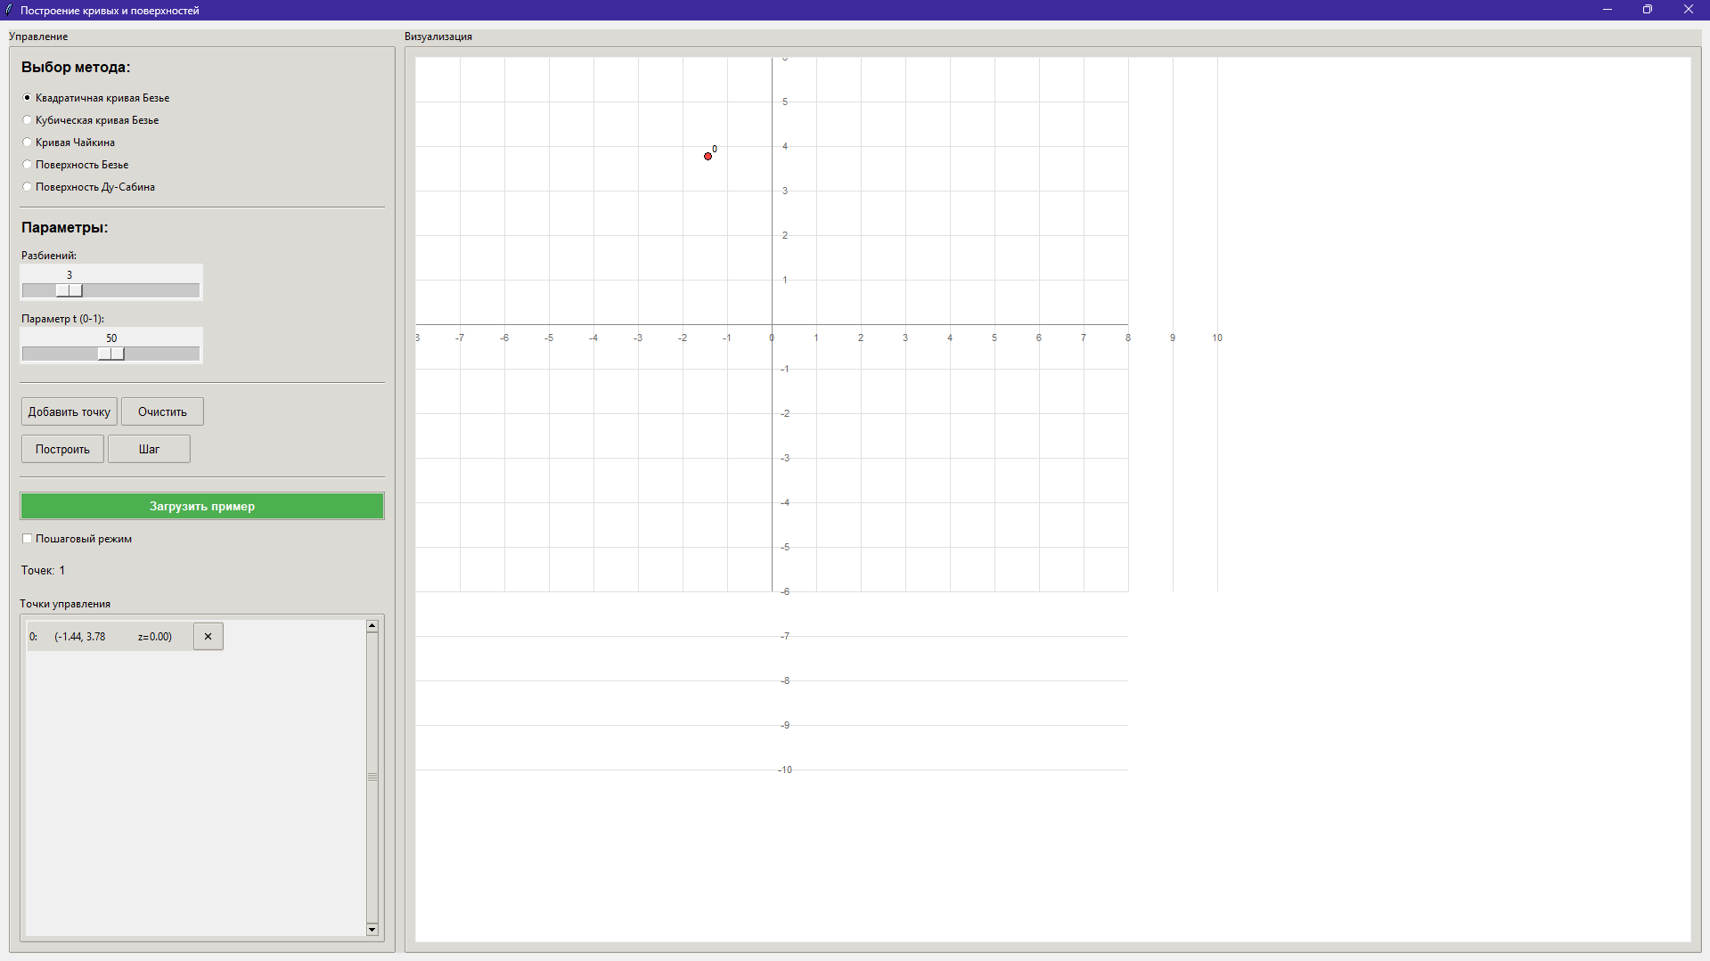
2.Квадратичная кривая Базье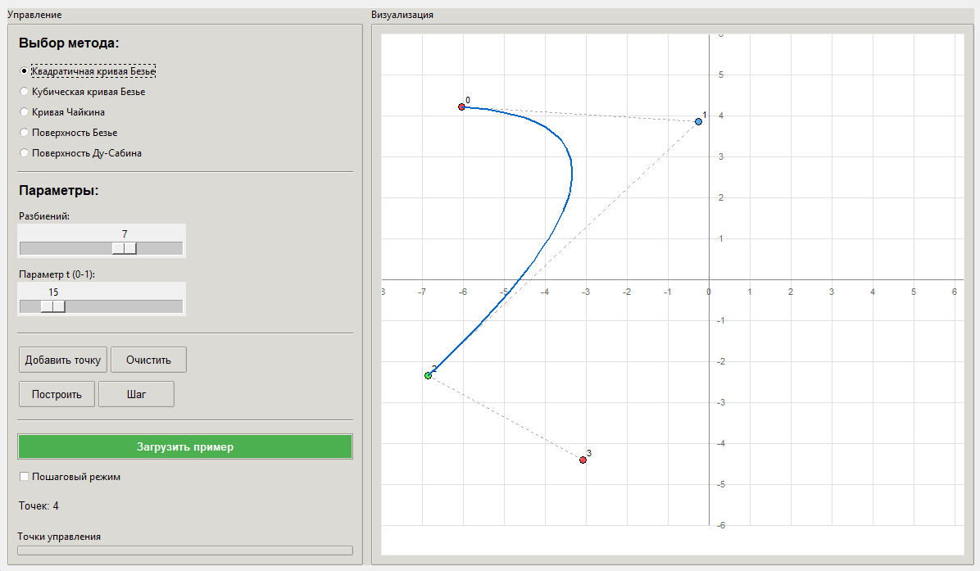
3.Кубическая кривая Базье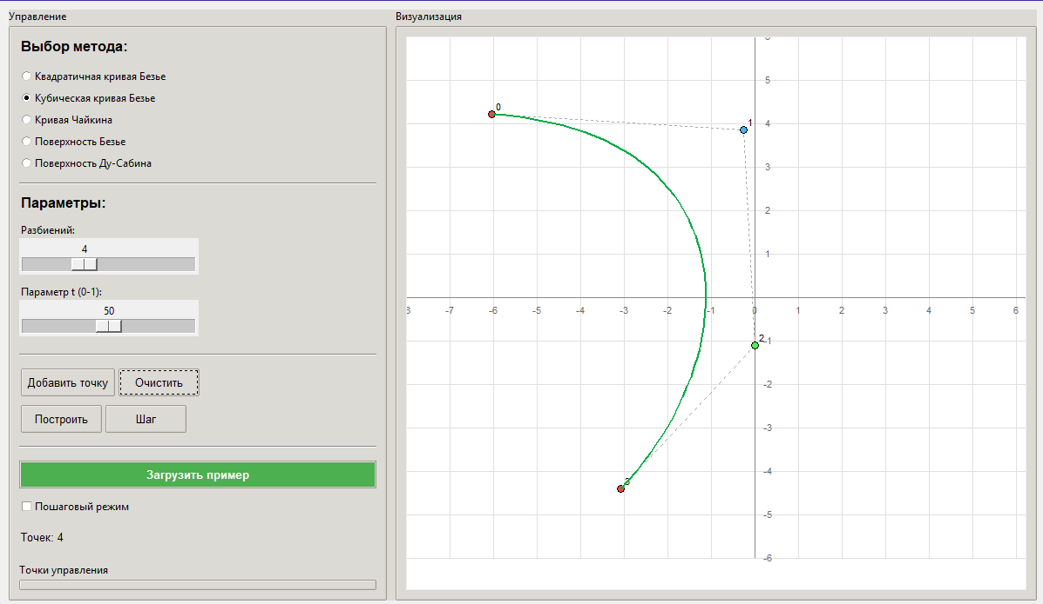
4.Кривая Чайкина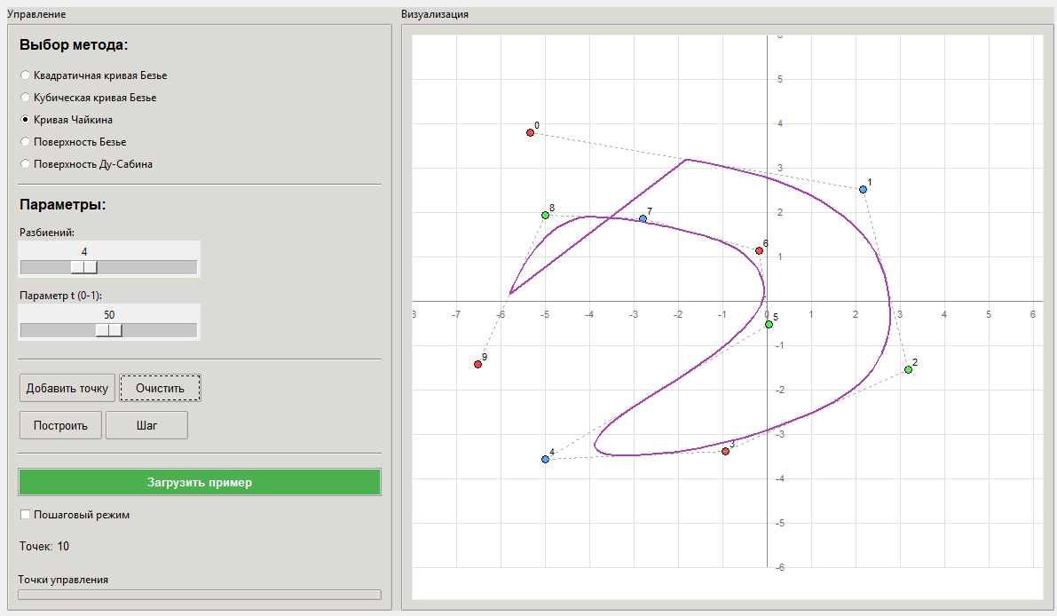
5.Поверхность Базье
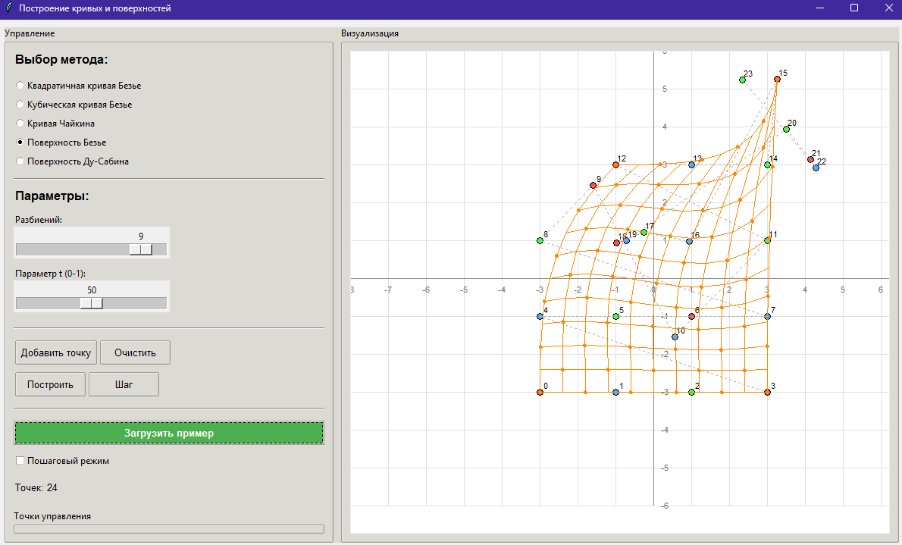
6.Поверхность Ду-Сабинина
