Plane Game 2D Tasks

The goal of the lab is to learn and to use a simple GameFramework to implement a complete 2D game.  
The framework is based from a GameInstitute framework and has the following features:

* Double Buffering
* Loading, drawing bitmaps (BMP files, width must be multiple of 4 !)
* Re-size bitmaps
* Sprites (masked and w/ transparent color)
* Animated sprites (only with mask)
* Sounds (only one at a time)

[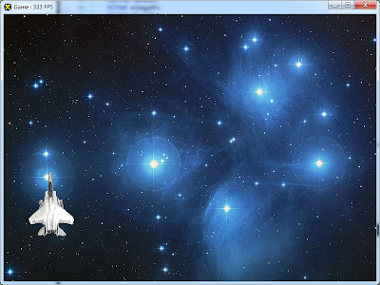](https://picasaweb.google.com/117936740219171833751/ImaginiBlogger?authkey=Gv1sRgCPSUyfuJhJyjWQ#5717101176355679250)  
  
Second step is to start improving the framework with features that will be used in the final game.  
The main goal is to implement a game as close as possible to [Raptor](http://en.wikipedia.org/wiki/Raptor:_Call_of_the_Shadows).

**Assignments**

* + Fix the bug with the incomplete explosion animated sprite (is should have all its 16 frames). Provide a generic solution.
  + Show a second sprite that explodes on Q.
  + Make the application full-screen.
  + Block the possibility of the plane exiting the screen.
  + The plane must be able to fire bullets.
  + Implement collision detection.
  + Implement moving enemies that randomly bombard you (similar to Space Invaders).
  + Make Space Invaders (lives and score).
  + Ability to rotate plane.
  + Space Invaders - Save and Load.
  + 2 Players that can move wherever on the screen, on whatever direction and can shoot each other. Each has 3 lives. Who kills the other wins.
  + Scrolling background.