Solution’s goal 1
Quick start 1
General concepts 3
More details on configuration process and relationships 3
Processing distribution mechanism. 5
Supported commands. 6

Solution’s goal

TWSDistr is intended for parallel sysplex environment with installed DB2 datasharing multimember group and IZWS (primarily OPC, TWS, TWSZ).
TWSDistr allows efficiently (according to WLM weights) distribute JCLs started from IZWS applications between members of DB2 datasharing group. Mechanism permanently query WLM to make decision on selecting preferrable DB2 member where JCL should be directed. Implemented algorithm works fairly good when IZWS starts either tenth JCLs per second as well as for rarely started JCLs.

Quick start
Download as binary EXIT.xmt and LINKLIB.xmt files to z/OS sequential fixed block dataset with LREC=80.
Perform TSO commands:
RECEIVE INDSN(‘EXIT.XMT’)
RECEIVE INDSN(‘LINKLIB.XMT’)
extracting configuration sources and modules to datasets with your site name convention.

Here is context of above .xmt datasets:
EXIT.xmt contains:
DEFKSD - definition JCL for INKDS control VSAM dataset
EQQUX000 - source of IZWS start/stop exit 000
EQQUX001 - source of IZWS JCL prestart exit 001
MODKDSJC - JCL version of modification of INKDS control dataset
MODKDSRX - REXX version of modification of INKDS control dataset
MTRDBENT - macro used in exits EQQUX000 and EQQUX001
MTRINP - sample configuration parm dataset for main ZMTRUS01 program
MTRWADAT - macro used in exits EQQUX000 and EQQUX001
TWSM - sample started task for running ZMTRUS01 program
WA7REC07 - macro used in exits EQQUX000 and EQQUX001
ZAPTWS95 - if you use TWS 9.5 or earlier run this JCL for modifying ZMTRUS01 load module
note: TWSDistr solution uses MCAUSERF field in MCA structure of IZWS subsystem. The offset of MCAUSERF in MCA was changed from 332 to 336 after TWS version 9.5, which is the reason of above modification

LINKLIB.xmt contains:
EQQUX000 - prebuilt version of IZWS exit 000. If you did not use exit 000 before you can just activate in IZWS supplied module.
EQQUX001 - prebuilt version of IZWS exit 001. It rather should be rebuilt from supplied assembler source so that to combine already implemented at your site exit 001 logic with code needed for TWSDistr functionality.
ZMTRUS01 - main module started from TWSM started task.
ZMTRUV01 - utility module used for dynamic excluding/including DB2 member from JCLs distribution.

Install in IZWS controller provided EQQUX000 and EQQUX001 exits. As customer probably already have EQQUX001 configured at least for user ID assignment (by customizing default SET_RUSE1 routine) already implemented routine should be preserved and injected into provided EQQUX001 source. After this EQQUX001 should be rebuilt. If you did not used EQQUX000 yet, then just use already supplied module in hlq.LINKLIB or build module from supplied assembler source and activate exit 000 in IZWS controller’s parms.
Define started task TWSM which will run ZMTRUS01 program by creating procedure:
//TWSM PROC
//TWSM EXEC PGM=ZMTRUS01
//STEPLIB DD DISP=SHR,DSN=HLQ.LINKLIB
//SYSPRINT DD SYSOUT=*,DCB=(RECFM=FB,LRECL=80)
//INKDS DD DISP=SHR,DSN=HLQ.ZMTRD
//SYSIN DD DISP=SHR,DSN=HLQ.PARM(MTRINP)

ZMTRUS01 load module should reside in authorized library.
SYSIN DD should contain start parameters, sample in MTRINP member in delivered samples.
Allocate VSAM for INKDS DD using DEFKSD sample.
Start TWSM started task. Check SYSPRINT DD on establishing run environment. Messages informs if adjacement with IZWS controller and DB2 datasharing group established.
Sample SYSPRINT output:
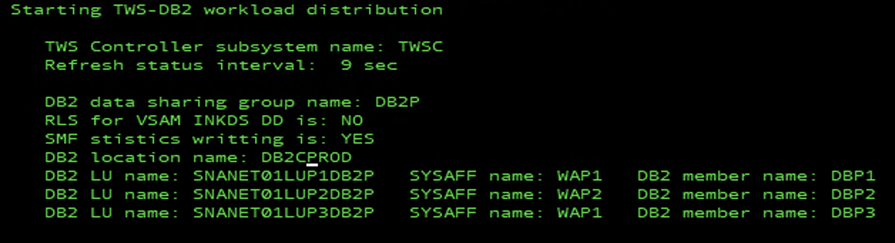

At this point IZWS application which have ‘AUTHORITY GROUP ID’ with value of DB2DISTR, DB2DIST3, DB2DIST4 or DB2DIST5 become eligible for distribution.

General concepts

TWSDistr consist of programs ZMTRUS01, ZMTRUV01 and IZWS exits EQQUX000, EQQUX001. ZMTRUS01 program queries WLM using IWMSRSR macro on WLM weights of DB2 members of DB2 datasharing group. Obtained weights are sent to IZWS controller address space and are used by JCL submission exit EQQUX001 for spreading JCLs according to WLM weights. WLM calculates weights considering available in LPAR CPU, DB2 member Performance Index (PI) and other attributes.
EQQUX001 directs each JCL to preferred DB2 member at current point of time. There is also mechanism for excluding some members from distributing (exclusion/inclusion can be done dynamically), which uses control VSAM dataset (INKDS DD) for keeping configuration.

More details on configuration process and relationships

Program ZMTRUS01 regularly query WLM on DB2 datasharing group members weights and passes this info to active IZWS controller using cross memory technic, so IZWS active controller should run in the same z/OS syslex image as ZMTRUS01 program as well as it should reside in authorized library because of cross memory technic requirement.
For general configuration parameters ZMTRUS01 uses parameters passed in SYSIN DD. ZMTRUS01 uses VSAM dataset allocated in INKDS DD for defining subsets of DB2 member to which distributions of JCL should be performed. Program ZMTRUV01 is used for modifying INKDS dataset.
In SYSIN DD passed to ZMTRUS01 it is defined list of DB2 members belonging to datasharing group, list of LPAR where DB2 instances run (in one LPAR it can be several DB2 instances) and other configuration parameters.

Here is sample SYSIN:
TWSCNTR=TWSC
DB2SYS=DB2P
DB2LOC=DB2LOCNM
REFRINT=9
RLS=NO

DB2LU=SNANET01LUP1DB2P
DB2CLONE=P1
DB2LPAR=LPR1

DB2LU=SNANET01LUP2DB2P
DB2CLONE=P3
DB2LPAR=LPR1

DB2LU=SNANET01LUP3DB2P
DB2CLONE=P2
DB2LPAR=LPR2

Global parms:
TWSCNTR – IZWS controller address space name
DB2SYS – DB2 datasharing group name
DB2LOC – DB2 location name
REFRINT – refresh time in seconds for obtaining data from WLM and monitors (1 - 9)
RLS – indicator whether RLS is active for VSAM (INKDS DD) control dataset (YES/NO)
SMF – put statistics on number of distributed JOBs into SMF 128 user record (YES/NO)

DB2 member related parms:
DB2LU – SNA network (8 chars padded with spaces if shorter) and LU name corresponding to DB2 provided without space - just after network name
DB2CLONE – DB2 clone name
DB2LPAR – LPAR name where DB2 member runs

Above configuration in sample SYSIN defines two DB2 member with DB2 clone name P1 and P3 run in sysplex member LPR1 and one DB2 member with DB2 clone name P2 in sysplex member LPR2. Program ZMTRUS01 uses VSAM from INKDS DD which should be prepared for current environment. It should contain records which are used as indicator which DB2 members are allowed for distribution. There are several groups of records which corresponds to four ‘AUTHORITY GROUP ID’ attribute values of IZWS application.
By default distribution according to WLM weights will be proceed to all DB2 members for each JCL which belongs to IZWS application having ‘AUTHORITY GROUP ID’ with value of DB2DISTR, DB2DIST3, DB2DIST4 or DB2DIST5. But we can modify this behavior so that for instance JCLs belonging to IZWS applications having ‘AUTHORITY GROUP ID’ equal to DB2DIST3 will be distributed only to DB2 with sysclone P1 and P2 by modifying INKDS VSAM dataset so it contains following entries:
P1M31, P2M31, P3M30
First two letters identify DB2 clone name (Px in above sample), third letter is always ‘M’ and fourth letter y corresponds to DB2DISTy specified in ‘AUTHORITY GROUP ID’ for DB2DIST3, DB2DIST4, DB2DIST5.
For ‘AUTHORITY GROUP ID’ equal to DB2DISTR mechanism works similar, but for allowing distribution to DB2 member DBPx VSAM should contain both entries PxM11, PxM21. If either PxM10 or PxM20 entry is present, then DB2 member DBPx will be excluded from distribution.
For modifying values in INKDS dataset you can use ZMTRUV01 program, which can be run as JCL or REXX.

INKDS dataset should be allocated using following supplied in samples JCL DEFKSD and contents of SYSUT1 DD of CRETMP5 step should be prepared according to your DB2 clone names in DB2 datasharing group. Namely: for each DB2 sysclone XX it should contain 5 entries:
XXM11
XXM21
XXM31
XXM41
XXM51

Processing distribution mechanism.

If JCL statement
‘SYSAFF=’
and
‘DSN SYSTEM(’
strings exists in started JCL exit EQQUX001 modifies statements ‘SYSAFF=lpnm’ and ‘DSN SYSTEM(dbnm)’ in JCL just before sending for execution by substituting appropriate values for lpnm and dbnm. This processing is coded in EQQUX001 exit in MODJCLAF routine.
If ‘SYSAFF=’ and ‘DSN SYSTEM(’ strings do not exist then nothing done, so actually they should exist in JCL for mechanism to work.
note: exit EQQUX001 search and changes JCL all strings starting from „SYSAFF=” and „SYSTEM(DB”. This behavior is coded in EQQUX001 and can be modified if needed

During JCL modification EQQUX001 uses WLM weights of DB2 members delivered by ZMTRUS01. Take into account that WLM returns weight for DB2 member only if DDF has been started for this member.
Current implementation allows distribution of JCL only if IZWS application attribute ‘AUTHORITY GROUP ID’ is assigned to one of the values: DB2DISTR, DB2DIST3, DB2DIST4, DB2DIST5 (so all other IZWS applications runs as is). Checking whether IZWS application has ‘AUTHORITY GROUP ID’ attribute is done in EQQUX001 and virtually you can code dependency on any other attribute of IZWS application by coding EQQUX001 exit.
For modification of VSAM HLQ.ZMTRD can be used REXX or JCL, which calls ZMTRUV01 with appropriate parms. REXX and JCL samples for invocation of ZMTRUV01 are in MODKDSRX and MODKDSJC sample members.
Here description of currently implemented select algorithm for ‘AUTHORITY GROUP ID’ - DB2DISTR, DB2DIST3, DB2DIST4, DB2DIST5:
DB2DISTR – it is selected preferred DB2 member among all defined for distribution DB2 members having value 1 for both DBcloneM1 and DBcloneM2 in INKDS control dataset.
DB2DIST3 - it is selected preferred DB2 member among all defined for distribution DB2 members having value 1 for DBcloneM3 in INKDS control dataset.
DB2DIST4 - it is selected preferred DB2 member among all defined for distribution DB2 members having value 1 for DBcloneM4 in INKDS control dataset.
DB2DIST5 - it is selected preferred DB2 member among all defined for distribution DB2 members having value 1 for DBcloneM5 in INKDS control dataset.

Supported commands.

Program ZMTRUS01 accepts following ‘MVS MODIFY’ commands:
MODIFY TWSM,JSTS – JCL statistic report written to SYSPRINT DD.
Here is sample output:
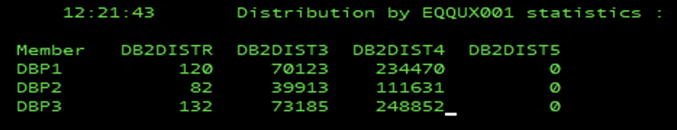
MODIFY TWSM,SHOW – switch ON/OFF printing of WLM weights for DB2 members.
Before WLM weight is written sign ‘+’ or ‘–‘ which indicate whether this DB2 member is excluded from distribution.
Here is sample output:
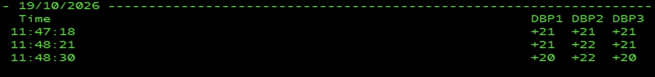

note: distributing mechanism starts to work in IZWS controller after start of TWSM address space which runs program ZMTRUS01. Stopping TWSM address space by MVS STOP TWSM also stops distribution mechanism in controller (do not use CANCEL for ZMTRUS01).

note: distribution mechanism assumes that at least one DB2 member is active (with DDF). If above not true then do not start TWSM.

note: if SMF=YES is in startup parameters statistic data on JCL distribution written to SMF record 128 which has following format:
SMJCLNUM 1F – number of distributed JCL
SMAUTHNM 8C – ‘AUTHORITY GROUP ID’ name
SMDB2NAM 4C – DB2 member name

