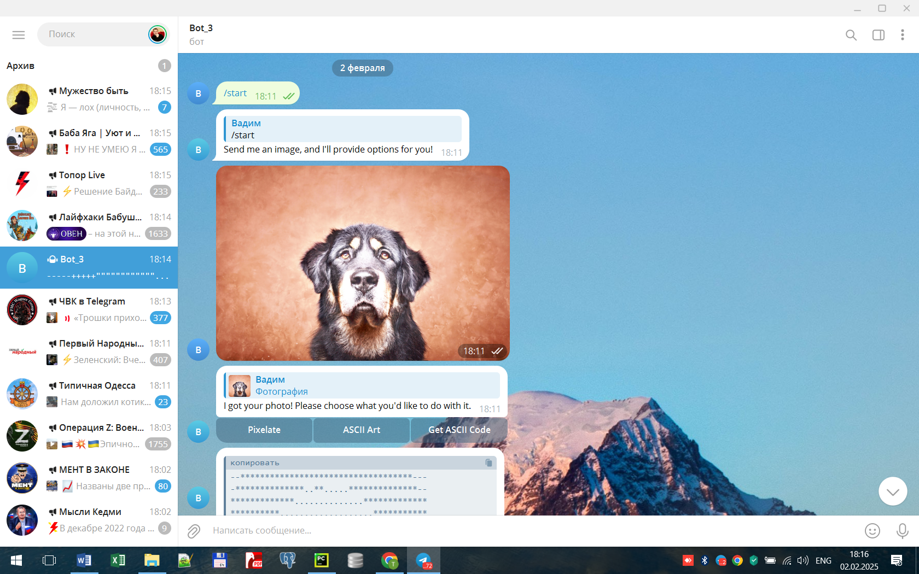

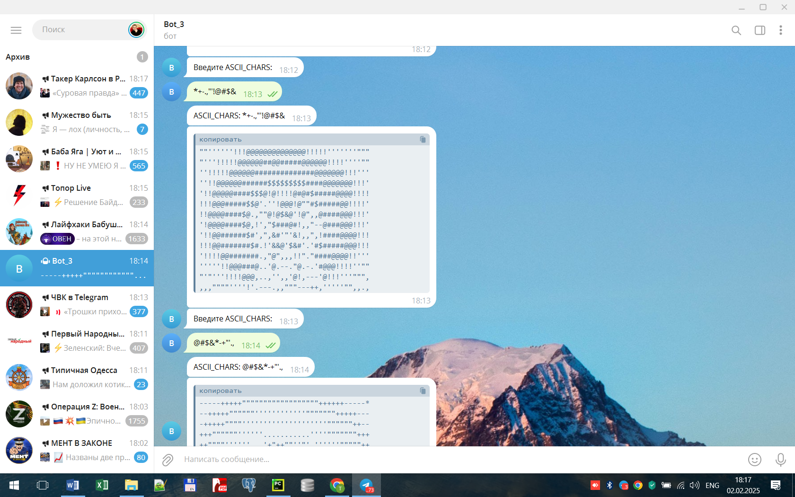

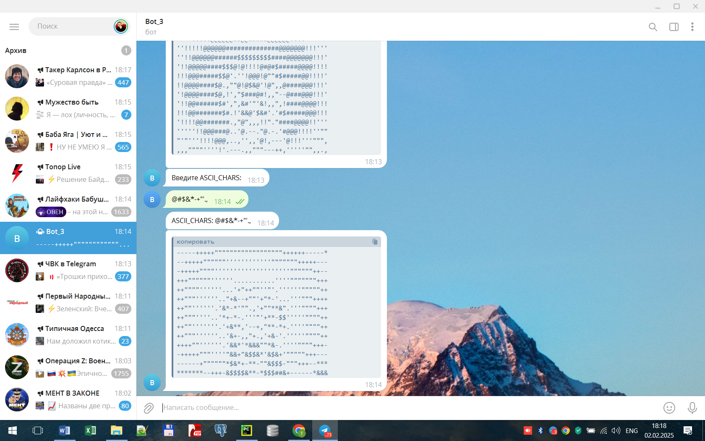

************************************************************************************

Terminal:

D:\PROBATION\SPRINT_3\.venv\Scripts\python.exe D:\PROBATION\SPRINT_3\bot_3_01.py

+-*.

560

I got your photo! Please choose what you'd like to do with it.

Initial_ASCII_CHARS = +-*.

resulting_ASCII_CHARS = *+-.,"'!@#$&

560

I got your photo! Please choose what you'd like to do with it.

Initial_ASCII_CHARS = *+-.,"'!@#$&

resulting_ASCII_CHARS = @#$&*-+"'.,

560

Process finished with exit code 0

************************************************************************************