
  - V A E L O R Y N

PRODUCT
DOCUMENTATION
VAELO Ecosystem & Product Overview
Version 1.0 • August 2026
Prepared for a Fjord Foundry partnered public-sale application.
Canonical Base Mainnet deployment: NOT DEPLOYED

Contents
01 Executive overview
02 The problem
03 The Vaeloryn vision
04 The Vaeloryn ecosystem
05 VAELO token
06 Product and token utility
07 Tokenomics
08 Founder vesting
09 Technical architecture
10 Security and testing
11 Treasury and allocation structure
12 Initial public sale
13 Use of initial capital
14 Roadmap
15 Current development status
16 Transparency and verification
17 Risks and limitations
18 Contact and links
Important status statement: the canonical VAELO protocol is implemented and internally tested, but has not been deployed on Base Mainnet. No Fjord sale has been created, approved, funded or launched.

01 / PRODUCT DOCUMENTATION

Executive overview
CURRENT STAGE — FOUNDATION / PRE-DEPLOYMENT
Vaeloryn is being developed as a long-term ecosystem intended to connect capital, expertise, technology and opportunity around projects capable of contributing to meaningful advances in science, medicine, energy and frontier technology.
The ambition is to create infrastructure through which resources can be coordinated toward real-world scientific and technological development. The canonical protocol is implemented and tested locally, but the broader ecosystem is not yet fully operational. Base Mainnet deployment, independent security review, the Fjord sale and full ecosystem launch remain incomplete.

02 / PRODUCT DOCUMENTATION

The problem
PROBLEM STATEMENT — NOT A CLAIM OF RESOLUTION
Promising scientific and technological initiatives can struggle to move from idea to implementation because required resources are fragmented. A coordinated ecosystem could potentially shorten this path by bringing complementary inputs together, while preserving project-specific diligence and execution discipline.
- Capital
- Specialist expertise
- Technical and physical infrastructure
- Professional networks
- Development resources
- Long-term support

03 / PRODUCT DOCUMENTATION

The Vaeloryn vision
LONG-TERM VISION — PLANNED
Vaeloryn’s long-term vision is to help coordinate the inputs required to move credible ideas toward measurable real-world development.
Capital + Expertise + Technology + Execution → Real-world innovation
Intended areas of focus include medical science, energy, artificial intelligence, computing, aerospace, engineering, fundamental science and other frontier technologies. These are areas of interest, not claims that Vaeloryn currently operates projects in every field.

04 / PRODUCT DOCUMENTATION

The Vaeloryn ecosystem
PLANNED ECOSYSTEM ARCHITECTURE
Participants may contribute capital, expertise, ideas, technology or execution capability. The intended VAELO ecosystem would coordinate appropriate forms of participation around selected initiatives.
Initiatives would still require independent evaluation, development, governance, compliance and execution. Real-world outcomes are an objective, not a guaranteed result. Successful work could expand the ecosystem’s future capacity.
Current state: the token protocol, documentation and preparation materials exist; operational products, selected flagship initiatives and a fully functioning participant network remain in development.
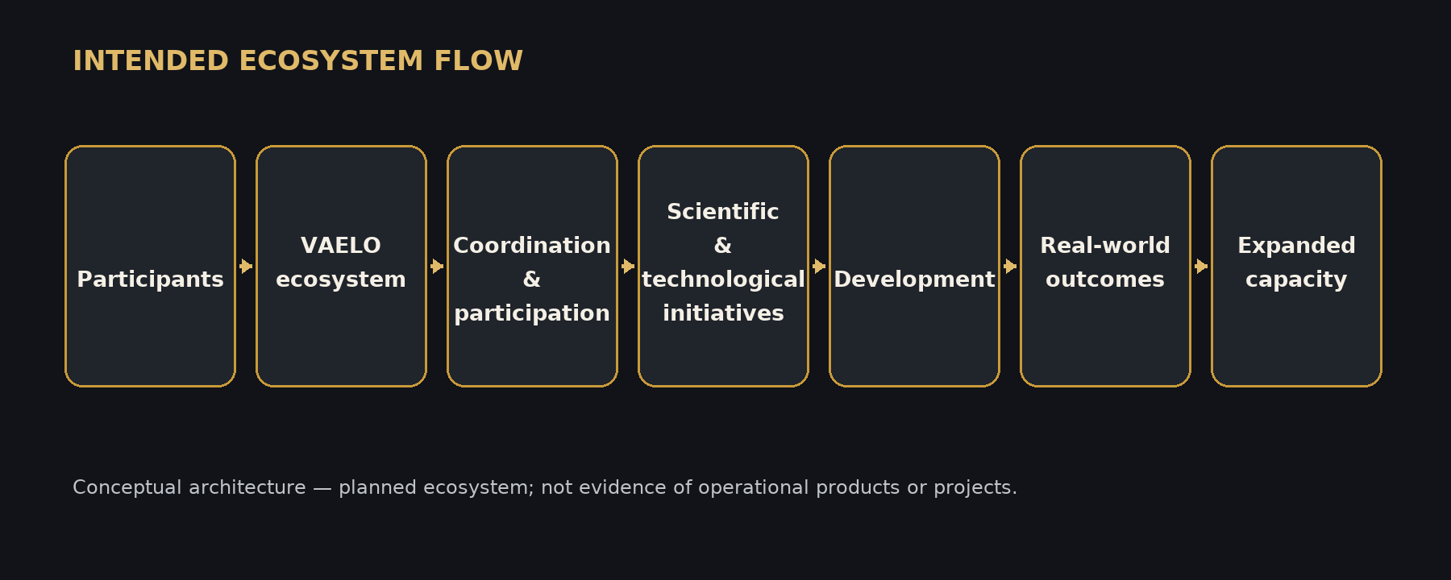

05 / PRODUCT DOCUMENTATION

VAELO token
IMPLEMENTED LOCALLY — NOT DEPLOYED ON BASE MAINNET
VAELO is the fixed-supply token designed for the intended Vaeloryn ecosystem. The target network is Base Mainnet. The canonical deployment package has been prepared, but the canonical token has not been deployed.
Currently implemented functionality: ERC-20 transfers and allowances; ERC20Burnable burn and burnFrom; ERC20Permit / EIP-2612 Permit; EIP-712 typed-data support; and nonce tracking.
The canonical token has no additional mint function, owner or administrator, upgrade mechanism, pause function, blacklist or transfer tax. These design properties do not imply utility, market value or returns.
Item | Verified or stated value
Token | VAELO
Fixed supply | 1,000,000,000 VAELO
Target network | Base Mainnet
Standard | ERC-20
Mainnet status | NOT DEPLOYED

06 / PRODUCT DOCUMENTATION

Product and token utility
PLANNED — NOT CURRENT FUNCTIONALITY
Potential future roles may include ecosystem participation, coordination, appropriate access to ecosystem initiatives, support for ecosystem funding mechanisms, participation in future products or services, and interactions among ecosystem participants.
No specific application, staking mechanism, governance system, payment system, revenue-sharing mechanism or current product access is represented as operational. Utility should follow useful products and approved operating models, rather than precede them.

07 / PRODUCT DOCUMENTATION

Tokenomics
FINALIZED CANONICAL ALLOCATION
The complete fixed supply is 1,000,000,000 VAELO. The six allocations total exactly 100% and are created as one canonical genesis distribution.
Allocation | VAELO | Share
Ecosystem & Community | 300,000,000 | 30%
Public Distribution | 200,000,000 | 20%
Vaeloryn Treasury | 200,000,000 | 20%
Team & Contributors | 150,000,000 | 15%
Founder | 100,000,000 | 10%
Strategic Partnerships | 50,000,000 | 5%
TOTAL | 1,000,000,000 | 100%

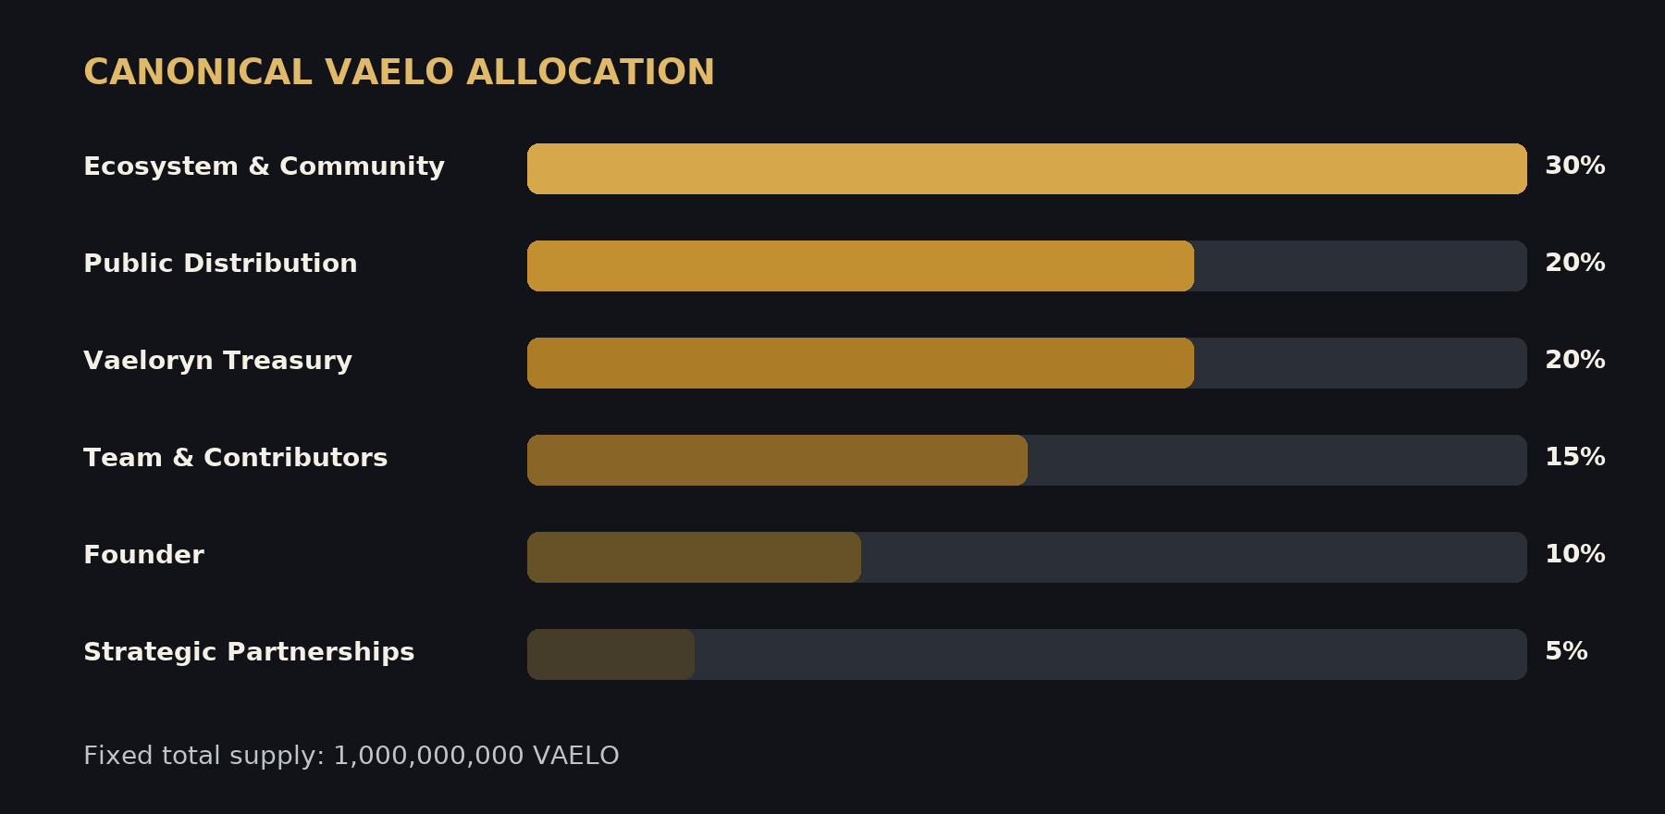

08 / PRODUCT DOCUMENTATION

Founder vesting
IMPLEMENTED CANONICAL SCHEDULE
The founder allocation is 100,000,000 VAELO. Token, beneficiary, start time, linear start and linear end are immutable in the canonical implementation. There is no fourth quarterly release.
Event | Timing | Additional release | Cumulative
Initial | T0 | 2,500,000 | 2,500,000
Quarter 1 | T0 + 90 days | 2,500,000 | 5,000,000
Quarter 2 | T0 + 180 days | 2,500,000 | 7,500,000
Quarter 3 | T0 + 270 days | 2,500,000 | 10,000,000
Linear phase | From T0 + 270 days for exactly 1,095 days | 90,000,000 linearly | 100,000,000

09 / PRODUCT DOCUMENTATION

Technical architecture
IMPLEMENTED LOCALLY — DEPLOYMENT PENDING
VaelorynDeploymentFactory is a constructor-only, one-shot factory that deploys the distribution, token and founder vesting contracts and completes allocation in the same transaction.
VaelorynGenesisDistribution receives the complete supply directly from the token and performs the one-time six-category allocation. VaelorynToken creates the fixed supply once and includes ERC-20, Burnable and Permit functionality. VaelorynFounderVesting enforces the founder schedule and allocation cap.
The atomic sequence reduces substitution risk between token creation, vesting creation and allocation. It does not mean that a Base Mainnet deployment has occurred.
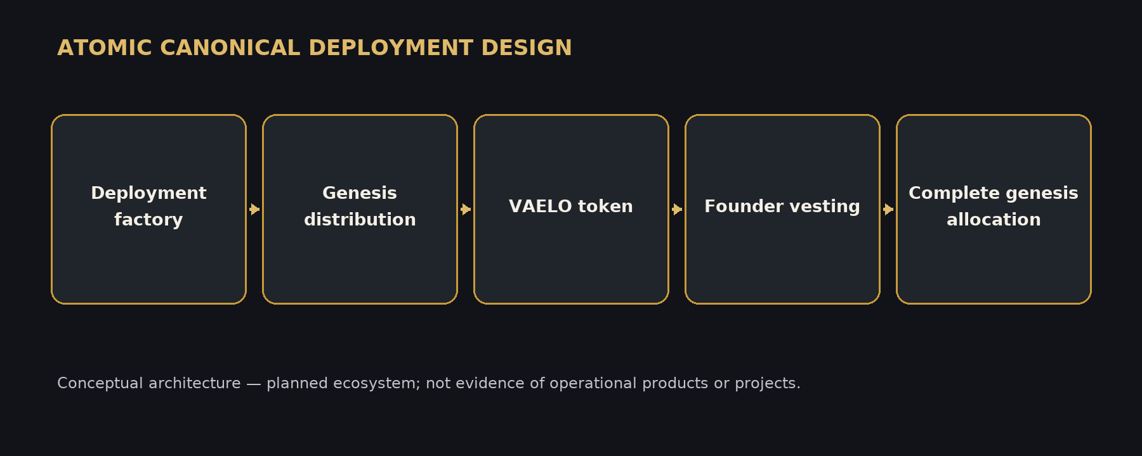

10 / PRODUCT DOCUMENTATION

Security and testing
INTERNAL VERIFICATION COMPLETE — INDEPENDENT AUDIT NOT COMPLETED
The targeted canonical hardening run recorded 27 tests passed, 0 failed and 0 skipped: 25 canonical unit, edge-case, Permit, allocation, vesting, fuzz and factory tests, plus two invariant suites.
Each fuzz target ran 256 times. Each invariant ran 128 times with 8,192 handler calls, for 16,384 invariant handler calls in total.
These are internal development and verification tests and do not constitute an independent security audit. Independent security audit: NOT YET COMPLETED.

11 / PRODUCT DOCUMENTATION

Treasury and allocation structure
APPROVED INTENDED RECIPIENT — NO TRANSFER HAS OCCURRED
The canonical design sends the Vaeloryn Treasury allocation through the one-time genesis distribution to the approved Treasury Safe. The intended use of a Safe supports shared custody and operational controls outside the immutable token contract.
Approved Treasury Safe: 0x3A9bee20360294F8439513Ae70D189f56288baF2
The manifest is marked NOT_DEPLOYED. No canonical VAELO has been transferred to this or any other Mainnet recipient.

12 / PRODUCT DOCUMENTATION

Initial public sale
PROPOSED / WORKING PARAMETERS — SUBJECT TO FINAL FJORD CONFIGURATION
The working concept is a tiered sale on Base using no more than 10,000,000 VAELO, equal to 1% of total supply and carved from the existing Public Distribution allocation. It is not an additional allocation.
The $5,000,000 target reference FDV and $0.005 reference price are planning references, not guaranteed valuations. The sale has not been created, approved, funded or launched.
Item | Verified or stated value
Network | Base
Sale type | Tiered
Maximum allocation | 10,000,000 VAELO / 1%
Reference FDV | $5,000,000
Reference price | $0.005
Maximum theoretical gross proceeds | $50,000

Tier | VAELO | Price | Gross proceeds
1 | 1,000,000 | $0.003 | $3,000
2 | 2,000,000 | $0.004 | $8,000
3 | 3,000,000 | $0.005 | $15,000
4 | 4,000,000 | $0.006 | $24,000
MAXIMUM | 10,000,000 | Weighted avg. $0.005 | $50,000

13 / PRODUCT DOCUMENTATION

Use of initial capital
INTENDED USES — NOT COMPLETED ACTIVITIES
If an approved sale proceeds, potential uses of initial project funding may include the following. Final budgets, timing and allocations remain subject to approval and available proceeds.
- Technical development
- Independent security review
- Infrastructure
- Essential team capability
- Legal and compliance work
- Corporate and operational setup
- Development of the first Vaeloryn initiative
- Communications and transparency infrastructure

14 / PRODUCT DOCUMENTATION

Roadmap
MILESTONE-GATED — NO DATES PROMISED
Progression is milestone-gated rather than calendar-gated. Future phases are objectives, not commitments to specific timing or outcomes.
Phase | Status | Representative milestones
Phase 1 — Foundation | IN PROGRESS | Canonical protocol implemented and tested; website and public documentation established. Community, legal/regulatory guidance, strategy and flagship-project evaluation remain in progress.
Phase 2 — Execution | PLANNED | Build a first flagship project; demonstrate measurable value; grow capability; introduce genuine VAELO utility only where useful.
Phase 3 — Expansion | PLANNED | Expand successful projects; develop additional initiatives; build partnerships; expand the contributor ecosystem; strengthen sustainability.
Phase 4 — Global Ecosystem | PLANNED | Develop a globally connected innovation ecosystem around meaningful science and technology projects.

15 / PRODUCT DOCUMENTATION

Current development status
STATUS AS OF AUGUST 2026
The project is at a foundation and preparation stage. The protocol work described below is local implementation and evidence, not a claim of Mainnet launch.
CURRENT / PREPARED | NOT YET COMPLETED
Canonical contracts implemented | Base Mainnet deployment
Canonical tokenomics finalized | Mainnet source verification
Targeted canonical test suite passing | Independent security audit
Mainnet deployment package prepared | Fjord sale creation and approval
Fjord preparation documentation prepared | Public token sale
Fjord pitch deck prepared | Full ecosystem launch

16 / PRODUCT DOCUMENTATION

Transparency and verification
FUTURE MAINNET VERIFICATION REQUIREMENTS
Canonical identity should be established through the approved Base Mainnet manifest, deployment event and verifiable on-chain evidence—not through a name or placeholder address.
Future publication should include the official VAELO, factory, genesis distribution and founder vesting addresses; deployment transaction; verified source code; compiler and constructor settings; bytecode hashes; tokenomics readback; and vesting readback.
No canonical Mainnet addresses or transaction identifiers exist in the manifest today, so none are inserted here.

17 / PRODUCT DOCUMENTATION

Risks and limitations
MATERIAL UNCERTAINTIES
Vaeloryn is early-stage. Development may be delayed, changed or discontinued. Smart contracts can contain defects despite testing, and an independent audit has not been completed.
Market demand, liquidity and token pricing are uncertain. Regulatory requirements may change or differ across jurisdictions. Adoption depends on participants, useful initiatives and execution capability. Sale operations, eligibility, payment assets, claims and unsold-token treatment require external Fjord confirmation and professional review.
VAELO does not guarantee returns. This document is informational and is not legal, tax, regulatory, financial or investment advice.

18 / PRODUCT DOCUMENTATION

Contact and links
REPOSITORY-VERIFIED LINKS ONLY
Only links verified in the repository are included. No social URL has been inferred from an account name.
Item | Verified or stated value
Website | https://vaeloryn.com
GitHub | https://github.com/Vaeloryn/Vaeloryn
X | Not supplied in the repository reviewed
Telegram | Not supplied in the repository reviewed

