ID: s267647
Name: Giorgio
Surname: Maritano

Homework 2 – Machine Learning and Artificial Intelligence

1 – Data Preparation

In this section what I was required to do was to edit the code I was given to make it load images from the provided train / test splits present in the Github repo and to use the provided Caltech class (used as Dataset) to store them and to filter out the BACKGROUND class, which must not be used, implementing all the logic.

I made the Caltech class the most general possible, which allowed me to use it without further edit also in the next point with the validation set.

So in the __init__ function after receiving all the parameters the class reads the file provided as “split” and saves all the entries in a list.

After that it execs the following lines:

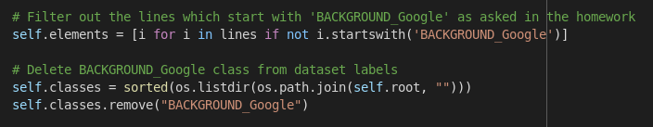
This way I completed the first point.

Of course I also implemented the Caltech’s methods to return the length of the dataset (by simply returning self.elements’ length) and to iterate over the dataset, using the pil_loader function provided to pass the data as a PIL image.

2 – Training from scratch

Here I was asked to split the original training set into a new training set and a validation set, of the same size

Since the code is widely commented I will just add a screenshot of this code snippet to show how I’ve done it.

I chose to execute this part outside of the Caltech class, because this way I could pass just the paths to the new files as the parameters and the class behaves just as it did before.
