**DAY 4 Assignment**

1.     List all customers and the products they ordered with the order date. (Inner join)

Tables used: customers, orders, order_details, products

Output should have below columns:

    companyname AS customer,   orderid,  productname,  quantity, orderdate

SELECT a.order_id, a.quantity, b.order_date, c.product_name, d.company_name AS customer

FROM order_details a

INNER JOIN orders b ON a.order_id = b.order_id

INNER JOIN products c ON c.product_id = a.product_id

INNER JOIN customers d ON d.customer_id = b.customer_id ;

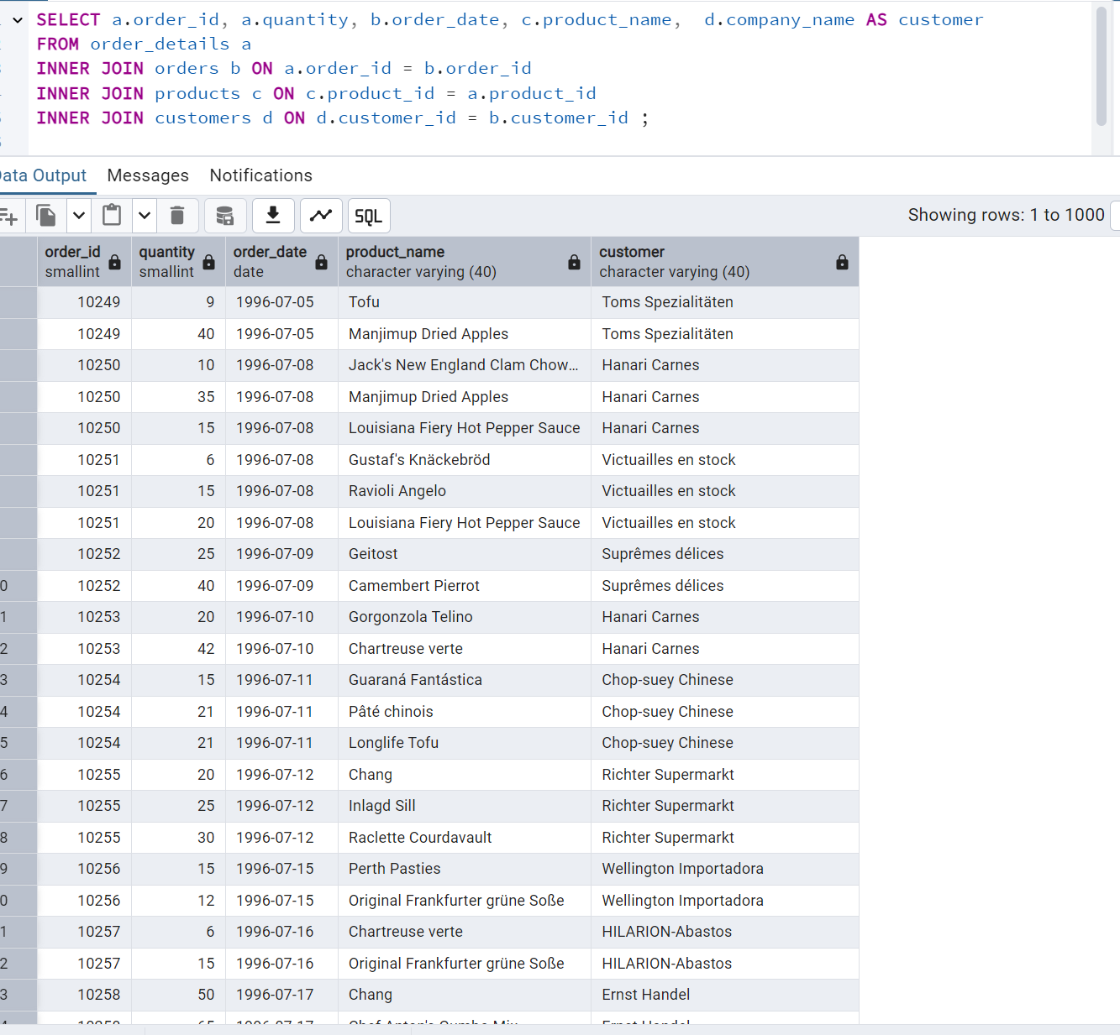

2.     Show each order with customer, employee, shipper, and product info — even if some parts are missing. (Left Join)

**Tables used: orders, customers, employees, shippers, order_details, products**

SELECT o.order_id, p.product_name, s.company_name, c.contact_name,

concat(e.first_name,' ', e.last_name) as employee_name, d.quantity FROM orders o

LEFT JOIN customers c ON o.customer_id = c.customer_id

LEFT JOIN employees e ON o.employee_id = e.employee_id

LEFT JOIN shippers s on o.ship_via = s.shipper_id

LEFT JOIN order_details d ON o.order_id = d.order_id

LEFT JOIN products p ON p.product_id = d.product_id ;

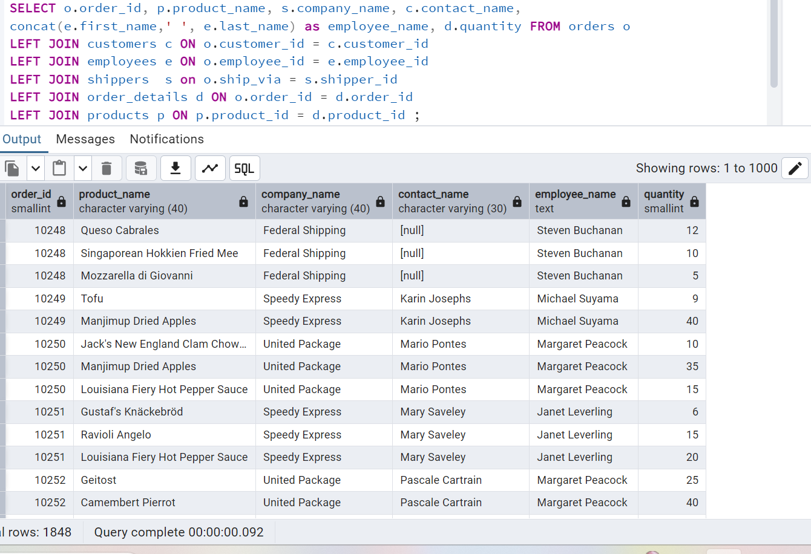

3.     Show all order details and products (include all products even if they were never ordered). (Right Join)

**Tables used: order_details, products**

**Output should have below columns:**

    orderid, productid, quantity, productname

SELECT d.order_id, p.product_id, d.quantity, p.product_name

FROM order_details d

RIGHT JOIN products p ON d.product_id = p.product_id;

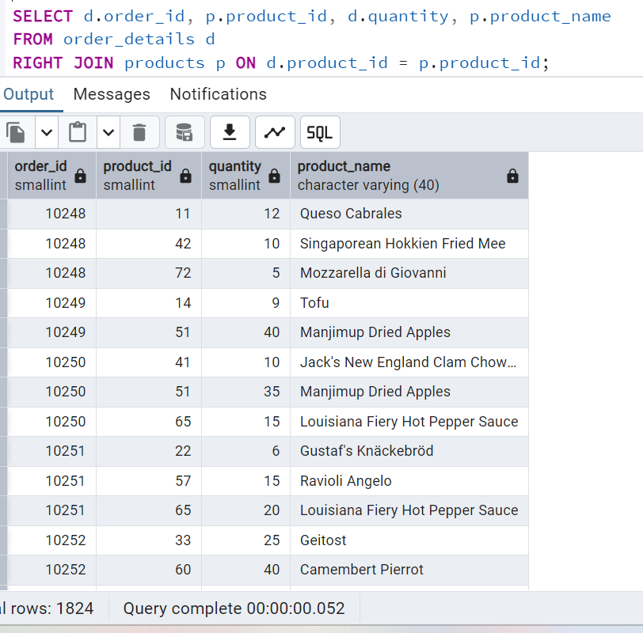

4. List all product categories and their products — including categories that have no products, and products that are not assigned to any category.(Outer Join)

**Tables used: categories, products**

SELECT p.category_id, p.product_name, c.category_name FROM products p

FULL OUTER JOIN categories c ON p.category_id = c.category_id;

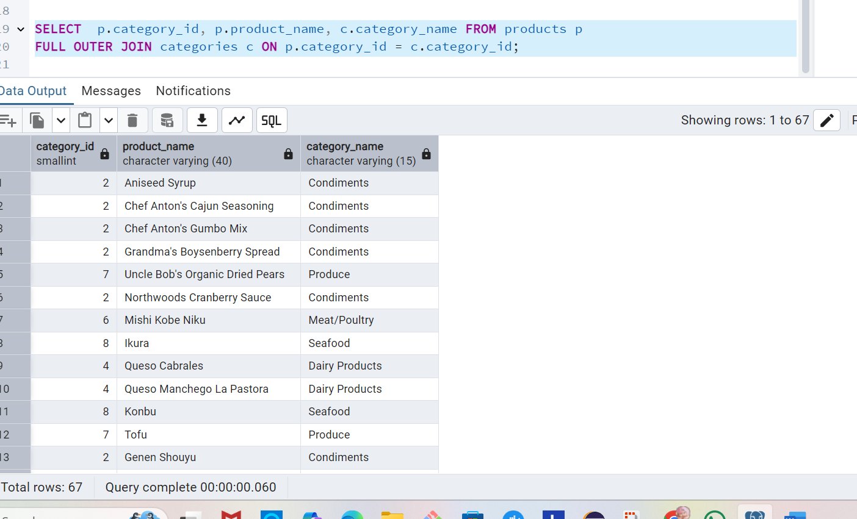

5. Show all possible product and category combinations (Cross join).

SELECT p.product_name, c.category_name FROM products p

CROSS JOIN categories c;

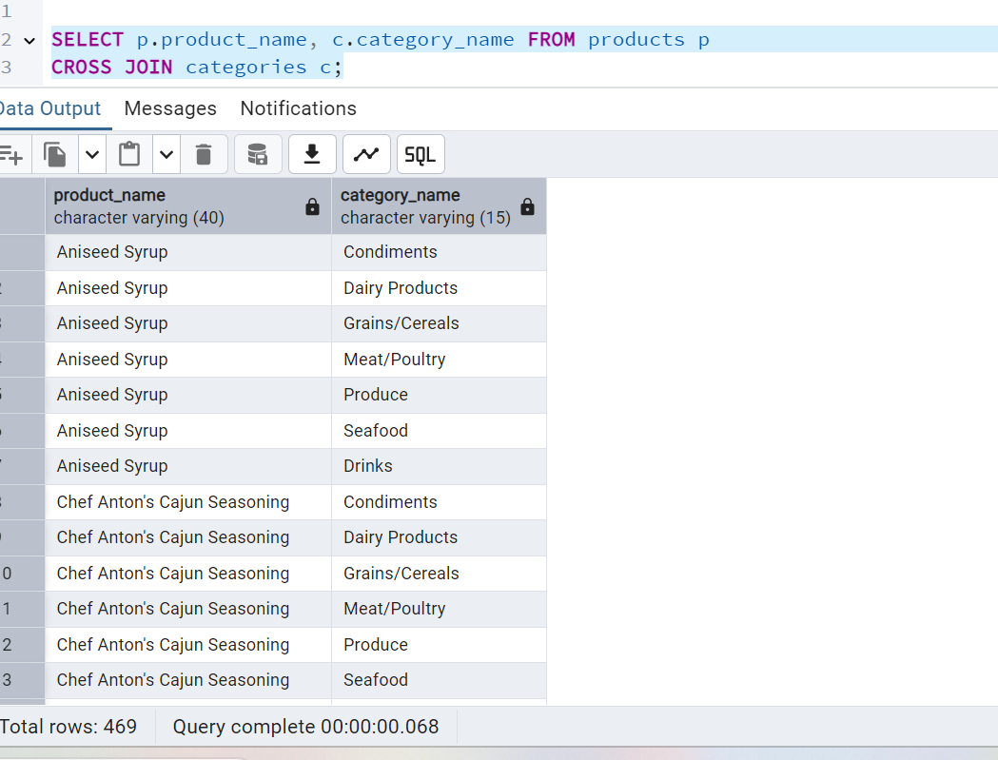

6. Show all employees who have the same manager(Self join)

SELECT (e1.first_name || ' ' || e1.last_name) as employee_name,

(e2.first_name || ' ' ||e2.last_name) as manager_name FROM employees e1

INNER JOIN employees e2 ON e2.employee_id = e1.reports_to

WHERE e1.employee_id != e2.employee_id;

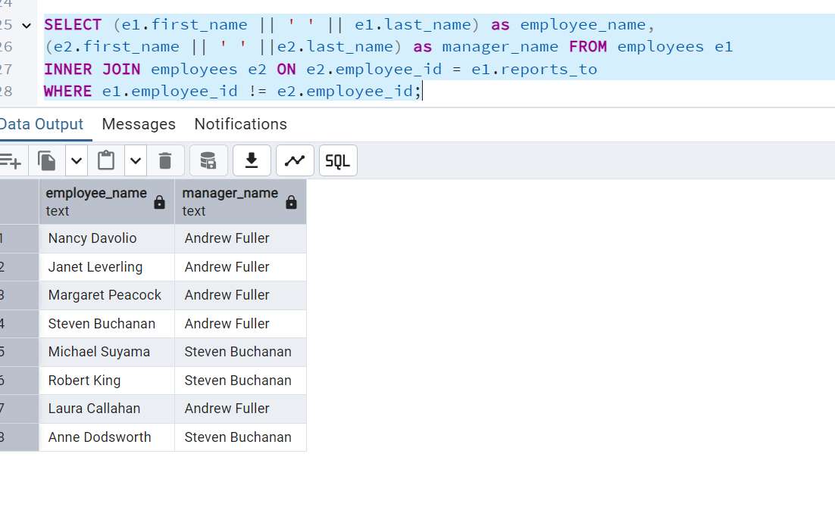

7. List all customers who have not selected a shipping method.

**Tables used:** customers, orders

**(Left Join, WHERE o.shipvia IS NULL)**

**SELECT o.order_id, c.contact_name, c.customer_id,o.order_date FROM customers c**

**LEFT JOIN orders o ON c.customer_id = o.customer_id**

**WHERE o.ship_via IS NULL;**

