DAY 6 Assignment

1.      Categorize products by stock status

(Display product_name, a new column stock_status whose values are based on below condition

 units_in_stock = 0  is 'Out of Stock'

       units_in_stock < 20  is 'Low Stock')

 SELECT

PRODUCT_NAME,

UNITS_IN_STOCK,

CASE

WHEN UNITS_IN_STOCK = 0 THEN 'Out of Stock'

WHEN UNITS_IN_STOCK < 20 THEN 'Low Stock'

END AS STOCK_STATUS

FROM PRODUCTS;

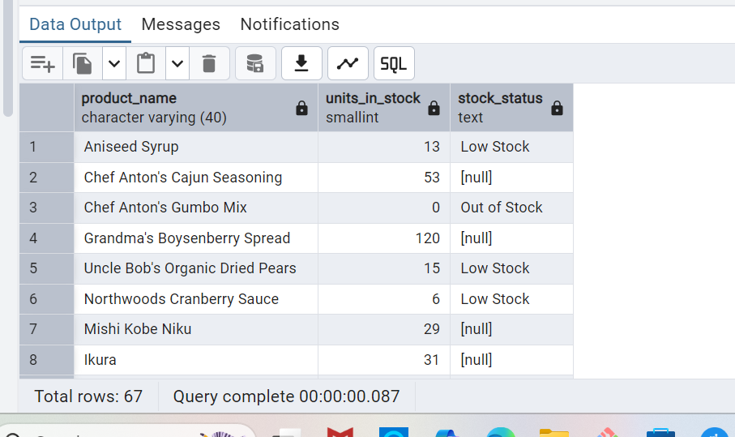

2.      Find All Products in Beverages Category

(Subquery, Display product_name,unitprice)

 SELECT

PRODUCT_NAME,

UNIT_PRICE

FROM

PRODUCTS

WHERE

CATEGORY_ID = (

SELECT

CATEGORY_ID

FROM

CATEGORIES

WHERE

CATEGORY_NAME = 'Beverages'

);

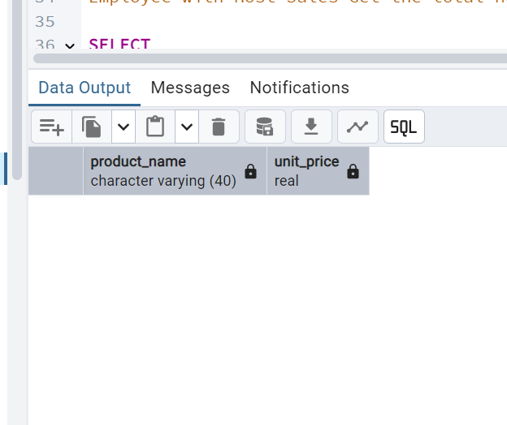

3.      Find Orders by Employee with Most Sales

(Display order_id,   order_date,  freight, employee_id.

Employee with Most Sales=Get the total no.of of orders for each employee then order by DESC and limit 1. Use Subquery)

 SELECT

ORDER_ID, ORDER_DATE, FREIGHT, EMPLOYEE_ID

FROM ORDERS

WHERE employee_id IN (

SELECT employee_id

FROM orders

Group BY employee_id

ORDER BY count(order_id) DESC

LIMIT 1 );

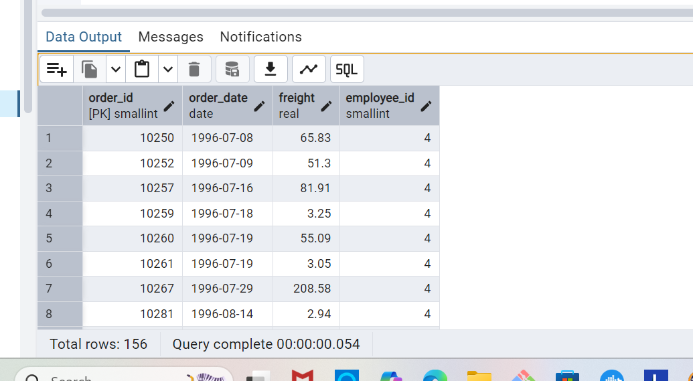

4.      Find orders  where for country!= ‘USA’ with freight costs higher than any order from USA. (Subquery, Try with ANY, ALL operators)

**----- ANY operator ----**

**SELECT ORDER_ID, SHIP_COUNTRY, FREIGHT**

**FROM ORDERS**

**WHERE SHIP_COUNTRY != 'USA'**

**AND FREIGHT > ANY (**

**SELECT FREIGHT**

**FROM ORDERS**

**WHERE SHIP_COUNTRY = 'USA' )**

**ORDER BY FREIGHT;**

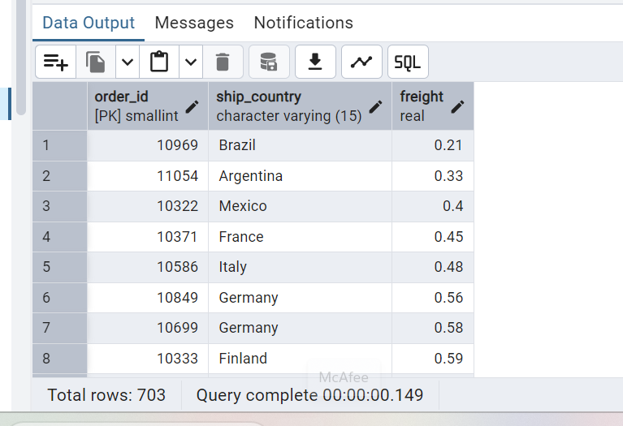

**------ ALL operator ----**

**SELECT ORDER_ID, SHIP_COUNTRY, FREIGHT**

**FROM ORDERS**

**WHERE SHIP_COUNTRY != 'USA'**

**AND FREIGHT > ALL (SELECT FREIGHT**

**FROM ORDERS**

**WHERE SHIP_COUNTRY = 'USA' )**

**ORDER BY FREIGHT;**

