1. Update the categoryName From “Beverages” to "Drinks" in the categories table.

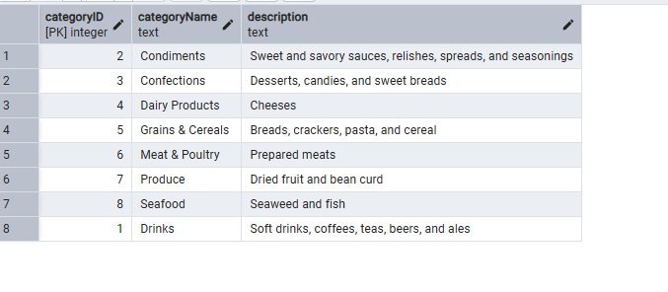

2) Insert into shipper new record (give any values) Delete that new record from shippers table.

After adding record

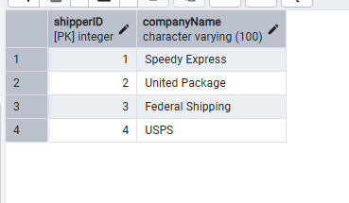

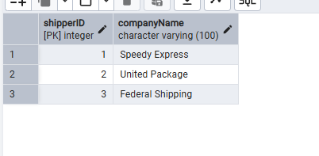

Update categoryID=1 to categoryID=1001. Make sure related products update their categoryID too. Display the both category and products table to show the cascade.

Delete the categoryID= “3” from categories. Verify that the corresponding records are deleted automatically from products.

Initially before updating

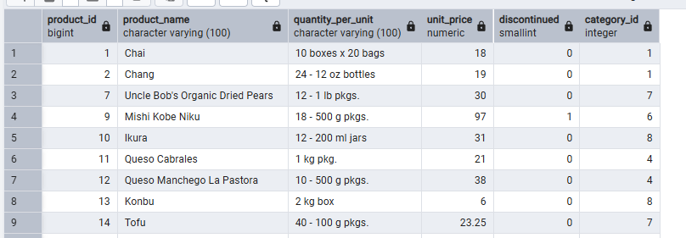

After updating categories table

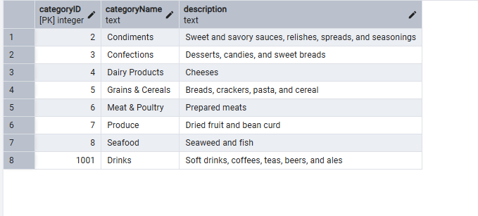

Products table

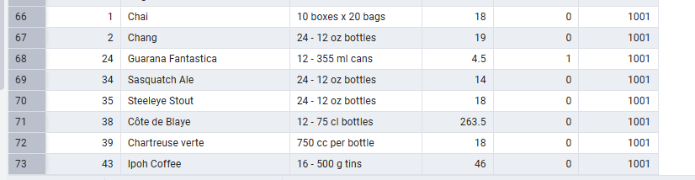

4) Delete the customer = “VINET” from customers. Corresponding customers in orders table should be set to null (HINT: Alter the foreign key on orders(customerID) to use ON DELETE SET NULL)

Orders table before deleting the customer = VINET

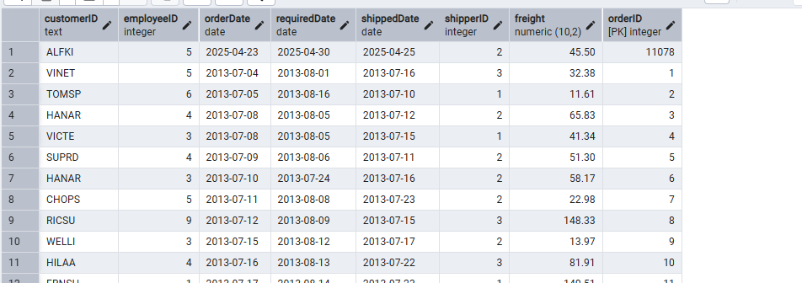

After deleting vinet customer

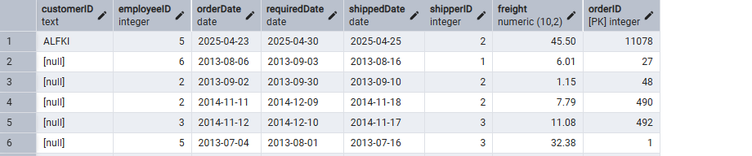

--product_id = 100, product_name = Wheat bread, quantity_per_unit=1,unitprice = 13, discontinued = 0, categoryID=3

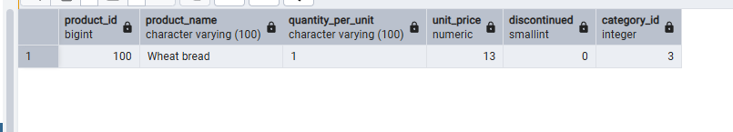

--product_id = 101, product_name = White bread, quantity_per_unit=5 boxes,unitprice = 13, discontinued = 0, categoryID=3

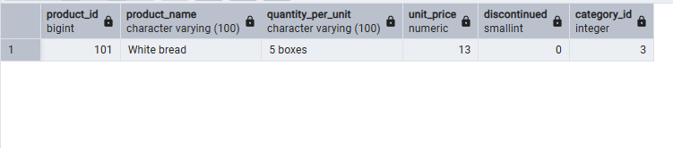

product_id = 100, product_name = Wheat bread, quantity_per_unit=10 boxes,unitprice = 13, discontinued = 0, categoryID=3

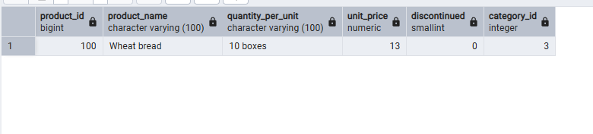

6) Write a **MERGE query**:

Create **temp table with name:**  ‘updated_products’ and insert values as below:

|  |  |  |  |  |  |
| --- | --- | --- | --- | --- | --- |
| productID | productName | quantityPerUnit | unitPrice | discontinued | categoryID |
| 100 | Wheat bread | 10 | 20 | 1 | 3 |
| 101 | White bread | 5 boxes | 19.99 | 0 | 3 |
| 102 | Midnight Mango Fizz | 24 - 12 oz bottles | 19 | 0 | 1 |
| 103 | Savory Fire Sauce | 12 - 550 ml bottles | 10 | 0 | 2 |

* Update the price and discontinued status for from below table ‘updated_products’ only if there are matching products and updated_products .discontinued =0
* If there are matching products and updated_products .discontinued =1 then delete

* Insert any new products from updated_products that don’t exist in products only if updated_products .discontinued =0.

