Day 7 Assignment

/*1. Rank employees by their total sales

(Total sales = Total no of orders handled, JOIN employees and orders table)*/

SELECT

E.EMPLOYEE_ID,

CONCAT(E.FIRST_NAME, ' ', E.LAST_NAME) AS EMPLOYEE_NAME,

COUNT(O.ORDER_ID) as Total_orders,

RANK() OVER (

ORDER BY COUNT(o.order_id)

) AS order_rank

FROM EMPLOYEES E

RIGHT JOIN ORDERS O ON E.EMPLOYEE_ID = O.EMPLOYEE_ID

GROUP BY E.EMPLOYEE_ID, EMPLOYEE_NAME

order by order_rank;

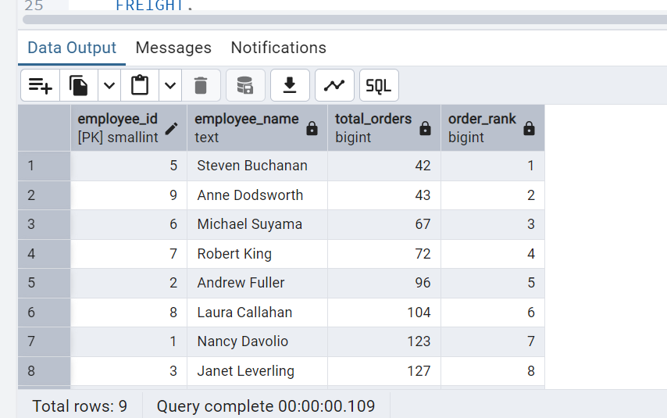

/*2. Compare current order's freight with previous and next order for each customer.

(Display order_id, customer_id, order_date, freight,

Use lead(freight) and lag(freight).*/

SELECT

ORDER_ID,

CUSTOMER_ID,

ORDER_DATE,

FREIGHT,

LAG(FREIGHT) OVER (

ORDER BY ORDER_ID

) AS PREVIOUS_ORDERFREIGHT,

FREIGHT - LAG(FREIGHT) OVER (

ORDER BY ORDER_ID

) AS FREIGHT_DIFFERENCES

FROM ORDERS;

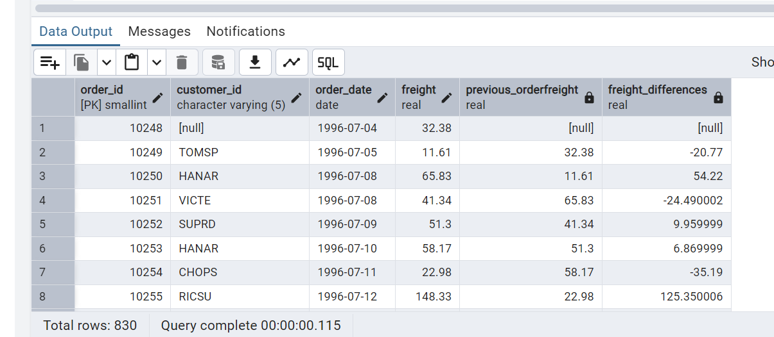

---- Lead ----

SELECT

ORDER_ID,

CUSTOMER_ID,

ORDER_DATE,

FREIGHT,

Lead(FREIGHT) OVER (

ORDER BY ORDER_ID

) AS Next_orderFreight,

FREIGHT -LEAD(FREIGHT) OVER (

ORDER BY ORDER_ID

) AS FREIGHT_DIFFERENCES

FROM ORDERS;

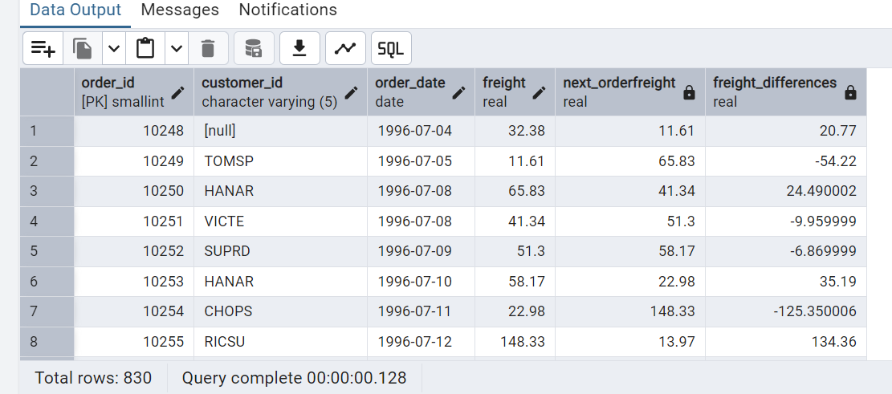

/*3. Show products and their price categories, product count in each category, avg price:

(HINT:· Create a CTE which should have price_category definition:

WHEN unit_price < 20 THEN 'Low Price'

WHEN unit_price < 50 THEN 'Medium Price'

ELSE 'High Price'

· In the main query display: price_category, product_count in each price_category, ROUND(AVG(unit_price)::numeric, 2) as avg_price)*/

SELECT

CASE

WHEN UNIT_PRICE < 20 THEN 'Low Price'

WHEN UNIT_PRICE < 50 THEN 'Medium Price'

ELSE 'HIGH price'

END AS PRICE_CATEGORY,

COUNT(CATEGORY_ID) AS PRODUCT_COUNT,

ROUND(AVG(UNIT_PRICE)::NUMERIC, 2) AS AVG_PRICE

FROM PRODUCTS

GROUP BY PRICE_CATEGORY;

