**1.Rank employees by their total sales**

**(Total sales = Total no of orders handled, JOIN employees and orders table)**

**SELECT e.first_name||''||e.last_name AS Full_name,**

**count(o.order_id) AS Total_sales,**

**RANK() OVER(**

**ORDER BY count(o.order_id) DESC**

**)As sales_rank**

**FROM orders o**

**INNER JOIN**

**employees e**

**ON o.employee_id= e.employee_id**

**GROUP BY**

**Full_name**

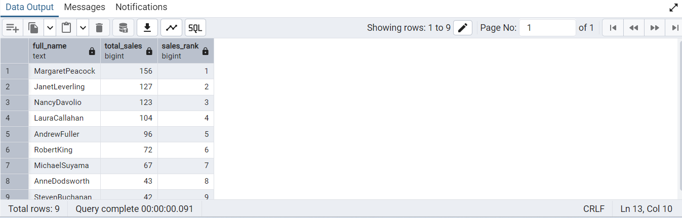

**==================================================**

**2.Compare current order's freight with previous and next order for each customer.**

**(Display order_id,  customer_id,  order_date,  freight,**

**Use lead(freight) and lag(freight).**

**SELECT order_id, customer_id,order_date,freight,**

**lag(freight) over(partition by customer_id ORDER BY order_date )As previous_freight,**

**lead(freight) over(partition by customer_id ORDER BY order_date )As next_freight**

**FROM orders**

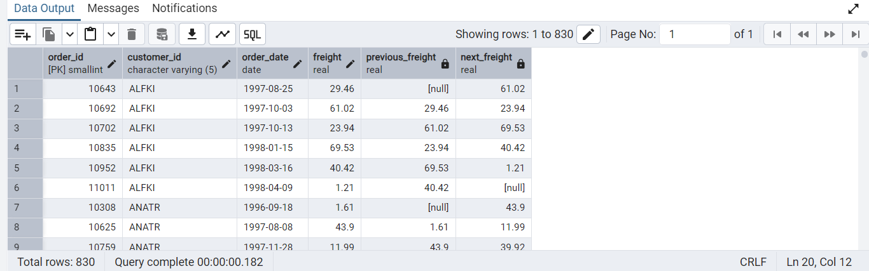

**==================================================**

**3.Show products and their price categories, product count in each category, avg price:**

**(HINT:**

**·  Create a CTE which should have price_category definition:**

**WHEN unit_price < 20 THEN 'Low Price'**

**WHEN unit_price < 50 THEN 'Medium Price'**

**ELSE 'High Price'**

**·  In the main query display: price_category,  product_count in each price_category,  ROUND(AVG(unit_price)::numeric, 2) as avg_price)**

**WITH price_cte AS (**

**SELECT**

**product_id,**

**product_name,**

**unit_price,**

**CASE**

**WHEN unit_price < 20 THEN 'Low Price'**

**WHEN unit_price < 50 THEN 'Medium Price'**

**ELSE 'High Price'**

**END AS price_category**

**FROM**

**products**

**)**

**SELECT**

**price_category,**

**COUNT(*) AS product_count,**

**ROUND(AVG(unit_price)::numeric, 2) AS avg_price**

**FROM**

**price_cte**

**GROUP BY**

**price_category**

**ORDER BY**

**Price_category;**

