DAY 9 assignment

1. Create AFTER UPDATE trigger to track product price changes

---Create a audit table

CREATE TABLE product_price_audit(

audit_id SERIAL PRIMARY KEY,

product_id INT,

product_name VARCHAR(40),

old_price DECIMAL(10,2),

new_price DECIMAL(10,2),

change_date TIMESTAMP DEFAULT CURRENT_TIMESTAMP,

user_name VARCHAR(50) DEFAULT CURRENT_USER

);

----1. define trigger function

CREATE OR REPLACE FUNCTION log_new_product()

RETURNs TRIGGER as $$

BEGIN

----2. Insert into aufit log table

INSERT INTO product_price_audit(

product_id,

product_name,

old_price,

new_price

)

VALUES (

OLD.product_id,

OLD.product_name,

OLD.unit_price,

NEW.unit_price

);

---3. return new row

RETURN NEW; ----required for AFTER TRIGGERS

END;

$$ LANGUAGE plpgsql;

---Create a row level trigger for below event: AFTER UPDATE OF unit_price ON products

CREATE TRIGGER after_product_uodate

AFTER UPDATE OF unit_price ON products

FOR EACH ROW

EXECUTE FUNCTION log_new_product();

--· Test the trigger by updating the product price by 10% to any one product_id.

UPDATE products

SET unit_price = unit_price* 1.1

WHERE product_id = 3;

SELECT * FROM products

WHERE product_id = 3;

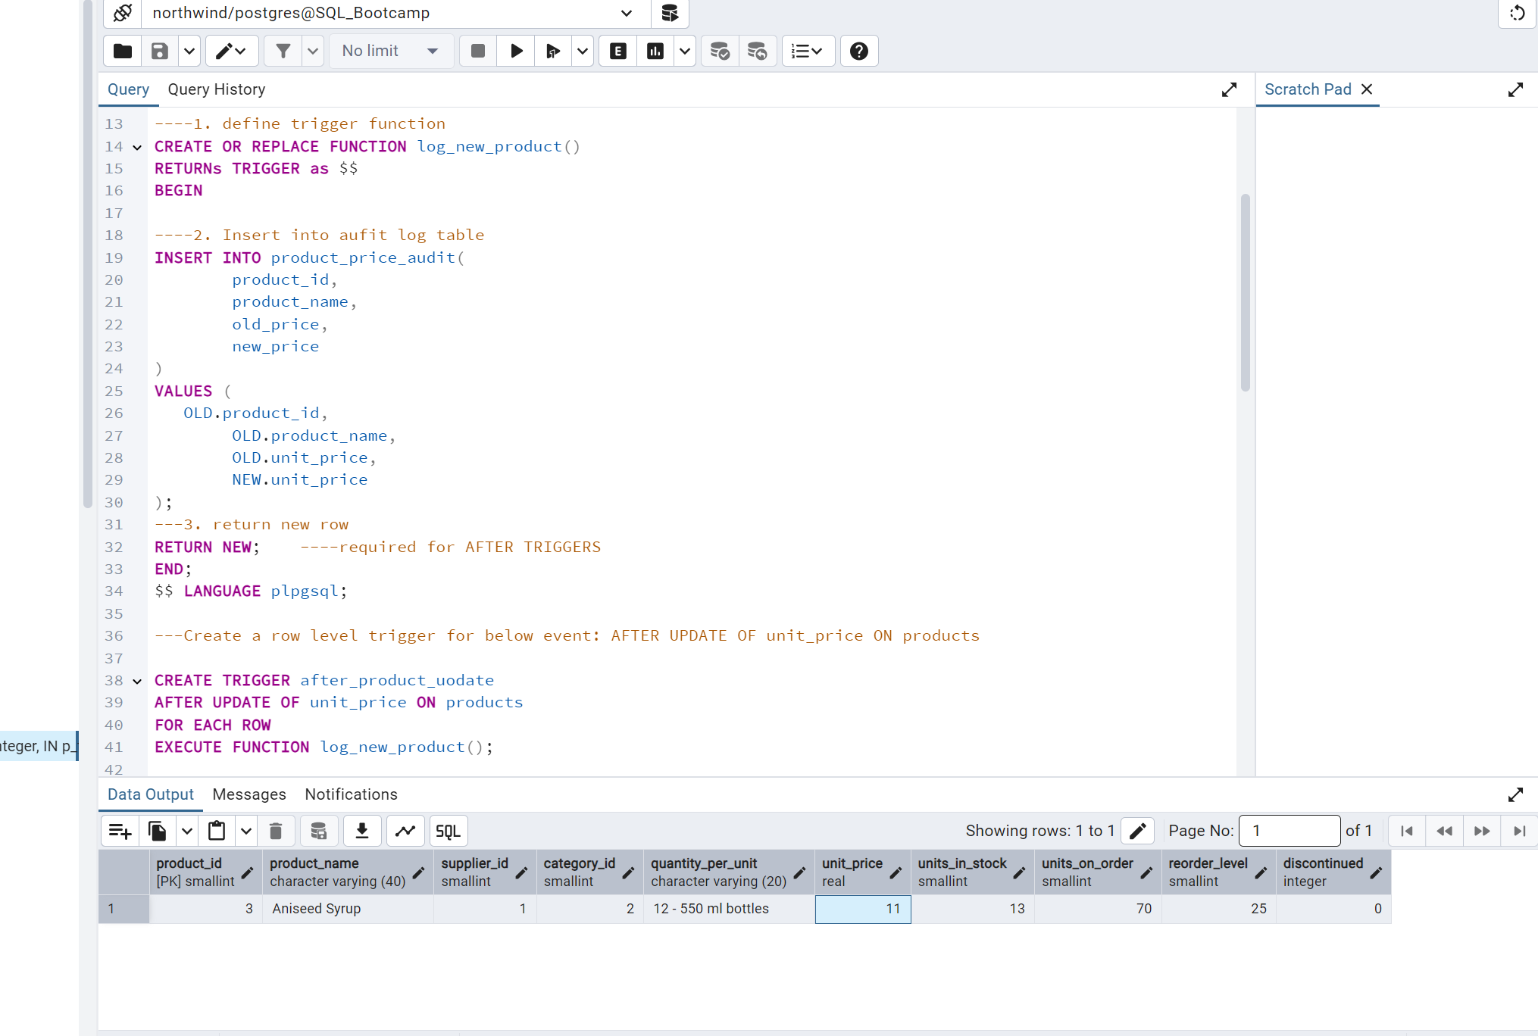

-- 2. Create stored procedure using IN and INOUT parameters to assign tasks to employees

CREATE or REPLACE PROCEDURE assign_tasks(

IN p_employee_id INT,

IN p_task_name VARCHAR(50),

INOUT p_task_count INT DEFAULT 0

)

LANGUAGE plpgsql

AS $$

BEGIN

---· Inside Logic: Create table employee_tasks:

CREATE TABLE IF NOT EXISTS employee_tasks(

task_id SERIAL PRIMARY KEY,

employee_id INT,

task_name VARCHAR(50),

assigned_date DATE DEFAULT CURRENT_DATE);

----- Insert employee_id, task_name into employee_tasks

INSERT INTO employee_tasks(employee_id,task_name)

Values(p_employee_id, p_task_name);

----· Count total tasks for employee and put the total count into p_task_count .

SELECT

count(*)

INTO p_task_count INT

FROM employee_tasks;

----· Raise NOTICE message:

RAISE NOTICE 'ask "%" assigned to employee %. Total tasks: %',p_task_name, p_employee_id, p_task_count;

END;

$$;

---After creating stored procedure test by calling it:

CALL assign_tasks( 2, 'Review Reports');

----You should see the entry in employee_tasks table.

SELECT * FROM employee_tasks;

