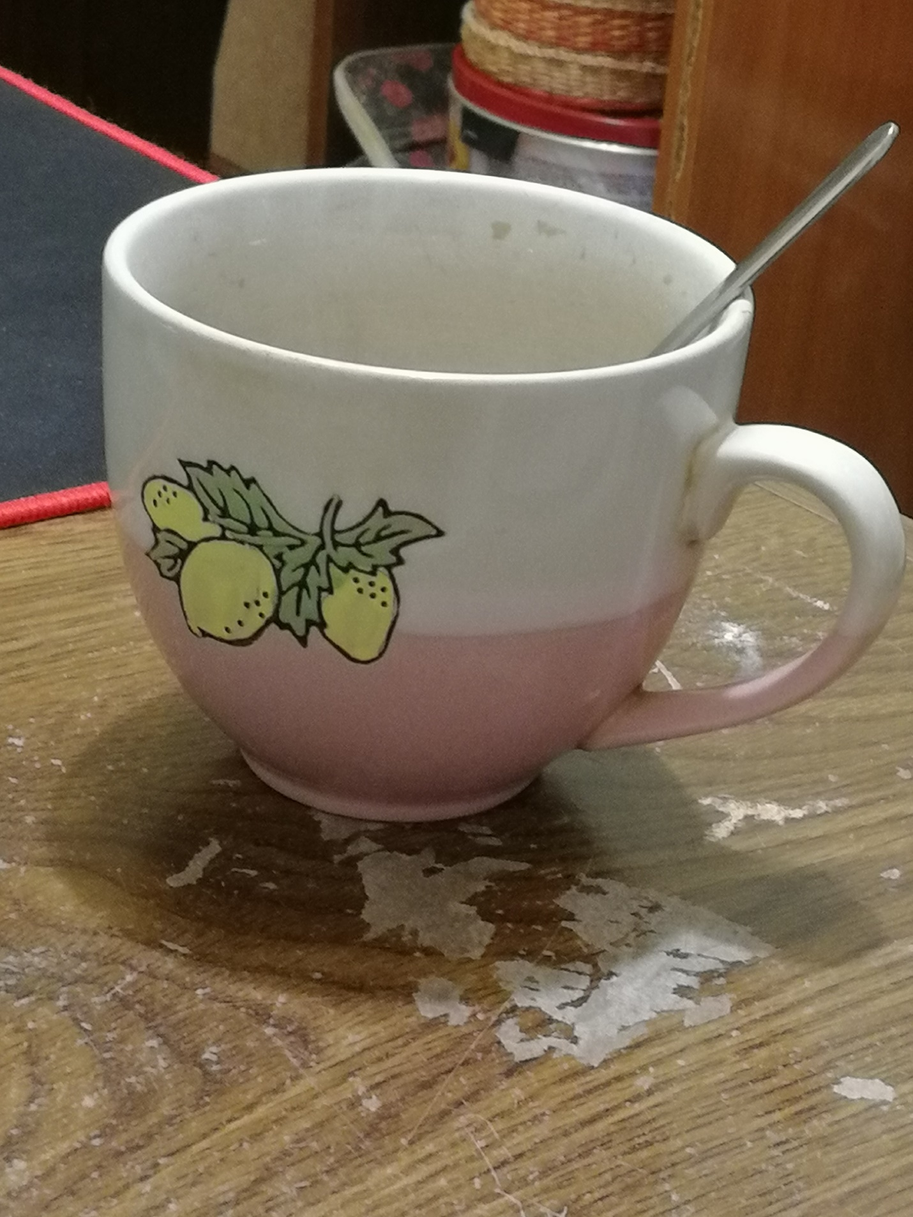

Были получены следующие данные:
create | 2020-12-04T15:29:17+00:00
ApertureValue | 227/100
BitsPerSample | 8, 8, 8
BrightnessValue | 0/1
ColorSpace | 1
ComponentsConfiguration | 1, 2, 3, 0
CompressedBitsPerPixel | 95/100
Compression | 6
Contrast | 0
CustomRendered | 1
DateTime | 2020:12:04 18:26:32
DateTimeDigitized | 2020:12:04 18:26:32
DateTimeOriginal | 2020:12:04 18:26:32
DeviceSettingDescription | 105, 112, 112, 0
DigitalZoomRatio | 100/100
DocumentName
ExifImageLength | 3968
ExifImageWidth | 2976
ExifOffset | 270
ExifVersion | 48, 50, 49, 48
ExposureBiasValue | 0/10
ExposureMode | 0
ExposureProgram | 2
ExposureTime | 50000000/1000000000
FileSource | 3
Flash | 0
FlashPixVersion | 48, 49, 48, 48
FNumber | 220/100
FocalLength | 3950/1000
FocalLengthIn35mmFilm | 87
GainControl | 0
ImageLength | 3968
ImageWidth | 2976
InteroperabilityIndex | R98
InteroperabilityOffset | 8490
InteroperabilityVersion | 48, 49, 48, 48
ISOSpeedRatings | 500
JPEGInterchangeFormat | 8650
JPEGInterchangeFormatLength | 23285
LightSource | 1
Make | HUAWEI
MakerNote | 65, 117, 116, 111, 0
MaxApertureValue | 227/100
MeteringMode | 5
Model | STF-L09
Orientation | 0
ResolutionUnit | 2
Saturation | 0
SceneCaptureType | 0
SceneType | 1
SensingMethod | 2
Sharpness | 0
ShutterSpeedValue | 298973/10000
Software | STF-L09 9.1.0.220(C10E2R1P6)
SubjectDistanceRange | 0
SubSecTime | 669399
SubSecTimeDigitized | 669399
SubSecTimeOriginal | 669399
WhiteBalance | 0
XResolution | 72/1
YCbCrPositioning | 1
YResolution | 72/1
modify | 2020-12-04T15:29:17+00:00
ApertureValue | 227/100
BitsPerSample | 8, 8, 8
BrightnessValue | 0/1
ColorSpace | 1
ComponentsConfiguration | 1, 2, 3, 0
CompressedBitsPerPixel | 95/100
Compression | 6
Contrast | 0
CustomRendered | 1
DateTime | 2020:12:04 18:26:32
DateTimeDigitized | 2020:12:04 18:26:32
DateTimeOriginal | 2020:12:04 18:26:32
DeviceSettingDescription | 105, 112, 112, 0
DigitalZoomRatio | 100/100
DocumentName
ExifImageLength | 3968
ExifImageWidth | 2976
ExifOffset | 270
ExifVersion | 48, 50, 49, 48
ExposureBiasValue | 0/10
ExposureMode | 0
ExposureProgram | 2
ExposureTime | 50000000/1000000000
FileSource | 3
Flash | 0
FlashPixVersion | 48, 49, 48, 48
FNumber | 220/100
FocalLength | 3950/1000
FocalLengthIn35mmFilm | 87
GainControl | 0
ImageLength | 3968
ImageWidth | 2976
InteroperabilityIndex | R98
InteroperabilityOffset | 8490
InteroperabilityVersion | 48, 49, 48, 48
ISOSpeedRatings | 500
JPEGInterchangeFormat | 8650
JPEGInterchangeFormatLength | 23285
LightSource | 1
Make | HUAWEI
MakerNote | 65, 117, 116, 111, 0
MaxApertureValue | 227/100
MeteringMode | 5
Model | STF-L09
Orientation | 0
ResolutionUnit | 2
Saturation | 0
SceneCaptureType | 0
SceneType | 1
SensingMethod | 2
Sharpness | 0
ShutterSpeedValue | 298973/10000
Software | STF-L09 9.1.0.220(C10E2R1P6)
SubjectDistanceRange | 0
SubSecTime | 669399
SubSecTimeDigitized | 669399
SubSecTimeOriginal | 669399
WhiteBalance | 0
XResolution | 72/1
YCbCrPositioning | 1
YResolution | 72/1
colorspace | 2
ApertureValue | 227/100
BitsPerSample | 8, 8, 8
BrightnessValue | 0/1
ColorSpace | 1
ComponentsConfiguration | 1, 2, 3, 0
CompressedBitsPerPixel | 95/100
Compression | 6
Contrast | 0
CustomRendered | 1
DateTime | 2020:12:04 18:26:32
DateTimeDigitized | 2020:12:04 18:26:32
DateTimeOriginal | 2020:12:04 18:26:32
DeviceSettingDescription | 105, 112, 112, 0
DigitalZoomRatio | 100/100
DocumentName
ExifImageLength | 3968
ExifImageWidth | 2976
ExifOffset | 270
ExifVersion | 48, 50, 49, 48
ExposureBiasValue | 0/10
ExposureMode | 0
ExposureProgram | 2
ExposureTime | 50000000/1000000000
FileSource | 3
Flash | 0
FlashPixVersion | 48, 49, 48, 48
FNumber | 220/100
FocalLength | 3950/1000
FocalLengthIn35mmFilm | 87
GainControl | 0
ImageLength | 3968
ImageWidth | 2976
InteroperabilityIndex | R98
InteroperabilityOffset | 8490
InteroperabilityVersion | 48, 49, 48, 48
ISOSpeedRatings | 500
JPEGInterchangeFormat | 8650
JPEGInterchangeFormatLength | 23285
LightSource | 1
Make | HUAWEI
MakerNote | 65, 117, 116, 111, 0
MaxApertureValue | 227/100
MeteringMode | 5
Model | STF-L09
Orientation | 0
ResolutionUnit | 2
Saturation | 0
SceneCaptureType | 0
SceneType | 1
SensingMethod | 2
Sharpness | 0
ShutterSpeedValue | 298973/10000
Software | STF-L09 9.1.0.220(C10E2R1P6)
SubjectDistanceRange | 0
SubSecTime | 669399
SubSecTimeDigitized | 669399
SubSecTimeOriginal | 669399
WhiteBalance | 0
XResolution | 72/1
YCbCrPositioning | 1
YResolution | 72/1
sampling-factor | 2x2,1x1,1x1
ApertureValue | 227/100
BitsPerSample | 8, 8, 8
BrightnessValue | 0/1
ColorSpace | 1
ComponentsConfiguration | 1, 2, 3, 0
CompressedBitsPerPixel | 95/100
Compression | 6
Contrast | 0
CustomRendered | 1
DateTime | 2020:12:04 18:26:32
DateTimeDigitized | 2020:12:04 18:26:32
DateTimeOriginal | 2020:12:04 18:26:32
DeviceSettingDescription | 105, 112, 112, 0
DigitalZoomRatio | 100/100
DocumentName
ExifImageLength | 3968
ExifImageWidth | 2976
ExifOffset | 270
ExifVersion | 48, 50, 49, 48
ExposureBiasValue | 0/10
ExposureMode | 0
ExposureProgram | 2
ExposureTime | 50000000/1000000000
FileSource | 3
Flash | 0
FlashPixVersion | 48, 49, 48, 48
FNumber | 220/100
FocalLength | 3950/1000
FocalLengthIn35mmFilm | 87
GainControl | 0
ImageLength | 3968
ImageWidth | 2976
InteroperabilityIndex | R98
InteroperabilityOffset | 8490
InteroperabilityVersion | 48, 49, 48, 48
ISOSpeedRatings | 500
JPEGInterchangeFormat | 8650
JPEGInterchangeFormatLength | 23285
LightSource | 1
Make | HUAWEI
MakerNote | 65, 117, 116, 111, 0
MaxApertureValue | 227/100
MeteringMode | 5
Model | STF-L09
Orientation | 0
ResolutionUnit | 2
Saturation | 0
SceneCaptureType | 0
SceneType | 1
SensingMethod | 2
Sharpness | 0
ShutterSpeedValue | 298973/10000
Software | STF-L09 9.1.0.220(C10E2R1P6)
SubjectDistanceRange | 0
SubSecTime | 669399
SubSecTimeDigitized | 669399
SubSecTimeOriginal | 669399
WhiteBalance | 0
XResolution | 72/1
YCbCrPositioning | 1
YResolution | 72/1

FOCA
Сбор информации будет производится с сайта МВД РФ, https://xn--b1aew.xn--p1ai/
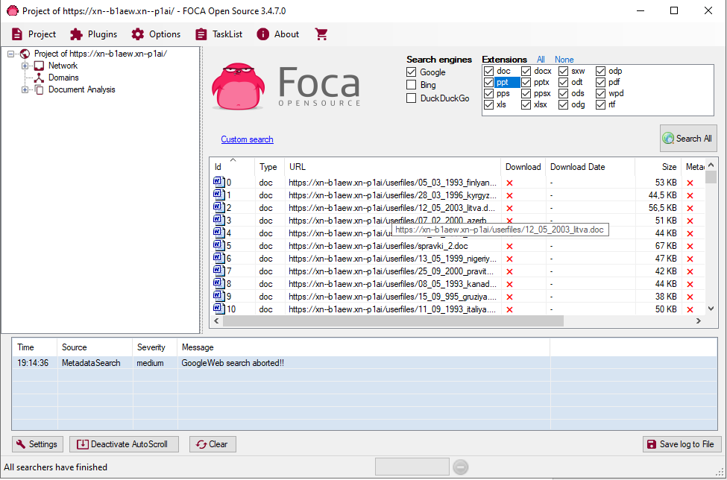
Произведя загрузку всех файлов с данного ресурса, производится автоматический анализ собранных файлов на наличие владельцев файлов, паролей и т.д.

CCleaner
