DATA STRUCTURES USING C
LAB PROJECT REPORT

Student Academic Performance & CGPA Tracker
A Linked-List Based C Language Mini Project

Submitted By | Shashawt Bhadre (SCFU125087)  Rehan Nadaf (SCFU125076)  Onkar Kalshetti (SCFU125095)
Program | B.Tech CSE (Division B)
Course | Data Structures Using C
Course Instructor | Prof. Sanjib Pal
Academic Year | 2025–2026

1. Project Overview
The Student Academic Performance & CGPA Tracker is a console-based application developed in the C programming language. The project is designed to manage complete student academic records, compute GPA/CGPA using a weighted credit system, rank students by academic performance, and identify students at risk due to backlogs.

The core data structure used is a singly linked list, where each node represents one student. Nodes are dynamically allocated using malloc() and freed at exit. This design allows the list to grow or shrink at runtime without wasting memory on a fixed-size array, making it a practical demonstration of dynamic memory management in C.

This project was developed as part of the Data Structures Using C laboratory course and implements several fundamental programming concepts simultaneously: structures, pointers, dynamic memory allocation, linked lists, sorting algorithms, and string processing.

2. Objectives
The key objectives of this project are:
- To design and implement a student record management system using a singly linked list in C.
- To compute CGPA dynamically using a credit-weighted formula based on subject marks and credit values.
- To provide search, edit, add, and display functionality through an interactive menu-driven interface.
- To rank students in descending order of CGPA using the Bubble Sort algorithm on a pointer array.
- To identify students in academic backlog (CGPA below 4.0) and display relevant warnings.
- To demonstrate effective use of dynamic memory allocation (malloc/free) and pointer manipulation.

3. Data Structure Used

3.1 Singly Linked List
The project uses a singly linked list as the primary data structure. Each node in the list is of type struct Student and holds all academic information for one student, along with a pointer to the next node in the list.

The node structure is defined as follows:

typedef struct Student {
char name[50]; // Student full name
char rollNo[15]; // Unique roll number
int numSubjects; // Number of subjects (1-8)
float marks[8]; // Marks per subject (0-10 scale)
int credits[8]; // Credits per subject (1-5)
float cgpa; // Calculated CGPA
struct Student *next; // Pointer to next node
} Student;

A single global head pointer Student *head = NULL tracks the beginning of the list. Nodes are always appended to the tail using the appendNode() function, preserving insertion order.

3.2 Pointer Array for Sorting
The menuToppers() function builds a temporary array of Student pointers (Student **arr) to perform Bubble Sort without modifying the linked list structure itself. After sorting and displaying, the temporary array is freed. This pattern sorts by rearranging pointers rather than copying or reordering actual data nodes.

4. Features of the System

# | Feature | Description
1 | Bulk Student Input | At startup, the user specifies how many students to enter. Data for each student — name, roll number, subject count, marks, and credits — is collected and a new linked-list node is allocated and appended.
2 | Add More Students | After initial input, students can be added at any time from the menu without restarting the program.
3 | Display All Students | Prints a formatted table of all students with serial number, name, roll number, and CGPA.
4 | Search by Roll Number | Traverses the linked list and prints full details (name, CGPA, subject-wise marks and credits, backlog status) for the matched student.
5 | Edit / Update Marks | Allows updating marks for any student identified by roll number. CGPA is recalculated immediately after the update.
6 | Class Rankings & Topper | Builds a pointer array, sorts it in descending CGPA order using Bubble Sort, and displays the ranked list with the topper highlighted.
7 | Backlog Detection | Scans the list and prints all students with CGPA below 4.0, along with a count and a warning label.
8 | Memory Management | All nodes are freed on exit via freeAll(), which traverses the list and calls free() on each node, preventing memory leaks.

5. CGPA Calculation Formula
CGPA is calculated using the credit-weighted average formula, implemented in the calcCGPA() function:

CGPA = Σ (Marksᵢ × Creditsᵢ) / Σ Creditsᵢ

Where Marks is the grade point for subject i (on a 0–10 scale) and Credits is the credit value assigned to that subject (1–5). The denominator is the total credits across all subjects. If total credits are zero, CGPA defaults to 0.0 to avoid division by zero.

Example calculation:

Subject | Marks (0-10) | Credits | Points
Mathematics | 8.5 | 4 | 34.0
Data Structures | 9.0 | 5 | 45.0
Digital Electronics | 7.5 | 3 | 22.5
Communication Skills | 8.0 | 2 | 16.0
CGPA = 117.5 / 14 = |  |  | 8.39

6. Program Flow

START
inputNStudents() — collect N student records into linked list
Display main menu
User selects option (1–6 or 0)
menuAdd() | menuDisplay() | menuSearch()
menuEdit() | menuToppers() | menuBacklogs()
Loop back to menu (while choice != 0)
freeAll() — release all dynamic memory
EXIT

7. Key Functions and Their Roles

Function | Purpose & Notes
calcCGPA(s) | Computes CGPA using credit-weighted average. Called after every data entry or edit. Updates the node in place via pointer.
appendNode(node) | Traverses to the last node and links the new node. Handles the special case of an empty list (head == NULL).
fillStudent(s) | Reads name, roll number, subject count, marks, and credits with input validation. Calls calcCGPA() at the end.
inputNStudents() | Wrapper for bulk input at startup. Allocates nodes with malloc() and appends them.
menuAdd() | Same as inputNStudents() but called from the menu for post-startup additions.
menuDisplay() | Traverses the list and prints a formatted table with serial numbers, names, roll numbers, and CGPAs.
menuSearch() | Linear search by roll number. Displays full student details including subject-wise breakdown and backlog status.
menuEdit() | Locates a student by roll number and allows updating marks subject by subject. Recalculates CGPA via pointer.
menuToppers() | Allocates a Student** pointer array, copies node pointers, sorts using Bubble Sort, prints ranked output, and frees the array.
menuBacklogs() | Scans the list and prints all students with CGPA < 4.0 (the BACKLOG_MIN constant).
freeAll() | Iterates the list from head to NULL, freeing each node with free(). Sets head = NULL to avoid dangling pointers.
clearBuf() | Consumes all characters in the input buffer up to and including the newline. Prevents stale input from affecting subsequent reads.

8. Technologies and Tools Used

Category | Details
Programming Language | C (C99 standard)
Compiler / IDE | Online GDB / OnlineGDB.com — browser-based GCC compiler
Data Structure | Singly Linked List (dynamically allocated nodes)
Sorting Algorithm | Bubble Sort on a pointer array
Memory Management | malloc() for allocation, free() in freeAll() for deallocation
Input Handling | fgets() for strings, scanf() for integers/floats, clearBuf() for buffer flushing
String Operations | strcspn(), strcmp(), strcpy() from <string.h>

9. Source Code Screenshots
The following screenshots show the complete source code of the project as developed in OnlineGDB. The code is split across 11 screenshots covering all functions from the struct definition through to main().

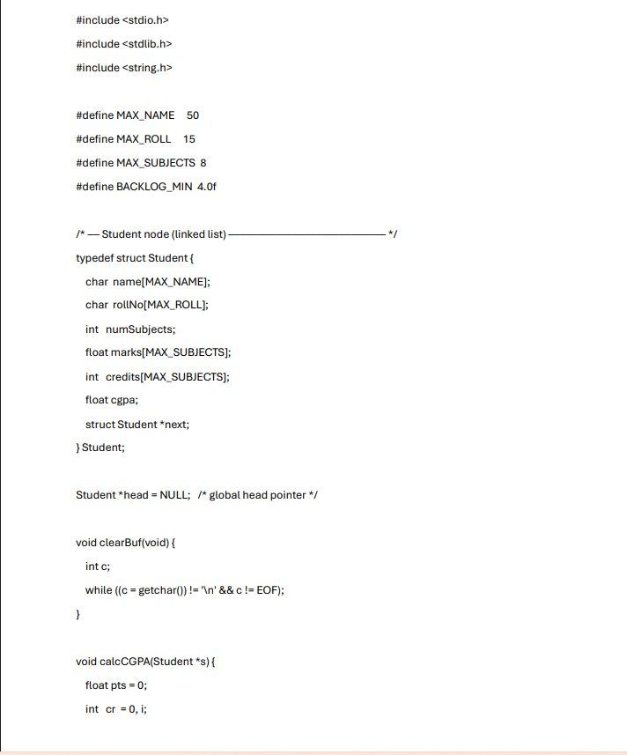
Screenshot 1: Header includes, macro definitions, Student struct definition, clearBuf() and calcCGPA()
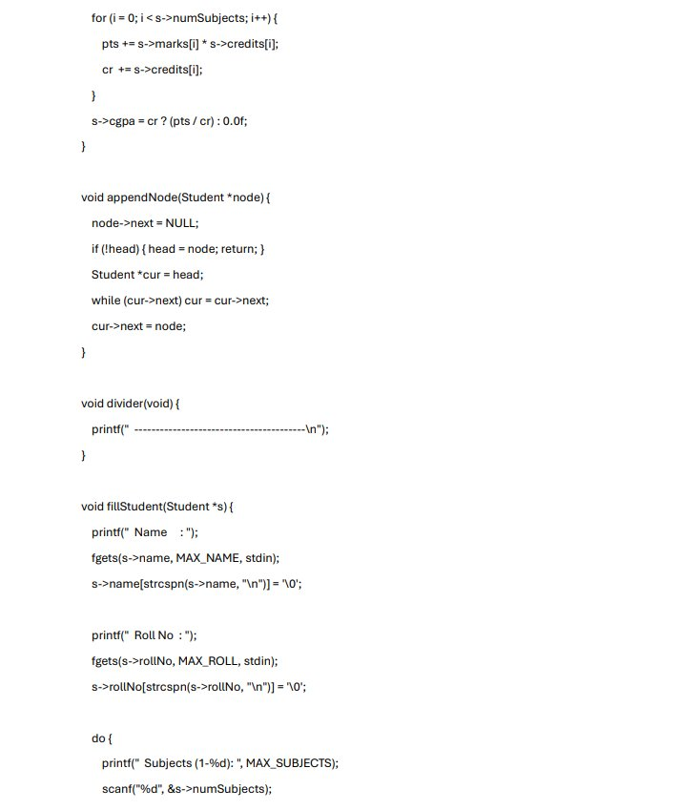
Screenshot 2: calcCGPA() loop, appendNode(), divider(), and fillStudent() — name and roll input
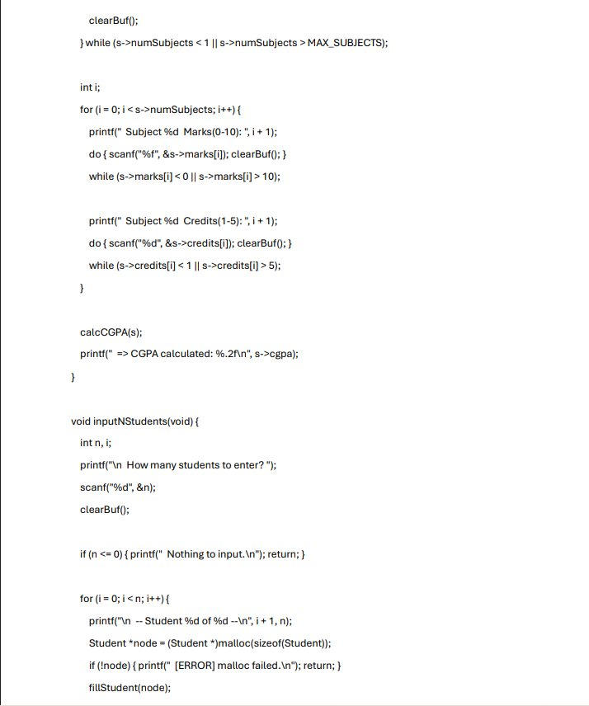
Screenshot 3: fillStudent() — subject marks/credits input with validation, calcCGPA call, inputNStudents()
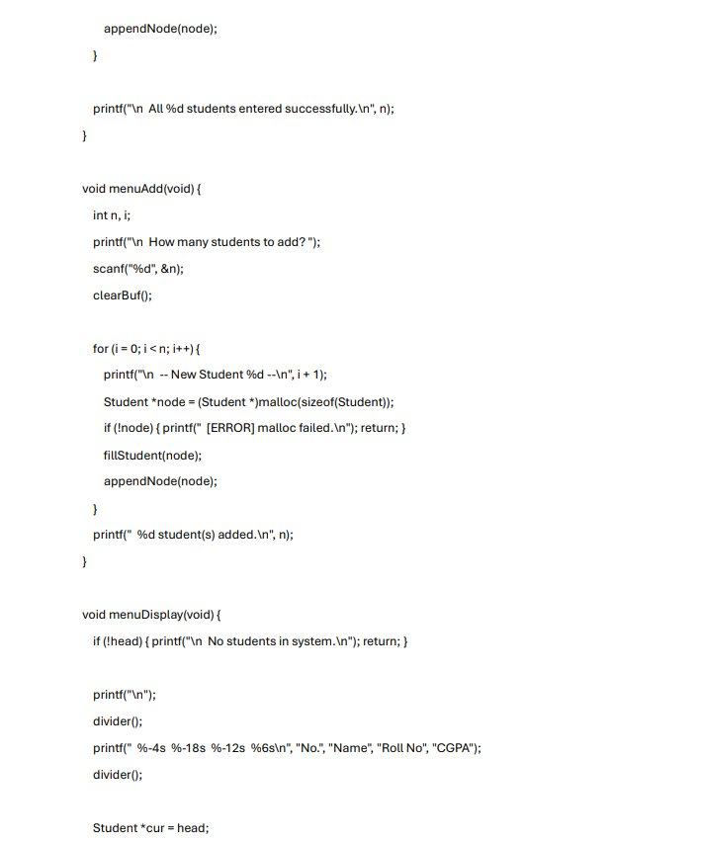
Screenshot 4: inputNStudents() completion, menuAdd(), and menuDisplay() — display table setup
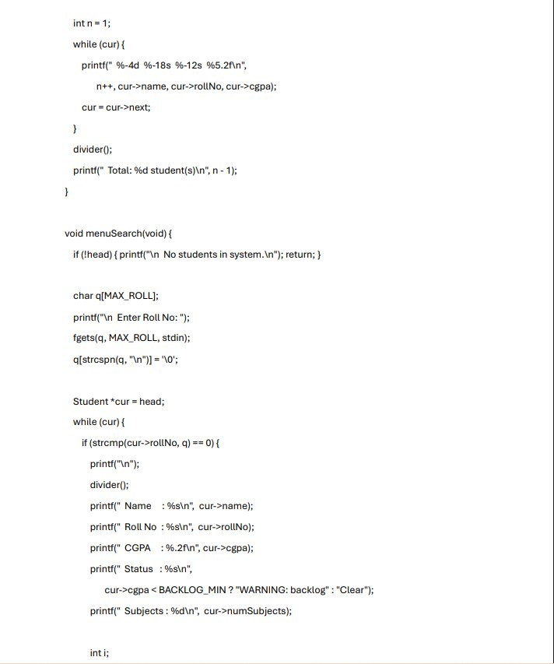
Screenshot 5: menuDisplay() — while loop printing rows, and menuSearch() — roll number search
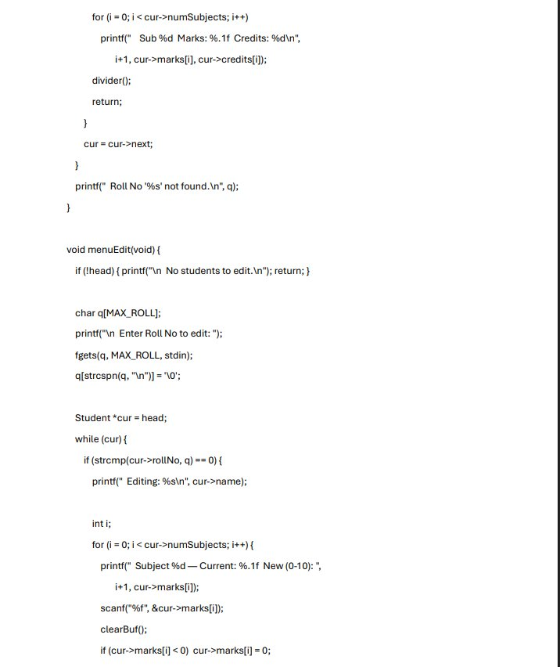
Screenshot 6: menuSearch() — subject detail printout, and menuEdit() — roll number lookup and marks update
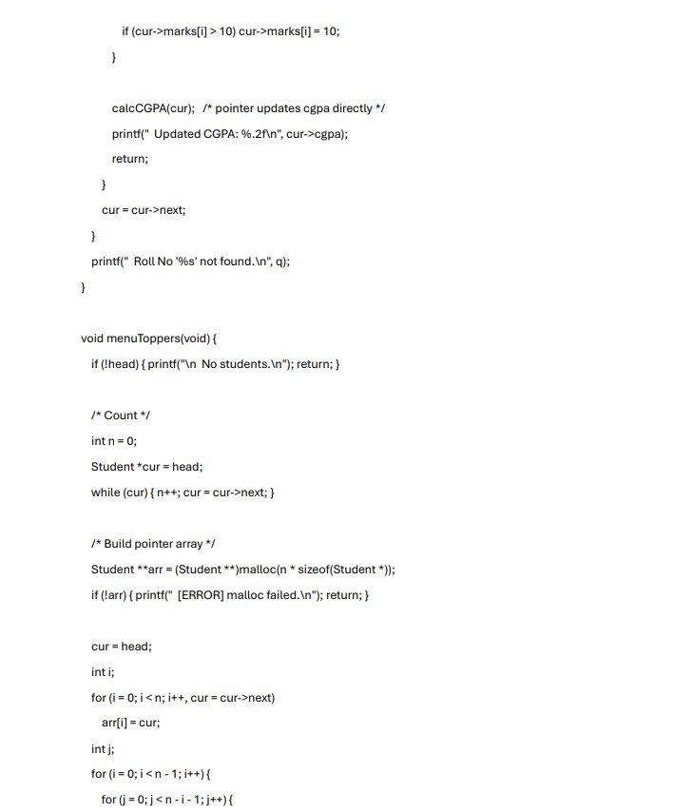
Screenshot 7: menuEdit() — marks clamping and CGPA update, menuToppers() — count and pointer array build
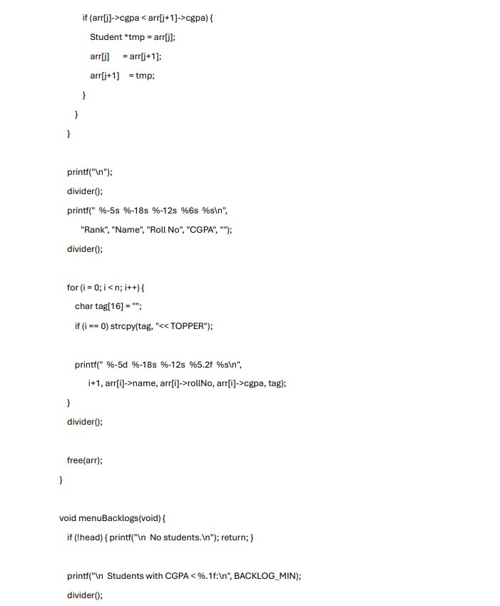
Screenshot 8: menuToppers() — Bubble Sort, ranked output with topper tag, and menuBacklogs() start
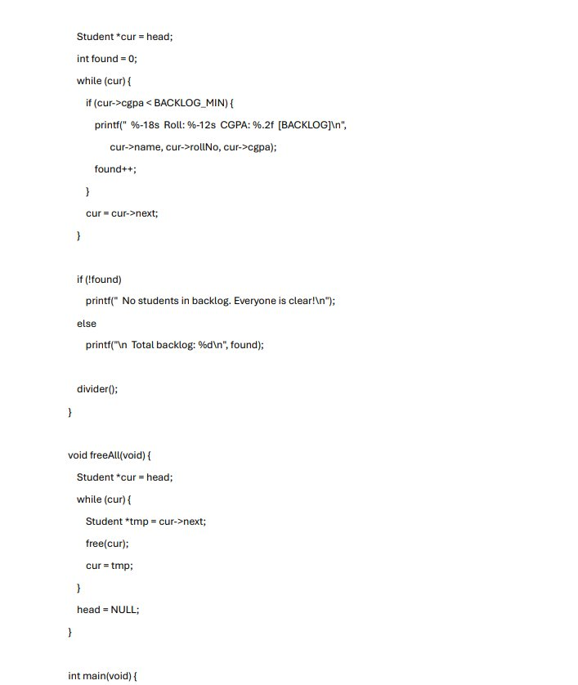
Screenshot 9: menuBacklogs() — CGPA scan and output, freeAll(), and main() function opening
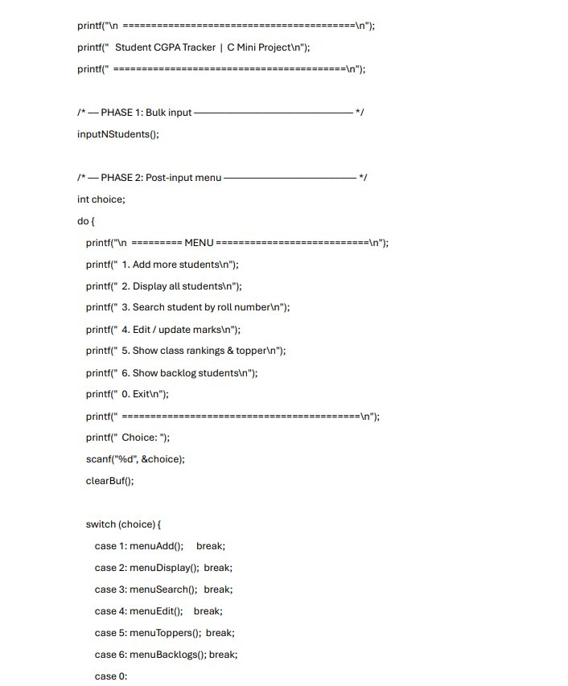
Screenshot 10: main() — banner print, Phase 1 inputNStudents(), Phase 2 menu do-while loop with switch
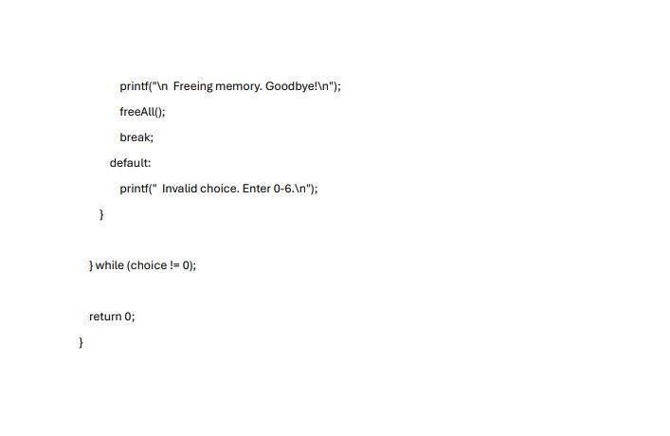
Screenshot 11: main() — case 0 exit handler, default invalid choice, while condition, and return 0

10. Advantages of the System
- Dynamic memory usage: the linked list grows only as needed, using no more memory than the number of students actually entered.
- No database required: all operations run in-memory, making the program portable and self-contained.
- Credit-weighted CGPA: the formula accurately reflects real-world academic grading by weighting high-credit subjects more heavily.
- Immediate recalculation: editing any student's marks triggers instant CGPA recalculation via pointer update.
- Clean memory exit: freeAll() ensures no memory leaks, demonstrating professional memory management practice.
- Robust input validation: marks and credit inputs are validated in do-while loops and clamped to valid ranges.

11. Limitations and Future Scope

11.1 Current Limitations
- Data is not persisted: all records are lost when the program exits because no file I/O is implemented.
- Single-session only: there is no load/save mechanism to restore previous sessions.
- Linear search: searching and editing require O(n) traversal; with thousands of records this would be slow.
- No duplicate roll number check: the system does not prevent two students from having the same roll number.
- Console-only UI: there is no graphical interface.

11.2 Future Enhancements
- File I/O using fopen()/fwrite()/fread() to save and load records across sessions.
- Binary Search Tree or Hash Table for O(log n) or O(1) search by roll number.
- Duplicate roll number validation at input time.
- Subject name storage and grade letter display (A+, B, C) alongside numeric marks.
- GUI front-end to replace the console interface.

12. Conclusion
The Student Academic Performance & CGPA Tracker successfully demonstrates how a singly linked list can serve as a practical backbone for a real-world data management application. By dynamically allocating each student node with malloc() and linking them through next pointers, the program achieves flexible, memory-efficient storage without the rigidity of fixed-size arrays.

The project integrates multiple core data structures and C programming concepts — structures, pointers, dynamic memory allocation, string handling, and sorting — into a single cohesive application. The credit-weighted CGPA formula mirrors actual academic grading systems, and features such as backlog detection and class ranking add practical value beyond a basic record-keeping system.

This project deepened the group's understanding of how abstract data structures translate into working software, and how careful memory management and input validation are essential in real C programs. The modular function design also made debugging and testing straightforward, as each feature is self-contained.

— End of Report —

