  
**Department of Computer Science and Information Technology**

**Software Engineering- COSC 625**

**Group Project**

**Project: - Sports Statistics Website**

**Team Members:**

|  |  |
| --- | --- |
| **Name** | **Email** |
| 1. Traivius A Chappell | [tachappell0@frostburg.edu](mailto:tachappell0@frostburg.edu) |
| 1. Travis C Hollingsworth | [tchollingsworth0@frostburg.edu](mailto:tchollingsworth0@frostburg.edu) |
| 1. Vageesh Hegde | [vhegde0@frostburg.edu](mailto:vhegde0@frostburg.edu) |

***Under the guidance of***

# **Dr. Michael B Flinn**



**2023**

**Applied Compute Science**

**README**  
  
**Important Files:**

**/Backend -**

This folder contains all the backend files of our website with the MySQL files.

**/sportsstats -**

This folder contains all of the front-end files of the sports stats web application.

**/sportstats/public -**

**Inside of the public folder contains the following:**

**index.html:** This is the main HTML file that serves as the entry point for your React application. It contains the root HTML structure and often includes a div element with an ID where the React app gets rendered.

/sportstats/src -

Inside of the src folder contains the following:  
  
Components folder: Houses the meticulously crafted UI and container components tailored for the web application. This repository encapsulates the core functionalities meticulously designed and implemented, breathing life into the web app experience.  
  
App.js - serves as the central hub where the application structure, routing, and state management are defined, orchestrating the overall functionality and appearance of the Sports Stats application.

Index.js - initiates the rendering process by injecting the root React component (App.js) into the designated HTML element in the DOM. It serves as a gateway to kickstart the React application and manage its interaction with the browser environment.

**Sports Stats Project Description:**

Sports Stats represents a versatile and user-centric web application tailored for sports enthusiasts, delivering a comprehensive array of features to elevate your sporting experience. Whether you're an ardent fan, a fervent follower of fantasy sports, or someone seeking profound sports statistics, Sports Stats caters to your needs. Presently centered on basketball, our platform is primed for future expansion, harboring ambitious plans to encompass a wider spectrum of sports under a strategic vision.

Within the application, users can delve into team standings, individual player statistics, and team analytics specific to a chosen season. Navigating through these functionalities is seamless, facilitated by an intuitive and user-friendly interface that ensures swift and efficient exploration.

Moreover, users benefit from daily updates on NBA sports news, alongside personalized profile customization options offering various wallpapers, profile images, and the ability to select favorite teams. Additionally, a dedicated help and contact page enables direct communication, empowering users to send queries or seek assistance, fostering responsive and supportive user-community interaction.

**Meet the Creators:**

*Travis:*

***Traivius:*** In this project, I took on the role of leading a dynamic team of three members, steering our collective efforts through an agile approach to navigate the software development lifecycle. We meticulously progressed through planning, thorough analysis, detailed design, and development stages.

My primary focus revolved around handling crucial API components within our web application. I led the development of these components, enabling seamless retrieval of the essential statistical information required for our users. Additionally, I orchestrated the migration of our initial codebase to React JS, thereby architecting a more streamlined and structured foundation. This transition resulted in a more coherent, easily maintainable, and updatable code structure, promoting efficiency and scalability within our project. I also integrated captivating customization capabilities to enhance the user experience and offer a more personalized journey while navigating our web application.

***Vageesh:*** In our group project, I had two roles: programmer and document writer. My main responsibility was to design the website framework and incorporate JavaScript components to enhance user interaction and experience. Additionally, I led the backend domain and ensured it aligned with the project's structure, despite the limited number of backend tasks in our project.

**Use Case diagram:**

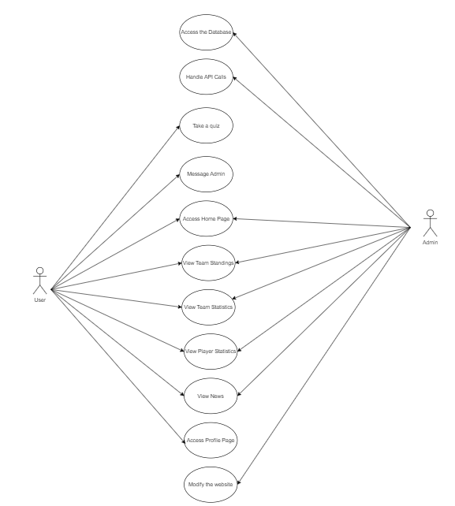

**Key Features:**

1. Basketball Statistics

Embark on an in-depth exploration of basketball statistics, meticulously designed to offer users a comprehensive experience. This feature-rich platform provides detailed player profiles, comprehensive team statistics, and team standings within the NBA. Utilize the search functionality to access player statistics by season and last name, empowering users with precise and targeted information about their favorite players. Moreover, seamlessly navigate through team standings and statistics by filtering data based on the season and specific team, ensuring a customized and detailed overview of team performance.

2. User Profiles

Tailor your experience by creating a personalized user profile. Select your favorite teams and players to receive customized updates.

3. Quiz Section

Challenge your NBA knowledge with our interactive quiz section. Enjoy a fun and educational experience while testing your understanding of basketball.

4. Theme Customization

Personalize Score Stats to reflect your unique style by customizing its theme and appearance. Select from a range of themes, including a sleek dark mode option, and adorn it with the logos of all NBA teams for a complete and tailored experience.

5. News

Within our web application, we harness the power of various APIs to deliver not just statistical data but also daily, up-to-date news. Users gain immediate access to the latest news directly on the homepage and can explore a comprehensive collection of articles within the dedicated news page, offering an expansive view of the diverse content regularly published in the NBA sports domain. This encompasses a wide spectrum, spanning from trending headlines to betting odds and beyond.

**Objectives:**

1. During Backlog preparation, objective 1 was to craft an engaging landing page that seamlessly provides comprehensive insights into basketball events while granting immediate access to a trove of basketball-related news and statistics. The focus lies in ensuring effortless navigation across the entire website, thereby ensuring a user-friendly journey as individuals explore the platform. The landing page's pivotal elements include a user-friendly interface facilitating account creation or login, which serves to enhance user engagement with the site's content and features. This foundational aspect paves the way for the addition of key features, forming the bedrock upon which subsequent enhancements can be seamlessly integrated.
2. Incorporate vital site functionalities into the web application by leveraging data retrieved from two APIs. These functionalities encompass enabling users to effortlessly search for individual player stats and information, access team standings, and explore team season statistics. Upholding the principles of seamless navigation and user-friendliness, each of these components will be individually presented with dedicated pages and distinct user interfaces, ensuring a fluid and intuitive experience while seamlessly delivering data to the user. This sprint is pivotal as we work towards implementing essential site functionalities. Our goal is to enhance the user experience by adding dedicated pages in the navigation bar for viewing game matchups, player profiles, seasons, and standings. Each of these features will come with its own beautifully designed user interface. To ensure we have the most up-to-date data, we will be retrieving information from an API (Application Programming Interface) for all these functions.
3. Our primary aim is to introduce features that elevate the sophistication and refinement of our platform. These enhancements entail the integration of personalized user profiles within our comprehensive profile management system. We're also implementing a seamless 'forgot password' functionality to bolster user account security significantly. Additionally, we're integrating an advanced search engine to optimize website navigation across all features, ensuring an even smoother and more efficient user experience. In our pursuit of crafting a distinctive and personalized user experience, unlike other sports news and stats applications, we are set to introduce customization options. This exciting feature will empower users to proudly represent and support their favorite team, adding a unique touch to their interaction with the platform.