PES-VCS Final Report

Name | Vageesh Hiremath
SRN | PES2UG24CS663
GitHub Repository | https://github.com/Vageeshhiremath/PES2UG24CS663-pes-vcs

This project implements a simplified Git-like Version Control System using content-addressable storage, tree structures, and commit history.

Phase 1: Object Storage Foundation
In this phase, I implemented content-addressable object storage using SHA-256 hashing.
Objects are stored inside .pes/objects using sharded directories, and object integrity is verified during reads.
Modified Code: object_write and object_read
int object_write(ObjectType type, const void *data, size_t len, ObjectID *id_out) { const char *type_str;
if (!data || !id_out) return -1;

switch (type) {
case OBJ_BLOB: type_str = "blob"; break; case OBJ_TREE: type_str = "tree"; break; case OBJ_COMMIT: type_str = "commit"; break; default: return -1;
}

char header[64];
int header_len = snprintf(header, sizeof(header), "%s %zu", type_str, len); if (header_len < 0 || (size_t)header_len + 1 > sizeof(header)) return -1;

size_t full_len = (size_t)header_len + 1 + len; unsigned char *full_object = malloc(full_len); if (!full_object) return -1;

memcpy(full_object, header, (size_t)header_len); full_object[header_len] = '\0'; memcpy(full_object + header_len + 1, data, len);

ObjectID id;
compute_hash(full_object, full_len, &id);
*id_out = id;
if (object_exists(&id)) { free(full_object); return 0; } char final_path[512];
object_path(&id, final_path, sizeof(final_path));

char shard_dir[512];
snprintf(shard_dir, sizeof(shard_dir), "%s", final_path); char *slash = strrchr(shard_dir, '/');
if (!slash) { free(full_object); return -1; }
*slash = '\0';

if (mkdir(shard_dir, 0755) != 0 && access(shard_dir, F_OK) != 0) { free(full_object); return -1;
}

char temp_path[512];
snprintf(temp_path, sizeof(temp_path), "%s.tmp.%ld", final_path, (long)getpid()); int fd = open(temp_path, O_CREAT | O_WRONLY | O_TRUNC, 0644);
if (fd < 0) { free(full_object); return -1; }

size_t written = 0;
while (written < full_len) {
ssize_t n = write(fd, full_object + written, full_len - written);
if (n <= 0) { close(fd); unlink(temp_path); free(full_object); return -1; } written += (size_t)n;
}

if (fsync(fd) != 0) { close(fd); unlink(temp_path); free(full_object); return -1; } if (close(fd) != 0) { unlink(temp_path); free(full_object); return -1; }
if (rename(temp_path, final_path) != 0) { unlink(temp_path); free(full_object); return -1; }

int dir_fd = open(shard_dir, O_RDONLY);
if (dir_fd >= 0) { fsync(dir_fd); close(dir_fd); } free(full_object);
return 0;
}

int object_read(const ObjectID *id, ObjectType *type_out, void **data_out, size_t *len_out) { if (!id || !type_out || !data_out || !len_out) return -1;

char path[512];
object_path(id, path, sizeof(path)); FILE *f = fopen(path, "rb");
if (!f) return -1;

if (fseek(f, 0, SEEK_END) != 0) { fclose(f); return -1; } long file_size = ftell(f);
if (file_size < 0) { fclose(f); return -1; } rewind(f);

unsigned char *buffer = malloc((size_t)file_size); if (!buffer) { fclose(f); return -1; }
size_t bytes_read = fread(buffer, 1, (size_t)file_size, f); fclose(f);

if (bytes_read != (size_t)file_size) { free(buffer); return -1; }

ObjectID actual_id;
compute_hash(buffer, (size_t)file_size, &actual_id);
if (memcmp(actual_id.hash, id->hash, HASH_SIZE) != 0) { free(buffer); return -1; }

unsigned char *nul = memchr(buffer, '\0', (size_t)file_size); if (!nul) { free(buffer); return -1; }

size_t header_len = (size_t)(nul - buffer); char header[128];
if (header_len >= sizeof(header)) { free(buffer); return -1; } memcpy(header, buffer, header_len);
header[header_len] = '\0';

char type_str[16]; size_t data_len;
if (sscanf(header, "%15s %zu", type_str, &data_len) != 2) { free(buffer); return -1; }

if (strcmp(type_str, "blob") == 0) *type_out = OBJ_BLOB;
else if (strcmp(type_str, "tree") == 0) *type_out = OBJ_TREE; else if (strcmp(type_str, "commit") == 0) *type_out = OBJ_COMMIT; else { free(buffer); return -1; }

size_t actual_data_len = (size_t)file_size - header_len - 1; if (actual_data_len != data_len) { free(buffer); return -1; }

void *data = malloc(data_len);
if (!data && data_len > 0) { free(buffer); return -1; } memcpy(data, nul + 1, data_len);
*data_out = data;
*len_out = data_len; free(buffer);
return 0;
}

Phase 1: Object Storage Foundation - Output Screenshots
Screenshot 1A: ./test_objects Output
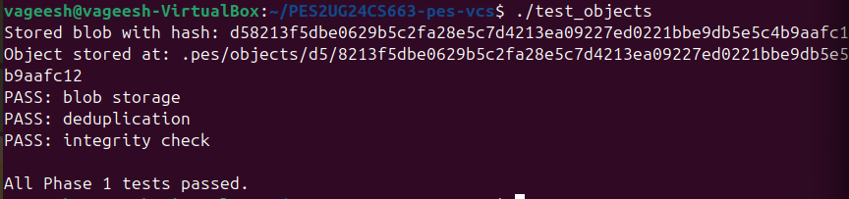

Screenshot 1B: .pes/objects Directory Structure
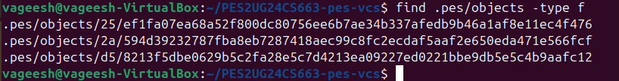

Phase 2: Tree Objects
In this phase, I implemented tree construction from the index to represent directory snapshots. Tree objects store file and directory entries using modes, names, and object hashes.
Modified Code: tree_from_index and helpers
static int tree_has_entry(const Tree *tree, const char *name) { for (int i = 0; i < tree->count; i++) {
if (strcmp(tree->entries[i].name, name) == 0) return 1;
}
return 0;
}

static int write_tree_level(const Index *index, const char *prefix, ObjectID *id_out) { Tree tree;
tree.count = 0;
size_t prefix_len = strlen(prefix);

for (int i = 0; i < index->count; i++) {
const char *path = index->entries[i].path;
if (strncmp(path, prefix, prefix_len) != 0) continue;

const char *remaining = path + prefix_len; if (remaining[0] == '\0') continue;

const char *slash = strchr(remaining, '/'); if (slash == NULL) {
if (tree.count >= MAX_TREE_ENTRIES) return -1; TreeEntry *entry = &tree.entries[tree.count++]; entry->mode = index->entries[i].mode;
entry->hash = index->entries[i].hash;
snprintf(entry->name, sizeof(entry->name), "%s", remaining);
} else {
size_t dir_len = (size_t)(slash - remaining); char dir_name[256];
if (dir_len == 0 || dir_len >= sizeof(dir_name)) return -1; memcpy(dir_name, remaining, dir_len);
dir_name[dir_len] = '\0';

if (tree_has_entry(&tree, dir_name)) continue; if (tree.count >= MAX_TREE_ENTRIES) return -1;

char child_prefix[512];
int written = snprintf(child_prefix, sizeof(child_prefix), "%s%s/", prefix, dir_name); if (written < 0 || (size_t)written >= sizeof(child_prefix)) return -1;

ObjectID child_id;
if (write_tree_level(index, child_prefix, &child_id) != 0) return -1;

TreeEntry *entry = &tree.entries[tree.count++]; entry->mode = MODE_DIR;
entry->hash = child_id;
snprintf(entry->name, sizeof(entry->name), "%s", dir_name);
}
}

void *data = NULL; size_t len = 0;
if (tree_serialize(&tree, &data, &len) != 0) return -1; int rc = object_write(OBJ_TREE, data, len, id_out); free(data);
return rc;
}

int tree_from_index(ObjectID *id_out) { if (!id_out) return -1;
if (index_load == NULL) return -1;

Index index;
if (index_load(&index) != 0) return -1; return write_tree_level(&index, "", id_out);
}

Phase 2: Tree Objects - Output Screenshots
Screenshot 2A: ./test_tree Output
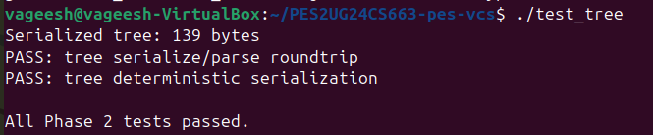

Screenshot 2B: Raw Object Using xxd
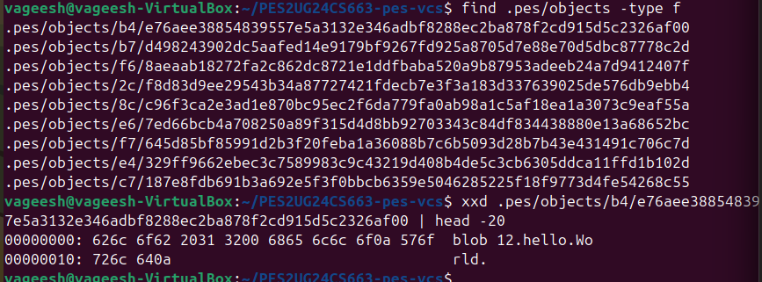

Phase 3: Index / Staging Area
In this phase, I implemented index loading, saving, and file staging.
The index stores staged file metadata including mode, blob hash, modification time, size, and path.
Modified Code: index_load, index_save and index_add
int index_load(Index *index) { if (!index) return -1; index->count = 0;

FILE *f = fopen(INDEX_FILE, "r"); if (!f) return 0;

while (index->count < MAX_INDEX_ENTRIES) {
IndexEntry *entry = &index->entries[index->count]; char hash_hex[HASH_HEX_SIZE + 1];
unsigned int mode; unsigned long long mtime; unsigned int size;
char path[sizeof(entry->path)];

int rc = fscanf(f, "%o %64s %llu %u %511s", &mode, hash_hex, &mtime, &size, path); if (rc == EOF) break;
if (rc != 5) { fclose(f); return -1; }
if (hex_to_hash(hash_hex, &entry->hash) != 0) { fclose(f); return -1; }

entry->mode = mode;
entry->mtime_sec = (uint64_t)mtime; entry->size = size;
snprintf(entry->path, sizeof(entry->path), "%s", path); index->count++;
}
fclose(f); return 0;
}

static int compare_index_entries(const void *a, const void *b) { const IndexEntry *entry_a = (const IndexEntry *)a;
const IndexEntry *entry_b = (const IndexEntry *)b; return strcmp(entry_a->path, entry_b->path);
}

int index_save(const Index *index) { if (!index) return -1;

IndexEntry *sorted = malloc((size_t)index->count * sizeof(IndexEntry)); if (!sorted && index->count > 0) return -1;
memcpy(sorted, index->entries, (size_t)index->count * sizeof(IndexEntry)); qsort(sorted, index->count, sizeof(IndexEntry), compare_index_entries);

FILE *f = fopen(INDEX_FILE ".tmp", "w"); if (!f) { free(sorted); return -1; }

for (int i = 0; i < index->count; i++) { char hash_hex[HASH_HEX_SIZE + 1]; hash_to_hex(&sorted[i].hash, hash_hex);
if (fprintf(f, "%o %s %llu %u %s\n", sorted[i].mode, hash_hex, (unsigned long long)sorted[i].mtime_sec, sorted[i].size, sorted[i].path) < 0) {
fclose(f); free(sorted); return -1;
}
}
free(sorted);

if (fflush(f) != 0) { fclose(f); return -1; }
if (fsync(fileno(f)) != 0) { fclose(f); return -1; } if (fclose(f) != 0) return -1;
if (rename(INDEX_FILE ".tmp", INDEX_FILE) != 0) return -1; return 0;
}

int index_add(Index *index, const char *path) { if (!index || !path) return -1;

struct stat st;
if (stat(path, &st) != 0) return -1; if (!S_ISREG(st.st_mode)) return -1;

FILE *f = fopen(path, "rb"); if (!f) return -1;

unsigned char *buffer = malloc((size_t)st.st_size);
if (!buffer && st.st_size > 0) { fclose(f); return -1; } size_t bytes_read = fread(buffer, 1, (size_t)st.st_size, f); fclose(f);
if (bytes_read != (size_t)st.st_size) { free(buffer); return -1; } ObjectID blob_id;

if (object_write(OBJ_BLOB, buffer, (size_t)st.st_size, &blob_id) != 0) { free(buffer); return -1;
}
free(buffer);

IndexEntry *entry = index_find(index, path); if (!entry) {
if (index->count >= MAX_INDEX_ENTRIES) return -1; entry = &index->entries[index->count++];
}

uint32_t mode = get_file_mode(path); if (mode == 0) return -1;

entry->mode = mode; entry->hash = blob_id;
entry->mtime_sec = (uint64_t)st.st_mtime; entry->size = (uint32_t)st.st_size;
snprintf(entry->path, sizeof(entry->path), "%s", path); return index_save(index);
}

Phase 3: Index / Staging Area - Output Screenshots
Screenshot 3A: pes init, pes add, and pes status
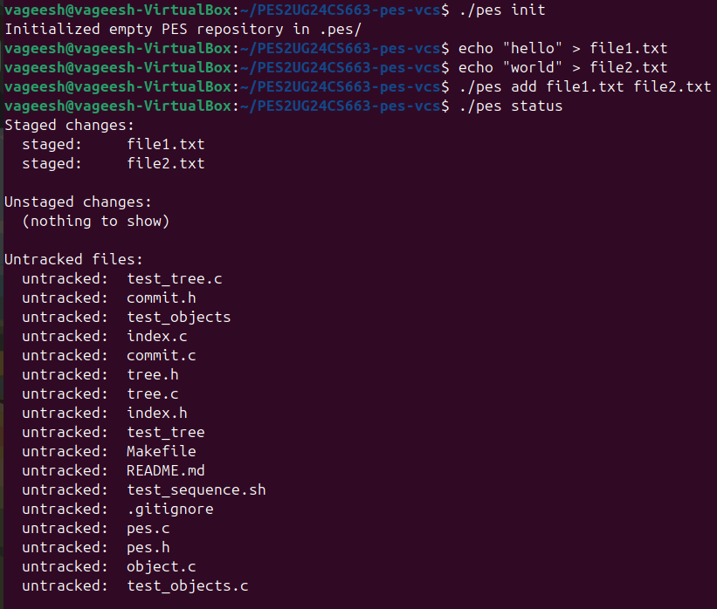

Screenshot 3B: .pes/index Contents
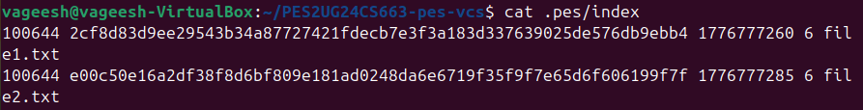

Phase 4: Commits and History
In this phase, I implemented commit creation using the staged index and generated root tree object. Each commit stores tree hash, parent commit, author, timestamp, and commit message.
Modified Code: commit_create
int commit_create(const char *message, ObjectID *commit_id_out) { if (!message || !commit_id_out) return -1;

Commit commit;
memset(&commit, 0, sizeof(commit));

if (tree_from_index(&commit.tree) != 0) return -1;

if (head_read(&commit.parent) == 0) commit.has_parent = 1; else commit.has_parent = 0;

snprintf(commit.author, sizeof(commit.author), "%s", pes_author()); commit.timestamp = (uint64_t)time(NULL);
snprintf(commit.message, sizeof(commit.message), "%s", message);

void *data = NULL; size_t len = 0;
if (commit_serialize(&commit, &data, &len) != 0) return -1;

if (object_write(OBJ_COMMIT, data, len, commit_id_out) != 0) { free(data);
return -1;
}
free(data);

if (head_update(commit_id_out) != 0) return -1;
return 0;
}

Phase 4: Commits and History - Output Screenshots
Screenshot 4A: ./pes log Output
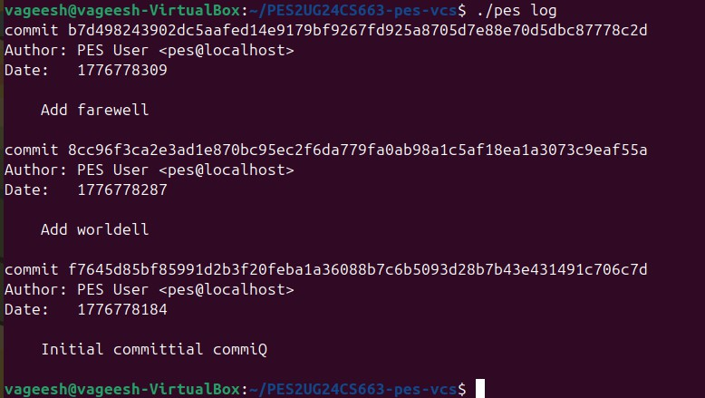

Screenshot 4B: .pes Files After Three Commits
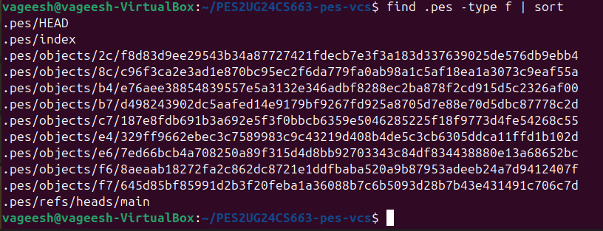

Screenshot 4C: HEAD and Branch Reference
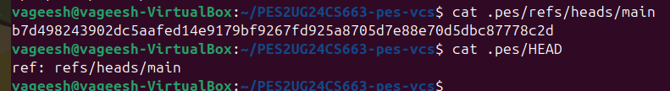

Final Integration Test
The final integration test verifies repository initialization, staging, committing, logging, reference updates, and object store creation.
Final Integration Test - Part 1
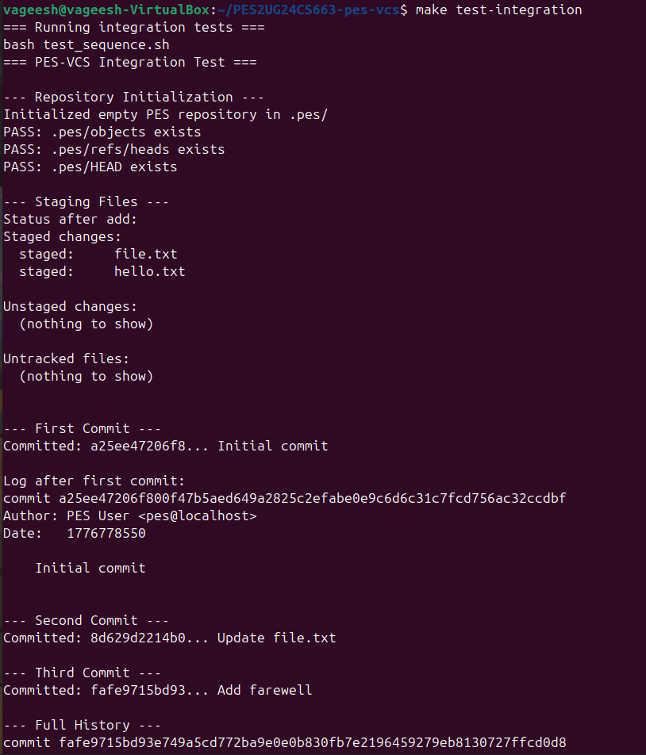
Final Integration Test - Part 2

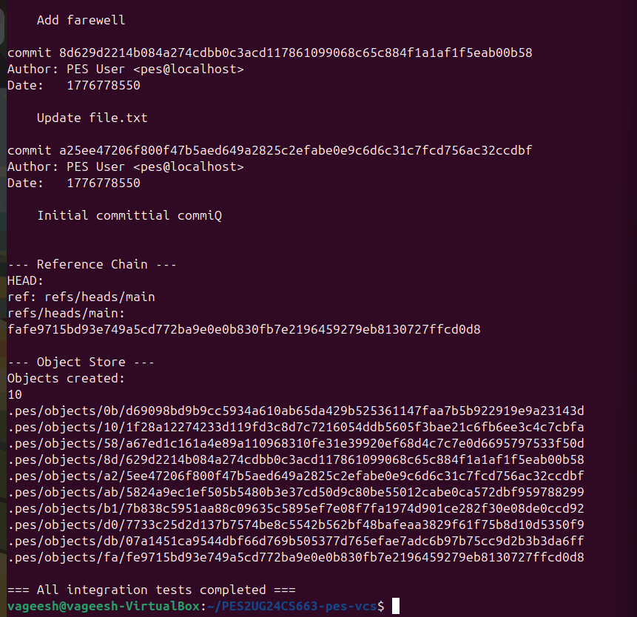

Analysis Questions
Q5.1: Implementing pes checkout
pes checkout would first check whether .pes/refs/heads/ exists. If it exists, .pes/HEAD would be updated to contain ref: refs/heads/. After updating HEAD, PES-VCS would read the commit hash from that branch, load the commit object, load its root tree, and update the working directory to match that tree snapshot.

Q5.2: Dirty Working Directory Detection
A dirty working directory conflict can be detected by comparing tracked files in the working directory with the index. PES-VCS can check file size, modification time, and, if needed, rehash file contents and compare them with the stored blob hash. If a tracked file has uncommitted changes and the target branch contains a different version of that file, checkout should refuse to continue.

Q5.3: Detached HEAD
Detached HEAD means .pes/HEAD stores a commit hash directly instead of pointing to a branch reference. New commits can still be created, but no branch name automatically points to them. The user can recover those commits by creating a new branch file inside .pes/refs/heads/ containing the detached commit hash.

Q6.1: Garbage Collection
Garbage collection would start from all branch references in .pes/refs/heads/ and mark every reachable commit. From each commit, it would recursively visit its tree objects, subtrees, and blob objects. All reachable hashes can be stored in a hash set, and any object not present in that set can be deleted.

Q6.2: Concurrent Garbage Collection Risk
Garbage collection is dangerous during a commit because the commit process may write new objects before updating the branch reference. During that gap, GC may think the new objects are unreachable and delete them. Git avoids this using locking, temporary object protection, and grace periods before deleting unreachable objects.

