**BOXMODEL 3**

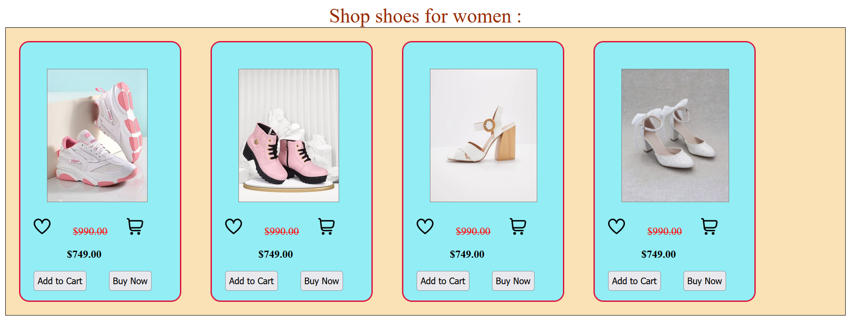

boxmodel3.html

=============

<!DOCTYPE html>

<html lang="en">

<head>

<meta charset="UTF-8">

<meta name="viewport" content="width=device-width, initial-scale=1.0">

<title>Box Model 3</title>

<link rel="stylesheet" href="/Lecture6/boxmodel3.css">

</head>

<body>

<header>Shop shoes for women :</header>

<div id="box">

<div id="box1">

<img id="img1 src="https://assets.myntassets.com/dpr_1.5,q_60,w_400,c_limit,fl_progressive/assets/images/23077180/2023/5/9/6aa54141-1aac-4359-942f-c4e7239567371683605849618CasualShoes1.jpg"

alt="">

<img src="/Lecture6/heart.png" alt="" id="heart">

<p id="text1">$990.00</p>

<img src="/Lecture6/shopping-cart.png" alt="" id="cart"><br />

<p id="text2">$749.00</p>

<input type="button" value="Add to Cart" id="btn1">

<input type="button" value="Buy Now" id="btn2">

</div>

<div id="box2">

<img id="img2" src="https://m.media-amazon.com/images/I/61PINfRzj1L._SY675_.jpg" alt="">

<img src="/Lecture6/heart.png" alt="" id="heart">

<p id="text1">$990.00</p>

<img src="/Lecture6/shopping-cart.png" alt="" id="cart"><br />

<p id="text2">$749.00</p>

<input type="button" value="Add to Cart" id="btn1">

<input type="button" value="Buy Now" id="btn2">

</div>

<div id="box3">

<img id="img3"

src="https://www.vicicollection.com/cdn/shop/files/UntitledCatalog10584_7f3ce4ed-c306-42e8-9da7-b3958df89c48_grande.jpg?v=1695775249"

alt="">

<img src="/Lecture6/heart.png" alt="" id="heart">

<p id="text1">$990.00</p>

<img src="/Lecture6/shopping-cart.png" alt="" id="cart"><br />

<p id="text2">$749.00</p>

<input type="button" value="Add to Cart" id="btn1">

<input type="button" value="Buy Now" id="btn2">

</div>

<div id="box4">

<img id="img4" src="https://i.ebayimg.com/thumbs/images/g/qicAAOSwqTBkDyv2/s-l640.jpg" alt="">

<img src="/Lecture6/heart.png" alt="" id="heart">

<p id="text1">$990.00</p>

<img src="/Lecture6/shopping-cart.png" alt="" id="cart"><br />

<p id="text2">$749.00</p>

<input type="button" value="Add to Cart" id="btn1">

<input type="button" value="Buy Now" id="btn2">

</div>

</div>

</body>

</html>

_______________________________________________________________________________

boxmodel3.css

=============

#box {

border: 1px solid black;

max-width: 1000th;

min-width: none;

max-height: 1000px;

background-color: rgb(250, 226, 182);

}

header {

text-align: center;

font-size: 30px;

color: rgb(153, 45, 6);

}

#box1 {

border: 2px solid crimson;

border-radius: 15px;

height: 350px;

width: 200px;

padding: 20px;

margin: 20px;

background-color: rgb(147, 237, 244);

display: inline-block;

vertical-align: top;

}

#img1 {

border: 1px solid grey;

height: 200px;

margin: 20px;

}

#heart {

height: 25px;

}

#cart {

height: 25px;

margin-left: 25px;

}

#text1 {

display: inline;

text-decoration: line-through;

color: red;

margin-left: 30px;

}

#text2 {

margin-left: 50px;

font-weight: bold;

}

#btn1 {

height: 30px;

}

#btn2 {

height: 30px;

margin-left: 30px;

}

#box2 {

border: 2px solid crimson;

border-radius: 15px;

height: 350px;

width: 200px;

padding: 20px;

margin: 20px;

background-color: rgb(147, 237, 244);

display: inline-block;

vertical-align: top;

}

#img2 {

border: 1px solid grey;

height: 200px;

margin: 20px;

}

#heart {

height: 25px;

}

#cart {

height: 25px;

margin-left: 25px;

}

#text1 {

display: inline;

text-decoration: line-through;

color: red;

margin-left: 30px;

}

#text2 {

margin-left: 50px;

font-weight: bold;

}

#btn1 {

height: 30px;

}

#btn2 {

height: 30px;

margin-left: 30px;

}

#box3 {

border: 2px solid crimson;

border-radius: 15px;

height: 350px;

width: 200px;

padding: 20px;

margin: 20px;

background-color: rgb(147, 237, 244);

display: inline-block;

vertical-align: top;

}

#img3 {

border: 1px solid grey;

height: 200px;

margin: 20px;

}

#heart {

height: 25px;

}

#cart {

height: 25px;

margin-left: 25px;

}

#text1 {

display: inline;

text-decoration: line-through;

color: red;

margin-left: 30px;

}

#text2 {

margin-left: 50px;

font-weight: bold;

}

#btn1 {

height: 30px;

}

#btn2 {

height: 30px;

margin-left: 30px;

}

#box4 {

border: 2px solid crimson;

border-radius: 15px;

height: 350px;

width: 200px;

padding: 20px;

margin: 20px;

background-color: rgb(147, 237, 244);

display: inline-block;

vertical-align: top;

}

#img4 {

border: 1px solid grey;

height: 200px;

margin: 20px;

}

#heart {

height: 25px;

}

#cart {

height: 25px;

margin-left: 25px;

}

#text1 {

display: inline;

text-decoration: line-through;

color: red;

margin-left: 30px;

}

#text2 {

margin-left: 50px;

font-weight: bold;

}

#btn1 {

height: 30px;

}

#btn2 {

height: 30px;

margin-left: 30px;

}

____________________________________________________________________________