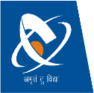 | CHAROTAR UNIVERSITY OF SCIENCE & TECHNOLOGY  DEVANG PATEL INSTITUTE OF ADVANCE TECHNOLOGY AND RESEARCH | 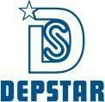

WEEKLY REPORT

Project ID:  PRJ_CSE_05_2026_28 | Student ID: 24DCS145(TL),24DCS135,24DCS140
From Date: 31/08/2026 | To Date: 06/09/2026
Semester: 5th | Week No : 8

Work Completed :
- Improved the document editing workflow based on testing.
- Fixed issues related to text formatting and document layout.
- Improved the natural language command processing.
- Added better error handling for failed commands.
- Improved the document upload and processing flow.
- Made some UI improvements based on testing.

Plans for next week:
- Work on the study-related AI features.
- Add summary generation module backend.
- Design page for summary generation of document.
- Add functionality to export summary.

Refrences:
- python-docx Documentation
- PyMuPDF Documentation
- React Documentation

Signature of Student Signature of Mentor

