PROJECT REPORT

Hospital

(Hospital Appointment Booking System)BY
Vaghela Akshay
(+91 9586364151)

- Structure Program
DFD
[ZERO LEVEL DFD OF KRISHNA CLINIC]

[LEVEL-0]

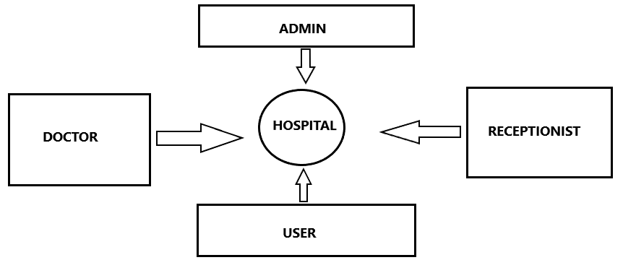

[ZERO LEVEL DFD OF KRISHNA CLINIC]

[LEVEL1]

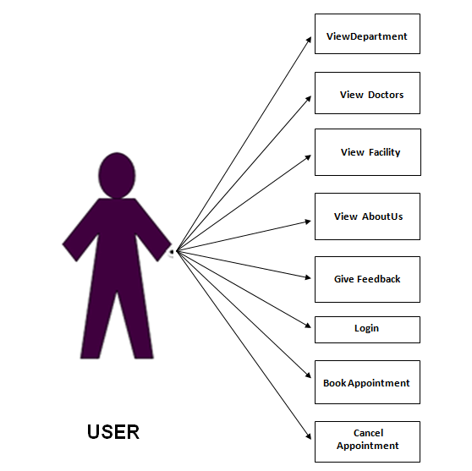

[ZERO LEVEL DFD OF KRISHNA CLINIC]

[LEVEL-2]

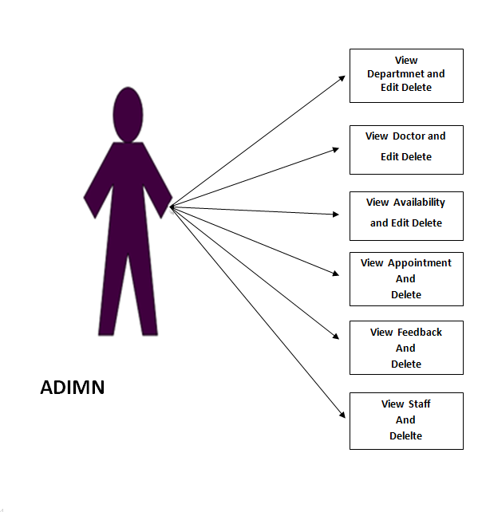

[ZERO LEVEL DFD OF KRISHNA CLINIC]

[LEVEL3]

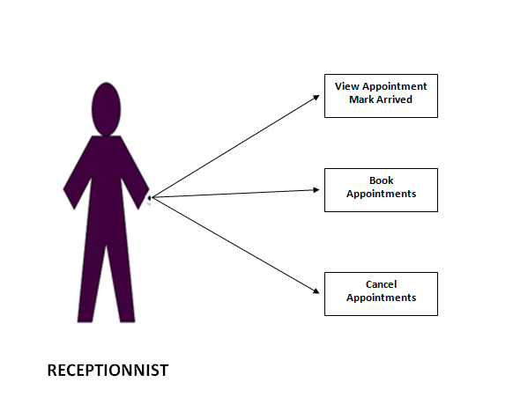

[ZERO LEVEL DFD OF KRISHNA CLINIC]

[LEVEL4]

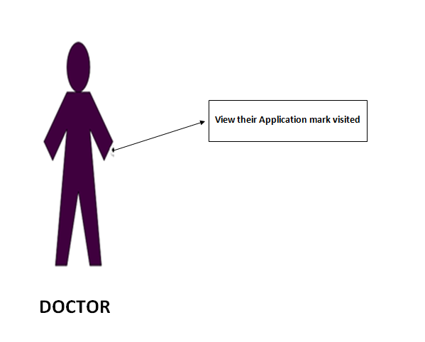

APPOINTMENTS

appointment_id
user_id
doctor_id
appointment_date
appointment_time
patient_name
patient_age
patient_gender
date_of_birth
patient_address
note
patient_mobilenumber
patient_weight
appointment_status
token_number
USER
user_id
user_name
user_dob
user_mobilenumber
user_age
user_gender
user_email
user_password
user_type
doctor_id
FACILITY
facility_id
facility_name
facility_logo

FEEDBACK
feedback_id
feedback_name
feedback_mobilenumber
feedback

DOCTOR
doctor_id
doctor_name
doctor_image
department_id
doctor_experience
doctor_degree
doctor_specialities
doctor_gender
doctor_age

AVAILABLITY
availability_id
doctor_id
available_date
start_time
end_time

DEPARTMENT
department_id
department_name
department_logo

- Data Dictionary

[1]
Table Name : appointments
Description : This table is used to store appointments of patients.
This table contains 15 fileds.
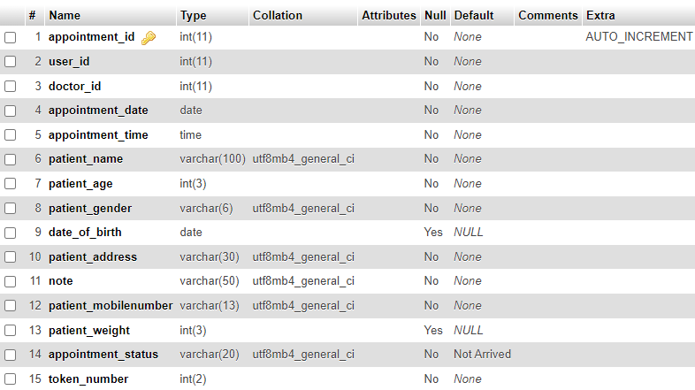

[2]
Table Name : availibility
Description : This table is used to store availability of doctor.
This table contains 5 fileds.
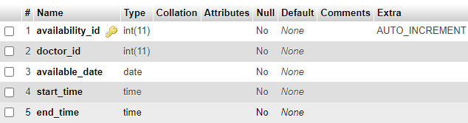

[3]
Table Name : department
Description : This table is used to store departments of the hospital.
This table contains 3 fileds.
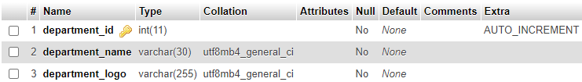

[4]
Table Name : doctor
Description : This table is used to store doctors of the hospital.
This table contains 9 fileds.
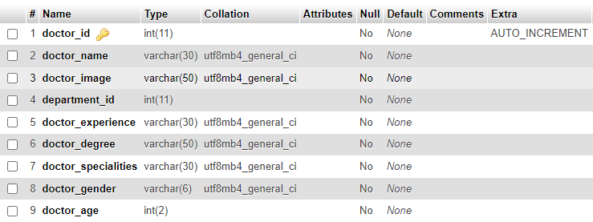

[5]
Table Name : facility
Description : This table is used to store facilitys of hospital.
This table contains 3 fileds.
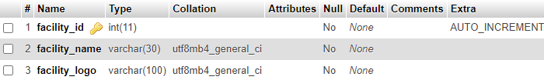
[6]
Table Name : feedback
Description : This table is used to store Feedbacks of users.
This table contains 4 fileds.
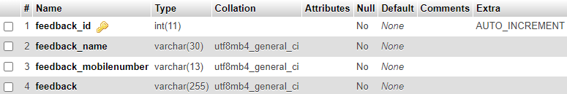

[7]
Table Name : user
Description : This table is used to store users of the website.
This table contains 10 fileds.

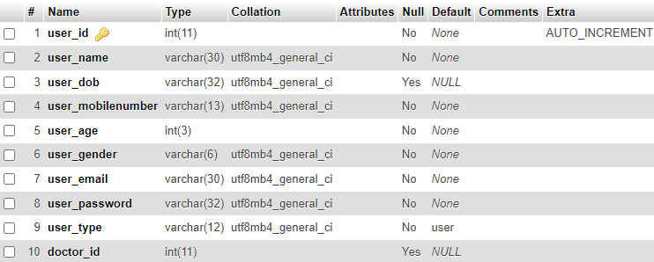
Screen Layout

- USER SIDE

[1] Home Page :-
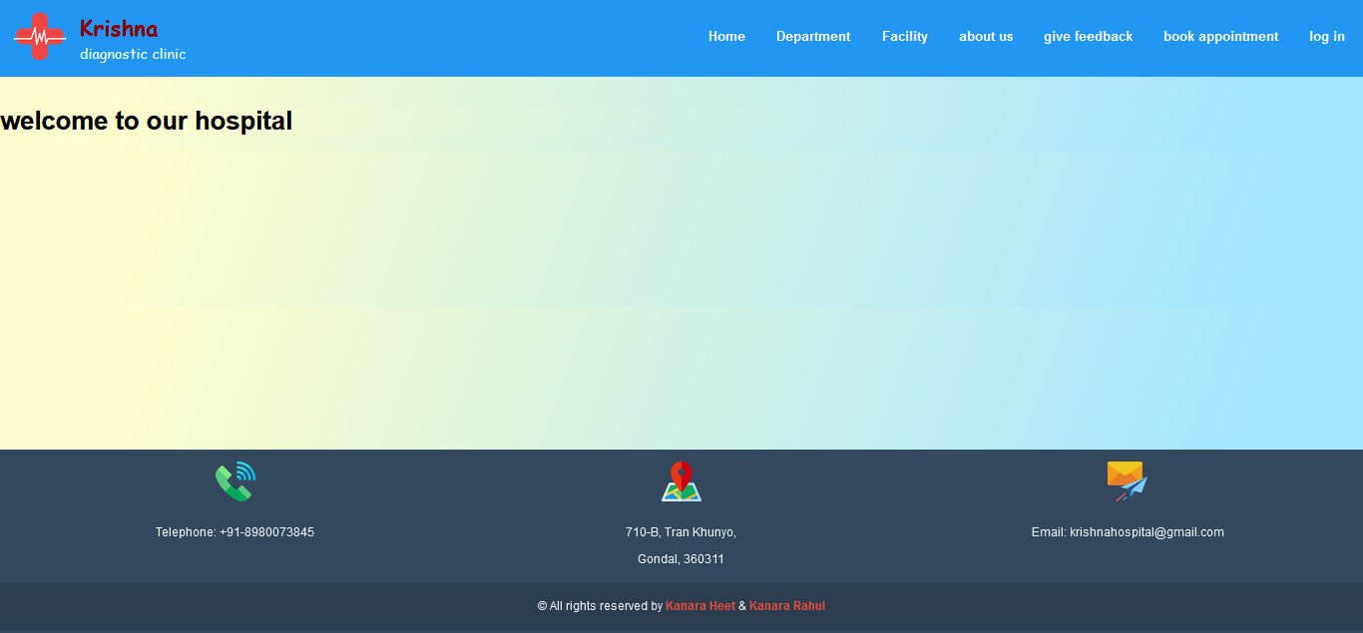

- Coding :- index.php

<?php
session_start();
?>
<!DOCTYPE html>
<html lang="en">
<head>
<meta charset="UTF-8">
<meta http-equiv="X-UA-Compatible" content="IE=edge">
<meta name="viewport" content="width=device-width, initial-scale=1.0">
<title>Krishna Clinic</title>
<link rel="shortcut icon" href="images/medicine.png" type="image/x-icon">
<body>
<?php
require_once('inc/header.php');
?>
<main>
<h1>welcome to our hospital</h1>
</main>
<?php
require_once('inc/footer.php');
?>
</body>
</html

[2] DEPARTMENT :-

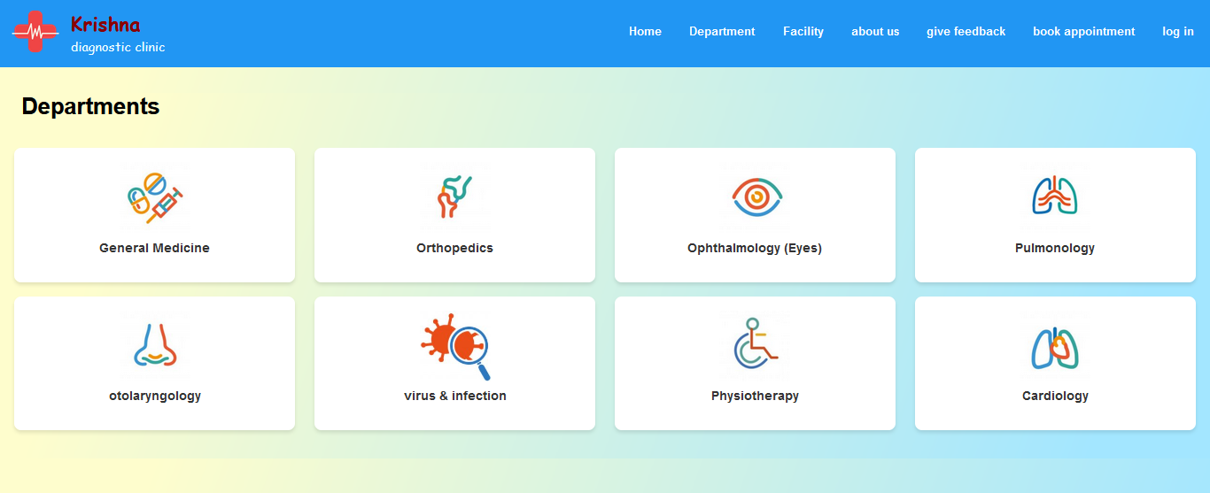

- Coding :- department.php
<!DOCTYPE html>
<html lang="en">
<head>
<meta charset="UTF-8">
<meta name="viewport" content="width=device-width, initial-scale=1.0">
<title>Krishna Clinic</title>
<style>
main {
margin-top: 5%;
}
h1 {
margin-left: 30px;
}
.department-container {
display: flex;
flex-wrap: wrap;
justify-content: space-between;
padding: 20px;
}
.box {
background-color: white;
border-radius: 10px;
box-shadow: 0 4px 6px rgba(0, 0, 0, 0.1);
margin-bottom: 20px;
flex: 0 1 calc(25% - 20px);
overflow: hidden;
text-decoration: none;
transition: transform 0.3s;
}
.box:hover {
transform: scale(1.05);
}
.content {
padding: 20px;
}
.img img {
max-width: 100px;
max-height: 100px;
display: block;
margin: 0 auto;
}
.department-name {
margin-top: 10px;
font-size: 18px;
font-weight: bold;
text-align: center;
color: #333;
}
</style>
</head>
<body>
<?php
require_once('inc/header.php');
?>
<main>
<h1>Departments</h1>
<div class="department-container">
<?php
require_once('inc/connection.php');
$select_department = "SELECT * FROM department";
$run_department = mysqli_query($conn, $select_department);
while ($row_department = mysqli_fetch_assoc($run_department)) {
$department_id = $row_department['department_id'];
$department_logo = $row_department['department_logo'];
$department_name = $row_department['department_name'];
?>
<a href="doctor.php?department_id=<?php echo $department_id; ?>" class="box">
<div class="content">
<div class="img">
<img src="admin/upload/<?php echo $department_logo; ?>" alt="<?php echo $department_name; ?> Logo">
</div>
<h3 class="department-name"><?php echo $department_name; ?></h3>
</div>
</a>
<?php } ?>
</div>
</main>
</body>
</html>

[i] DOCTORS OF THE DEPARTMENT :-



- Coding :- doctor.php
<?php
require_once('inc/connection.php');
if (isset($_GET['department_id'])) {
$department_id = $_GET['department_id'];
$select_department = "SELECT * FROM department WHERE department_id = $department_id";
$run_department = mysqli_query($conn, $select_department);
$department = mysqli_fetch_assoc($run_department);
$select_doctors = "SELECT * FROM doctor WHERE department_id = $department_id";
$run_doctors = mysqli_query($conn, $select_doctors);
$num_doctors = mysqli_num_rows($run_doctors);
} else {
echo "Department not specified.";
exit;
}
?>
<!DOCTYPE html>
<html lang="en">
<head>
<meta charset="UTF-8">
<meta name="viewport" content="width=device-width, initial-scale=1.0">
<title>Krishna Clinic - Doctors in <?php echo $department['department_name']; ?></title>
<style>
main {
margin-top: 5%;
}

h1 {
margin-left: 30px;
}
.doctor-container {
display: flex;
flex-wrap: wrap;
justify-content: space-between;
padding: 20px;
}
.box {
background-color: white;
border-radius: 10px;
box-shadow: 0 4px 6px rgba(0, 0, 0, 0.1);
margin-bottom: 20px;
flex: 0 1 calc(25% - 20px);
overflow: hidden;
text-decoration: none;
transition: transform 0.3s;
}
.box:hover {
transform: scale(1.05);
}
.content {
padding: 20px;
}
.img img {
max-width: 100px;
max-height: 100px;
display: block;
margin: 0 auto;
}
.doctor-name {
margin-top: 10px;
font-size: 18px;
font-weight: bold;
text-align: center;
color: #333;
}
</style>
</head>
<body>
<?php require_once('inc/header.php'); ?>
<main>
<h1>Doctors in <?php echo $department['department_name']; ?> Department</h1>
<?php
if ($num_doctors > 0) {
echo '<div class="doctor-container">';
while ($row_doctor = mysqli_fetch_assoc($run_doctors)) {
$doctor_name = $row_doctor['doctor_name'];
$doctor_image = $row_doctor['doctor_image'];
$doctor_degree = $row_doctor['doctor_degree'];
?>
<a href="#" class="box">
<div class="content">
<div class="img">
<img src="admin/upload/<?php echo $doctor_image; ?>" alt="<?php echo $doctor_name; ?> Photo">
</div>
<h3 class="doctor-name"><?php echo $doctor_name; ?></h3>
<h3 class="doctor-name"><?php echo $doctor_degree; ?></h3>
</div>
</a>
<?php
}
echo '</div>';
} else {
echo '<p>No doctors available in this department.</p>';
}
?>
</main>
</body>
</html>
[3]FACILITY:-

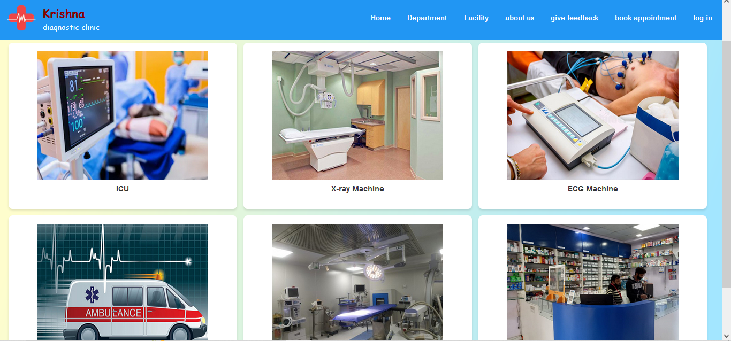

- Coding :- facility.php
<!DOCTYPE html>
<html lang="en">
<head>
<meta charset="UTF-8">
<meta name="viewport" content="width=device-width, initial-scale=1.0">
<title>Krishna Clinic</title>
<style>
main {
margin-top: 5%;
}
h1 {
margin-left: 30px;
}
.facility-container {
display: flex;
flex-wrap: wrap;
justify-content: space-between;
padding: 20px;
}
.box {
background-color: white;
border-radius: 10px;
box-shadow: 0 4px 6px rgba(0, 0, 0, 0.1);
margin: 0 15px 15px 0;
width: calc(33.33% - 15px);
overflow: hidden;
text-decoration: none;
transition: transform 0.3s;
}
.content {
padding: 20px;
}
.img img {
max-width: 100%;
max-height: 100%;
display: block;
margin: 0 auto;
}
.facility-name {
margin-top: 10px;
font-size: 18px;
font-weight: bold;
text-align: center;
color: #333;
}
</style>
</head>
<body>
<?php
require_once('inc/header.php');
?>
<main>
<h1>Facilities</h1>
<div class="facility-container">
<?php
require_once('inc/connection.php');
$select_facility = "SELECT * FROM facility";
$run_facility = mysqli_query($conn, $select_facility);
while ($row_facility = mysqli_fetch_assoc($run_facility)) {
$facility_id = $row_facility['facility_id'];
$facility_logo = $row_facility['facility_logo'];
$facility_name = $row_facility['facility_name'];
?>
<div class="box">
<div class="content">
<div class="img">
<img src="admin/upload/<?php echo $facility_logo; ?>" alt="<?php echo $facility_name; ?> Logo">
</div>
<h3 class="facility-name"><?php echo $facility_name; ?></h3>
</div>
</div>
<?php } ?>
</div>
</main>
</body>
</html>

[4]ABOUT US:-

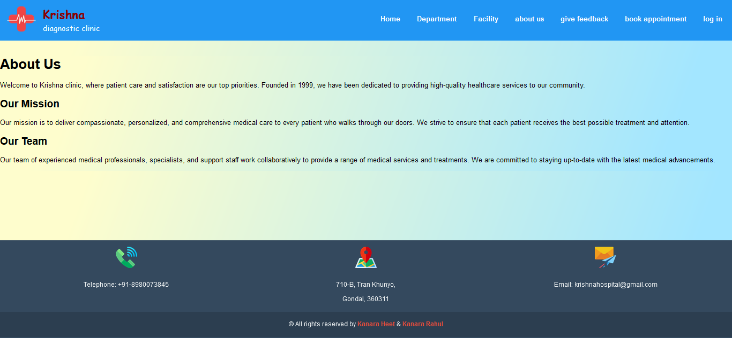
- Coding :-aboutus.php
<!DOCTYPE html>
<html lang="en">
<head>
<meta charset="UTF-8">
<meta name="viewport" content="width=device-width, initial-scale=1.0">
<title>Krishna Clinic</title>
</head>
<body>
<?php
require_once("inc/header.php");
?>
<main>
<h1>About Us</h1>
<p>Welcome to Krishna clinic, where patient care and satisfaction are our top priorities. Founded in 1999, we have been dedicated to providing high-quality healthcare services to our community.</p>
<h2>Our Mission</h2>
<p>Our mission is to deliver compassionate, personalized, and comprehensive medical care to every patient who walks through our doors. We strive to ensure that each patient receives the best possible treatment and attention.</p>
<h2>Our Team</h2>
<p>Our team of experienced medical professionals, specialists, and support staff work collaboratively to provide a range of medical services and treatments. We are committed to staying up-to-date with the latest medical advancements.</p>
</main>
<?php
require_once('inc/footer.php');
?>
</body>
</html>
[5] GIVE FEEDBACK:-
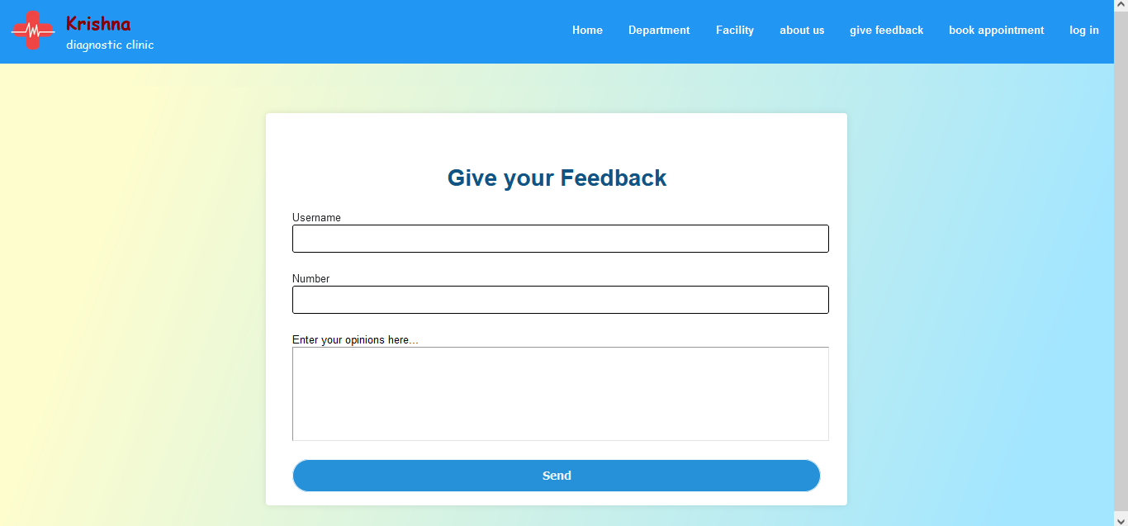
- Coding :- feedback.php
<?php
session_start();
?>
<!DOCTYPE html>
<html lang="en">
<head>
<title>Krishna Clinic</title>
<style>
main{
display: flex;
align-items: center;
justify-content: center;
padding: 40px;
}
.container{
background: #fff;
width: 800px;
padding: 25px 40px 10px 40px;
box-shadow: 0px 0px 10px rgba(0,0,0,0.1);
border-radius: 5px;
}
.container h1{
text-align: center;
font-size: 35px;
color: #115484;
}
.container form{
padding: 30px 0 0 0;
}
form .id{
position: relative;
border-radius: 2px;
margin: 30px 0;
}
.id input{
width: 100%;
padding: 0 5px;
height: 40px;
font-size: 18px;
border: 2px solid black;
border-radius:3px;
background: none;
}
.id label{
left: 5px;
color: #272a2c;
font-size: 16px;
pointer-events: none;
}
textarea{
width: 100%;
padding: 0 5px;
height: 35%;
font-size: 20px;
border: 2px soldi black;
background: none;
}
.btn{
width: 100%;
height: 50px;
border: 1px solid;
background: #2691d9;
border-radius: 25px;
font-size: 18px;
color: #e9f4fb;
font-weight: 700;
cursor: pointer;
outline: none;
margin-top: 5px;
margin-bottom: 10px;
}
</style>
</head>
<body>
<?php
require_once("inc/header.php");
?>
<main>
<div class="container">
<form method="POST">
<h1>Give your Feedback</h1>
<div class="id">
<label>Username</label>
<input type="text" name="feedback_name" required>
</div>
<div class="id">
<label>Number</label>
<input type="tel" name="feedback_mobilenumber" required>
</div>
<div>
<label>Enter your opinions here...</label>
<textarea name="feedback" cols="10" rows="5" style="resize: none;" required></textarea>
</div>
<br>
<input type="submit" value="Send" name="send_btn" class="btn">
</form>
<?php
require_once('inc/connection.php');
if(isset($_POST['send_btn'])){
$feedback_name = $_POST['feedback_name'];
$feedback_mobilenumber = $_POST['feedback_mobilenumber'];
$feedback = $_POST['feedback'];
$insert_feedback = "INSERT INTO feedback(feedback_name,feedback_mobilenumber,feedback) VALUES('$feedback_name','$feedback_mobilenumber','$feedback')";
$run_feedback = mysqli_query($conn,$insert_feedback);
if($run_feedback === true){
echo "thanks for give feedback";
}else{
echo "please, try again";
}
}
?>
</div>
</main>
</body>
</html>
[6] LOG IN:-

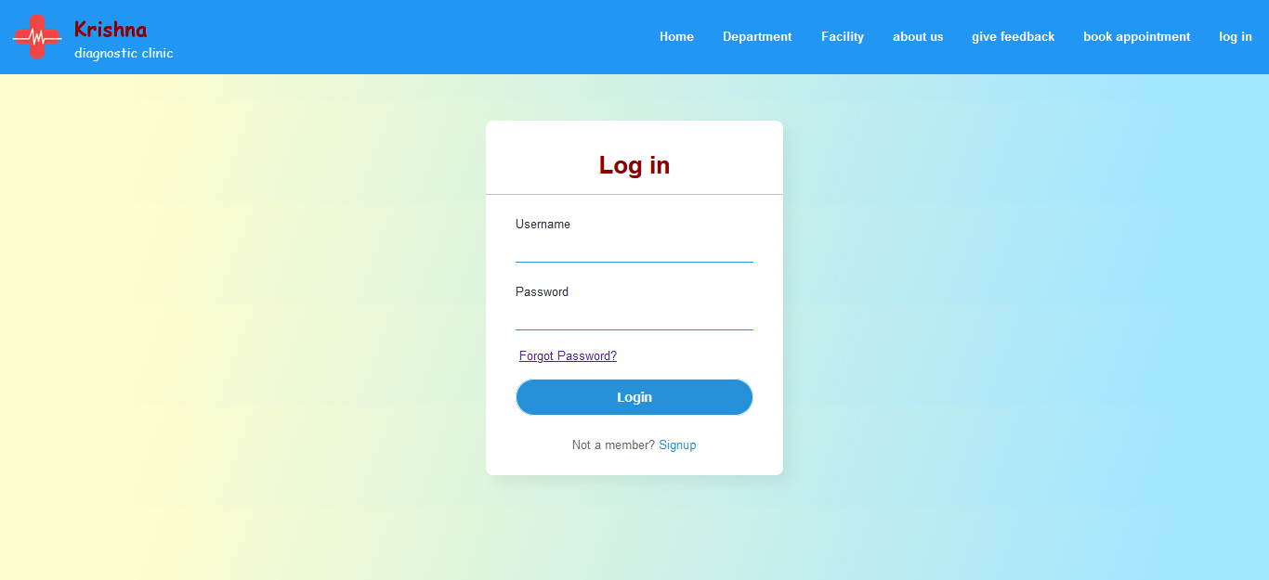
- Coding :- login.php
<!DOCTYPE html>
<html lang="en">
<head>
<title>Krishna Clinic</title>
<style>
.center {
position: absolute;
top: 50%;
left: 50%;
transform: translate(-50%, -50%);
width: 400px;
background: white;
border-radius: 10px;
box-shadow: 10px 10px 15px rgba(0,0,0,0.05);
}
.center h1 {
color: darkred;
text-align: center;
padding: 20px 0;
border-bottom: 1px solid silver;
}
.center form {
padding: 0 40px;
box-sizing: border-box;
}
form .txt_field {
position: relative;
border-bottom: 2px solid #2691d9;
margin: 30px 0;
}
.txt_field input {
width: 100%;
padding: 0 5px;
height: 40px;
font-size: 20px;
border: none;
background: none;
outline: none;
}
.txt_field label {
left: 5px;
color: #272a2c;
font-size: 16px;
pointer-events: none;
}
.pass {
margin: -5px 0 20px 5px;
color: #a6a6a6;
cursor: pointer;
}
.pass:hover {
text-decoration: underline;
}
input[type="submit"] {
width: 100%;
height: 50px;
border: 1px solid;
background: #2691d9;
border-radius: 25px;
font-size: 18px;
color: #e9f4fb;
font-weight: 700;
cursor: pointer;
outline: none;
}
input[type="submit"]:hover {
border-color: #2691d9;
transition: .5s;
}
.signup_link {
margin: 30px 0;
text-align: center;
font-size: 16px;
color: #666666;
}
.signup_link a {
color: #2691d9;
text-decoration: none;
}
.signup_link a:hover {
text-decoration: underline;
}
</style>
</head>
<body>
<?php
require_once("inc/header.php");
?>
<main>
<div class="center">
<h1>Log in</h1>
<form method="post">
<div class="txt_field">
<label>Username</label>
<input type="text" required name="email">
</div>
<div class="txt_field">
<label>Password</label>
<input type="password" required name="password">
</div>
<div class="pass"><a href="reset_pass.php">Forgot Password?</a></div>
<input type="submit" value="Login" name="login-btn">
<div class="signup_link">
Not a member? <a href="signup.php">Signup</a>
</div>
</form>
<?php
require_once('inc/connection.php');
if (isset($_POST['login-btn'])) {
$email = $_POST['email'];
$password = $_POST['password'];
$hashed_password = md5($password);
$check_email = "SELECT * FROM user WHERE user_email='$email'";
$run_email = mysqli_query($conn, $check_email);
if (mysqli_num_rows($run_email) == 1) {
$row_email = mysqli_fetch_array($run_email);
$db_hashed_password = $row_email['user_password'];
if ($hashed_password === $db_hashed_password) {
$db_user_id = $row_email['user_id'];
$db_doctor_id = $row_email['doctor_id'];
$db_name = $row_email['user_name'];
$db_type = $row_email['user_type'];
$db_email = $row_email['user_email'];
if ($db_type == 'user') {
$_SESSION['user_id'] = $db_user_id;
$_SESSION['email'] = $db_email;
$_SESSION['name'] = $db_name;
$_SESSION['type'] = $db_type;
$_SESSION['ulogged_in'] = true;
echo "<script>window.open('user_home.php','_self');</script>";
exit();
} elseif ($db_type == 'admin') {
$_SESSION['email'] = $db_email;
$_SESSION['name'] = $db_name;
$_SESSION['type'] = $db_type;
$_SESSION['alogged_in'] = true;
echo "<script>window.open('admin/admin_home.php','_self');</script>";
exit();
} elseif ($db_type == 'receptionist') {
$_SESSION['user_id'] = $db_user_id;
$_SESSION['email'] = $db_email;
$_SESSION['name'] = $db_name;
$_SESSION['type'] = $db_type;
$_SESSION['rlogged_in'] = true;
echo "<script>window.open('receptionist/rec_home.php','_self');</script>";
exit();
} elseif ($db_type == 'doctor') {
$_SESSION['doctor_id'] = $db_doctor_id;
$_SESSION['email'] = $db_email;
$_SESSION['name'] = $db_name;
$_SESSION['type'] = $db_type;
$_SESSION['dlogged_in'] = true;
echo "<script>window.open('doctor/dr_home.php','_self');</script>";
exit();
}
} else {
echo "Password is incorrect.";
}
} else {
echo "Email not found.";
}
}
?>
</div>
</main>
</body>
</html>
[i]FORGOT PASSWORD :-

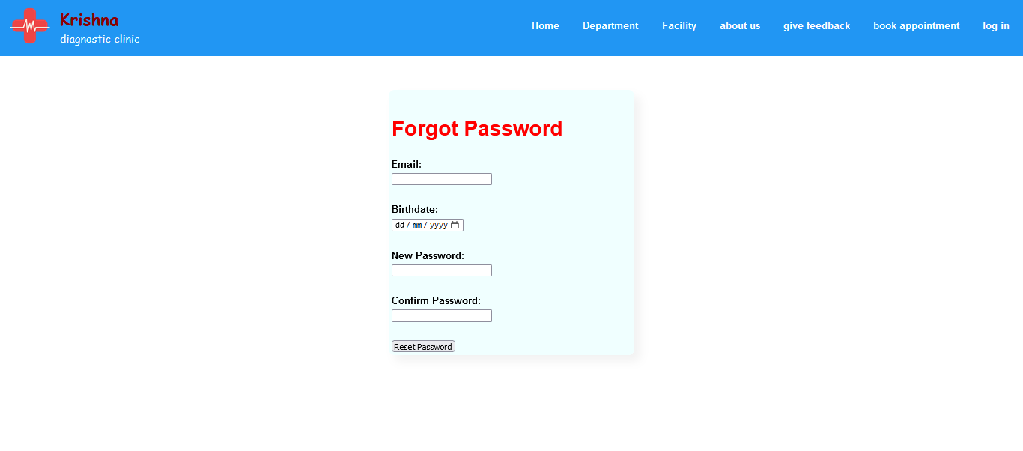
- Coding:-reset_pass.php
<?php
session_start();
include('inc/connection.php');
if ($_SERVER['REQUEST_METHOD'] === 'POST' && isset($_POST['reset-btn'])) {
$email = $_POST['email'];
$birthdate = $_POST['birthdate'];
$newPassword = $_POST['new_password'];
$confirmPassword = $_POST['confirm_password'];
$check_user = "SELECT * FROM user WHERE user_email='$email' AND user_dob=MD5('$birthdate')";
$run_check_user = mysqli_query($conn, $check_user);
if (mysqli_num_rows($run_check_user) > 0) {
if ($newPassword === $confirmPassword) {
$hashed_password = md5($newPassword);
$update_password = "UPDATE user SET user_password='$hashed_password' WHERE user_email='$email'";
$run_update_password = mysqli_query($conn, $update_password);
if ($run_update_password) {
$reset_success = "Password reset successful. You can now login with your new password.";
header("location: login.php");
} else {
$reset_error = "Password reset failed.";
}
} else {
$reset_error = "Passwords do not match.";
}
} else {
$reset_error = "Invalid email or birthdate.";
}
}
?>
<!DOCTYPE html>
<html lang="en">
<head>
<title>Krishna Clinic</title>
<style>
main{
display: flex;
padding: 5px;
width: 80%;
}
.container{
position: absolute;
top: 30%;
left: 50%;
transform: translate(-50%, -50%);
width: 400px;
background: azure;
border-radius: 10px;
box-shadow: 10px 10px 15px rgba(0,0,0,0.05);
}
.new{
width: 360px;
}
h2{
font-size: 35px;
color: red;
}
form{
padding: 10px 0 0 0;
}
form .nm{
margin: 30px 0;
}
.nm label{
font-weight: bold;
margin-bottom: 5px;
display: block;
}
.btn {
display: inline-block;
padding: 10px 20px;
background-color: blue;
color: #fff;
border: none;
border-radius: 5px;
cursor: pointer;
margin-top: 20px;
}
</style>
</head>
<body>
<?php
require_once("inc/header.php");
?>
<main class="container">
<div class= "new">
<form method="post" action="">
<h2>Forgot Password</h2>
<div class="nm">
<label for="email">Email:</label>
<input type="email" name="email" required><br>
</div>
<div class="nm">
<label for="birthdate">Birthdate:</label>
<input type="date" name="birthdate" required><br>
</div>
<div class="nm">
<label for="new_password">New Password:</label>
<input type="password" name="new_password" required><br>
</div>
<div class="nm">
<label for="confirm_password">Confirm Password:</label>
<input type="password" name="confirm_password" required><br>
</div>
<input type="submit" value="Reset Password" name="reset-btn">
</form>
<?php
if (isset($reset_success)) {
echo "<p>$reset_success</p>";
} elseif (isset($reset_error)) {
echo "<p>$reset_error</p>";
}
?>
</div>
</main>
</body>
</html>
[ii] SIGN UP :-
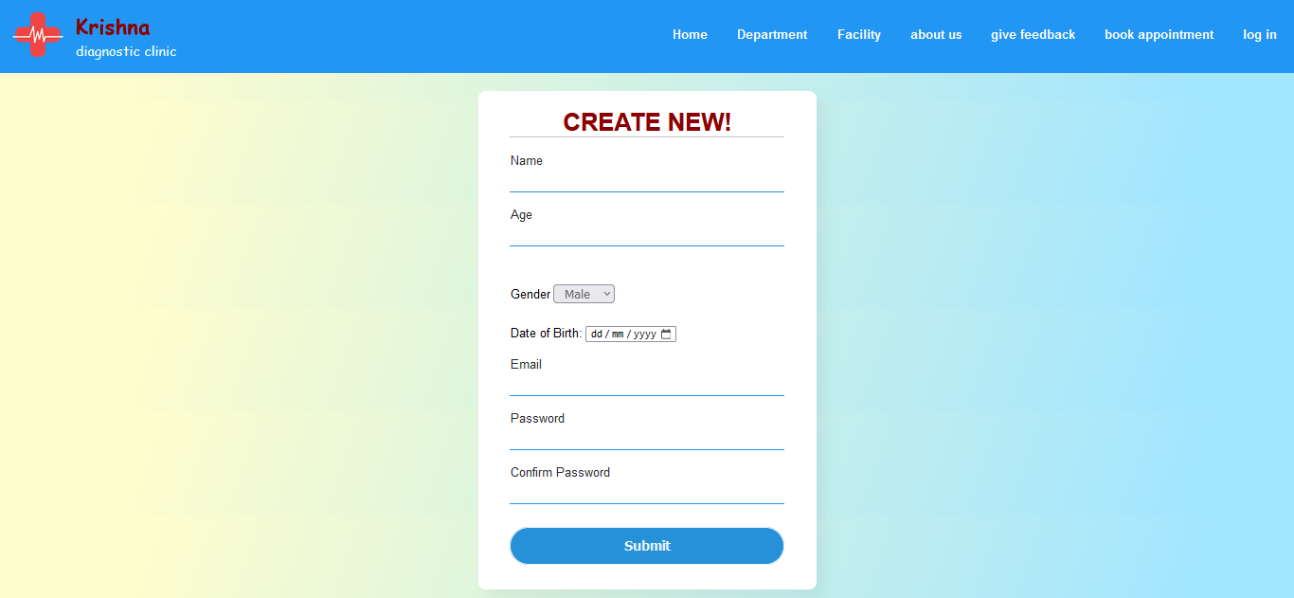
- Coding :- signup.php
<!DOCTYPE html>
<html lang="en">
<head>
<title>Krishna Clinic</title>
<style>
body{
padding: 5%;
}
.container{
position: absolute;
top: 50%;
left: 50%;
transform: translate(-50%, -50%);
width: 360;
padding: 2px;
margin-top: 3%;
background: white;
border-radius: 10px;
box-shadow: 10px 10px 15px rgba(0,0,0,0.05);
}
.container h1{
color:darkred;
text-align: center;
border-bottom: 1px solid silver;
}
.container
form{
padding: 0 40px;
box-sizing: border-box;
}
form .id{
position: relative;
border-bottom: 2px solid #2691d9;
margin: 20px 0;
}
.id input{
width: 100%;
padding: 5px 5px;
height: 20px;
font-size: 18px;
border: none;
background: none;
outline: none;
}
.id label{
left: 5px;
color: #272a2c;
font-size: 16px;
pointer-events: none;
}
button{
width: 100%;
height: 50px;
border: 1px solid;
background: #2691d9;
border-radius: 25px;
font-size: 18px;
color: #e9f4fb;
font-weight: 700;
cursor: pointer;
outline: none;
}
button:hover{
border-color: #2691d9;
transition: .5s;
}
.btn{
margin: 30px 0;
text-align: center;
font-size: 16px;
color: #666666;
}
.btn a{
color: #2691d9;
text-decoration: none;
}
.btn a:hover{
text-decoration: underline;
}
</style>
</head>
<body>
<?php
require_once("inc/header.php");
?>
<main>
<div class="container">
<form action="" method="post" class="new">
<h1>CREATE NEW!</h1>
<div class="id">
<label>Name</label>
<input type="text" name="user_name"/>
</div>
<div class="id">
<label>Age</label>
<input type="text" name="user_age"/>
</div>
<div class="btnn">
Gender
<select class="btn" name="user_gender">
<option>Male</option>
<option>Female</option>
<option>Other</option>
</select>
</div>
<div>
<label for="user_dob">Date of Birth:</label>
<input type="date" name="user_dob" required>
</div>
<div class="id">
<label>Email</label>
<input type="email" name="user_email"/>
</div>
<div class="id">
<label>Password</label>
<input type="password" name="user_password" required />
</div>
<div class="id">
<label>Confirm Password</label>
<input type="password" name="user_cpassword" required />
</div>
<div class="btn">
<button value="submit" name="insert_btn">Submit</button>
</div>
</form>
</div>
<?php
require_once('inc/connection.php');
if(isset($_POST['insert_btn'])){
$user_name = $_POST['user_name'];
$user_age = $_POST['user_age'];
$user_gender = $_POST['user_gender'];
$userDOB = md5($_POST['user_dob']);
$user_email = $_POST['user_email'];
$user_password = $_POST['user_password'];
$user_cpassword = $_POST['user_cpassword'];
if ($user_password !== $user_cpassword) {
echo "Passwords do not match. Please try again.";
} else {
$check_email = "SELECT * FROM user WHERE user_email='$user_email'";
$run_check_email = mysqli_query($conn, $check_email);
if(mysqli_num_rows($run_check_email) > 0){
echo "Email Already Exists";
} else {
$hashed_password = md5($user_password);
$insert_user = "INSERT INTO user(user_name,user_age,user_gender,user_dob,user_email,user_password) VALUES('$user_name','$user_age','$user_gender','$userDOB','$user_email','$hashed_password')";
$run_insert = mysqli_query($conn, $insert_user);
if($run_insert === true){
echo "<script>window.open('login.php','_self');</script>";
} else {
echo "Failed, Try Again";
}
}
}
}
?>
</main>
</body>
</html>
[7] HOMEPAGE (after log in ):-

- Coding:-user_home.php
<?php
session_start();
if(isset($_SESSION['ulogged_in']) && $_SESSION['ulogged_in']==true){
echo "welcome $_SESSION[email]";
}else{
header("location:login.php");
}
?>
<!DOCTYPE html>
<html lang="en">
<head>
<meta charset="UTF-8">
<meta http-equiv="X-UA-Compatible" content="IE=edge">
<meta name="viewport" content="width=device-width, initial-scale=1.0">
<title>Krishna Clinic</title>
<body>
<?php
include 'inc/header.php';
?>
<main>
<h1>Hello <b><?php echo $_SESSION['name']; ?></b> welcome to hospital</h1>
</main>
</body>
</html>
[8] BOOK APPOINTMENT:-
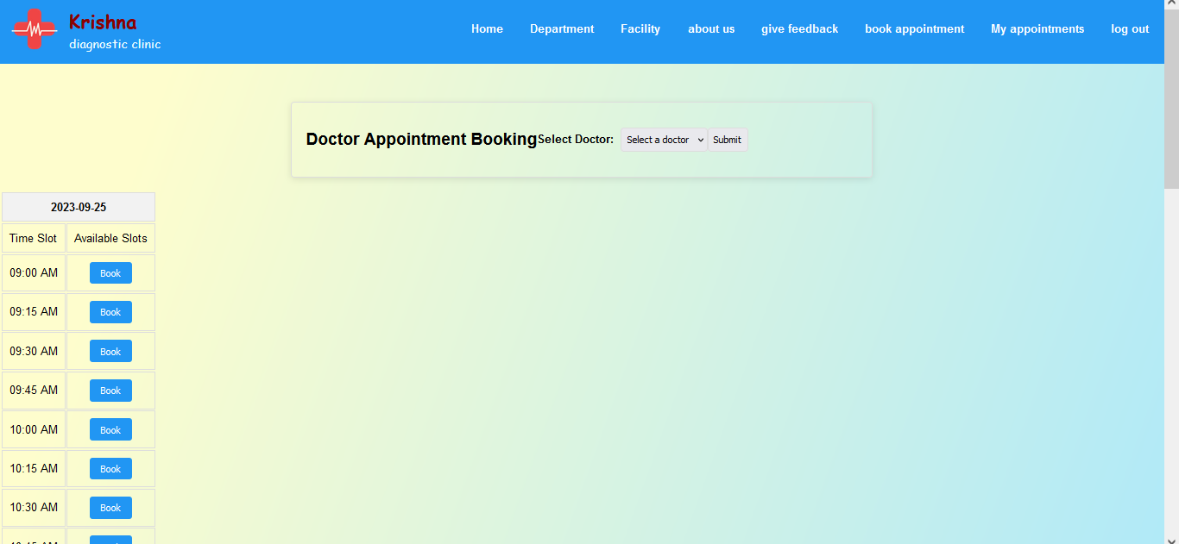
- Coding:-bookapp.php
<?php
require_once('inc/connection.php');
session_start();
if(isset($_SESSION['ulogged_in']) && $_SESSION['ulogged_in'] == true){
echo "Welcome $_SESSION[user_id]";
}else{
header("location:login.php");
}
date_default_timezone_set('Asia/Kolkata');
function isTimeSlotPassed($date, $timeSlot) {
$currentTime = time();
$dateTimeSlot = strtotime("$date $timeSlot");
return $dateTimeSlot < $currentTime;
}
function convertToUserLocalTime($serverTimestamp, $userTimezoneOffset) {
$serverTime = strtotime($serverTimestamp);
$userTime = $serverTime + ($userTimezoneOffset * 60);
return date('h:i A', $userTime);
}
?>
<!DOCTYPE html>
<html lang="en">
<head>
<meta charset="UTF-8">
<meta http-equiv="X-UA-Compatible" content="IE=edge">
<meta name="viewport" content="width=device-width, initial-scale=1.0">
<title>Krishna Clinic</title>
<style>
h2 {
font-size: 24px;
margin-bottom: 20px;
display:block;
}
form {
display: flex;
align-items: center;
margin-bottom: 20px;
max-width: 800px;
margin: 20px auto;
padding: 20px;
border: 1px solid #ddd;
border-radius: 5px;
box-shadow: 0px 3px 10px rgba(0, 0, 0, 0.1);
}
label {
font-weight: bold;
margin-right: 10px;
}
select, input[type="submit"] {
padding: 8px;
border: 1px solid #ddd;
border-radius: 4px;
font-size: 14px;
}
.appointment-table {
display: inline-block;
vertical-align: top;
margin-right: 20px;
}
.appointment-table {
width: 300px;
max-width: 100%;
}
.table-container {
overflow: auto;
white-space: nowrap;
}

.appointment-table th, .appointment-table td {
padding: 10px;
text-align: center;
border: 1px solid #ddd;
}
.appointment-table th {
background-color: #f2f2f2;
font-weight: bold;
}
.appointment-table tr:hover {
background-color: #f5f5f5;
}
.booked {
color: #e74c3c;
font-weight: bold;
}
.not-available {
color: #9e9e9e;
font-weight: bold;
}
.book-button {
padding: 8px 16px;
background-color: #2196F3;
color: white;
border: none;
border-radius: 4px;
cursor: pointer;
}
.book-button:hover {
background-color: #1565C0;
}
</style>
</head>
<body>
<?php
include 'inc/header.php';
?>
<main>
<form method="POST" action="">
<h2>Doctor Appointment Booking</h2>
<label for="doctor">Select Doctor:</label>
<select id="doctor" name="doctor" required>
<option value="">Select a doctor</option>
<?php
include 'inc/connection.php';
$sql = "SELECT doctor_id, doctor_name FROM doctor";
$result = mysqli_query($conn, $sql);
while ($row = mysqli_fetch_assoc($result)) {
$doctorId = $row['doctor_id'];
$doctorName = $row['doctor_name'];

// Check if the doctor has available time slots
$sqlAvailability = "SELECT * FROM availability WHERE doctor_id = $doctorId";
$resultAvailability = mysqli_query($conn, $sqlAvailability);
if (mysqli_num_rows($resultAvailability) > 0) {
echo "<option value=\"$doctorId\">$doctorName</option>";
}
}
?>
</select>
<input type="submit" name="submit_doctor" value="Submit">
</form>
<?php
if (isset($_POST['submit_doctor']) && isset($_POST['doctor'])) {
$selectedDoctor = $_POST['doctor'];
$sqlAvailability = "SELECT available_date, start_time, end_time FROM availability WHERE doctor_id = $selectedDoctor";
$resultAvailability = mysqli_query($conn, $sqlAvailability);
$availableSlots = array();
while ($row = mysqli_fetch_assoc($resultAvailability)) {
$date = $row['available_date'];
$startTime = $row['start_time'];
$endTime = $row['end_time'];
$timeSlotInterval = 15;
$currentTime = strtotime($startTime);
while ($currentTime <= strtotime($endTime)) {
$timeSlot24Hour = date('H:i', $currentTime);
$timeSlot12Hour = date('h:i A', strtotime($timeSlot24Hour));
$availableSlots[$date][] = array('24-hour' => $timeSlot24Hour, '12-hour' => $timeSlot12Hour);
$currentTime += $timeSlotInterval * 60;
}
}
?>
<div class="table-container">
<?php foreach ($availableSlots as $date => $timeSlots) {?>
<table class="appointment-table">
<thead>
<tr>
<th colspan="2"><?php echo $date; ?></th>
</tr>
</thead>
<tbody>
<tr>
<td class="time-label">Time Slot</td>
<td class="time-slot">Available Slots</td>
</tr>
<?php foreach ($timeSlots as $timeSlot) { ?>
<tr>
<td><?php echo $timeSlot['12-hour']; ?></td>
<td>
<?php
$sqlCheckBooking = "SELECT * FROM appointments WHERE doctor_id = $selectedDoctor AND appointment_date = '$date' AND appointment_time = '{$timeSlot['24-hour']}'";
$resultBooking = mysqli_query($conn, $sqlCheckBooking);
if (isTimeSlotPassed($date, $timeSlot['24-hour'])) {
echo "Not available";
} elseif (mysqli_num_rows($resultBooking) > 0) {
echo "Booked";
} else {
$sqlDoctorName = "SELECT doctor_name FROM doctor WHERE doctor_id = $selectedDoctor";
$resultDoctorName = mysqli_query($conn, $sqlDoctorName);
$doctorName = mysqli_fetch_assoc($resultDoctorName)['doctor_name'];
$formattedTimeSlot = date('H:i', strtotime($timeSlot['12-hour']));
?>
<button class="book-button" onclick="confirmBooking(<?php echo $selectedDoctor; ?>, '<?php echo $doctorName; ?>', '<?php echo $date; ?>', '<?php echo $formattedTimeSlot; ?>')">Book</button>
<?php
}
?>
</td>
</tr>
<?php } ?>
</tbody>
</table>
<?php } ?>
</div>
<?php } ?>

</main>
<script>
function confirmBooking(doctorId, doctorName, date, timeSlot) {
const confirmationMessage = `Are you sure you want to book an appointment with ${doctorName} on ${date} at ${timeSlot}?`;
const confirmation = confirm(confirmationMessage);
if (confirmation) {
window.location.href = `book_appointment.php?doctor_id=${doctorId}&date=${date}&time_slot=${timeSlot}`;
}
}
</script>
</body>
</html>
[i] CONFIRMING APPOINTMENT :-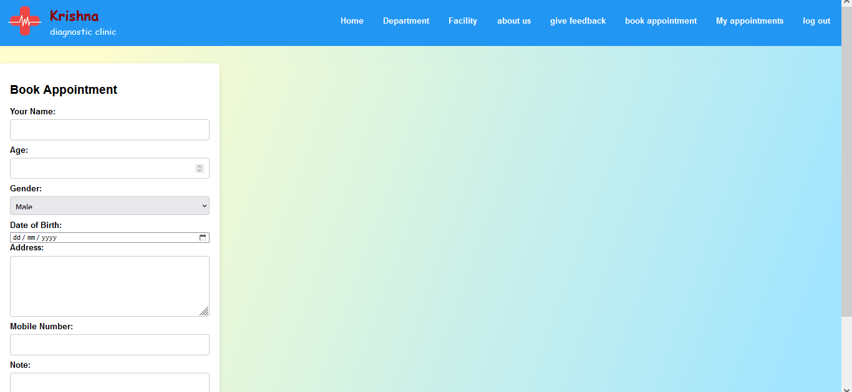
- Coding :- book_appointment.php
<?php
require_once('inc/connection.php');
session_start();
if(isset($_SESSION['ulogged_in']) && $_SESSION['ulogged_in']==true){
$userId = $_SESSION['user_id'];
}else{
header("location:login.php");
}
?>
<?php
if ($_SERVER['REQUEST_METHOD'] === 'GET') {
if (isset($_GET['doctor_id']) && isset($_GET['date']) && isset($_GET['time_slot'])) {
include 'inc/connection.php';
$doctorId = $_GET['doctor_id'];
$date = $_GET['date'];
$timeSlot = $_GET['time_slot'];
$sqlCheckBooking = "SELECT * FROM appointments WHERE doctor_id = $doctorId AND appointment_date = '$date' AND appointment_time = '$timeSlot'";
$resultBooking = mysqli_query($conn, $sqlCheckBooking);
if (mysqli_num_rows($resultBooking) > 0) {
echo "Sorry, the selected slot is already booked.";
} else {
?>
<!DOCTYPE html>
<html>
<head>
<title>Krishna Clinic</title>
<style>
.container {
width: 400px;
padding: 20px;
background-color: #fff;
box-shadow: 0px 3px 10px rgba(0, 0, 0, 0.1);
border-radius: 5px;
}

h2 {
font-size: 24px;
margin-bottom: 20px;
}
form {
display: flex;
flex-direction: column;
}
label {
font-weight: bold;
margin-bottom: 5px;
}
input[type="text"],
input[type="number"],
input[type="tel"],
select,
textarea {
padding: 10px;
margin-bottom: 10px;
border: 1px solid #ccc;
border-radius: 4px;
font-size: 16px;
}
select {
height: 38px;
}
textarea {
height: 100px;
resize: vertical;
}
input[type="submit"] {
background-color: #2196F3;
color: #fff;
border: none;
border-radius: 4px;
padding: 10px 20px;
cursor: pointer;
font-size: 16px;
margin-top: 20px;
}
input[type="submit"]:hover {
background-color: #1565C0;
}
</style>
</head>
<body>
<?php
require_once("inc/header.php");
?>
<main class="container">
<h2>Book Appointment</h2>
<form method="POST" action="">
<input type="hidden" name="doctor_id" value="<?php echo $doctorId; ?>">
<input type="hidden" name="date" value="<?php echo $date; ?>">
<input type="hidden" name="time_slot" value="<?php echo $timeSlot; ?>">
<input type="hidden" name="user_id" value="<?php echo $userId; ?>">
<label for="patient_name">Your Name:</label>
<input type="text" id="patient_name" name="patient_name" required>
<label for="patient_age">Age:</label>
<input type="number" id="patient_age" name="patient_age" required>
<label for="patient_gender">Gender:</label>
<select id="patient_gender" name="patient_gender" required>
<option value="Male">Male</option>
<option value="Female">Female</option>
<option value="Other">Other</option>
</select>
<label for="date_of_birth">Date of Birth:</label>
<input type="date" id="date_of_birth" name="date_of_birth" required>
<label for="patient_address">Address:</label>
<textarea id="patient_address" name="patient_address" required></textarea>
<label for="patient_mobilenumber">Mobile Number:</label>
<input type="tel" id="patient_mobilenumber" name="patient_mobilenumber" required>
<label for="note">Note:</label>
<textarea id="note" name="note"></textarea>
<input type="submit" name="submit_booking" value="Book Appointment">
</form>
</main>
</body>
</html>
<?php
}
} else {
header('Location: bookapp.php');
exit;
}
}
if ($_SERVER['REQUEST_METHOD'] === 'POST') {
if (isset($_POST['submit_booking'])) {
include 'inc/connection.php';
$doctorId = $_POST['doctor_id'];
$date = $_POST['date'];
$timeSlot = $_POST['time_slot'];
$patientName = $_POST['patient_name'];
$patientAge = $_POST['patient_age'];
$patientGender = $_POST['patient_gender'];
$dateOfBirth = $_POST['date_of_birth'];
$patientAddress = $_POST['patient_address'];
$patientMobileNumber = $_POST['patient_mobilenumber'];
$note = $_POST['note'];
$sqlInsertBooking = "INSERT INTO appointments (user_id, doctor_id, appointment_date, appointment_time, patient_name, patient_age, patient_gender, date_of_birth, patient_address, patient_mobilenumber, note) VALUES ('$userId', '$doctorId', '$date','$timeSlot', '$patientName', '$patientAge', '$patientGender', '$dateOfBirth', '$patientAddress', '$patientMobileNumber', '$note')";
mysqli_query($conn, $sqlInsertBooking);
header('Location: cancelapp.php');
exit;
}
}
?>
[9] MY APPOINTMENTS:-
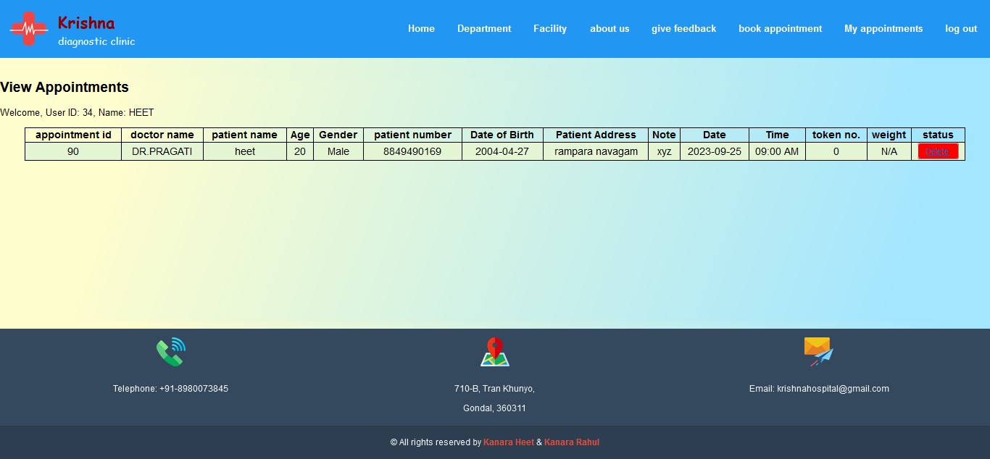
- Coding :- book_appointment.php
<?php
require_once('inc/connection.php');
session_start();
if(isset($_SESSION['ulogged_in']) && $_SESSION['ulogged_in']==true){
$userId = $_SESSION['user_id'];
}else{
header("location:login.php");
}
$userId = $_SESSION['user_id'];
include 'inc/connection.php';
$sqlUserName = "SELECT user_name FROM user WHERE user_id = $userId";
$resultUserName = mysqli_query($conn, $sqlUserName);
$rowUserName = mysqli_fetch_assoc($resultUserName);
$userName = $rowUserName['user_name'];
$sqlAppointments = "SELECT * FROM appointments WHERE user_id = $userId";
$resultAppointments = mysqli_query($conn, $sqlAppointments);
?>
<!DOCTYPE html>
<html lang="en">
<head>
<title>Krishna Clinic</title>
<style>
table {
margin: 0 auto;
font-size: large;
border: 1px solid black;
width:95%;
border-collapse:collapse;

}
h1 {
margin-left:35px;
color: #006600;
display:inline;
}
td {
background-color: #E4F5D4;
border: 1px solid black;
}
th,
td {
font-weight: bold;
border: 1px solid black;
text-align: center;
}
td {
font-weight: lighter;
}
.red{ background-color:red;
border-radius:4px;
padding:5px 15px;
}
</style>
</head>
<body>
<?php
require_once("inc/header.php");
?>
<main>
<?php
require_once('inc/connection.php');
if(isset($_GET['del'])){
$del_id=$_GET['del'];
$delete = "DELETE FROM appointments WHERE appointment_id='$del_id' ";
$run_delete = mysqli_query($conn,$delete);
if($run_delete === true){
echo"record has been deleted";
}else{
echo "Failed , try again";
}
}
?>
<h2>View Appointments</h2>
<p>Welcome, User ID: <?php echo $userId; ?>, Name: <?php echo $userName; ?></p>
<table>
<thead>
<tr>
<th>appointment id</th>
<th>doctor name</th>
<th>patient name</th>
<th>Age</th>
<th>Gender</th>
<th>patient number</th>
<th>Date of Birth</th>
<th>Patient Address
<th>Note</th>
<th>Date</th>
<th>Time</th>
<th>token no.</th>
<th>weight</th>
<th>status</th>
</tr>
</thead>
<tbody>
<?php
while ($rowAppointment = mysqli_fetch_assoc($resultAppointments)) {
$appointmentId = $rowAppointment['appointment_id'];
$doctorId = $rowAppointment['doctor_id'];
$patientName = $rowAppointment['patient_name'];
$patientName = $rowAppointment['patient_name'];
$patientAge = $rowAppointment['patient_age'];
$patientGender = $rowAppointment['patient_gender'];
$dateOfBirth = $rowAppointment['date_of_birth'];
$patientAddress = $rowAppointment['patient_address'];
$note = $rowAppointment['note'];
$patientNumber = $rowAppointment['patient_mobilenumber'];
$appointmentDate = $rowAppointment['appointment_date'];
$appointmentTime = $rowAppointment['appointment_time'];
$appointmentStatus = $rowAppointment['appointment_status'];
$patientWeight = $rowAppointment['patient_weight'];
$tokenNumber = $rowAppointment['token_number'];
$sqlDoctor = "SELECT doctor_name FROM doctor WHERE doctor_id = $doctorId";
$resultDoctor = mysqli_query($conn, $sqlDoctor);
$rowDoctor = mysqli_fetch_assoc($resultDoctor);
$doctorName = $rowDoctor['doctor_name'];
?>
<tr>
<td><?php echo $appointmentId; ?></td>
<td><?php echo $doctorName; ?></td>
<td><?php echo $patientName; ?></td>
<td><?php echo !empty($patientAge) ? $patientAge : 'N/A'; ?></td>
<td><?php echo !empty($patientGender) ? $patientGender : 'N/A'; ?></td>
<td><?php echo $patientNumber; ?></td>
<td><?php echo !empty($dateOfBirth) ? $dateOfBirth : 'N/A'; ?></td>
<td><?php echo !empty($patientAddress) ? $patientAddress : 'N/A'; ?></td>
<td><?php echo !empty($note) ? $note : 'N/A'; ?></td>
<td><?php echo $appointmentDate; ?></td>
<td><?php echo date("h:i A", strtotime($appointmentTime)); ?></td>
<td><?php echo $tokenNumber; ?></td>
<td>
<?php if ( !empty($patientWeight)) : ?>
<?php echo $patientWeight; ?>
<?php else : ?>
N/A
<?php endif; ?>
</td>
<td>
<?php if ($appointmentStatus === 'Arrived') : ?>
<span>Arrived, cannot delete</span>
<?php elseif ($appointmentStatus === 'Visited') : ?>
<span>visited</span>
<?php else : ?>
<button class="red"><a href="cancelapp.php?del=<?php echo $appointmentId ;?> " onclick="return confirm('Are you sure you want to delete this appointment?')">Delete</a></button>
<?php endif; ?>
</td>
</tr>
<?php
}
?>
</tbody>
</table>
</main>
<?php
require_once('inc/footer.php');
?>
</body>
</html>

- ADMIN SIDE

[1]ADMIN HOME :-

- Coding :- admin_home.php
<?php
session_start();
if(isset($_SESSION['alogged_in']) && $_SESSION['alogged_in']==true){
//run
}else{
header("location:../login.php");
}
?>
<!DOCTYPE html>
<html lang="en">
<head>
<meta charset="UTF-8">
<meta name="viewport" content="width=device-width, initial-scale=1.0">
<title>Krishna Clinic</title>
</head>
<body>
<?php
include 'sidebar.php';
?>
<main>
<h1>hello admin</h1>
</main>
</body>
</html>
[2]FACILITYS
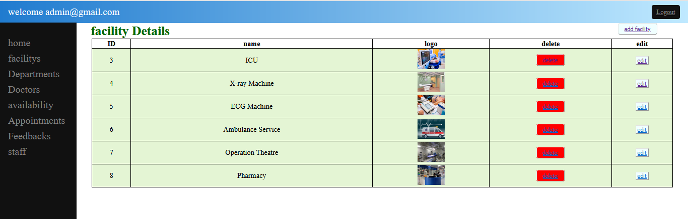
- Coding :- facilitys.php
<?php
session_start();
if(isset($_SESSION['alogged_in']) && $_SESSION['alogged_in']==true){
//run
}else{
header("location:../login.php");
}
?>
<!DOCTYPE html>
<html lang="en">
<head>
<meta charset="UTF-8">
<meta name="viewport" content="width=device-width, initial-scale=1.0">
<title>Krishna Clinic</title>
<style>
table {
margin: 0 auto;
font-size: large;
border: 1px solid black;
width:95%;
border-collapse:collapse;
}
h1 {
margin-left:35px;
color: #006600;
display:inline;
}
td {
background-color: #E4F5D4;
border: 1px solid black;
}
th,
td {
font-weight: bold;
border: 1px solid black;
text-align: center;
}
td {
font-weight: lighter;
}
.red{ background-color:red;
border-radius:4px;
padding:5px 15px;
}
.green{
background-color:azure;
}
.add{background-color:azure;
border-radius:4px;
padding:5px 15px;
float:right;
margin-right:5%;
}
</style>
</head>
<body>
<?php
include 'sidebar.php';
?>
<main>
<h1>facility Details </h1><button class="add"><a href="add_facility.php">add facility</a></button>
<?php
require_once('../inc/connection.php');
if(isset($_GET['del'])){
$del_id=$_GET['del'];
$delete = "DELETE FROM facility WHERE facility_id='$del_id' ";
$run_delete = mysqli_query($conn,$delete);
if($run_delete === true){
echo"record has been deleted";
}else{
echo "Failed , try again";
}
}
?>
<table >
<thead>
<tr>
<th>ID</th>
<th>name</th>
<th>logo</th>
<th>delete</th>
<th>edit</th>
</tr>
</thead>
<tbody>
<?php
require_once('../inc/connection.php');
$select_facility = "SELECT * FROM facility";
$run_facility = mysqli_query($conn,$select_facility);
while ($row_facility = mysqli_fetch_array($run_facility)){
$facility_id = $row_facility['facility_id'];
$facility_name = $row_facility['facility_name'];
$facility_logo = $row_facility['facility_logo'];
?>
<tr>
<td><?php echo $facility_id;?></td>
<td><?php echo $facility_name;?></td>
<td><img src="upload/<?php echo $facility_logo;?>"height="50px"></td>
<td ><button class="red"><a href="facilitys.php?del=<?php echo $facility_id ;?>" onclick="return confirm('Are you sure you want to delete this facility?')" >delete</a></button></td>
<td ><button class="green"><a href="edit_facility.php?edit=<?php echo $facility_id?>">edit</a></button></td>
</tr>
<?php }?>
</tbody>
</table>
</main>
</body>
</html>
[i]EDIT FACILITY :-
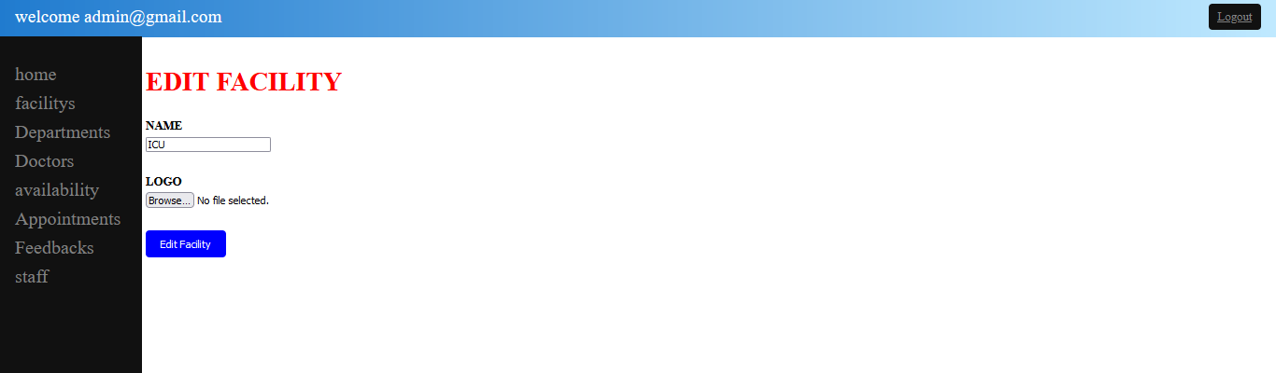
- Coding :- edit_facility.php
<?php
session_start();
if(isset($_SESSION['alogged_in']) && $_SESSION['alogged_in']==true){
//run
}else{
header("location:../login.php");
}
?>
<!DOCTYPE html>
<html lang="en">
<head>
<meta charset="UTF-8">
<meta name="viewport" content="width=device-width, initial-scale=1.0">
<title>Krishna Clinic</title>
<style>
main{
display: flex;
padding: 5px;
width: 80%;
}
.new{
width: 360px;
}
.new h1{
font-size: 35px;
color: red;
}
.new form{
padding: 10px 0 0 0;
}
form .nm{
margin: 30px 0;
}
.nm label{
font-weight: bold;
margin-bottom: 5px;
display: block;
}
.btn {
display: inline-block;
padding: 10px 20px;
background-color: blue;
color: #fff;
border: none;
border-radius: 5px;
cursor: pointer;
}
</style>
</head>
<body>
<?php
include 'sidebar.php';
?>
<main>
<?php
require_once('../inc/connection.php');
if(isset($_GET['edit'])){
$edit_id = $_GET['edit'];
$select_facility ="SELECT * FROM facility WHERE facility_id ='$edit_id'";
$run_facility = mysqli_query($conn,$select_facility);
$row_facility = mysqli_fetch_array($run_facility);
$dbfacility_name = $row_facility['facility_name'];
$dbfacility_id = $row_facility['facility_id'];
$dbfacility_logo = $row_facility['facility_logo'];
}
?>
<div class="new">
<form action="" method="post" enctype="multipart/form-data">
<h1>EDIT FACILITY</h1>
<div class="nm">
<label>NAME</label>
<input type="text" name="facility_name" value="<?php echo $dbfacility_name;?>" required>
</div>
<div class="nm">
<label>LOGO</label>
<input type="file" name="facility_logo">
</div>
<div>
<input type="submit" value="Edit Facility" name ="insert_btn" class="btn">
</div>
</form>
</div>
<?php
require_once('../inc/connection.php');
if(isset($_POST['insert_btn'])){
$facility_name = $_POST['facility_name'];
$facility_logo_name = $_FILES['facility_logo']['name'];
$facility_logo_tmp_name = $_FILES['facility_logo']['tmp_name'];
if(empty($facility_logo_name)){
$facility_logo_name = $dbfacility_logo;
}
$update_facility = "UPDATE facility SET facility_name='$facility_name',facility_logo='$facility_logo_name' WHERE facility_id='$edit_id'";
$run_update = mysqli_query($conn,$update_facility);
if($run_update === true){
echo "data has been updated";
move_uploaded_file($facility_logo_tmp_name,"upload/$facility_logo_name");
echo "<script>window.open('facilitys.php','_self');</script>";
}else{
echo "failed , try again";
}
}
?>
</main>
</body>
</html>
[ii]ADD FACILITY :-
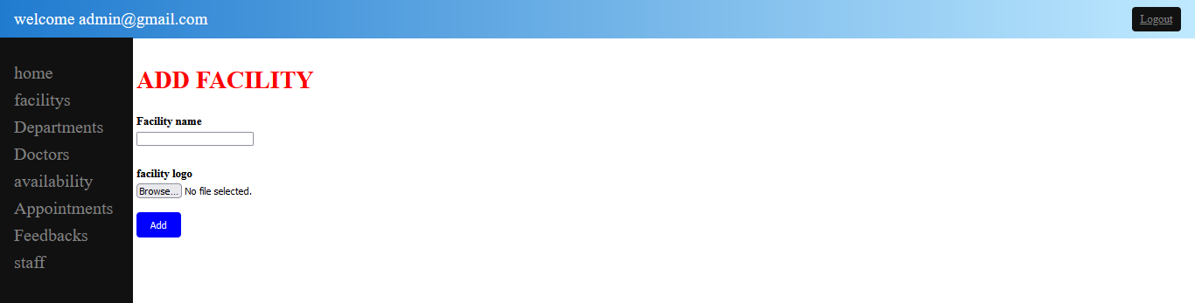
- Coding :- add_facility.php
<?php
session_start();
if(isset($_SESSION['alogged_in']) && $_SESSION['alogged_in']==true){
//run
}else{
header("location:../login.php");
}
?>
<!DOCTYPE html>
<html lang="en">
<head>
<meta charset="UTF-8">
<meta name="viewport" content="width=device-width, initial-scale=1.0">
<title>Krishna Clinic</title>
<style>
main{
display: flex;
padding: 5px;
width: 80%;
}
.new{
width: 360px;
}
.new h1{
font-size: 35px;
color: red;
}
.new form{
padding: 10px 0 0 0;
}
form .nm{
margin: 30px 0;
}
.nm label{
font-weight: bold;
margin-bottom: 5px;
display: block;
}
.btn {
display: inline-block;
padding: 10px 20px;
background-color: blue;
color: #fff;
border: none;
border-radius: 5px;
cursor: pointer;
margin-top: 20px;
}
</style>
</head>
<body>
<?php
include 'sidebar.php';
?>
<main>
<div class="new">
<form action="" method="post" enctype="multipart/form-data">
<h1>ADD FACILITY</h1>
<div class="nm">
<label>Facility name</label>
<input type="text" name="facility_name" required>
</div>
<div class="nm">
<label>facility logo</label>
<input type="file" name="facility_logo" required>
<div >
<input type="submit" value="Add" name="insert-btn" class="btn">
</div>
</form>
</div>
<?php
require_once('../inc/connection.php');
if(isset($_POST['insert-btn'])){
$facility_name = $_POST['facility_name'];
$facility_logo_name = $_FILES['facility_logo']['name'];
$facility_logo_tmp_name = $_FILES['facility_logo']['tmp_name'];
$insert_facility = "INSERT INTO facility(facility_name,facility_logo) VALUES('$facility_name','$facility_logo_name')";
$run_facility = mysqli_query($conn,$insert_facility);
if($run_facility === true){
echo "data has been inserted";
move_uploaded_file($facility_logo_tmp_name,"upload/$facility_logo_name");
echo "<script>window.open('facilitys.php','_self');</script>";
}else{
echo "failsed , try again";
}
}
?>
</main>
</body>
</html>

[3]DEPARTMENT :-
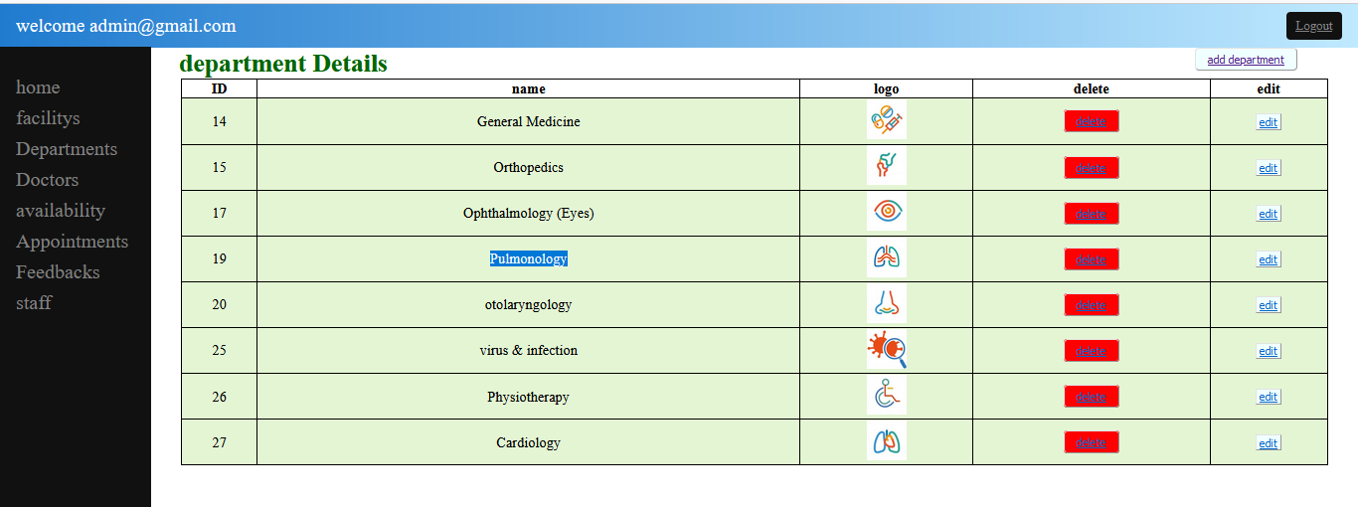
- Coding :-departments.php
<?php
session_start();
if(isset($_SESSION['alogged_in']) && $_SESSION['alogged_in']==true){
//run
}else{
header("location:../login.php");
}
?>
<!DOCTYPE html>
<html lang="en">
<head>
<meta charset="UTF-8">
<meta name="viewport" content="width=device-width, initial-scale=1.0">
<title>Krishna Clinic</title>
<style>
table {
margin: 0 auto;
font-size: large;
border: 1px solid black;
width:95%;
border-collapse:collapse;
}
h1 {
margin-left:35px;
color: #006600;
display:inline;
}
td {
background-color: #E4F5D4;
border: 1px solid black;
}

th,
td {
font-weight: bold;
border: 1px solid black;
text-align: center;
}
td {
font-weight: lighter;
}
.red{ background-color:red;
border-radius:4px;
padding:5px 15px;
}
.green{
background-color:azure;
}
.add{background-color:azure;
border-radius:4px;
padding:5px 15px;
float:right;
margin-right:5%;
}
</style>
</head>
<body>
<?php
include 'sidebar.php';
?>
<main>
<h1>department Details </h1><button class="add"><a href="add_department.php">add department</a></button>
<?php
require_once('../inc/connection.php');
if(isset($_GET['del'])){
$del_id=$_GET['del'];
$delete = "DELETE FROM department WHERE department_id='$del_id' ";
$run_delete = mysqli_query($conn,$delete);
if($run_delete === true){
echo"record has been deleted";
}else{
echo "Failed , try again";
}
}
?>
<table >
<thead>
<tr>
<th>ID</th>
<th>name</th>
<th>logo</th>
<th>delete</th>
<th>edit</th>
</tr>
</thead>
<tbody>
<?php
require_once('../inc/connection.php');
$select_department = "SELECT * FROM department";
$run_department = mysqli_query($conn,$select_department);
while ($row_department = mysqli_fetch_array($run_department)){
$department_id = $row_department['department_id'];
$department_name = $row_department['department_name'];
$department_logo = $row_department['department_logo'];
?>
<tr>
<td><?php echo $department_id;?></td>
<td><?php echo $department_name;?></td>
<td><img src="upload/<?php echo $department_logo;?>"height="50px"></td>
<td ><button class="red"><a href="departments.php?del=<?php echo $department_id ;?>" onclick="return confirm('Are you sure you want to delete this department?')" >delete</a></button></td>
<td ><button class="green"><a href="edit_department.php?edit=<?php echo $department_id?> ">edit</a></button></td>
</tr>
<?php }?>
</tbody>
</table>
</main>
</body>
</html>

[i]EDIT DEPARTMENT:-
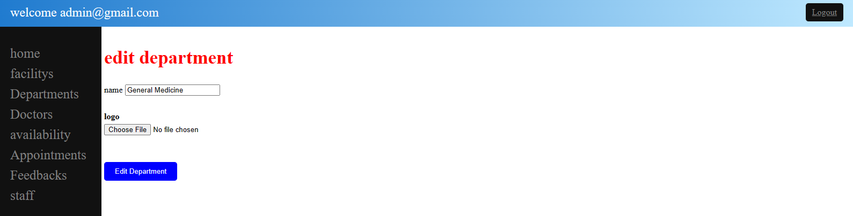
- Coding :- edit_department.php
<?php
session_start();
if(isset($_SESSION['alogged_in']) && $_SESSION['alogged_in']==true){
//run
}else{
header("location:../login.php");
}
?>
<!DOCTYPE html>
<html lang="en">
<head>
<meta charset="UTF-8">
<meta name="viewport" content="width=device-width, initial-scale=1.0">
<title>Krishna Clinic</title>
<style>
main{
display: flex;
padding: 5px;
width: 80%;
}
.new{
width: 360px;
}
.new h1{
font-size: 35px;
color: red;
}
.new form{
padding: 10px 0 0 0;
}
form .nm{
margin: 30px 0;
}
.nm label{
font-weight: bold;
margin-bottom: 5px;
display: block;
}
.btn {
display: inline-block;
padding: 10px 20px;
background-color: blue;
color: #fff;
border: none;
border-radius: 5px;
cursor: pointer;
margin-top: 20px;
}
</style>

</head>
<body>
<?php
include 'sidebar.php';
?>
<main>
<?php
require_once('../inc/connection.php');
if(isset($_GET['edit'])){
$edit_id = $_GET['edit'];
$select_department ="SELECT * FROM department WHERE department_id ='$edit_id'";
$run_department = mysqli_query($conn,$select_department);
$row_department = mysqli_fetch_array($run_department);
$dbdepartment_name = $row_department['department_name'];
$dbdepartment_id = $row_department['department_id'];
$dbdepartment_logo = $row_department['department_logo'];
}
?>
<div class="new">
<form action="" method="post" enctype="multipart/form-data">
<h1>edit department</h1>
<div class="nm">
<lable>name</lable>
<input type="text" name="department_name" value="<?php echo $dbdepartment_name;?>" required>
</div>
<div class="nm">
<label>logo</label>
<input type="file" name="department_logo">
</div>
<div>
<input type="submit" value="Edit Department" name ="insert_btn" class="btn">
</div>
</form>
</div>
<?php
require_once('../inc/connection.php');
if(isset($_POST['insert_btn'])){
$department_name = $_POST['department_name'];
$department_logo_name = $_FILES['department_logo']['name'];
$department_logo_tmp_name = $_FILES['department_logo']['tmp_name'];
if(empty($department_logo_name)){
$department_logo_name = $dbdepartment_logo;
}
$update_department = "UPDATE department SET department_name='$department_name',department_logo='$department_logo_name' WHERE department_id='$edit_id'";
$run_update = mysqli_query($conn,$update_department);
if($run_update === true){
echo "data has been updated";
move_uploaded_file($department_logo_tmp_name,"upload/$department_logo_name");
echo "<script>window.open('departments.php','_self');</script>";
}else{
echo "failed , try again";
}
}
?>
</main>
</body>
</html>
[ii]ADD DEPARTMENT :-
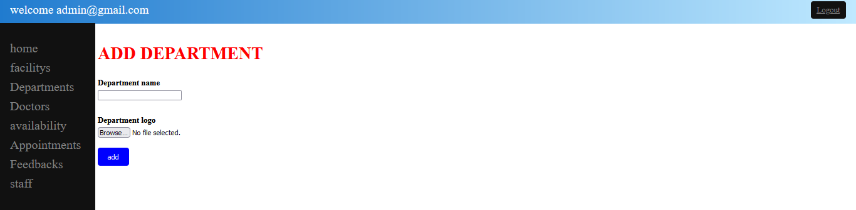
- Coding :- add_department.php
<?php
session_start();
if(isset($_SESSION['alogged_in']) && $_SESSION['alogged_in']==true){
//run
}else{
header("location:../login.php");
}
?>
<!DOCTYPE html>
<html lang="en">
<head>
<meta charset="UTF-8">
<meta name="viewport" content="width=device-width, initial-scale=1.0">
<title>Krishna Clinic</title>
<style>
main{
display: flex;
padding: 5px;
width: 80%;
}
.new{
width: 360px;
}
.new h1{
font-size: 35px;
color: red;
}
.new form{
padding: 10px 0 0 0;
}
form .nm{
margin: 30px 0;
}
.nm label{
font-weight: bold;
margin-bottom: 5px;
display: block;
}
.btn {
display: inline-block;
padding: 10px 20px;
background-color: blue;
color: #fff;
border: none;
border-radius: 5px;
cursor: pointer;
margin-top: 20px;
}
</style>
</head>
<body>
<?php
include 'sidebar.php';
?>
<main>
<div class="new">
<form action="" method="post" enctype="multipart/form-data">
<h1>ADD DEPARTMENT</h1>
<div class="nm">
<label>Department name</label>
<input type="text" name="department_name" required>
</div>
<div class="nm" >
<label>Department logo</label>
<input type="file" name="department_logo" >
<div >
<input type="submit" value="add" name="insert-btn" class="btn" >
</div>
</form>
</div>
<?php
require_once('../inc/connection.php');
if(isset($_POST['insert-btn'])){
$department_name = $_POST['department_name'];
$department_logo_name = $_FILES['department_logo']['name'];
$department_logo_tmp_name = $_FILES['department_logo']['tmp_name'];
$insert_department = "INSERT INTO department(department_name,department_logo) VALUES('$department_name','$department_logo_name')";
$run_department = mysqli_query($conn,$insert_department);
if($run_department === true){
echo "data has been inserted";
move_uploaded_file($department_logo_tmp_name,"upload/$department_logo_name");
echo "<script>window.open('departments.php','_self');</script>";
}else{
echo "failsed , try again";
}
}
?>
</div>
</div> </main> </body>
</html>

[4]DOCTORS
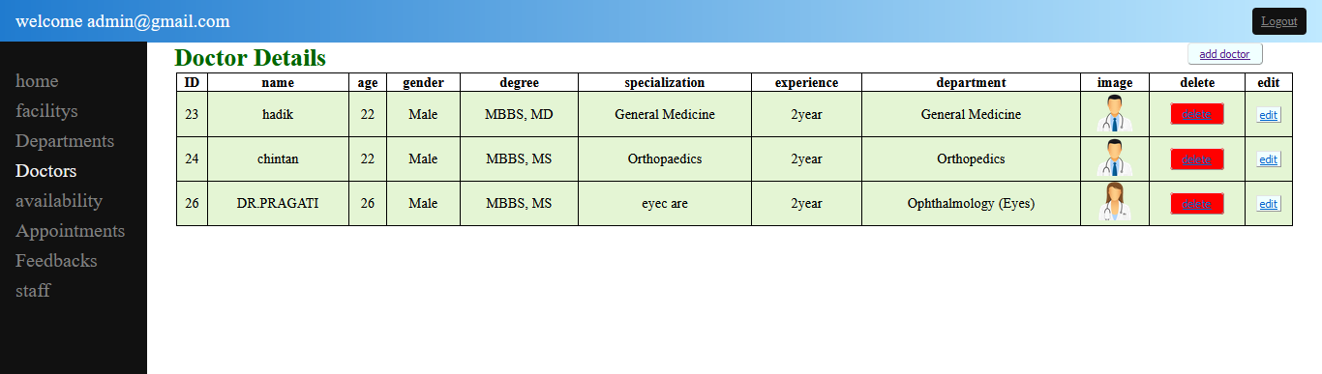
- Coding :- doctors.php
<?php
session_start();
if(isset($_SESSION['alogged_in']) && $_SESSION['alogged_in']==true){
//run
}else{
header("location:../login.php");
}
?>
<!DOCTYPE html>
<html lang="en">
<head>
<meta charset="UTF-8">
<meta http-equiv="X-UA-Compatible" content="IE=edge">
<meta name="viewport" content="width=device-width, initial-scale=1.0">
<title>Krishna Clinic</title>
<style>
table {
margin: 0 auto;
font-size: large;
border: 1px solid black;
width:95%;
border-collapse:collapse;
}
h1 {
margin-left:35px;
color: #006600;
display:inline;
}
td {
background-color: #E4F5D4;
border: 1px solid black;
}
th,
td {
font-weight: bold;
border: 1px solid black;
text-align: center;
}
td {
font-weight: lighter;
}
.red{ background-color:red;
border-radius:4px;
padding:5px 15px;
}
.green{
background-color:azure;
}
.add{background-color:azure;
border-radius:4px;
padding:5px 15px;
float:right;
margin-right:5%;
}
</style>
<body>
<?php
include 'sidebar.php';
?>
<main>
<h1>Doctor Details </h1><button class="add"><a href="add_doctor.php">add doctor</a></button>
<?php
require_once('../inc/connection.php');
if(isset($_GET['del'])){
$del_id=$_GET['del'];
$delete = "DELETE FROM doctor WHERE doctor_id='$del_id' ";
$run_delete = mysqli_query($conn,$delete);
if($run_delete === true){
echo"record has been deleted";
}else{
echo "Failed , try again";
}
}
?>
<table >
<thead>
<tr>
<th>ID</th>
<th>name</th>
<th>age</th>
<th>gender</th>
<th>degree</th>
<th>specialization</th>
<th>experience</th>
<th>department</th>
<th>image</th>
<th>delete</th>
<th>edit</th>
</tr>
</thead>
<tbody>
<?php
require_once('../inc/connection.php');
$select_doctor = "SELECT * FROM doctor";
$run_doctor = mysqli_query($conn,$select_doctor);
while ($row_doctor = mysqli_fetch_array($run_doctor)){
$doctor_id = $row_doctor['doctor_id'];
$doctor_age = $row_doctor['doctor_age'];
$doctor_gender = $row_doctor['doctor_gender'];
$doctor_degree = $row_doctor['doctor_degree'];
$doctor_specialities = $row_doctor['doctor_specialities'];
$doctor_experience = $row_doctor['doctor_experience'];
$department_id = $row_doctor['department_id'];
$doctor_name = $row_doctor['doctor_name'];
$doctor_image = $row_doctor['doctor_image'];
$select_department = "SELECT * FROM department WHERE department_id='$department_id'";
$run_department = mysqli_query($conn,$select_department);
$row_department = mysqli_fetch_array($run_department);
$department_name = $row_department['department_name'];
?>
<tr>
<td><?php echo $doctor_id;?></td>
<td><?php echo $doctor_name;?></td>
<td><?php echo $doctor_age;?></td>
<td><?php echo $doctor_gender;?></td>
<td><?php echo $doctor_degree;?></td>
<td><?php echo $doctor_specialities;?></td>
<td><?php echo $doctor_experience;?></td>
<td><?php echo $department_name;?></td>
<td><img src="upload/<?php echo $doctor_image;?>"height="50px"></td>
<td ><button class="red"><a href="doctors.php?del=<?php echo $doctor_id ;?>" onclick="return confirm('Are you sure you want to delete this doctor?')" >delete</a></button></td>
<td ><button class="green"><a href="edit_doctor.php?edit=<?php echo $doctor_id?>">edit</a></button></td>
</tr>
<?php }?>
</tbody>
</table>
</main>
</body>
</html>
[ii] EDIT DOCTOR:-
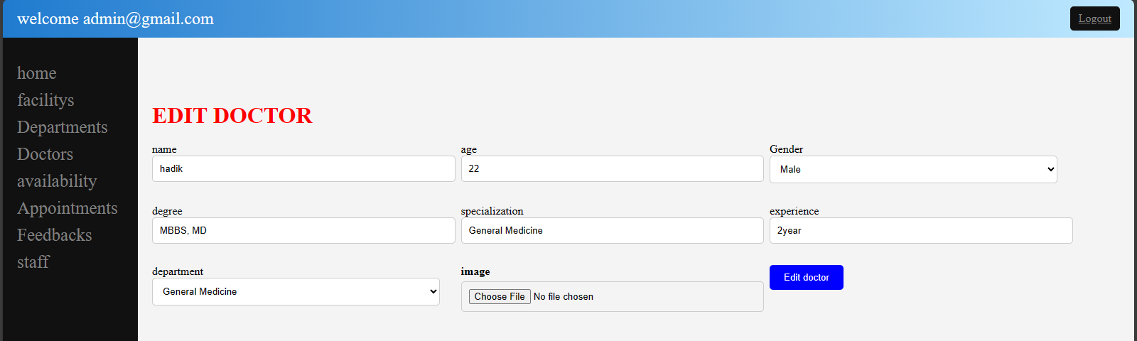
- Coding :- edit_doctor.php
<?php
session_start();
if(isset($_SESSION['alogged_in']) && $_SESSION['alogged_in']==true){
//run
}else{
header("location:../login.php");
}
?>
<!DOCTYPE html>
<html lang="en">
<head>
<meta charset="UTF-8">
<meta name="viewport" content="width=device-width, initial-scale=1.0">
<title>Krishna Clinic</title>
<style>
body {
background-color: #f4f4f4;
}
main {
width: 80%;
margin: 50px auto;
padding: 20px;
}
h1 {
color: red;
margin-bottom: 20px;
}
form {
display: grid;
grid-template-columns: repeat(auto-fit, minmax(300px, 1fr));
gap: 30px;
}
label {
font-weight: bold;
margin-bottom: 5px;
display: block;
}
input[type="text"],
input[type="number"],
input[type="tel"],
select,
input[type="file"] {
width: 100%;
padding: 10px;
border: 1px solid #ccc;
border-radius: 5px;
}
select {
padding: 10px;
border: 1px solid #ccc;
border-radius: 5px;
}
.btn {
display: inline-block;
padding: 10px 20px;
background-color: blue;
color: #fff;
border: none;
border-radius: 5px;
cursor: pointer;
}
</style>
</head>
<body>
<?php
include 'sidebar.php';
?>
<main>
<?php
require_once('../inc/connection.php');
if(isset($_GET['edit'])){
$edit_id = $_GET['edit'];
$select_doctor ="SELECT * FROM doctor WHERE doctor_id ='$edit_id'";
$run_doctor = mysqli_query($conn,$select_doctor);
$row_doctor = mysqli_fetch_array($run_doctor);
$dbdoctor_name = $row_doctor['doctor_name'];
$dbdoctor_age = $row_doctor['doctor_age'];
$dbdoctor_gender = $row_doctor['doctor_gender'];
$dbdoctor_mobilenumber = $row_doctor['doctor_mobilenumber'];
$dbdoctor_degree = $row_doctor['doctor_degree'];
$dbdoctor_specialities = $row_doctor['doctor_specialities'];
$dbdoctor_experience = $row_doctor['doctor_experience'];
$dbdepartment_id = $row_doctor['department_id'];
$dbdoctor_image = $row_doctor['doctor_image'];
}
?>
<h1>EDIT DOCTOR</h1>
<form action="" method="post" enctype="multipart/form-data">
<div>
<lable>name</lable>
<input type="text" name="doctor_name" value="<?php echo $dbdoctor_name;?>" required>
</div>
<div>
<lable>age</lable>
<input type="number" name="doctor_age" value="<?php echo $dbdoctor_age;?>" required>
</div>
<div >
Gender
<select name="doctor_gender" value="<?php echo $dbdoctor_gender;?>">
<option>Male</option>
<option>Female</option>
<option>Other</option>
</select>
</div>
<div>
<lable>degree</lable>
<input type="text" name="doctor_degree" value="<?php echo $dbdoctor_degree;?>" required>
</div>
<div>
<lable>specialization</lable>
<input type="text" name="doctor_specialities" value="<?php echo $dbdoctor_specialities;?>" required>
</div>
<div>
<lable>experience</lable>
<input type="text" name="doctor_experience" value="<?php echo $dbdoctor_experience;?>" required>
</div>
<div>
<lable>department</lable>
<select name="department_id" required>
<option disabled>--select department--</option>
<?php
require_once('../inc/connection.php');
$select_department="Select * FROM department ";
$run_department = mysqli_query($conn,$select_department);
while($row_department = mysqli_fetch_array($run_department)){
$department_id = $row_department['department_id'];
$department_name = $row_department['department_name'];
?>
<option <?php if($dbdepartment_id == $department_id){echo "selected";}?> value="<?php echo $department_id; ?>"><?php echo $department_name; ?></option>
<?php } ?>
</select>
</div>
<div>
<label>image</label>
<input type="file" name="doctor_image">
</div>
<div>
<input type="submit" value="Edit doctor" name ="insert_btn" class="btn">
</div>
</form>
<?php
require_once('../inc/connection.php');
if(isset($_POST['insert_btn'])){
$doctor_name = $_POST['doctor_name'];
$doctor_age = $_POST['doctor_age'];
$doctor_gender = $_POST['doctor_gender'];
$doctor_degree = $_POST['doctor_degree'];
$doctor_specialities = $_POST['doctor_specialities'];
$doctor_experience = $_POST['doctor_experience'];
$edepartment_id = $_POST['department_id'];
$doctor_image_name = $_FILES['doctor_image']['name'];
$doctor_image_tmp_name = $_FILES['doctor_image']['tmp_name'];
if(empty($doctor_image_name)){
$doctor_image_name = $dbdoctor_image;
}
$update_doctor = "UPDATE doctor SET doctor_name='$doctor_name',doctor_age='$doctor_age',doctor_gender='$doctor_gender',doctor_degree='$doctor_degree',doctor_specialities='$doctor_specialities',doctor_experience='$doctor_experience',department_id='$edepartment_id',doctor_image='$doctor_image_name' WHERE doctor_id='$edit_id'";
$run_update = mysqli_query($conn,$update_doctor);
if($run_update === true){
echo "data has been updated";
move_uploaded_file($doctor_image_tmp_name,"upload/$doctor_image_name");
echo "<script>window.open('doctors.php','_self');</script>";
}else{
echo "failed , try again";
}
}
?>
</main>
</body>
</html>
[ii]ADD DOCTOR :-
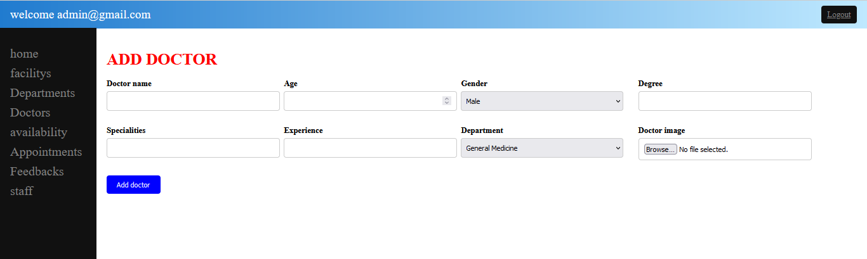
- Coding :- add_doctor.php
<?php
session_start();
if(isset($_SESSION['alogged_in']) && $_SESSION['alogged_in']==true){
//run
}else{
header("location:../login.php");
}
?>
<!DOCTYPE html>
<html lang="en">
<head>
<meta charset="UTF-8">
<meta name="viewport" content="width=device-width, initial-scale=1.0">
<title>Krishna Clinic</title>
<style>
main {
width: 80%;
padding: 20px;
}
h1 {
color: red;
margin-bottom: 20px;
}
form {
display: grid;
grid-template-columns: repeat(auto-fit, minmax(300px, 1fr));
gap: 30px;
}
label {
font-weight: bold;
margin-bottom: 5px;
display: block;
}
input[type="text"],
input[type="number"],
input[type="tel"],
select,
input[type="file"] {
width: 100%;
padding: 10px;
border: 1px solid #ccc;
border-radius: 5px;
}
select {
padding: 10px;
border: 1px solid #ccc;
border-radius: 5px;
}
.btn {
display: inline-block;
padding: 10px 20px;
background-color: blue;
color: #fff;
border: none;
border-radius: 5px;
cursor: pointer;
}
</style>
</head>
<body>
<?php
include 'sidebar.php';
?>
<main>
<div class="new">
<h1>ADD DOCTOR</h1>
<form action="" method="post" enctype="multipart/form-data">
<div class="nm">
<label> Doctor name</label>
<input type="text" name="doctor_name" required>
</div>
<div class="nm">
<label>Age</label>
<input type="number" name="doctor_age" required>
</div>
<div class="nm">
<label >Gender</label>
<select name="doctor_gender">
<option >Male</option>
<option>Female</option>
<option>Other</option>
</select>
</div>
<div class="nm">
<label>Degree</label>
<input type="text" name="doctor_degree" required>
</div>
<div class="nm">
<label > Specialities</label>
<input type="text" name="doctor_specialities" required>
</div>
<div class="nm">
<label>Experience</label>
<input type="text" name="doctor_experience" required>
</div>
<div class="nm">
<label>Department</label>
<select name="department_id" required>
<option disabled>--select department--</option>
<?php
require_once('../inc/connection.php');
$select_department="Select * FROM department";
$run_department = mysqli_query($conn,$select_department);
while($row_department = mysqli_fetch_array($run_department)){
$department_id = $row_department['department_id'];
$department_name = $row_department['department_name'];
?>
<option value="<?php echo $department_id; ?>"><?php echo $department_name; ?></option>
<?php } ?>
</select>
</div>
<div class="nm">
<label>Doctor image</label>
<input type="file" name="doctor_image" class="form-control">
</div>
<div>
<input type="submit" value="Add doctor" name ="insert_btn" class="btn">
</div>
</form>
</div>
<?php
require_once('../inc/connection.php');
if(isset($_POST['insert_btn'])){
$doctor_name = $_POST['doctor_name'];
$doctor_age = $_POST['doctor_age'];
$doctor_gender = $_POST['doctor_gender'];
$doctor_degree = $_POST['doctor_degree'];
$doctor_specialities = $_POST['doctor_specialities'];
$doctor_experience = $_POST['doctor_experience'];
$department_id = $_POST['department_id'];
$doctor_image_name = $_FILES['doctor_image']['name'];
$doctor_image_tmp_name = $_FILES['doctor_image']['tmp_name'];
$insert_doctor = "INSERT INTO doctor(doctor_name,doctor_age,doctor_gender,doctor_degree,doctor_specialities,doctor_experience,department_id,doctor_image)
VALUES('$doctor_name','$doctor_age','$doctor_gender','$doctor_degree','$doctor_specialities','$doctor_experience','$department_id','$doctor_image_name')";

$run_doctor = mysqli_query($conn,$insert_doctor);
if($run_doctor === true){
echo "data has been inserted";
move_uploaded_file($doctor_image_tmp_name,"upload/$doctor_image_name");
echo "<script>window.open('doctors.php','_self');</script>";
}else{
echo "failed , try again";
}
}
?>
</main>
</body>
</html>
[5]DOCTOR AVAILABLITY
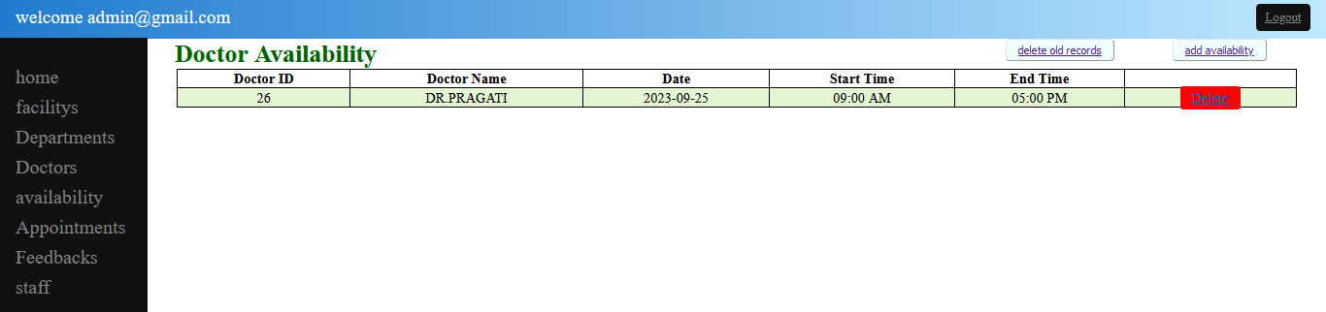
- Coding :- availablity.php
<?php
session_start();
if(isset($_SESSION['alogged_in']) && $_SESSION['alogged_in']==true){
//run
}else{
header("location:../login.php");
}
?>
<!DOCTYPE html>
<html lang="en">
<head>
<meta charset="UTF-8">
<meta name="viewport" content="width=device-width, initial-scale=1.0">
<title>Krishna Clinic</title>
<style>
table {
margin: 0 auto;
font-size: large;
border: 1px solid black;
width:95%;
border-collapse:collapse;
}
h1 {
margin-left:35px;
color: #006600;
display:inline;
}
td {
background-color: #E4F5D4;
border: 1px solid black;
}
th,
td {
font-weight: bold;
border: 1px solid black;
text-align: center;
}
td {
font-weight: lighter;
}
.red{ background-color:red;
border-radius:4px;
padding:5px 15px;
}
.green{
background-color:azure;
}
.add{background-color:azure;
border-radius:4px;
padding:5px 15px;
float:right;
margin-right:5%;
}

</style>
</head>
<body>
<?php
include 'sidebar.php';
?>
<main>
<?php
require_once('../inc/connection.php');
if(isset($_GET['del'])) {
$del_id = $_GET['del'];
$delete = "DELETE FROM availability WHERE availability_id='$del_id'";
$run_delete = mysqli_query($conn, $delete);
if($run_delete === true) {
echo "Record has been deleted";
} else {
echo "Failed to delete the record, please try again";
}
}
$sqlAvailability = "SELECT * FROM availability";
$resultAvailability = mysqli_query($conn, $sqlAvailability);

?>
<h1>Doctor Availability</h1><button class="add"><a href="add_availability.php">add availability</a></button><button class="add"><a href="delete_past_availability.php">delete old records</a></button>
<table>
<thead>
<tr>
<th>Doctor ID</th>
<th>Doctor Name</th>
<th>Date</th>
<th>Start Time</th>
<th>End Time</th>
</tr>
</thead>
<tbody>
<?php
while ($row = mysqli_fetch_assoc($resultAvailability)) {
$doctorId = $row['doctor_id'];
$sqlDoctor = "SELECT doctor_name FROM doctor WHERE doctor_id = $doctorId";
$resultDoctor = mysqli_query($conn, $sqlDoctor);
$doctorName = mysqli_fetch_assoc($resultDoctor)['doctor_name'];
echo "<tr>";
echo "<td>{$row['doctor_id']}</td>";
echo "<td>{$doctorName}</td>";
echo "<td>{$row['available_date']}</td>";
echo "<td>" . date('h:i A', strtotime($row['start_time'])) . "</td>";
echo "<td>" . date('h:i A', strtotime($row['end_time'])) . "</td>";
echo "<td><a class='red' href='?del={$row['availability_id']}' onclick='return confirm(\"Are you sure you want to delete this record?\")'>Delete</a></td>";
echo "</tr>";
}
?>
</tbody>
</table>
</main>
</body>
</html>
[i]ADD AVAILIBILITY:-
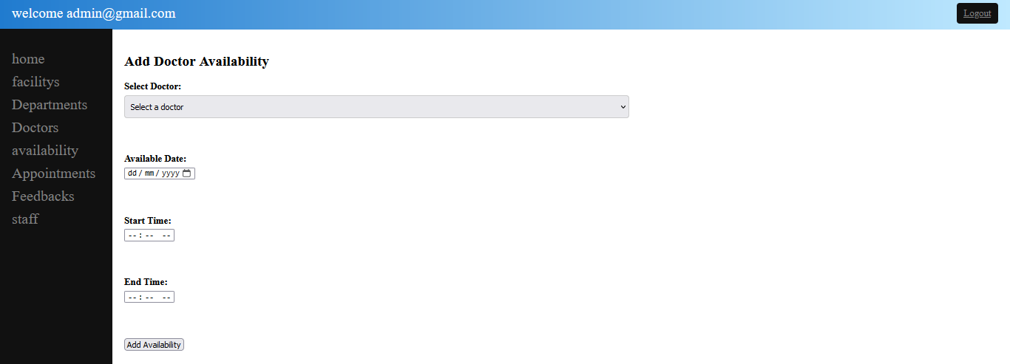
- Coding :- add_availibility.php
<?php
session_start();
if(isset($_SESSION['alogged_in']) && $_SESSION['alogged_in']==true){
//run
}else{
header("location:../login.php");
}
?>
<!DOCTYPE html>
<html lang="en">
<head>
<meta charset="UTF-8">
<meta name="viewport" content="width=device-width, initial-scale=1.0">
<title>Krishna Clinic</title>
<style>
main {
width: 50%;
padding: 20px;
}
h1 {
color: red;
margin-bottom: 20px;
}
form {
display: grid;
gap: 30px;
}
label {
font-weight: bold;
margin-bottom: 5px;
display: block;
}

input[type="text"],
input[type="number"],
input[type="tel"],
select,
input[type="file"] {
width: 100%;
padding: 10px;
border: 1px solid #ccc;
border-radius: 5px;
}
select {
padding: 10px;
border: 1px solid #ccc;
border-radius: 5px;
}
.btn {
display: inline-block;
padding: 10px 20px;
background-color: blue;
color: #fff;
border: none;
border-radius: 5px;
cursor: pointer;
}
</style>
</head>
<body>
<?php
include 'sidebar.php';
?>
<main>
<div class="new">
<?php
require_once('../inc/connection.php');
if ($_SERVER['REQUEST_METHOD'] === 'POST') {
$doctorId = $_POST['doctor_id'];
$availableDate = $_POST['available_date'];
$startTime = $_POST['start_time'];
$endTime = $_POST['end_time'];
$sql = "INSERT INTO availability (doctor_id, available_date, start_time, end_time) VALUES ('$doctorId', '$availableDate', '$startTime', '$endTime')";
$result = mysqli_query($conn, $sql);
if ($result) {
echo "Availability added successfully!";
} else {
echo "Error: " . mysqli_error($conn);
}
}
?>

<h2>Add Doctor Availability</h2>
<form method="POST" action="">
<div class="id">
<label for="doctor_id">Select Doctor:</label>
<select id="doctor_id" name="doctor_id" required>
<option value="">Select a doctor</option>
<?php
$sqlDoctors = "SELECT doctor_id, doctor_name FROM doctor";
$resultDoctors = mysqli_query($conn, $sqlDoctors);
while ($rowDoctor = mysqli_fetch_assoc($resultDoctors)) {
echo "<option value=\"{$rowDoctor['doctor_id']}\">{$rowDoctor['doctor_name']}</option>";
}
?>
</select>
</div>
<br>
<div class="id">
<label for="available_date">Available Date:</label>
<input type="date" id="available_date" name="available_date" required>
</div>
<br>
<div class="id">
<label for="start_time">Start Time:</label>
<input type="time" id="start_time" name="start_time" required>
</div>
<br>
<div class="id">
<label for="end_time">End Time:</label>
<input type="time" id="end_time" name="end_time" required>
</div>
<br>
<div class="id">
<input type="submit" value="Add Availability">
</div>
</form>
</div>
</main>
</body>
</html>
[6]APPOINTMENTS:-
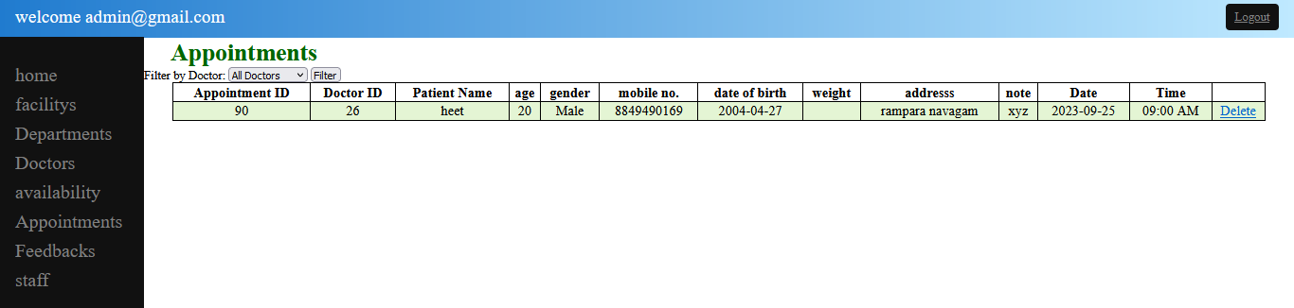
- Coding :- appointments.php
<?php
session_start();
if(isset($_SESSION['alogged_in']) && $_SESSION['alogged_in']==true){
//run
}else{
header("location:../login.php");
}
?>
<!DOCTYPE html>
<html lang="en">
<head>
<meta charset="UTF-8">
<meta name="viewport" content="width=device-width, initial-scale=1.0">
<title>Krishna Clinic</title>
<style>
table {
margin: 0 auto;
font-size: large;
border: 1px solid black;
width:95%;
border-collapse:collapse;
}
h1 {
margin-left:35px;
color: #006600;
display:inline;
}
td {
background-color: #E4F5D4;
border: 1px solid black;
}
th,
td {
font-weight: bold;
border: 1px solid black;
text-align: center;
}
td {
font-weight: lighter;
}
</style>
</head>
<body>
<?php
include 'sidebar.php';
?>
<main>
<?php
require_once('../inc/connection.php');
if(isset($_GET['del'])) {
$del_id = $_GET['del'];
$sqlDeleteAppointment = "DELETE FROM appointments WHERE appointment_id='$del_id'";
$run_delete = mysqli_query($conn, $sqlDeleteAppointment);
if($run_delete === true) {
echo "Record has been deleted";
} else {
echo "Failed to delete the record, please try again";
}
}
$sqlDoctors = "SELECT doctor_id, doctor_name FROM doctor";
$resultDoctors = mysqli_query($conn, $sqlDoctors);
$doctorFilter = isset($_GET['doctor']) ? $_GET['doctor'] : 'all';
$sqlAppointments = "SELECT * FROM appointments";
if ($doctorFilter !== 'all') {
$sqlAppointments .= " WHERE doctor_id = $doctorFilter";
}
$resultAppointments = mysqli_query($conn, $sqlAppointments);
?>
<h1>Appointments</h1>
<form method="GET" action="">
<label for="doctor">Filter by Doctor:</label>
<select id="doctor" name="doctor">
<option value="all">All Doctors</option>
<?php
while ($rowDoctor = mysqli_fetch_assoc($resultDoctors)) {
$selected = $doctorFilter == $rowDoctor['doctor_id'] ? 'selected' : '';
echo "<option value=\"{$rowDoctor['doctor_id']}\" $selected>{$rowDoctor['doctor_name']}</option>";
}
?>
</select>
<input type="submit" value="Filter">
</form>
<table>
<thead>
<tr>
<th>Appointment ID</th>
<th>Doctor ID</th>
<th>Patient Name</th>
<th>age</th>
<th>gender</th>
<th>mobile no.</th>
<th>date of birth</th>
<th>weight</th>
<th>addresss</th>
<th>note</th>
<th>Date</th>
<th>Time</th>
</tr>
</thead>
<tbody>
<?php
while ($row = mysqli_fetch_assoc($resultAppointments)) {
echo "<tr>";
echo "<td>{$row['appointment_id']}</td>";
echo "<td>{$row['doctor_id']}</td>";
echo "<td>{$row['patient_name']}</td>";
echo "<td>{$row['patient_age']}</td>";
echo "<td>{$row['patient_gender']}</td>";
echo "<td>{$row['patient_mobilenumber']}</td>";
echo "<td>{$row['date_of_birth']}</td>";
echo "<td>{$row['patient_weight']}</td>";
echo "<td>{$row['patient_address']}</td>";
echo "<td>{$row['note']}</td>";
echo "<td>{$row['appointment_date']}</td>";
echo "<td>" . date('h:i A', strtotime($row['appointment_time'])) . "</td>";
echo "<td><a class='red' href='?del={$row['appointment_id']}' onclick='return confirm(\"Are you sure you want to delete this appointment?\")'>Delete</a></td>";
echo "</tr>";
}
?>
</tbody>
</table>
</main>
</body>
</html>
[7]FEEDBACKS:-
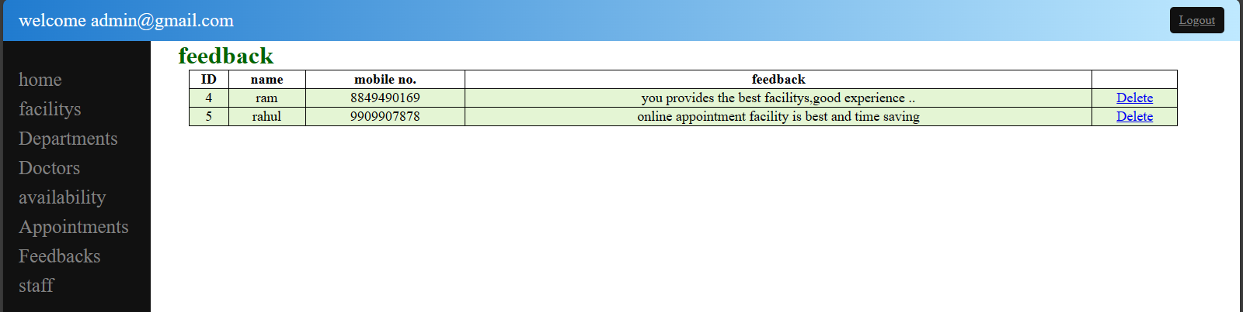
- Coding :- feedbacks.php
<?php
session_start();
if(isset($_SESSION['alogged_in']) && $_SESSION['alogged_in']==true){
//run
}else{
header("location:../login.php");
}
?>
<!DOCTYPE html>
<html lang="en">
<head>
<meta charset="UTF-8">
<meta name="viewport" content="width=device-width, initial-scale=1.0">
<title>Krishna Clinic</title>
<style>
table {
margin-left:15%;
font-size: large;
border: 1px solid black;
width:80%;
border-collapse:collapse;
}
h1 {
margin-left:35px;
color: #006600;
display:inline;
}
td {
background-color: #E4F5D4;
border: 1px solid black;
}
th,
td {
font-weight: bold;
border: 1px solid black;
text-align: center;
}
td {
font-weight: lighter;
}
</style>
</head>
<body>
<?php
include 'sidebar.php';
?>
<table>
<thead>
<tr>
<th>ID</th>
<th>name</th>
<th>mobile no.</th>
<th>feedback</th>
</tr>
</thead>
<tbody>
<main>
<h1>feedback</h1>
<?php
require_once('../inc/connection.php');
if(isset($_GET['del'])) {
$del_id = $_GET['del'];
$delete = "DELETE FROM feedback WHERE feedback_id='$del_id'";
$run_delete = mysqli_query($conn, $delete);
if($run_delete === true) {
echo "Record has been deleted";
} else {
echo "Failed to delete the record, please try again";
}
}
$select_feedback = "SELECT * FROM feedback";
$run_feedback = mysqli_query($conn,$select_feedback);
while ($row_feedback = mysqli_fetch_assoc($run_feedback)){
$feedback_id = $row_feedback['feedback_id'];
$feedback_name = $row_feedback['feedback_name'];
$feedback_mobilenumber = $row_feedback['feedback_mobilenumber'];
$feedback = $row_feedback['feedback'];
?>
<tr>
<td><?php echo $feedback_id;?></td>
<td><?php echo $feedback_name;?></td>
<td><?php echo $feedback_mobilenumber;?></td>
<td><?php echo $feedback;?></td>
<td><a class='red' href='?del=<?php echo $feedback_id; ?>' onclick='return confirm("Are you sure you want to delete this feedback?")'>Delete</a></td>
<?php }?>
</main>
</body>
</html>
[8]STAFF:-
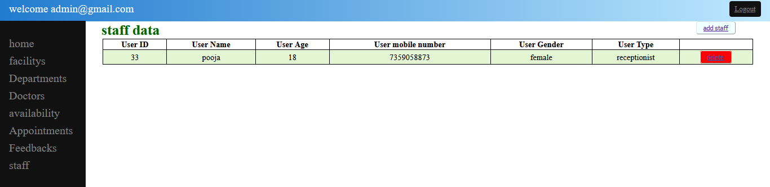
- Coding :- staff.php
<?php
session_start();
if(isset($_SESSION['alogged_in']) && $_SESSION['alogged_in'] == true){
// Continue running
} else {
header("location:../login.php");
}
?>
<!DOCTYPE html>
<html lang="en">
<head>
<meta charset="UTF-8">
<meta name="viewport" content="width=device-width, initial-scale=1.0">
<title>Krishna Clinic</title>
<style>
table {
margin: 0 auto;
font-size: large;
border: 1px solid black;
width:95%;
border-collapse:collapse;
}
h1 {
margin-left:35px;
color: #006600;
display:inline;
}
td {
background-color: #E4F5D4;
border: 1px solid black;
}
th,
td {
font-weight: bold;
border: 1px solid black;
text-align: center;
}
td {
font-weight: lighter;
}
.red{ background-color:red;
border-radius:4px;
padding:5px 15px;
}
.add{background-color:azure;
border-radius:4px;
padding:5px 15px;
float:right;
margin-right:5%;
}

</style>
</head>
<body>
<?php
include 'sidebar.php';
?>
<main>
<?php
require_once('../inc/connection.php');
if(isset($_GET['del'])){
$del_id=$_GET['del'];
$delete = "DELETE FROM user WHERE user_id='$del_id' ";
$run_delete = mysqli_query($conn,$delete);
if($run_delete === true){
echo"record has been deleted";
}else{
echo "Failed , try again";
}
}
?>
<h1>staff data</h1><button class="add"><a href="add_staff.php">add staff</a></button>
<table>
<thead>
<tr>
<th>User ID</th>
<th>User Name</th>
<th>User Age</th>
<th>User mobile number</th>
<th>User Gender</th>
<th>User Type</th>
</tr>
</thead>
<tbody>
<?php
require_once('../inc/connection.php');
$select_user = "SELECT * FROM user WHERE user_type IN ('doctor', 'receptionist')";
$run_user = mysqli_query($conn, $select_user);

while ($row_user = mysqli_fetch_array($run_user)){
$user_id = $row_user['user_id'];
$user_name = $row_user['user_name'];
$user_age = $row_user['user_age'];
$user_mobilenumber = $row_user['user_mobilenumber'];
$user_gender = $row_user['user_gender'];
$user_type = $row_user['user_type'];
?>
<tr>
<td><?php echo $user_id;?></td>
<td><?php echo $user_name;?></td>
<td><?php echo $user_age;?></td>
<td><?php echo $user_mobilenumber;?></td>
<td><?php echo $user_gender;?></td>
<td><?php echo $user_type;?></td>
<td ><button class="red"><a href="staff.php?del=<?php echo $user_id ;?>" onclick="return confirm('Are you sure you want to delete this user?')">delete</a></button></td>
</tr>
<?php }?>
</tbody>
</table>
</main>
</body>
</html>
[i]ADD STAFF :-
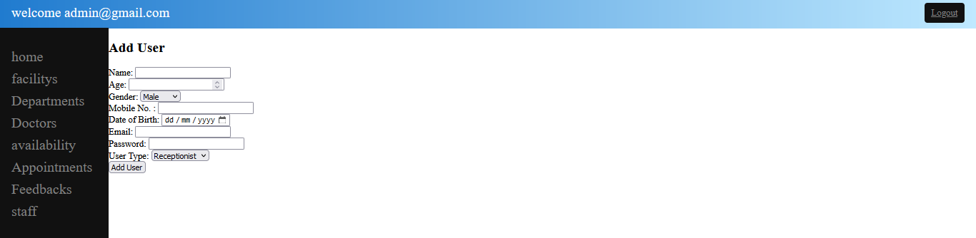
- Coding :- add_staff.php
<?php
session_start();
if(isset($_SESSION['alogged_in']) && $_SESSION['alogged_in'] == true){
// Continue running
} else {
header("location:../login.php");
}
?>
<!DOCTYPE html>
<html lang="en">
<head>
<meta charset="UTF-8">
<meta name="viewport" content="width=device-width, initial-scale=1.0">
<title>Krishna Clinic</title>
<style>
table {
margin: 0 auto;
font-size: large;
border: 1px solid black;
width:95%;
border-collapse:collapse;
}
h1 {
margin-left:35px;
color: #006600;
display:inline;
}
td {
background-color: #E4F5D4;
border: 1px solid black;
}
th,
td {
font-weight: bold;
border: 1px solid black;
text-align: center;
}
td {
font-weight: lighter;
}
.red{ background-color:red;
border-radius:4px;
padding:5px 15px;
}
.add{background-color:azure;
border-radius:4px;
padding:5px 15px;
float:right;
margin-right:5%;
}
</style>
</head>
<body>
<?php
include 'sidebar.php';
?>
<main>
<?php
require_once('../inc/connection.php');
if ($_SERVER['REQUEST_METHOD'] === 'POST') {
$userName = $_POST['user_name'];
$userAge = $_POST['user_age'];
$userGender = $_POST['user_gender'];
$userMobilenumber = $_POST['user_mobilenumber'];
$userEmail = $_POST['user_email'];
$userPassword = md5($_POST['user_password']);
$userType = $_POST['user_type'];
$userDOB = md5($_POST['user_dob']);
$doctorId = ($userType === 'doctor') ? $_POST['doctor_id'] : null;
$check_email = "SELECT * FROM user WHERE user_email='$userEmail'";
$run_check_email = mysqli_query($conn, $check_email);
if(mysqli_num_rows($run_check_email) > 0) {
echo "Email Already Exists";
} else {
$sqlInsert = "INSERT INTO user (user_name, user_age, user_gender, user_mobilenumber, user_email, user_password, user_type, user_dob, doctor_id)
VALUES ('$userName', '$userAge', '$userGender', '$userMobilenumber', '$userEmail', '$userPassword', '$userType', '$userDOB', '$doctorId')";
$resultInsert = mysqli_query($conn, $sqlInsert);
if ($resultInsert) {
echo "User added successfully!";
} else {
echo "Error: " . mysqli_error($conn);
}
}
}
?>
<h2>Add User</h2>
<form method="POST" action="">
<div class>
<label for="user_name">Name:</label>
<input type="text" name="user_name" required>
</div>
<div>
<label for="user_age">Age:</label>
<input type="number" name="user_age" required>
</div>
<div>
<label for="user_gender">Gender:</label>
<select name="user_gender">
<option value="male">Male</option>
<option value="female">Female</option>
<option value="other">Other</option>
</select>
</div>
<div>
<label for="user_mobilenumber">Mobile No. :</label>
<input type="tel" name="user_mobilenumber" required>
</div>
<div>
<label for="user_dob">Date of Birth:</label>
<input type="date" name="user_dob" required>
</div>
<div>
<label for="user_name">Email:</label>
<input type="email" name="user_email" required>
</div>
<div>
<label for="user_password">Password:</label>
<input type="password" name="user_password" required>
</div>
<div>
<label for="user_type">User Type:</label>
<select name="user_type" id="user_type">
<option value="receptionist">Receptionist</option>
<option value="doctor">Doctor</option>
</select>
</div>
<div id="doctor_select" style="display: none;">
<label for="doctor_id">Select Doctor:</label>
<select name="doctor_id">
<?php
$sqlDoctors = "SELECT doctor_id, doctor_name FROM doctor";
$resultDoctors = mysqli_query($conn, $sqlDoctors);
while ($rowDoctor = mysqli_fetch_assoc($resultDoctors)) {
echo '<option value="' . $rowDoctor['doctor_id'] . '">' . $rowDoctor['doctor_name'] . '</option>';
}
?>
</select>
</div>
<div>
<input type="submit" value="Add User">
</div>
</form>
</main>
<script>
document.getElementById('user_type').addEventListener('change', function() {
var doctorSelectDiv = document.getElementById('doctor_select');
if (this.value === 'doctor') {
doctorSelectDiv.style.display = 'block';
} else {
doctorSelectDiv.style.display = 'none';
}
});
</script>
</body>
</html>
- RECEPTIONIST SIDE

[1] RECEPTIONST HOME:-
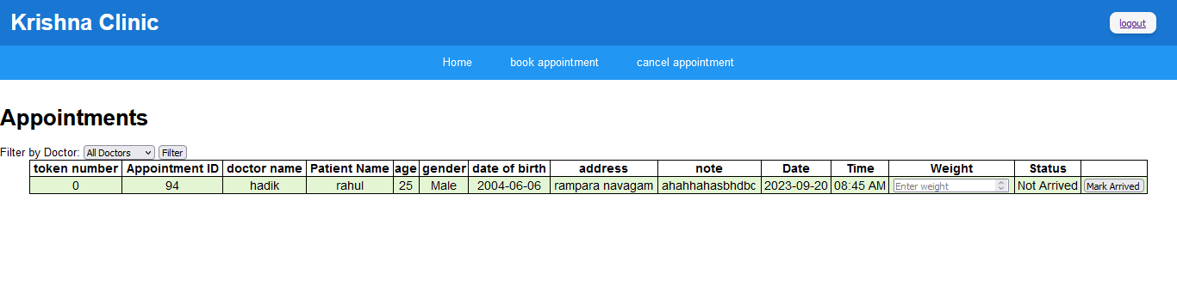
- Coding :- rec_home.php
<?php
session_start();
if(isset($_SESSION['rlogged_in']) && $_SESSION['rlogged_in']==true){
$userId = $_SESSION['user_id'];
}else{
header("location:login.php");
}
?>
<!DOCTYPE html>
<html lang="en">
<head>
<meta charset="UTF-8">
<meta http-equiv="X-UA-Compatible" content="IE=edge">
<meta name="viewport" content="width=device-width, initial-scale=1.0">
<title>Krishna Clinic</title>
<style>
table {
margin: 0 auto;
font-size: large;
border: 1px solid black;
width:95%;
border-collapse:collapse;
}
td {
background-color: #E4F5D4;
border: 1px solid black;
}
th,
td {
font-weight: bold;
border: 1px solid black;
text-align: center;
}
td {
font-weight: lighter;
}
</style>
<body>
<?php
include 'topnav.php';
?>
<main>
<?php
require_once('../inc/connection.php');
$currentDate = date("Y-m-d");
$doctorFilter = isset($_GET['doctor']) ? $_GET['doctor'] : 'all';
$sqlDoctors = "SELECT doctor_id, doctor_name FROM doctor";
$resultDoctors = mysqli_query($conn, $sqlDoctors);
$sqlAppointments = "SELECT * FROM appointments WHERE appointment_date = '$currentDate'";
if ($doctorFilter !== 'all') {
$sqlAppointments .= " AND doctor_id = $doctorFilter";
}
$sqlAppointments .= " ORDER BY appointment_time";
$resultAppointments = mysqli_query($conn, $sqlAppointments);
?>
<h1>Appointments</h1>
<form method="GET" action="">
<label for="doctor">Filter by Doctor:</label>
<select id="doctor" name="doctor">
<option value="all">All Doctors</option>
<?php
while ($rowDoctor = mysqli_fetch_assoc($resultDoctors)) {
$selected = ($doctorFilter == $rowDoctor['doctor_id']) ? 'selected' : '';
echo "<option value=\"{$rowDoctor['doctor_id']}\" $selected>{$rowDoctor['doctor_name']}</option>";
}
?>
</select>
<input type="submit" value="Filter">
</form>
<table>
<thead>
<tr>
<th>token number</th>
<th>Appointment ID</th>
<th>doctor name</th>
<th>Patient Name</th>
<th>age</th>
<th>gender</th>
<th>date of birth</th>
<th>address</th>
<th>note</th>
<th>Date</th>
<th>Time</th>
<th>Weight</th>
<th>Status</th>
</tr>
</thead>
<tbody>
<?php
while ($row = mysqli_fetch_assoc($resultAppointments)) {
$doctorNameQuery = "SELECT doctor_name FROM doctor WHERE doctor_id = {$row['doctor_id']}";
$doctorNameResult = mysqli_query($conn, $doctorNameQuery);
$doctorNameRow = mysqli_fetch_assoc($doctorNameResult);
$doctorName = $doctorNameRow['doctor_name'];
$appointmentTime12Hour = date("h:i A", strtotime($row['appointment_time']));
echo "<tr>";
echo "<td>{$row['token_number']}</td>";
echo "<td>{$row['appointment_id']}</td>";
echo "<td>$doctorName</td>";
echo "<td>{$row['patient_name']}</td>";
echo "<td>{$row['patient_age']}</td>";
echo "<td>{$row['patient_gender']}</td>";
echo "<td>{$row['date_of_birth']}</td>";
echo "<td>{$row['patient_address']}</td>";
echo "<td>{$row['note']}</td>";
echo "<td>{$row['appointment_date']}</td>";
echo "<td>{$appointmentTime12Hour}</td>";
echo "<td>";
echo "<form method='POST' action=''>";
echo "<input type='hidden' name='appointment_id' value='{$row['appointment_id']}'>";
echo "<input type='hidden' name='weight' value='{$row['patient_weight']}'>";
if (empty($row['patient_weight'])) {
echo "<input type='number' name='patient_weight' placeholder='Enter weight' required>";
} else {
echo $row['patient_weight'];
}
echo "</td>";
echo "<td>{$row['appointment_status']}</td>";
echo "<td>";
if (empty($row['patient_weight'])) {
echo "<input type='submit' name='mark_arrived' value='Mark Arrived'>";
}
echo "</form>";
}
?>
</tbody>
</table>

<?php
if ($_SERVER['REQUEST_METHOD'] === 'POST' && isset($_POST['mark_arrived'])) {
$appointmentId = $_POST['appointment_id'];
$currentDate = date("Y-m-d");
$doctorIdQuery = "SELECT doctor_id FROM appointments WHERE appointment_id = '$appointmentId'";
$doctorIdResult = mysqli_query($conn, $doctorIdQuery);
$doctorIdRow = mysqli_fetch_assoc($doctorIdResult);
$doctorId = $doctorIdRow['doctor_id'];
$maxTokenQuery = "SELECT MAX(token_number) AS max_token FROM appointments WHERE appointment_date = '$currentDate' AND doctor_id = '$doctorId'";
$maxTokenResult = mysqli_query($conn, $maxTokenQuery);
$maxTokenRow = mysqli_fetch_assoc($maxTokenResult);
$maxTokenNumber = $maxTokenRow['max_token'];
$newTokenNumber = ($maxTokenNumber !== null) ? $maxTokenNumber + 1 : 1;
$newWeight = $_POST['patient_weight'];
$updateStatusQuery = "UPDATE appointments SET patient_weight = '$newWeight', appointment_status = 'Arrived', token_number = '$newTokenNumber' WHERE appointment_id = '$appointmentId'";
$updateStatusResult = mysqli_query($conn, $updateStatusQuery);
if ($updateStatusResult) {
echo "Token generated successfully. New Token Number: " . $newTokenNumber;
exit();
} else {
echo "Error updating appointment status.";
}
}
?>
</main>
</body>
</html>

[2] BOOK APPOINTMENT:-
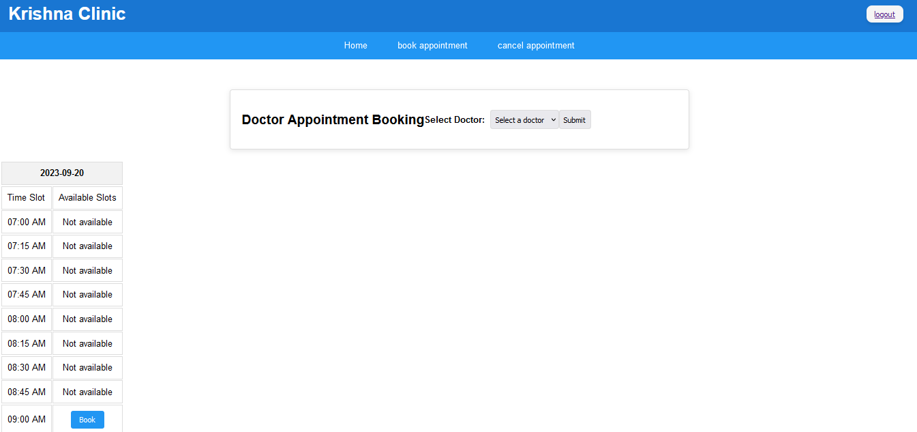

- Coding :- new_app.php
<?php
require_once('../inc/connection.php');
session_start();
if(isset($_SESSION['rlogged_in']) && $_SESSION['rlogged_in'] == true){
echo "Welcome $_SESSION[user_id]";
}else{
header("location:login.php");
}
date_default_timezone_set('Asia/Kolkata');
function isTimeSlotPassed($date, $timeSlot) {
$currentTime = time();
$dateTimeSlot = strtotime("$date $timeSlot");
return $dateTimeSlot < $currentTime;
}
function convertToUserLocalTime($serverTimestamp, $userTimezoneOffset) {
$serverTime = strtotime($serverTimestamp);
$userTime = $serverTime + ($userTimezoneOffset * 60);
return date('h:i A', $userTime);
}
if (isset($_POST['book_button'])) {
$selectedDoctor = $_POST['doctor_id'];
$selectedDate = $_POST['date'];
$selectedTimeSlot = $_POST['time_slot'];
$twentyFourHourTime = date('H:i:s', strtotime($selectedTimeSlot));
$sqlInsertAppointment = "INSERT INTO appointments (doctor_id, appointment_date, appointment_time) VALUES ($selectedDoctor, '$selectedDate', '$twentyFourHourTime')";
$resultInsertAppointment = mysqli_query($conn, $sqlInsertAppointment);
if ($resultInsertAppointment) {
echo "Appointment booked for $selectedDate at $selectedTimeSlot.";
} else {
echo "Error booking the appointment.";
}
}
?>
<!DOCTYPE html>
<html lang="en">
<head>
<meta charset="UTF-8">
<meta http-equiv="X-UA-Compatible" content="IE=edge">
<meta name="viewport" content="width=device-width, initial-scale=1.0">
<title>Krishna Clinic</title>
<style>
h2 {
font-size: 24px;
margin-bottom: 20px;
display:block;
}
form {
display: flex;
align-items: center;
margin-bottom: 20px;
max-width: 800px;
margin: 20px auto;
padding: 20px;
border: 1px solid #ddd;
border-radius: 5px;
box-shadow: 0px 3px 10px rgba(0, 0, 0, 0.1);
}
label {
font-weight: bold;
margin-right: 10px;
}
select, input[type="submit"] {
padding: 8px;
border: 1px solid #ddd;
border-radius: 4px;
font-size: 14px;
}
.appointment-table {
display: inline-block;
vertical-align: top;
margin-right: 20px;
}
.appointment-table {
width: 300px;
max-width: 100%;
}
.table-container {
overflow: auto;
white-space: nowrap;
}
.appointment-table th, .appointment-table td {
padding: 10px;
text-align: center;
border: 1px solid #ddd;
}
.appointment-table th {
background-color: #f2f2f2;
font-weight: bold;
}
.appointment-table tr:hover {
background-color: #f5f5f5;
}
.booked {
color: #e74c3c;
font-weight: bold;
}
.not-available {
color: #9e9e9e;
font-weight: bold;
}
.book-button {
padding: 8px 16px;
background-color: #2196F3;
color: white;
border: none;
border-radius: 4px;
cursor: pointer;
}
.book-button:hover {
background-color: #1565C0;
}
</style>
</head>
<body>
<?php
include 'topnav.php';
?>
<main>
<form method="POST" action="">
<h2>Doctor Appointment Booking</h2>
<label for="doctor">Select Doctor:</label>
<select id="doctor" name="doctor" required>
<option value="">Select a doctor</option>
<?php
include 'inc/connection.php';
$sql = "SELECT doctor_id, doctor_name FROM doctor";
$result = mysqli_query($conn, $sql);
while ($row = mysqli_fetch_assoc($result)) {
echo "<option value=\"{$row['doctor_id']}\">{$row['doctor_name']}</option>";
}
?>
</select>
<input type="submit" name="submit_doctor" value="Submit">
</form>
<?php
if (isset($_POST['submit_doctor']) && isset($_POST['doctor'])) {
$selectedDoctor = $_POST['doctor'];
$sqlAvailability = "SELECT available_date, start_time, end_time FROM availability WHERE doctor_id = $selectedDoctor";
$resultAvailability = mysqli_query($conn, $sqlAvailability);
$availableSlots = array();
while ($row = mysqli_fetch_assoc($resultAvailability)) {
$date = $row['available_date'];
$startTime = $row['start_time'];
$endTime = $row['end_time'];
$timeSlotInterval = 15;
$currentTime = strtotime($startTime);
while ($currentTime <= strtotime($endTime)) {
$timeSlot24Hour = date('H:i', $currentTime);
$timeSlot12Hour = date('h:i A', strtotime($timeSlot24Hour));
$availableSlots[$date][] = array('24-hour' => $timeSlot24Hour, '12-hour' => $timeSlot12Hour);
$currentTime += $timeSlotInterval * 60;
}
}
?>
<div class="table-container">
<?php foreach ($availableSlots as $date => $timeSlots) {?>
<table class="appointment-table">
<thead>
<tr>
<th colspan="2"><?php echo $date; ?></th>
</tr>
</thead>
<tbody>
<tr>
<td class="time-label">Time Slot</td>
<td class="time-slot">Available Slots</td>
</tr>
<?php foreach ($timeSlots as $timeSlot) { ?>
<tr>
<td><?php echo $timeSlot['12-hour']; ?></td>
<td>
<?php
$sqlCheckBooking = "SELECT * FROM appointments WHERE doctor_id = $selectedDoctor AND appointment_date = '$date' AND appointment_time = '{$timeSlot['24-hour']}'";
$resultBooking = mysqli_query($conn, $sqlCheckBooking);
if (isTimeSlotPassed($date, $timeSlot['24-hour'])) {
echo "Not available";
} elseif (mysqli_num_rows($resultBooking) > 0) {
echo "Booked";
} else {
$sqlDoctorName = "SELECT doctor_name FROM doctor WHERE doctor_id = $selectedDoctor";
$resultDoctorName = mysqli_query($conn, $sqlDoctorName);
$doctorName = mysqli_fetch_assoc($resultDoctorName)['doctor_name'];
$formattedTimeSlot = date('H:i', strtotime($timeSlot['12-hour']));
?>
<button class="book-button" onclick="confirmBooking(<?php echo $selectedDoctor; ?>, '<?php echo $doctorName; ?>', '<?php echo $date; ?>', '<?php echo $formattedTimeSlot; ?>')">Book</button>
<?php
}
?>
</td>
</tr>
<?php } ?>
</tbody>
</table>
<?php } ?>
</div>
<?php } ?>
</main>
<script>
function confirmBooking(doctorId, doctorName, date, timeSlot) {
const confirmationMessage = `Are you sure you want to book an appointment with ${doctorName} on ${date} at ${timeSlot}?`;
const confirmation = confirm(confirmationMessage);
if (confirmation) {
window.location.href = `new_appointment.php?doctor_id=${doctorId}&date=${date}&time_slot=${timeSlot}`;
}
}
</script>
</body>
</html>
[i]ADD DEPARTMENT :-
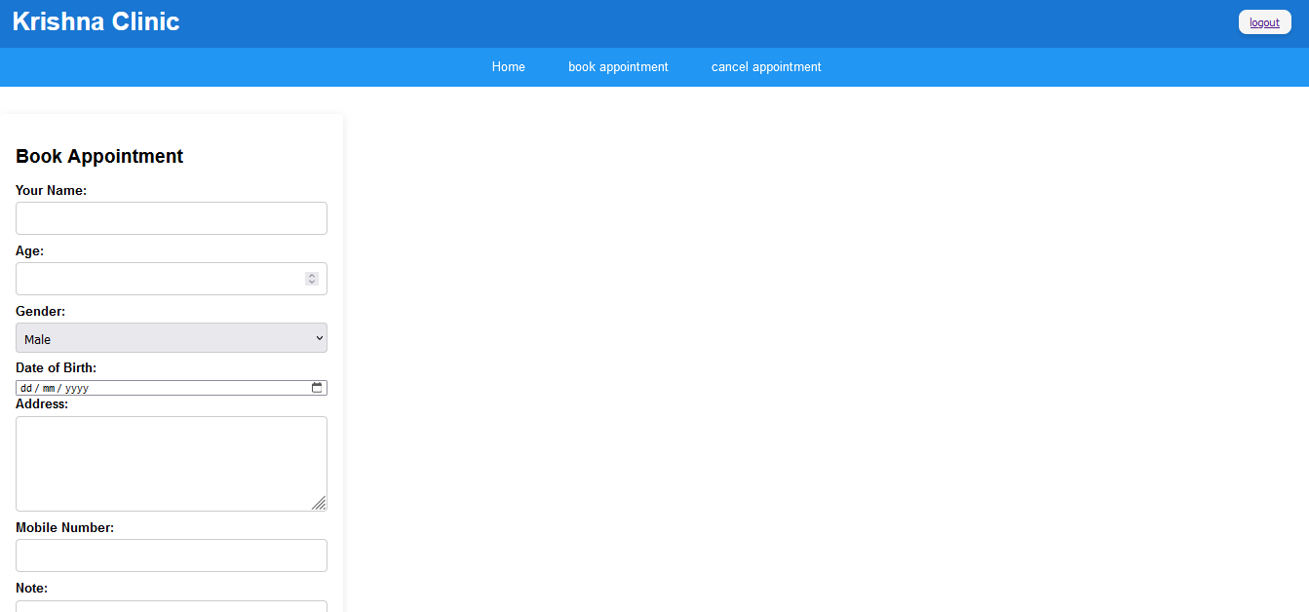
- Coding :- new_appointment.php
<?php
require_once('../inc/connection.php');
session_start();
if(isset($_SESSION['rlogged_in']) && $_SESSION['rlogged_in']==true){
$userId = $_SESSION['user_id'];
}else{
header("location:../login.php");
}
?>
<?php
if ($_SERVER['REQUEST_METHOD'] === 'GET') {
if (isset($_GET['doctor_id']) && isset($_GET['date']) && isset($_GET['time_slot'])) {
include '../inc/connection.php';
$doctorId = $_GET['doctor_id'];
$date = $_GET['date'];
$timeSlot = $_GET['time_slot'];
$sqlCheckBooking = "SELECT * FROM appointments WHERE doctor_id = $doctorId AND appointment_date = '$date' AND appointment_time = '$timeSlot'";
$resultBooking = mysqli_query($conn, $sqlCheckBooking);
if (mysqli_num_rows($resultBooking) > 0) {
echo "Sorry, the selected slot is already booked.";
} else {
?>
<!DOCTYPE html>
<html>
<head>
<title>Krishna Clinic</title>
<style>
.container {
width: 400px;
padding: 20px;
background-color: #fff;
box-shadow: 0px 3px 10px rgba(0, 0, 0, 0.1);
border-radius: 5px;
}
h2 {
font-size: 24px;
margin-bottom: 20px;
}
form {
display: flex;
flex-direction: column;
}
label {
font-weight: bold;
margin-bottom: 5px;
}
input[type="text"],
input[type="number"],
input[type="tel"],
select,
textarea {
padding: 10px;
margin-bottom: 10px;
border: 1px solid #ccc;
border-radius: 4px;
font-size: 16px;
}
select {
height: 38px;
}
textarea {
height: 100px;
resize: vertical;
}
input[type="submit"] {
background-color: #2196F3;
color: #fff;
border: none;
border-radius: 4px;
padding: 10px 20px;
cursor: pointer;
font-size: 16px;
margin-top: 20px;
}

input[type="submit"]:hover {
background-color: #1565C0;
}
</style>
</head>
<body>
<?php
require_once("topnav.php");
?>
<main class="container">
<h2>Book Appointment</h2>
<form method="POST" action="">
<input type="hidden" name="doctor_id" value="<?php echo $doctorId; ?>">
<input type="hidden" name="date" value="<?php echo $date; ?>">
<input type="hidden" name="time_slot" value="<?php echo $timeSlot; ?>">
<input type="hidden" name="user_id" value="<?php echo $userId; ?>">
<label for="patient_name">Your Name:</label>
<input type="text" id="patient_name" name="patient_name" required>
<label for="patient_age">Age:</label>
<input type="number" id="patient_age" name="patient_age" required>
<label for="patient_gender">Gender:</label>
<select id="patient_gender" name="patient_gender" required>
<option value="Male">Male</option>
<option value="Female">Female</option>
<option value="Other">Other</option>
</select>
<label for="date_of_birth">Date of Birth:</label>
<input type="date" id="date_of_birth" name="date_of_birth" required>
<label for="patient_address">Address:</label>
<textarea id="patient_address" name="patient_address" required></textarea>
<label for="patient_mobilenumber">Mobile Number:</label>
<input type="tel" id="patient_mobilenumber" name="patient_mobilenumber" required>
<label for="note">Note:</label>
<textarea id="note" name="note"></textarea>
<input type="submit" name="submit_booking" value="Book Appointment">
</form>
</main>
</body>
</html>
<?php
}
} else {
header('Location: new_app.php');
exit;
}
}
if ($_SERVER['REQUEST_METHOD'] === 'POST') {
if (isset($_POST['submit_booking'])) {
include '../inc/connection.php';
$doctorId = $_POST['doctor_id'];
$date = $_POST['date'];
$timeSlot = $_POST['time_slot'];
$patientName = $_POST['patient_name'];
$patientAge = $_POST['patient_age'];
$patientGender = $_POST['patient_gender'];
$dateOfBirth = $_POST['date_of_birth'];
$patientAddress = $_POST['patient_address'];
$patientMobileNumber = $_POST['patient_mobilenumber'];
$note = $_POST['note'];
$sqlInsertBooking = "INSERT INTO appointments (user_id, doctor_id, appointment_date, appointment_time, patient_name, patient_age, patient_gender, date_of_birth, patient_address, patient_mobilenumber, note) VALUES ('$userId', '$doctorId', '$date','$timeSlot', '$patientName', '$patientAge', '$patientGender', '$dateOfBirth', '$patientAddress', '$patientMobileNumber', '$note')";
mysqli_query($conn, $sqlInsertBooking);
header('Location: cancel_appo.php');
exit;
}
}
?>
[3] CANCEL APOINTMNET:-
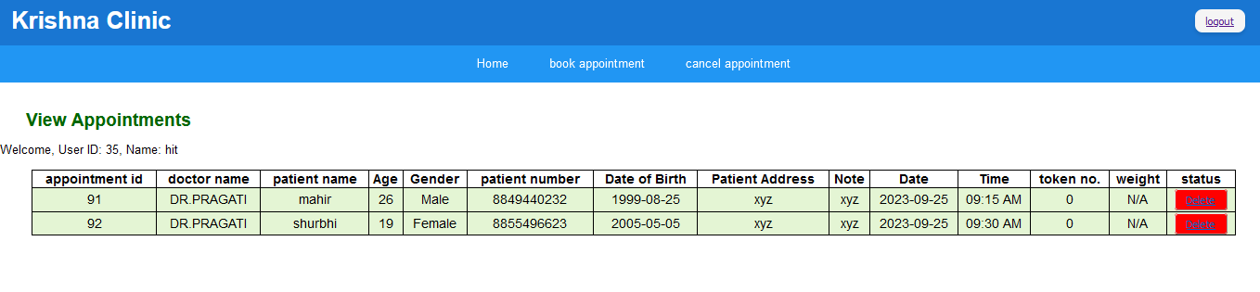
- Coding :- cancel_appo.php
<?php
require_once('../inc/connection.php');
session_start();
if(isset($_SESSION['rlogged_in']) && $_SESSION['rlogged_in']==true){
$userId = $_SESSION['user_id'];
}else{
header("location:../login.php");
}
$userId = $_SESSION['user_id'];
include '../inc/connection.php';
$sqlUserName = "SELECT user_name FROM user WHERE user_id = $userId";
$resultUserName = mysqli_query($conn, $sqlUserName);
$rowUserName = mysqli_fetch_assoc($resultUserName);
$userName = $rowUserName['user_name'];
$sqlAppointments = "SELECT * FROM appointments WHERE user_id = $userId";
$resultAppointments = mysqli_query($conn, $sqlAppointments);
?>
<!DOCTYPE html>
<html lang="en">
<head>
<title>Krishna Clinic</title>
<style>
table {
margin: 0 auto;
font-size: large;
border: 1px solid black;
width:95%;
border-collapse:collapse;
}
h2 {
margin-left:35px;
color: #006600;
display:inline;
}
td {
background-color: #E4F5D4;
border: 1px solid black;
}

th,
td {
font-weight: bold;
border: 1px solid black;
text-align: center;
}
td {
font-weight: lighter;
}
.red{ background-color:red;
border-radius:4px;
padding:5px 15px;
}
</style>
</head>
<body>
<?php
require_once("topnav.php");
?>
<main>
<?php
require_once('../inc/connection.php');
if(isset($_GET['del'])){
$del_id=$_GET['del'];
$delete = "DELETE FROM appointments WHERE appointment_id='$del_id' ";
$run_delete = mysqli_query($conn,$delete);
if($run_delete === true){
echo"record has been deleted";
}else{
echo "Failed , try again";
}
}
?>
<h2>View Appointments</h2>
<p>Welcome, User ID: <?php echo $userId; ?>, Name: <?php echo $userName; ?></p>
<table>
<thead>
<tr>
<th>appointment id</th>
<th>doctor name</th>
<th>patient name</th>
<th>Age</th>
<th>Gender</th>
<th>patient number</th>
<th>Date of Birth</th>
<th>Patient Address
<th>Note</th>
<th>Date</th>
<th>Time</th>
<th>token no.</th>
<th>weight</th>
<th>status</th>
</tr>
</thead>
<tbody>
<?php
while ($rowAppointment = mysqli_fetch_assoc($resultAppointments)) {
$appointmentId = $rowAppointment['appointment_id'];
$doctorId = $rowAppointment['doctor_id'];
$patientName = $rowAppointment['patient_name'];
$patientName = $rowAppointment['patient_name'];
$patientAge = $rowAppointment['patient_age'];
$patientGender = $rowAppointment['patient_gender'];
$dateOfBirth = $rowAppointment['date_of_birth'];
$patientAddress = $rowAppointment['patient_address'];
$note = $rowAppointment['note'];
$patientNumber = $rowAppointment['patient_mobilenumber'];
$appointmentDate = $rowAppointment['appointment_date'];
$appointmentTime = $rowAppointment['appointment_time'];
$appointmentStatus = $rowAppointment['appointment_status'];
$patientWeight = $rowAppointment['patient_weight'];
$tokenNumber = $rowAppointment['token_number'];
$sqlDoctor = "SELECT doctor_name FROM doctor WHERE doctor_id = $doctorId";
$resultDoctor = mysqli_query($conn, $sqlDoctor);
$rowDoctor = mysqli_fetch_assoc($resultDoctor);
$doctorName = $rowDoctor['doctor_name'];
?>
<tr>
<td><?php echo $appointmentId; ?></td>
<td><?php echo $doctorName; ?></td>
<td><?php echo $patientName; ?></td>
<td><?php echo !empty($patientAge) ? $patientAge : 'N/A'; ?></td>
<td><?php echo !empty($patientGender) ? $patientGender : 'N/A'; ?></td>
<td><?php echo $patientNumber; ?></td>
<td><?php echo !empty($dateOfBirth) ? $dateOfBirth : 'N/A'; ?></td>
<td><?php echo !empty($patientAddress) ? $patientAddress : 'N/A'; ?></td>
<td><?php echo !empty($note) ? $note : 'N/A'; ?></td>
<td><?php echo $appointmentDate; ?></td>
<td><?php echo date("h:i A", strtotime($appointmentTime)); ?></td>
<td><?php echo $tokenNumber; ?></td>
<td>
<?php if ( !empty($patientWeight)) : ?>
<?php echo $patientWeight; ?>
<?php else : ?>
N/A
<?php endif; ?>
</td>
<td>
<?php if ($appointmentStatus === 'Arrived') : ?>
<span>Arrived, cannot delete</span>
<?php elseif ($appointmentStatus === 'Visited') : ?>
<span>visited</span>
<?php else : ?>
<button class="red"><a href="cancelapp.php?del=<?php echo $appointmentId ;?>" onclick="return confirm('Are you sure you want to delete this appointment?')">Delete</a></button>
<?php endif; ?>
</td>
</tr>
<?php
}
?>
</tbody>
</table>
</main>
</body>
</html>
- DOCTOR SIDE

[1] DOCTOR HOME:-
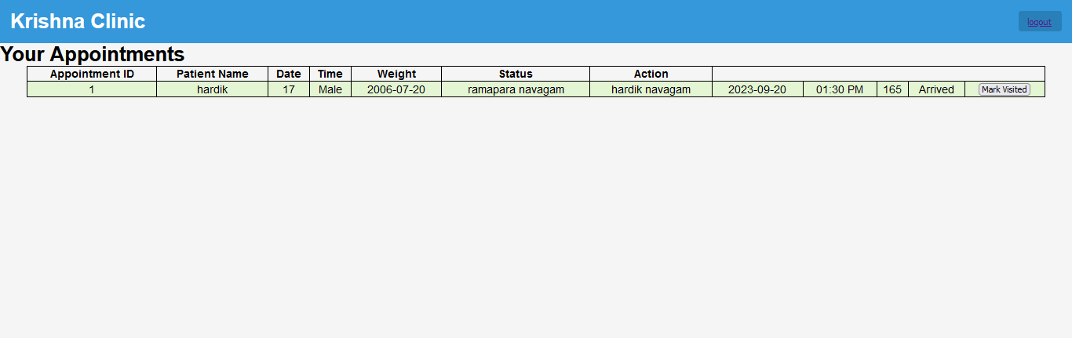
- Coding :- dr_home.php
<?php
session_start();
if(isset($_SESSION['dlogged_in']) && $_SESSION['dlogged_in'] == true){
$doctorId = $_SESSION['doctor_id'];
}else{
header("location:login.php");
}
?>

<!DOCTYPE html>
<html lang="en">
<head>
<meta charset="UTF-8">
<meta http-equiv="X-UA-Compatible" content="IE=edge">
<meta name="viewport" content="width=device-width, initial-scale=1.0">
<title>Krishna Clinic</title>
<style>
table {
margin: 0 auto;
font-size: large;
border: 1px solid black;
width:95%;
border-collapse:collapse;
}
td {
background-color: #E4F5D4;
border: 1px solid black;
}
th,
td {
font-weight: bold;
border: 1px solid black;
text-align: center;
}
td {
font-weight: lighter;
}
</style>
</head>
<body>
<?php
include 'navbar.php';
?>
<main>
<?php
require_once('../inc/connection.php');

$sqlAppointments = "SELECT * FROM appointments WHERE doctor_id = $doctorId AND appointment_status = 'Arrived'";
$resultAppointments = mysqli_query($conn, $sqlAppointments);
?>
<h1>Your Appointments</h1>
<table>
<thead>
<tr>
<th>Appointment ID</th>
<th>Patient Name</th>
<th>Date</th>
<th>Time</th>
<th>Weight</th>
<th>Status</th>
<th>Action</th>
</tr>
</thead>
<tbody>
<?php
while ($row = mysqli_fetch_assoc($resultAppointments)) {
$appointmentTime12Hour = date("h:i A", strtotime($row['appointment_time']));
echo "<tr>";
echo "<td>{$row['token_number']}</td>";
echo "<td>{$row['patient_name']}</td>";
echo "<td>{$row['patient_age']}</td>";
echo "<td>{$row['patient_gender']}</td>";
echo "<td>{$row['date_of_birth']}</td>";
echo "<td>{$row['patient_address']}</td>";
echo "<td>{$row['note']}</td>";
echo "<td>{$row['appointment_date']}</td>";
echo "<td>{$appointmentTime12Hour}</td>";
echo "<td>{$row['patient_weight']}</td>";
echo "<td>{$row['appointment_status']}</td>";
echo "<td>";

if ($row['appointment_status'] !== 'Visited') {
echo "<form method='POST' action=''>";
echo "<input type='hidden' name='appointment_id' value='{$row['appointment_id']}'>";
echo "<input type='submit' name='mark_visited' value='Mark Visited'>";
echo "</form>";
}
echo "</td>";
echo "</tr>";
}
?>
</tbody>
</table>
<?php
if ($_SERVER['REQUEST_METHOD'] === 'POST' && isset($_POST['mark_visited'])) {
$appointmentId = $_POST['appointment_id'];
$updateStatusQuery = "UPDATE appointments SET appointment_status = 'Visited' WHERE appointment_id = '$appointmentId'";
$updateStatusResult = mysqli_query($conn, $updateStatusQuery);
if ($updateStatusResult) {
echo "Appointment status updated to 'Visited'.";
} else {
echo "Error updating appointment status.";
}
}

?>
</main>
</body>
</html>

