Evagelos Petropoulos
U75564436
Project 3 Part 2

Training History and the Changes of Rewards During Progress
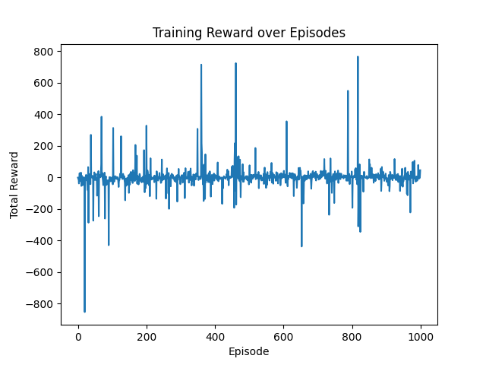
Training Progress Sample
Example of training logs(after epsilon reached minimum):
Episode 945 finished | Total reward: 15.48 | Steps: 153 | Epsilon: 0.050
Ep 946 Step 0 | state=7, action=3, reward=-1.32, next_state=7, done=False
Ep 946 Step 25 | state=7, action=2, reward=0.01, next_state=7, done=False
Ep 946 Step 50 | state=0, action=3, reward=3.45, next_state=0, done=False
Ep 946 Step 75 | state=0, action=1, reward=0.02, next_state=0, done=False
Ep 946 Step 100 | state=0, action=1, reward=0.02, next_state=0, done=False
Ep 946 Step 125 | state=0, action=2, reward=0.01, next_state=0, done=False
Ep 946 Step 150 | state=0, action=2, reward=-0.17, next_state=0, done=False
Ep 946 Step 175 | state=0, action=6, reward=0.37, next_state=0, done=False
Episode 946 finished | Total reward: 54.96 | Steps: 187 | Epsilon: 0.050
Ep 947 Step 0 | state=7, action=3, reward=-1.43, next_state=7, done=False
Ep 947 Step 25 | state=7, action=3, reward=-0.08, next_state=7, done=False
Ep 947 Step 50 | state=7, action=2, reward=0.42, next_state=7, done=False
Episode 947 finished | Total reward: -36.82 | Steps: 71 | Epsilon: 0.050
Ep 948 Step 0 | state=7, action=6, reward=-2.99, next_state=7, done=False
Ep 948 Step 25 | state=2, action=1, reward=-5.61, next_state=2, done=True
Episode 948 finished | Total reward: -59.38 | Steps: 26 | Epsilon: 0.050
Ep 949 Step 0 | state=7, action=1, reward=-0.83, next_state=7, done=False
Ep 949 Step 25 | state=0, action=1, reward=0.01, next_state=0, done=False
Ep 949 Step 50 | state=0, action=1, reward=-0.03, next_state=0, done=False
Ep 949 Step 75 | state=0, action=2, reward=-0.01, next_state=0, done=False
Ep 949 Step 100 | state=0, action=2, reward=-0.10, next_state=0, done=False
Ep 949 Step 125 | state=0, action=1, reward=0.03, next_state=0, done=False
Ep 949 Step 150 | state=7, action=2, reward=0.16, next_state=7, done=False
Ep 949 Step 175 | state=0, action=4, reward=-0.13, next_state=0, done=False
Episode 949 finished | Total reward: -18.59 | Steps: 200 | Epsilon: 0.050
Ep 950 Step 0 | state=7, action=4, reward=-1.89, next_state=7, done=False
Ep 950 Step 25 | state=0, action=0, reward=-0.69, next_state=0, done=False
Episode 950 finished | Total reward: -25.35 | Steps: 39 | Epsilon: 0.050
Ep 951 Step 0 | state=7, action=0, reward=-0.11, next_state=7, done=False
Ep 951 Step 25 | state=0, action=0, reward=0.02, next_state=0, done=False
Ep 951 Step 50 | state=1, action=2, reward=-1.00, next_state=1, done=False
Ep 951 Step 75 | state=7, action=4, reward=-0.03, next_state=7, done=False
Ep 951 Step 100 | state=6, action=0, reward=-0.13, next_state=6, done=False
Ep 951 Step 125 | state=7, action=0, reward=0.02, next_state=7, done=False
Ep 951 Step 150 | state=7, action=2, reward=0.02, next_state=7, done=False
Ep 951 Step 175 | state=7, action=2, reward=0.02, next_state=7, done=False
Episode 951 finished | Total reward: -3.63 | Steps: 200 | Epsilon: 0.050
Ep 952 Step 0 | state=7, action=0, reward=-0.10, next_state=7, done=False
Ep 952 Step 25 | state=0, action=0, reward=0.01, next_state=0, done=False
Ep 952 Step 50 | state=7, action=0, reward=-0.01, next_state=7, done=False
Ep 952 Step 75 | state=7, action=0, reward=-0.03, next_state=7, done=False
Ep 952 Step 100 | state=7, action=0, reward=-0.04, next_state=7, done=False
Ep 952 Step 125 | state=0, action=2, reward=0.05, next_state=0, done=False
Ep 952 Step 150 | state=0, action=2, reward=0.01, next_state=0, done=False
Ep 952 Step 175 | state=0, action=2, reward=0.00, next_state=0, done=False
Episode 952 finished | Total reward: -1.54 | Steps: 200 | Epsilon: 0.050
Ep 953 Step 0 | state=7, action=0, reward=-1.85, next_state=7, done=False
Ep 953 Step 25 | state=7, action=0, reward=12.55, next_state=7, done=False
Ep 953 Step 50 | state=6, action=1, reward=0.02, next_state=6, done=False
Episode 953 finished | Total reward: 11.62 | Steps: 74 | Epsilon: 0.050
Ep 954 Step 0 | state=7, action=0, reward=-0.10, next_state=7, done=False
Ep 954 Step 25 | state=0, action=0, reward=0.02, next_state=0, done=False
Ep 954 Step 50 | state=0, action=0, reward=0.01, next_state=0, done=False
Ep 954 Step 75 | state=0, action=1, reward=0.02, next_state=0, done=False
Ep 954 Step 100 | state=0, action=1, reward=0.02, next_state=0, done=False
Ep 954 Step 125 | state=0, action=1, reward=0.02, next_state=0, done=False
Ep 954 Step 150 | state=0, action=1, reward=0.02, next_state=0, done=False
Ep 954 Step 175 | state=0, action=1, reward=0.02, next_state=0, done=False
Episode 954 finished | Total reward: -10.96 | Steps: 200 | Epsilon: 0.050
Ep 955 Step 0 | state=7, action=0, reward=-0.10, next_state=7, done=False
Ep 955 Step 25 | state=0, action=2, reward=1.09, next_state=0, done=False
Ep 955 Step 50 | state=6, action=2, reward=0.03, next_state=6, done=False
Ep 955 Step 75 | state=6, action=6, reward=0.03, next_state=6, done=False
Episode 955 finished | Total reward: 60.69 | Steps: 94 | Epsilon: 0.050
Ep 956 Step 0 | state=7, action=0, reward=-0.11, next_state=7, done=False
Ep 956 Step 25 | state=0, action=0, reward=0.01, next_state=0, done=False
Ep 956 Step 50 | state=6, action=0, reward=-0.01, next_state=6, done=False
Ep 956 Step 75 | state=7, action=0, reward=-0.22, next_state=7, done=False
Ep 956 Step 100 | state=1, action=2, reward=1.08, next_state=1, done=False
Ep 956 Step 125 | state=7, action=0, reward=0.09, next_state=7, done=False
Ep 956 Step 150 | state=6, action=0, reward=-0.18, next_state=6, done=False
Ep 956 Step 175 | state=6, action=0, reward=0.01, next_state=6, done=False
Episode 956 finished | Total reward: -12.21 | Steps: 200 | Epsilon: 0.050

Average Time Needed to Rotate Cube by 90 Degrees
There was sufficient rotation in my model in training around the 500 episode mark, but I believe due to the too quick decay of epsilon to .05 around 700 episodes, the model trained itself to “survive” instead of focusing on 90 degree rotations. Thus, it had a tendency to stay in the same state and not traverse outside of it, which was usually state 7(0 degrees), and on the rare occasion going to 45 degree angles or 90 degree angles. Thus, in my three times running the test, I only had a handful of times where it met the goal. Most of the episodes ended in failure. The average of these times was 12.3 seconds.

