XCP-ng getting started

This month, I would like to show you how to set up you XCP-ng instance.
XCP-ng is my Hypervisor of choice, I have been using for years now at work.
This is our solution for our lab in APAC and this is a rock solid solution.
I have never experienced any issue with it except due to hardware issues which is essentially disks failing.
Few years ago it was not as intuitive as the other hypervisor to get started such as vmWare ( When it was not Qualcomm ), or Proxmox ( to be fully transparent I have not tested it yet ).
But today with the Vates team, which is the company now supporting XCP-ng and which built Xen Orchestra, it is now getting much easier to install, and maintain a single node or manage multiple nodes.

High level infra
In simple architecture for an home lab as of today you will need to install XCP-ng and then deploy Xen Orchestra ( Aka XOA ).
XCP-ng is the hypervisor which will host your Virtual machines and XOA is the layer that permits you to deploy, configure, monitor your XCP-ng hosts and Virtual machines.

Xen Orchestra comes with two versions.
XO lite which is a built-in management and deployment tool of the full fledge XOA.
XOA is the full version of the Virtual machine and XCP-ng host management tool, it is web based solution that you will have to deploy as a virtual machine in XCP-ng to start administer your XCP-ng and VMs infra.
This is not clear up what level of feature Vates itend to go to for XO lite. So far as I know the goal of this version is to provide a single node only capable solution to deploy VMs, and administer the node on which it is running on. This should be good enough for an home laber that done need to run several nodes on XCP-ng but still deploy and manage all VMs and host configuration.
That said, this is still a long way to be done. This is still a work in progress.
From my initial testing with XO lite you can only deploy XOA full version and perform only basic configuration.
You’ll find lot’s of button that don’t work and teasing a future feature, but you can’t really tell when it will happen.
With this is mind as of now the main route for now is once you have installed XCP-ng on your machine you will deploy XOA full version which can be done from XO lite directly.

Install steps

Install XCP-ng
First you need to download the ISO image
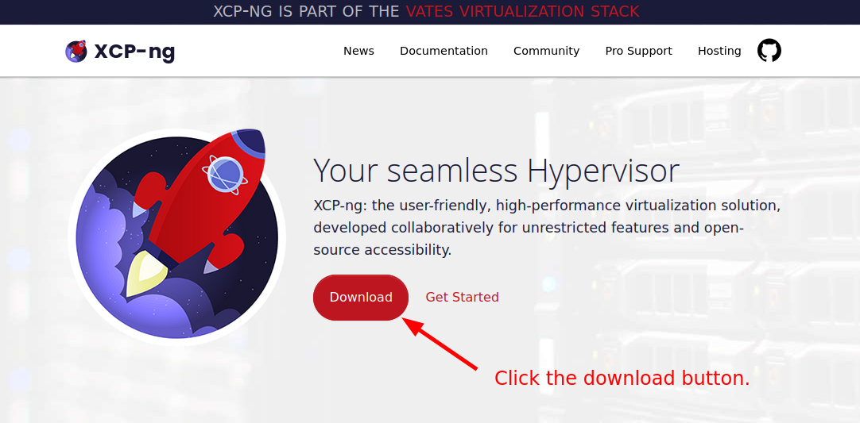
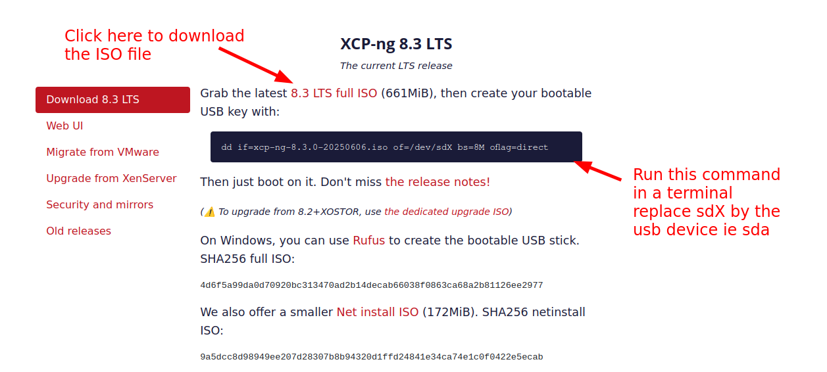
Once the image has been downloaded, if your Linux distribution doesn’t mount automatically your USB key ( which is good for a security stand point ), in a terminal run “sudo dmesg -Tw” then plug your usb stick.
With this command you will see on which device your usb stick has been detected.
You can stop dmesg with the shortcut key “Ctrl + c”, you will then return to the terminal prompt.
If your USB key has been automatically mounted, un-mount it with the command “eject” for example if your USB has been mounted in the /media folder, you can do “eject /media”
!!!After the next step everything on the USB will be erased!!!
The command has been provided by the XCP-ng on their website I put it here again for ease, adjust the xcp-ng iso filename with the version you have downloaded.
“sudo dd if=xcp-ng-8.3.0-20250606.iso of=/dev/sdX bs=8M oflag=direct “
Double check your sdX to avoid erasing the wrong device, as mention earlier the X should be replaced with the letter your have seen showing up in the dmesg.
Wait for the copy to finish, it may take sometimes depending on the performance of the USB key.
Once key is ready we can go through the installation step.
Install XCP-NG on your machine
XCP-NG being a Hypervisor type 1, it is design to be the only distribution to be installed on your machine, on my side I have not tested any kind of dual boot by installing it on a different disk along side another OS, this is not a something a would recommend unless you want to tinker.
Plug your USB key with the XCP-NG image to your machine.
You should then be able to boot the USB key in my case I hit the “xx” key then select the USB Key

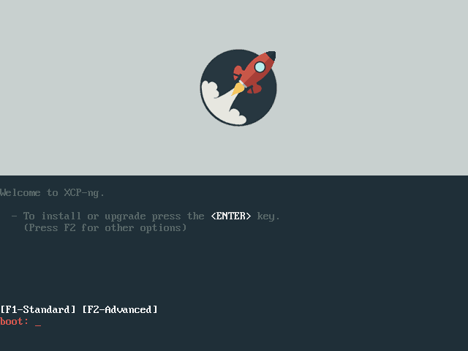
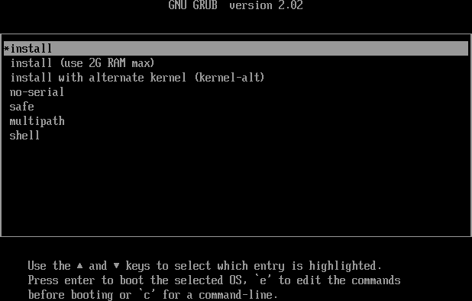

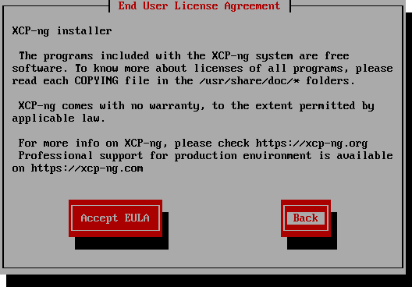

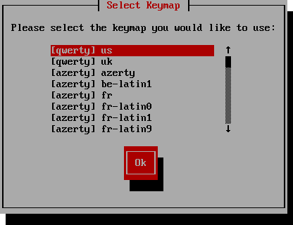

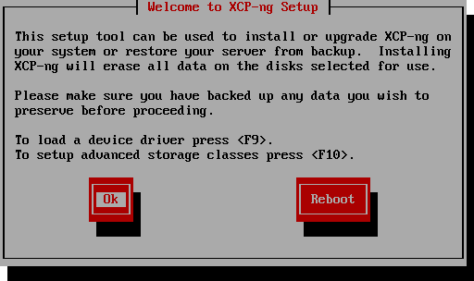

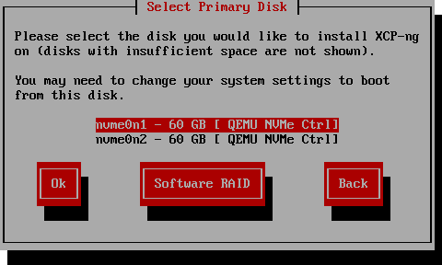

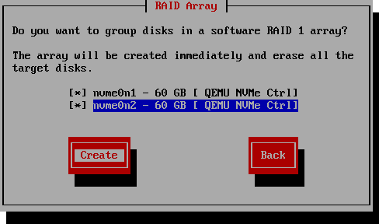

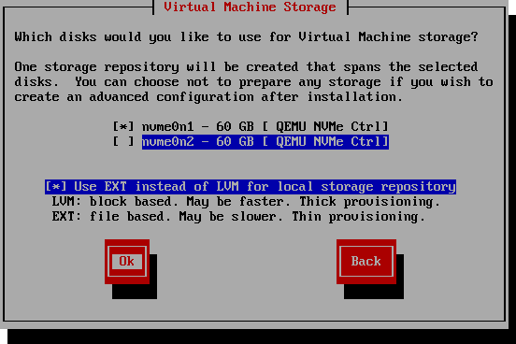

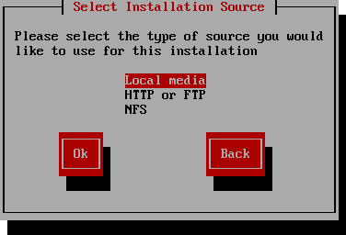

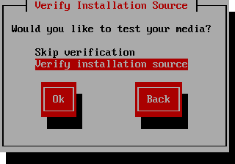

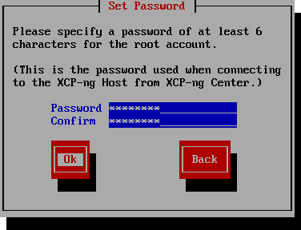

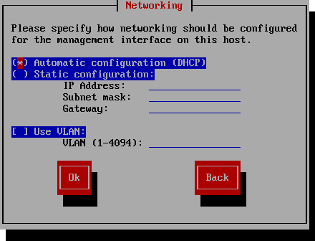

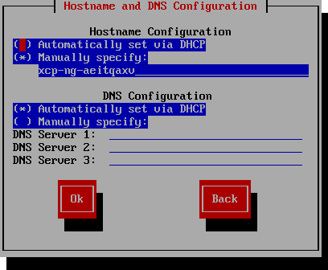

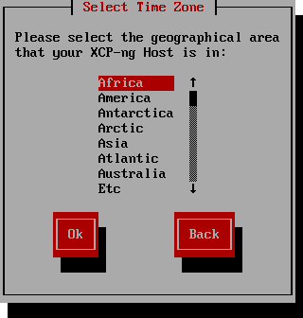

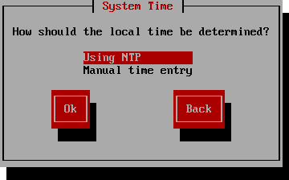

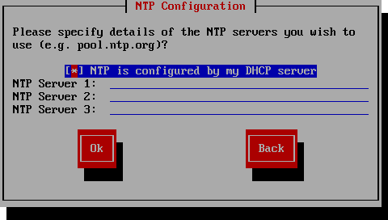

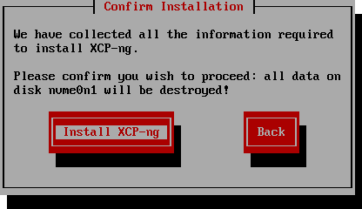

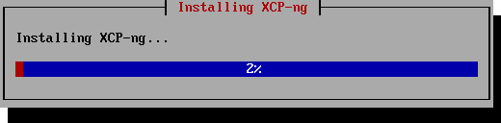

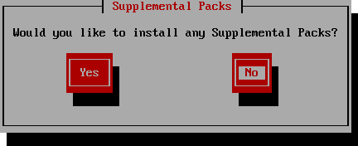

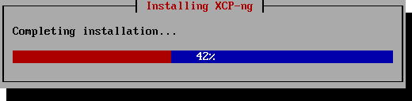

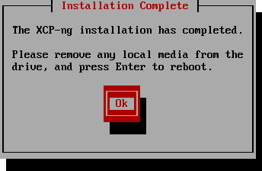

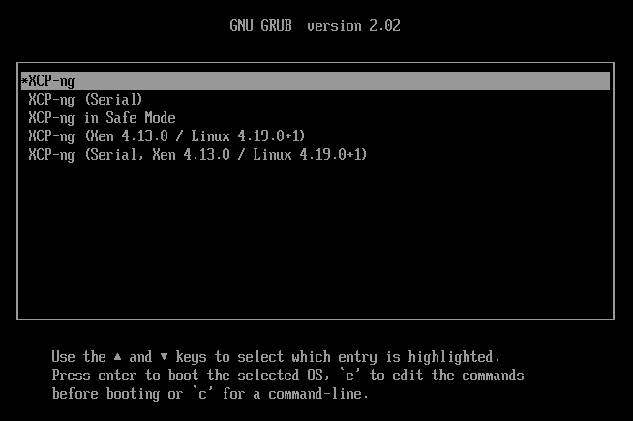

Then we follow the steps on the Terminal UI, there is not much choice apart regional settings and if
you want thin provisioning or thick provisioning.
Briefly thin provisioning means that XCP-NG when it will create virtual disks for your VMs this will only use the storage space that your data in the VM actually use, for instance if you create a Virtual disk of 1TB and put on it 20GB on data, the corresponding disk file will take around 20GB of actual disk space on your host.
- The Inconvenient it will impact the performances of your machine as it needs to resize the physical file that represent your disk when adding new data.
- The advantage this is much better to control the storage usage and avoid cluttering your host dirve with almost empty virtual drives file.
By experience this type of provision is good enough for an homelaber or a test lab en a dev/test environment which is not test/validating any performance related scenario.
Thick provisioning will actually reserve all the space as soon as the disk is created whatever the quantity of data you have in the disk. If you create a thick provisioned disk of 1TB, this will actually reserve this amount of data, even if you have only 20GB on effective data in the Virtual disk on your VM.
- The inconvenient it will take much more space on your storage and can be a issue when you are limited in disk space.
- The advantage is that it improves the performances, since it doesn’t have grow the physical file that represent your disk on the host.
I would recommend this model in Enterprise to make sure you don’t impact the performance and reduce any application performances related to the expansion of the physical file.
You can start small and extend the Disk size from XOA afterward, so not much to worry here.

Well done you have now installed XCP-NG you can then remove the key and reboot your machine

XCP-ng terminal
After booting you should see terminal like this one below.
This give you the possibility to do some basic admin task ( Network, view VMs, ressources, backup restore XCP-ng, etc) for this host only.

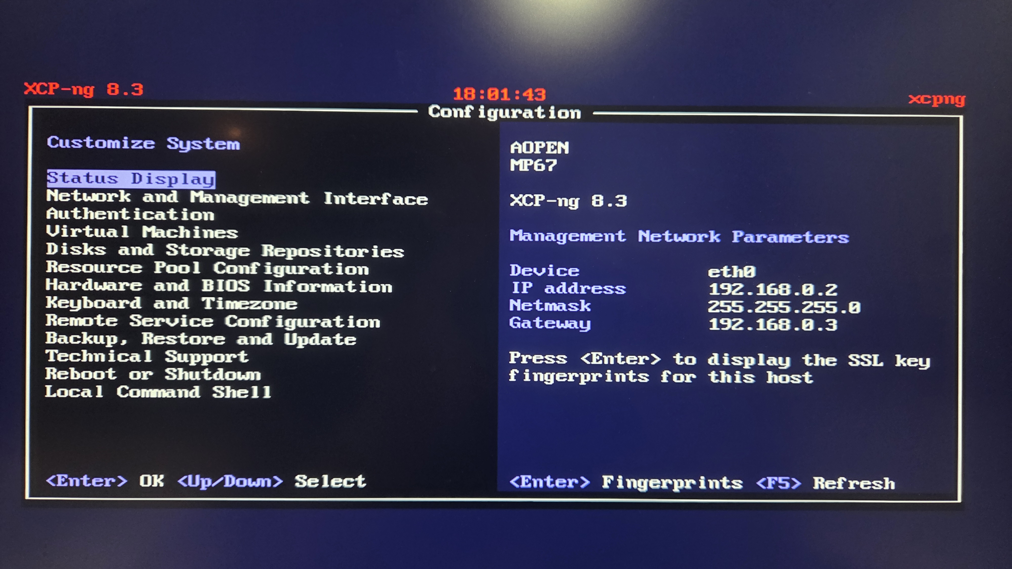
To be able to administer this host more closely and mainly deploy a VM, for now you need XOA
But first let’s have a look at XO lite, a host-only strip down version of XOA.
You will be able to do
xx
xx
xx

XO lite
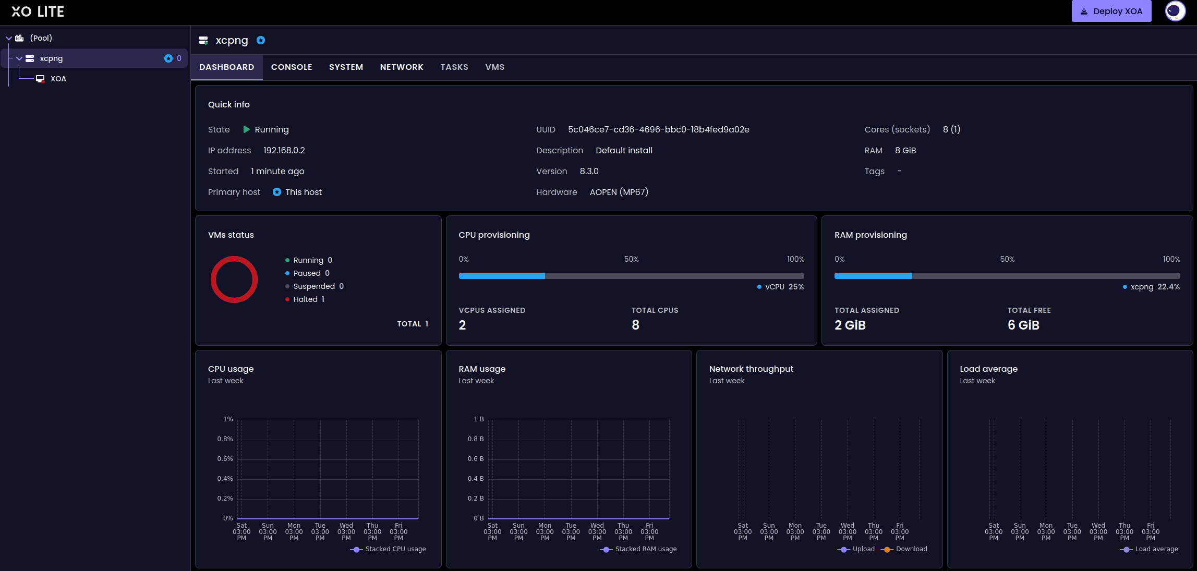

Deploy XOA
