My auto titles – Part 2

The Ollama backend workflow

Last month, we’ve talked about the workflow from my dev machine side

Today we are going to review the backend and going to look at the workflow on the backend side.

For that purpose I have setup a local LLM workflow based on Ollama and lang-chain

Steps
0 - Install the VM
1 - Install Ollama
2 - Download models
3 - install LangChain
4 - Build the python script to automate everything.
5 - Configure ssh with key instead of password to automate the work

Install VM

I recommend to run this on a VM to separate the tasks and avoid cluttering your own machine.
Unless your local machine is very powerful with a good GPU or lot’s of RAM, I recommend to put the LLM on a separate machine.
You can do it any preferred way you wish VirtualBox, Vmware Workstation, XCP-ng, Proxmox and so on.
On side I have an XCP-ng host on which I’m deploying my Virtual machines.
At the end of the day you need a machine running Linux as this is what I’m using to show the steps in this article.
This is not the focus for today, so I will not go to the details, in the future I will propose dedicated articles for the XCP-ng set up and VM deployments.

Install Ollama

On Linux you will get the install command from the ollama.com website.
At the time of writing, this goes through an install script that can be trigger after downloading it.

I strongly recommend to read any script you download from the net prior running them this is a basic sanity check to avoid surprise or compromising your machine.

Once Ollama install you can check that everything it correctly installed by checking the version
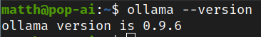

At the time of writing I’m using Ollama version 0.9.6

Download model

You can now download any model you want from Ollama Library

For instance you would like the Gemma3n, you can download it with this command

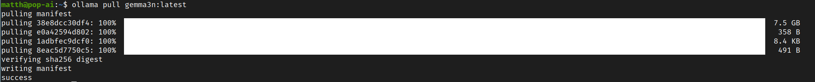

Install LangChain

LangChain is a framework designed to assist developers in building applications that utilize large language models.
On a Debian/Ubuntu like distribution, you will need to install python and pip python virtual environment, then you can install Lang Chain through pip
The way I have been using this is by creating a python environment for LangChain

I can then source it prior running my python script to use LangChain framework

Python script that run the Ai workflow

You will find the script in my GitHub repo link below.

This script when being trigger is looking for odt files in a watch folder, it will monitor the folder for new files until the script is terminated.

It the process the odt files one by one

Odt processing through LLM using RAG ( Retrieval Augmented generation )

Disclosure: I don’t really know what I’m doing here, this is my interpretation of the workflow.
I may and probably are wrong in some concept or interpretation.

The way it’s done here, is that the file is split-ed in chunk then imported in a vector db using an embedding model.
We import each file in a different collection in the vector db to make sure we are always only on the context of the current file being imported.
I encounter this issue where in my original testing all my files where imported in the same collection consequently the context was completely polluted and the output of the LLM was base on all my articles, ending up with several time the same title.

In high level is what is going on here:

We build the context for the LLM at this stage

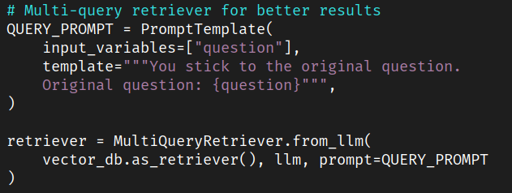

We make sure the LLM doesn’t go out of the context

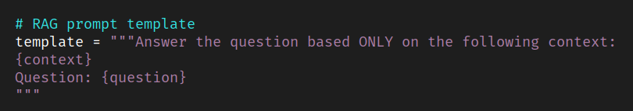

Based on the context and rules built above we ask the question to the LLM to get what we want

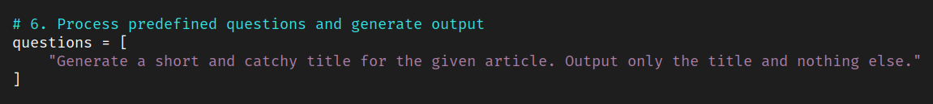

Output the response

The response we then get we output it to a text file which will have the same name as the odt file for retrieval by the script which is building the HTML file that includes all the articles.

BuildTitle.sh
as explain in last month article we then copy back the output files to insert the titles for each article.

