ASSET Version 1 and Version 2
A Comparison of Capabilities and Flows

Presented to the Faculty of the
College of Computer Studies
Carlos Hilado Memorial State University

In Partial Fulfillment
of the Requirements in
MANACQ 413 — MANAGEMENT OF INFORMATION SYSTEMS

by

TRIX JUSTIN A. AGUILAR
BSIS 4B

October 2026
Table of Contents
CHAPTER 1 5
The Two Versions 5
1.1 Origin and Relationship 5
1.2 Summary of Differences 5
1.3 What a Record Carries 6
1.4 What Version 2 Leaves Unchanged 7
CHAPTER 2 8
How Each Flow Works 8
2.1 Deposit of a Holding 8
2.2 Approval of a Submission 10
2.3 Search and Retrieval 11
2.4 Release of a Full Document 12
2.5 Backup and Restoration 14
2.6 Archive Composition Reporting 16
CHAPTER 3 18
Summary 18
3.1 Where the Difference Lies 18
3.2 What Did Not Change 18
REFERENCES 20

List of Figures
Figure Deposit of a holding in Version 1 and Version 2 10
Figure Approval of a submission in Version 1 and Version 2 11
Figure Search and retrieval in Version 1 and Version 2 12
Figure Release of a full document in Version 1 and Version 2 14
Figure Backup and restoration in Version 1 and Version 2 16
Figure Archive composition reporting in Version 1 and Version 2 17

List of Tables
Table Capabilities of Version 1 Compared with Version 2 6
Table Fields Carried by a Holding in Each Version 6
Table Screens of Version 1 Retained in Version 2 7
Table Deposit Flow in Version 2 9
Table Approval Flow in Version 2 10
Table Search and Retrieval Flow in Version 2 12
Table Full Document Release Flow in Version 2 13
Table Backup and Restoration Flow in Version 2 15
Table Archive Composition Reporting Flow in Version 2 17
Table Degree of Change in Each Flow 18

CHAPTER 1

The Two Versions

1.1 Origin and Relationship
ASSET — the Archiving System for Social, Experimental and Technical Paper — was developed at the Aparri Campus of Cagayan State University by Tindoc, Torres, Corpuz, Salem and Paliuanan (2023) and built in PHP and MySQL on the Laravel 9 framework. It replaced a manual arrangement in which completed theses were kept in rack book records and on compact discs, exposed to termite infestation, to water damage during typhoons, and to retrieval difficulty arising from unorganised filing. It was evaluated at 4.583 under ISO/IEC 25010:2011 and 4.640 under user acceptance. This document refers to that system as Version 1.
Version 2 is the enhancement proposed under the CHED Research Programme and Grants-in-Aid submission. It is not a replacement. The existing technology stack is retained and the existing screens are retained; what is added are five functions the original system does not possess, three of which its own developers identified as outstanding. The distinction matters throughout this document: where Version 1 already did something adequately, Version 2 leaves it alone.
Chapter 1 sets out what differs between the two versions. Chapter 2 walks through each of the six flows a user actually performs, showing where the two versions diverge and what the enhanced system does at each step. Chapter 3 summarises where the difference lies.

1.2 Summary of Differences
Table 1 compares the two versions capability by capability. The first four rows are functions Version 1 performs and Version 2 inherits; the remainder are the gaps the enhancement closes.
Table 1
Capabilities of Version 1 Compared with Version 2
Capability | Version 1 | Version 2
Deposit of a holding | Title, author, co-authors, adviser, keywords, year, agency, abstract and one of three categories | The same fields, with campus, college, subject area, access level and recorded author consent added
Adviser approval | Submissions marked for approval until a research teacher approves them | Unchanged, with origin, access level and a duplicate warning shown to the approver
Keyword search | A single search box over the holdings | Unchanged, and the term is recorded for the Most Searched panel
Analytics and system logs | Dashboard counters, most viewed, downloaded, searched and liked; a system log of user activity | Unchanged, extended with indicators for discoverability, campuses represented and the last verified backup
Narrowing of results | None. Three broad categories were recorded at deposit but the paper documents no way to narrow results by them | Filters by year, adviser, college, subject area and campus, with the v1 category promoted to a filter of its own
Record origin | Not recorded. Holdings from different sources could not be distinguished | Campus and college captured on every record, prefilled from the depositor’s account
Duplicate detection | None. A resubmitted study would be accepted silently | Every submission compared against existing holdings; close matches shown before the deposit is accepted
Visibility outside the campus | None. An institutional account was required before anything could be viewed | Record descriptions public and carrying harvestable metadata; full documents remain gated
Preservation | No backup mechanism of any kind | Dumps fingerprinted with SHA-256, verified before use, and restoration refused from a dump that fails
Reporting on holdings | Not possible, since no origin was recorded | Composition by college, campus, subject area, year and access level, exportable as CSV

1.3 What a Record Carries
Most of the difference between the two versions rests on four fields. Table 2 lists what a holding carries in each version; the rows marked as added are what make filtering, origin reporting and tiered release possible at all. Nothing was removed, so a holding deposited under Version 1 remains complete under Version 2.
Table 2
Fields Carried by a Holding in Each Version
Field | Version 1 | Version 2
Title, authors, co-authors, adviser | Recorded | Unchanged
Keywords, year published, agency | Recorded | Unchanged
Abstract and uploaded document | Recorded | Unchanged
Category (Social, Experimental, Technological) | Recorded at deposit | Retained, and now searchable
Approval status | Recorded | Unchanged
Campus of origin | Not recorded | Added — the basis of inter-campus reporting
College of origin | Not recorded | Added — the basis of composition by college
Subject area | Not recorded | Added — finer than the three broad categories
Access level | Not recorded | Added — public, restricted or withheld

1.4 What Version 2 Leaves Unchanged
Every screen documented in the original paper survives into Version 2, in the same arrangement and to the same purpose. This is deliberate. Library and research office personnel trained on Version 1 should not have to relearn the system in order to benefit from the enhancement, and an evaluator comparing the two should be able to see at a glance that the work is additive. Table 3 maps the original figures onto the enhanced system.
Table 3
Screens of Version 1 Retained in Version 2
Screen | Original paper | Treatment in Version 2
Landing page with search bar | Figure 2 | Retained; a holdings counter and a link into the filtered search are added
Admin dashboard and analytics | Figure 3 | Retained in full; three enhancement indicators are added below it
System logs | Figure 4 | Retained; now also carries document releases and backup verifications
My Profile | Figure 5 | Retained; campus and college are added
Publications and approval | Figure 6 | Retained; origin, access level and duplicate warnings are added
Submit a paper | Figure 7 | Retained; origin, subject area, access level and consent are added

CHAPTER 2

How Each Flow Works
Six flows cover everything the archive is used for: depositing a holding, approving it, finding it, obtaining its full document, preserving the archive, and reporting on what it contains. Each is treated below. The figure accompanying each section places the two versions side by side, so that what the enhancement adds can be read directly against what the original system did. The accompanying table walks through the Version 2 flow step by step and names the file that performs each step, so that a reader may follow the behaviour into the source.
Within each figure, shading carries meaning: grey marks an action by a person, blue a check the system performs, a rounded outline a decision, amber a point at which the flow is held for human review, red a step that is refused or that the version does not provide, and green the outcome. The pale boxes at the foot of several flows are entries written to the system log.

2.1 Deposit of a Holding
In Version 1 the depositor completed a form and the record was saved, marked for approval. Nothing was checked and nothing was asked beyond the fields themselves. Version 2 keeps that form and extends it in three ways. Campus, college and subject area are captured, prefilled from the depositor’s own account so that origin is populated as a matter of course rather than by discipline. The depositor sets an access level, which determines later whether the full document is released. The author’s consent to deposit is recorded, which is the first of the three system-side elements on which the Republic Act No. 10173 commitment rests.
The substantive addition is the check that runs before the record is accepted. The submitted title is reduced to lowercase letters, digits and spaces, and compared against every existing holding; any match at seventy per cent similarity or above is reported. A flagged submission is not rejected. The matches are shown with their similarity, campus and year, and the deposit proceeds only once the depositor confirms, having seen them, that the study is distinct. The reasoning is practical: a librarian needs to be told about a probable duplicate, not prevented from recording a legitimately similar study.
Table 4
Deposit Flow in Version 2
# | What happens | Implemented in
1 | The depositor signs in and opens Submit a Paper. Campus and college are prefilled from their account. | deposit.php
2 | The form is completed and the author’s consent to deposit is recorded. | deposit.php
3 | The title is normalised and compared against every existing holding. | find_duplicates(), config.php
4 | Any match at 70% or above is listed with its similarity, campus and year, and the deposit is held. | deposit.php
5 | If nothing is flagged, or the depositor confirms the study is distinct, the record is saved with its origin and access level. | deposit.php
6 | The deposit is written to the system log. | log_action(), config.php
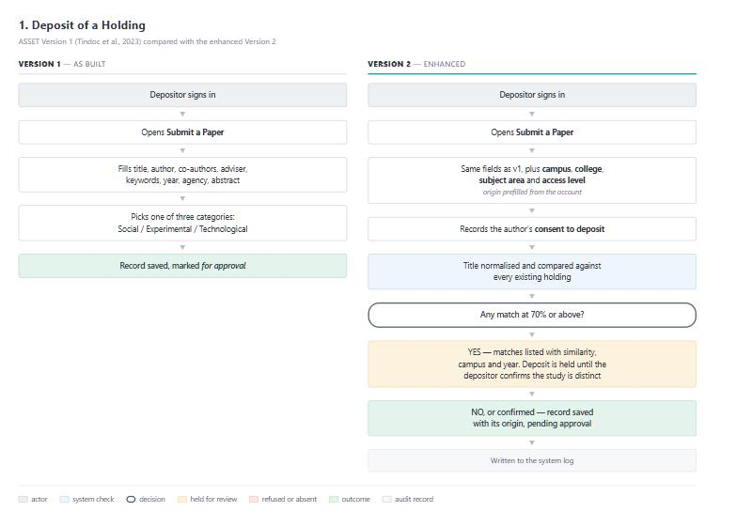
Figure 1
Deposit of a holding in Version 1 and Version 2

2.2 Approval of a Submission
Approval is the flow that changed least. In both versions a research teacher opens the publications list, sees which submissions are awaiting approval, and approves them. Version 2 adds the information an approver needs in order to decide well rather than merely quickly.
Every pending submission is re-checked against the archive at the moment the list is drawn, not only at the moment it was deposited. This matters because it catches a duplicate that entered the archive before the check existed, or one deposited while another similar study was itself still pending. The approver also sees the campus and subject area of each submission and the access level the depositor requested. A student opening the same screen sees only their own deposits.
Table 5
Approval Flow in Version 2
# | What happens | Implemented in
1 | A research teacher opens Publications. A student sees only their own deposits. | publications.php
2 | Each pending submission is re-checked against every existing holding. | find_duplicates(), config.php
3 | A flagged submission is shown with its closest match, similarity, campus and year. | publications.php
4 | The approver presses Approve, and the holding is published to the archive. | publications.php
5 | From that moment its description is publicly readable and appears in the sitemap. | record.php, sitemap.php
6 | The approval is written to the system log. | log_action(), config.php
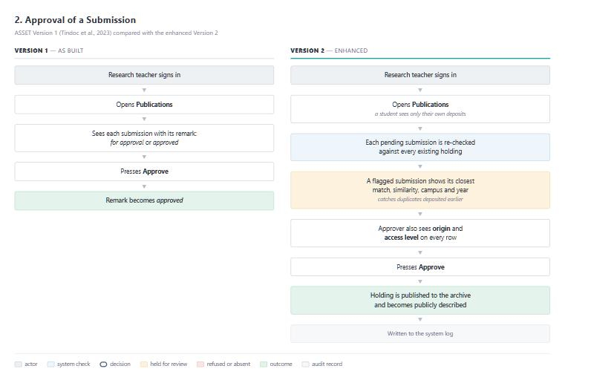
Figure 2
Approval of a submission in Version 1 and Version 2

2.3 Search and Retrieval
Version 1 required an account before anything could be seen, and offered a single search box with no means of narrowing what came back. Its own developers listed a filtering feature among their recommendations. Version 2 opens the search to anyone and places a filter panel beside the results.
The four facets the objective names — year, adviser, college and subject area — are provided, with campus of origin alongside them because the record now carries it, and the three Version 1 categories promoted to a filter of their own. Choices combine, so that each narrows the result further rather than replacing the last. The values offered in each filter are drawn from the approved holdings themselves, which means the panel never presents a choice that would return nothing. Above every result set the system prints how many holdings matched and how long the retrieval took, which is the measure the project compares against its Month 1 baseline.
Table 6
Search and Retrieval Flow in Version 2
# | What happens | Implemented in
1 | Anyone, signed in or not, opens the archive, with or without a search term. | search.php
2 | A search term is recorded for the Most Searched panel on the dashboard. | search.php
3 | Filter values are drawn from the approved holdings, so no choice returns an empty result by surprise. | search.php
4 | Selected filters are applied together with one another and with the search term. | search.php
5 | Matching holdings are listed with the number retrieved and the time taken. | search.php
6 | Opening a result shows its description, whether or not the reader has an account. | record.php
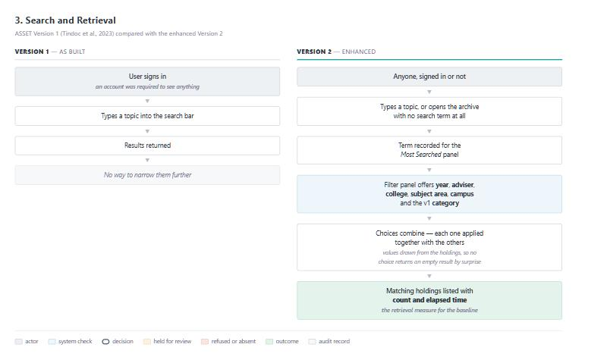
Figure 3
Search and retrieval in Version 1 and Version 2

2.4 Release of a Full Document
This is the flow in which the two versions differ most sharply. Version 1 made no distinction between the description of a holding and the holding itself: a visitor without an institutional account saw nothing at all, not even a title. Research deposited in the archive therefore could not be located from outside the campus network and could not be reached by an external academic search service.
Version 2 separates the two. The description of every approved holding — its title, authors, adviser, origin, year, keywords and abstract — is served to anyone, and the page carries twelve Dublin Core elements and a schema.org description of itself, which is what a harvester reads. The full document is handled separately. A holding marked withheld releases its document to no one but the administrator, while its description stays public. Otherwise a visitor who is not signed in is sent to sign in and returned afterwards to the record they asked for, and an authenticated institutional user receives the file. Every release is written to the system log, which is the audit trail the tiered access policy rests on.
Table 7
Full Document Release Flow in Version 2
# | What happens | Implemented in
1 | A visitor opens a record. The description is served whether or not they are signed in. | record.php
2 | The page emits Dublin Core and schema.org metadata for external search services. | record.php
3 | The visitor requests the full document. | download.php
4 | If the holding is withheld, the document is released to the administrator alone. | can_download(), config.php
5 | Otherwise, a visitor who is not signed in is sent to sign in and returned to the record afterwards. | download.php
6 | An authenticated user receives the file and the release is written to the system log. | download.php
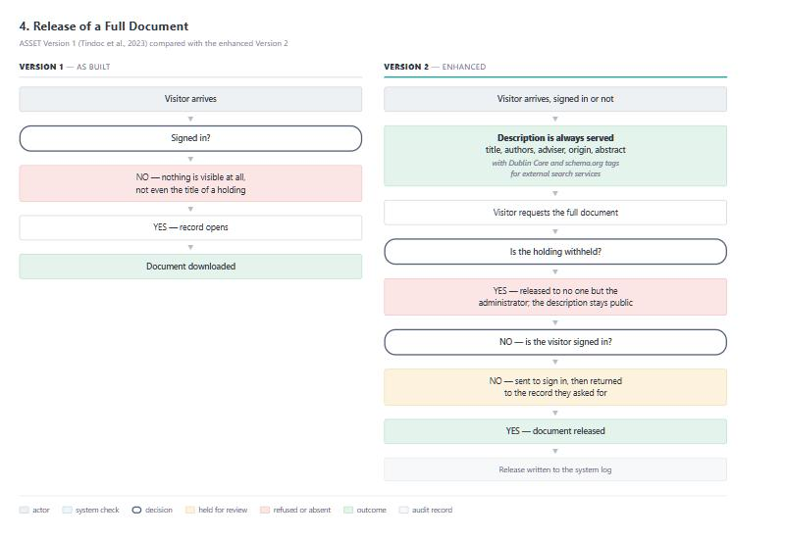
Figure 4
Release of a full document in Version 1 and Version 2

2.5 Backup and Restoration
Version 1 had no backup mechanism, which its developers recorded among their own recommendations. The consequence is worth stating plainly: the preservation risk that justified building the system in the first place — loss of irreplaceable student work — continued to exist, having merely changed form from a damaged rack book to an unrecoverable database.
Version 2 writes the holdings, accounts, system log and search history to a dump file and computes a SHA-256 digest of that file at the moment it is written. Verification, performed later, recomputes the digest and confirms that the dump still parses into at least as many statements as it captured rows. Restoration re-runs that verification first and is refused outright if it does not pass. This is the distinction the objective turns on, and it is what the word verified in verified restoration means: a file that exists is not a backup, whereas a file whose integrity is proved at the moment of use is. The dump is produced within the application rather than by calling an external program, so the mechanism works wherever the application runs. In deployment it is driven by a scheduler; in the proof of concept a button stands in for one.
Table 8
Backup and Restoration Flow in Version 2
# | What happens | Implemented in
1 | The scheduler runs. Holdings, accounts, logs and search history are written to a dump file. | make_backup(), backup.php
2 | A SHA-256 digest of the dump is computed and recorded as the file is written. | make_backup(), backup.php
3 | When verification is requested, the digest is recomputed and the statements counted. | verify_backup(), backup.php
4 | A digest that no longer matches marks the dump failed. | verify_backup(), backup.php
5 | Restoration re-runs verification first and is refused if the dump does not pass. | backup.php
6 | A verified dump is replayed and the archive returns to that point in time. | restore_backup(), backup.php
7 | Every run, verification and restoration is written to the system log. | log_action(), config.php
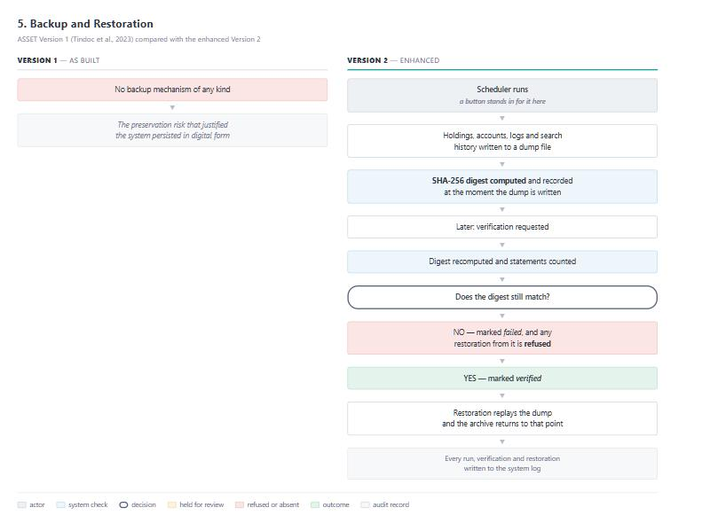
Figure 5
Backup and restoration in Version 1 and Version 2

2.6 Archive Composition Reporting
Version 1 could not report on the composition of its own holdings, for the straightforward reason that it recorded nothing to report on. Without a campus, a college or a subject area against each record, the question of what the archive contains has no answer beyond a count.
Version 2 groups the approved holdings by college, campus, subject area, year of publication and access level, showing each group with its share of the archive, how many of its holdings are publicly discoverable, and its download activity. Deposit volume is also broken down by quarter, which is the cadence the logical framework reports on. Any dimension exports as a CSV file, which is the form in which a research office attaches evidence to an accreditation submission. This flow exists only because deposit captures origin, and its stated risk in the logical framework is precisely that the origin fields go unpopulated — which is why the deposit form prefills them.
Table 9
Archive Composition Reporting Flow in Version 2
# | What happens | Implemented in
1 | The research office opens the composition report. | reports.php
2 | Approved holdings are grouped by college, campus, subject area, year and access level. | reports.php
3 | Each group is shown with its share, its publicly discoverable count and its downloads. | reports.php
4 | Deposit volume is broken down by quarter. | reports.php
5 | Any dimension is exported as a CSV file for an accreditation submission. | reports.php
6 | The export is written to the system log. | log_action(), config.php
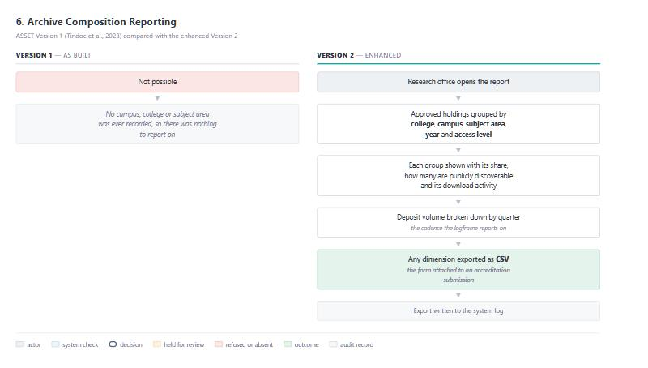
Figure 6
Archive composition reporting in Version 1 and Version 2

CHAPTER 3

Summary

3.1 Where the Difference Lies
Of the six flows, two are essentially unchanged, two are extended, and two did not exist at all in Version 1. Table 4 sets this out, and it is the clearest single statement of what the enhancement is.
Table 10
Degree of Change in Each Flow
Flow | Degree of change | What accounts for it
Approval of a submission | Extended | The flow is the same; the approver is now shown origin, access level and a duplicate warning
Search and retrieval | Extended | The search box is unchanged; filtering, public access and the retrieval measure are added
Deposit of a holding | Extended | The form is unchanged; origin, access level, consent and the duplicate check are added
Release of a full document | Rewritten | Version 1 had one tier and required an account for everything; Version 2 has two tiers and makes descriptions public
Backup and restoration | New | Version 1 had no backup mechanism of any kind
Archive composition reporting | New | Version 1 recorded no origin, so there was nothing to report on
Three of the additions were named by the original developers themselves. Their recommendations ask for a filtering feature and for a mechanism for storing back-up; the third, duplicate detection, follows from the origin tracking the proposal introduces. The enhancement is therefore not a critique of Version 1 but a continuation of it, implementing what its own authors identified as unfinished.

3.2 What Did Not Change
The technology stack is retained, the database schema is extended rather than restructured, no field is removed from any record, and every screen documented in the original paper survives with its arrangement intact. A user trained on Version 1 can operate Version 2 without retraining; what they gain is the ability to narrow a search, to see where a holding came from, to be warned of a duplicate, to reach a description without signing in, to recover the archive after a loss, and to describe the holdings as a whole.

REFERENCES
Commission on Higher Education. (2016). CMO No. 52, s. 2016: Pathways to equity, relevance and advancement in research, innovation and extension in Philippine higher education. Commission on Higher Education.
Republic Act No. 10173. (2012). An Act Protecting Individual Personal Information in Information and Communications Systems in the Government and the Private Sector (Data Privacy Act of 2012). Congress of the Philippines.
Tindoc, F. P., Jr., Torres, R. G., Corpuz, K. A. C., Salem, J. T., & Paliuanan, L. P. (2023). Design and development of the ASSET: A web-based research archiving system. Journal of Pure and Applied Sciences, 1(2). https://doi.org/10.5281/zenodo.20724570

