Functional Verification of the Enhanced ASSET
Research Archiving System

A Proof of Concept Demonstrating the Five Proposed Enhancements

Presented to the Faculty of the
College of Computer Studies
Carlos Hilado Memorial State University

In Partial Fulfillment
of the Requirements in
MANACQ 413 — MANAGEMENT OF INFORMATION SYSTEMS

by

TRIX JUSTIN A. AGUILAR
BSIS 4B

October 2026
Table of Contents
CHAPTER 1
The Proof of Concept
1.1 Purpose and Scope
1.2 Build Environment
1.3 Demonstration Data and Accounts
1.4 Reproducing the Verification
CHAPTER 2
Verification of Each Objective
2.1 Objective 2 — Backup with Verified Restoration
2.2 Objective 3 — Search Filtering
2.3 Objective 4 — Record Origin Tracking and Duplicate Detection
2.4 Objective 5 — Tiered Access and External Discoverability
2.5 Outcome 3 — Archive Composition Reporting
CHAPTER 3
Summary and Limitations
3.1 Summary of Results
3.2 Automated Self-Check
3.3 Limitations of the Proof of Concept
3.4 Conclusion
REFERENCES

List of Figures

List of Tables

CHAPTER 1

The Proof of Concept
This document reports the functional verification of a working proof of concept built for the project Enhancement of ASSET: A Web-Based Research Archiving System. The original ASSET system was developed and evaluated by Tindoc, Torres, Corpuz, Salem, and Paliuanan (2023) at the Aparri Campus of Cagayan State University, where it attained a weighted mean of 4.583 under ISO/IEC 25010:2011 and 4.640 under user acceptance evaluation. Its software quality is therefore established and is not re-examined here. What this document examines is whether the five functions the original system does not possess, and which the proposal commits to developing, in fact work.
Each specific objective that can be demonstrated in software is treated in turn. For each one, the document states the gap in the original system, the function built to close it, the test performed against the running application, the result expected, and the result actually observed. Every observed result reported in Chapter 2 was recorded from an execution of the proof of concept on the date of this writing, not estimated or described from the design.

1.1 Purpose and Scope
The proof of concept exists to show that the proposed enhancement is buildable on the existing technology stack and that each proposed function behaves as the objectives specify. It is a demonstration instrument and not a deployment. It carries demonstration data rather than institutional holdings, it runs on a local development server rather than on university infrastructure, and it is not connected to any external academic search service.
Four of the eight specific objectives are demonstrable in software. Objectives 2, 3, 4, and 5 define functions to be built, and all four are implemented and verified here. The archive composition report, which the logical framework carries as Outcome 3 rather than as a numbered objective, is also implemented and verified because it depends directly on the origin fields introduced under Objective 4. The remaining objectives are field activities that software alone cannot satisfy, and Section 3.3 states plainly what each one still requires.

1.2 Build Environment
The proposal commits to retaining the existing PHP and MySQL stack, and the proof of concept honours that commitment. It departs from the deployed system in one respect: it is written in plain PHP rather than on the Laravel framework, so that it runs from a standard XAMPP installation with nothing to install and nothing to configure. No external stylesheet, script, or font is loaded from the internet, so the demonstration runs without a network connection. Table 1 lists the environment.
Table
Build Environment of the Proof of Concept
Layer | Technology | Note
Web server | Apache 2.4 (XAMPP) | Served from htdocs/PoC
Application | PHP 8.2 | Plain PHP; the deployed system retains Laravel
Database | MySQL (MariaDB, XAMPP) | Schema asset_v2, created by install.php
Interface | Hand-written CSS | Follows the v1 screenshots; no CDN dependency
Preservation | PHP dump with SHA-256 | No dependency on an external mysqldump binary

1.3 Demonstration Data and Accounts
The archive is seeded with sixteen holdings, of which fourteen are approved and two are left awaiting approval. The seed is deliberately composed so that every function has something to act upon: the holdings span seven campuses, seven colleges, nine subject areas, and five years of publication, and they carry all three access levels. One pending submission is a near-duplicate of an approved holding from a different campus, so that duplicate detection can be observed working on data the evaluator did not enter. Three accounts cover the roles, as set out in Table 2.
Table
Demonstration Accounts and Their Permissions
Account | Role | Permitted
admin@csu.edu.ph | Administrator | All functions, including backup, restoration, system logs, and release of withheld documents
faculty@csu.edu.ph | Research teacher | Dashboard, deposit, approval queue, archive composition report
student@csu.edu.ph | Student researcher | Deposit, own submissions, full documents of public and restricted holdings
(not signed in) | Public visitor | Record descriptions only

1.4 Reproducing the Verification
Apache and MySQL are started from the XAMPP control panel, install.php is opened once to build and seed the database, and the archive is then reachable at http://localhost/PoC/. Re-opening install.php at any point returns the demonstration to the state described above, so a test that alters the archive, such as a restoration, can be run repeatedly.
The proof of concept also carries a command-line self-check, selfcheck.php, which asserts the behaviour of the logic that cannot be judged by reading the screen: title similarity, the access rule, and the backup cycle. It is listed in Section 3.2 and runs against the live database, leaving it as it found it.

CHAPTER 2

Verification of Each Objective
Each section below takes one objective, states the gap in the original system that the objective addresses, describes the function built, and reports the tests performed against it. Tests were executed against the running application over HTTP, in the same manner a user or an external client would reach it, so that what is reported is the behaviour of the system and not of its source code in isolation.

2.1 Objective 2 — Backup with Verified Restoration
The original developers identified the absence of a backup mechanism as an outstanding requirement, and Tindoc et al. (2023) record it among their own recommendations. Until it is met, the preservation risk that justified the system in the first place — termite damage, flooding, and loss of unorganised physical files — simply persists in digital form. The objective requires not merely a backup but a backup with verified restoration.
The function implemented writes a complete dump of the archive — users, holdings, system logs, and search history — and computes a SHA-256 digest of that dump at the moment it is written. Verification recomputes the digest and confirms that the dump still parses into at least as many statements as it captured rows. Restoration is refused outright unless the dump passes verification at the moment restoration is requested. This is the distinction the objective turns on: a file that exists is not a backup, whereas a file whose integrity is proved at the moment of use is. The dump is produced within the application rather than by calling an external mysqldump program, so the mechanism works wherever the application runs.
In deployment this runs on a schedule. In the proof of concept a button stands in for the scheduler, so that the cycle can be executed and observed during a demonstration. Table 3 reports the tests.
Table
Verification of Objective 2 — Backup and Verified Restoration
ID | Test performed | Expected result | Observed result | Verdict
TC-2.1 | Run a backup of the seeded archive. | A dump file is written and its digest recorded. | asset_v2-20261019-172029.sql written, 36 rows captured, 22.3 KB, SHA-256 recorded. | Pass
TC-2.2 | Verify the dump just written. | Verification passes. | Verified. 50 statements replayable, SHA-256 matches, 40 rows captured. | Pass
TC-2.3 | Delete three holdings to simulate data loss, then restore from the verified dump. | The deleted holdings return. | Holdings fell from 16 to 13; after restoration of 50 statements, 16 again. | Pass
TC-2.4 | Alter the dump file on disk outside the application, then verify it again. | Verification fails and identifies the cause. | Failed — checksum mismatch; recorded 2949ddbe299c23b4…, recomputed f492ca1b7be3ef12…. | Pass
TC-2.5 | Request restoration from the altered dump. | Restoration is refused. | Restoration refused: this dump does not pass verification. The archive was left untouched. | Pass
TC-2.6 | Request verification of a dump whose file is missing. | Verification fails rather than reporting success. | Failed — the dump file is missing from backups/. | Pass
The objective is met. A backup is produced, its integrity is proved before it is relied upon, restoration demonstrably returns lost holdings, and a dump that has been altered is refused rather than silently restored. Figure 1 shows the backup log after a dump has been taken and verified.
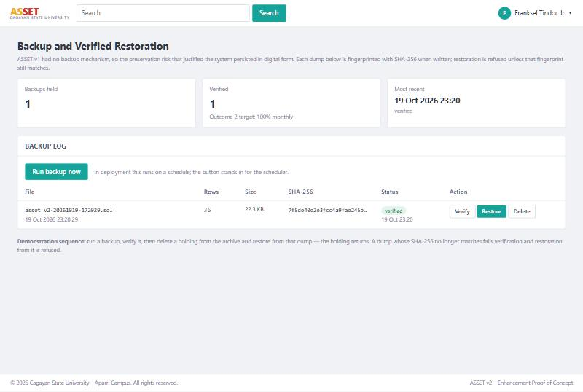
Figure
Backup log showing a dump verified against its recorded SHA-256 digest

2.2 Objective 3 — Search Filtering
ASSET v1 provided a single search box and no filtering controls at all. Holdings carried one of three broad categories — Social, Experimental, or Technological — recorded at deposit, but Tindoc et al. (2023) document no means by which results could be narrowed by it; the category appears in their account only on the deposit form and as a dashboard statistic. The original developers listed a filtering feature among their own outstanding recommendations, and the objective requires that results be narrowable by year, adviser, college, and subject area.
The function implemented presents a filter panel beside the results. The four filters the objective names are provided, and campus of origin is provided alongside them because Objective 4 makes it available. The three v1 categories are promoted to a sixth filter rather than discarded, so that the field already carried by every holding deposited under v1 becomes a means of retrieval for the first time, and so that the comparison with the original system stays visible to an evaluator. Filter values are drawn from the approved holdings themselves, which means the panel never offers a choice that would return nothing. Filters combine, and the number of holdings retrieved and the time taken are printed above every result set, which is the measure the project will compare against the Month 1 baseline. Table 4 reports the tests, all against the fourteen approved holdings.
Table
Verification of Objective 3 — Search Filtering
ID | Test performed | Expected result | Observed result | Verdict
TC-3.1 | Open the search with no filter applied. | All approved holdings are listed. | 14 holdings. | Pass
TC-3.2 | Search the keyword tilapia. | Only the matching holding is returned. | 1 holding. | Pass
TC-3.3 | Filter by year published 2022. | Only 2022 holdings are returned. | 5 holdings. | Pass
TC-3.4 | Filter by college: Information and Computing Sciences. | Only that college is returned. | 4 holdings. | Pass
TC-3.5 | Filter by adviser: Leo P. Paliuanan. | Only that adviser is returned. | 4 holdings. | Pass
TC-3.6 | Filter by subject area: Education. | Only that subject area is returned. | 2 holdings. | Pass
TC-3.7 | Filter by campus of origin: Aparri. | Only Aparri holdings are returned. | 9 holdings. | Pass
TC-3.8 | Apply year 2022 and college CICS together. | The result narrows below either filter alone. | 2 holdings, against 5 and 4 separately. | Pass
TC-3.9 | Filter by a year with no holdings (1999). | An empty result is reported, not an error. | 0 holdings; the page reports that none match. | Pass
TC-3.10 | Observe the retrieval measure. | Count and elapsed time are reported. | Reported on every result set; 3.4 ms for the combined filter above. | Pass
The objective is met. Each of the four filters the objective names narrows the result set correctly, the filters combine, and an empty result is handled as a result rather than as a failure. Figure 2 shows two filters applied together.
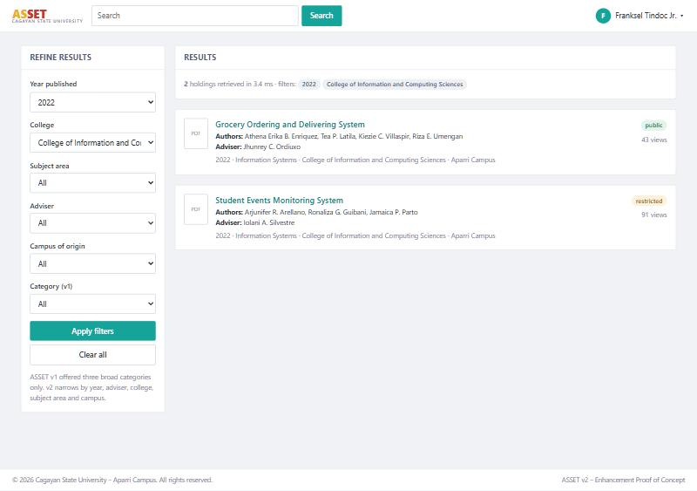
Figure
Search filtered by year published and college, with the retrieval measure reported

2.3 Objective 4 — Record Origin Tracking and Duplicate Detection
ASSET v1 recorded no campus or college of origin, so holdings from different sources could not be distinguished and the university could not describe its own research by where it came from. The objective requires origin tracking by campus and college, together with duplicate detection against existing holdings.
Campus, college, and subject area were added to the record and to the deposit form, prefilled from the depositor’s own account so that the fields are populated as a matter of course rather than by discipline. Duplicate detection compares the normalised title of a submission against every existing holding and flags any match at or above seventy per cent similarity. A flagged submission is not rejected outright; the matches are shown to the depositor with their similarity, their campus, and their year, and the deposit proceeds only if the depositor confirms, after review, that the study is distinct. This is deliberate. A librarian needs to be told about a probable duplicate, not prevented from recording a legitimately similar study. The same warning is raised against pending submissions in the approval queue, so that a duplicate is caught at the point of approval even when it was deposited before the check existed. Table 5 reports the tests.
Table
Verification of Objective 4 — Origin Tracking and Duplicate Detection
ID | Test performed | Expected result | Observed result | Verdict
TC-4.1 | Inspect the origin fields across all holdings. | Every holding carries a campus and a college. | 16 of 16 holdings; 7 distinct campuses represented. | Pass
TC-4.2 | Deposit a title identical to an existing holding. | The submission is held and the match is shown. | Held. Duplicate Detection reported 2 possible matches, the first at 100%. | Pass
TC-4.3 | Examine the second match in the same result. | A near-duplicate from another campus is also caught. | Grocery Ordering and Delivery System, Carig Campus, 2023, at 94.6% similarity. | Pass
TC-4.4 | Deposit a title unrelated to any holding. | The deposit proceeds without a warning. | Accepted; holdings rose from 16 to 17 and the depositor was returned to the publications list. | Pass
TC-4.5 | Repeat the duplicate deposit, confirming after review that the study is distinct. | The deposit is allowed to proceed. | Accepted; holdings rose from 17 to 18. | Pass
TC-4.6 | Open the approval queue. | A pending near-duplicate is flagged to the approver. | The seeded pending submission is shown with its closest match, similarity, campus, and year. | Pass
The objective is met. Origin is captured on every record, an exact duplicate and a lightly retitled near-duplicate from a different campus are both detected, an unrelated study passes without obstruction, and the depositor retains the ability to proceed after reviewing the evidence. Figure 3 shows the detection raised at deposit.
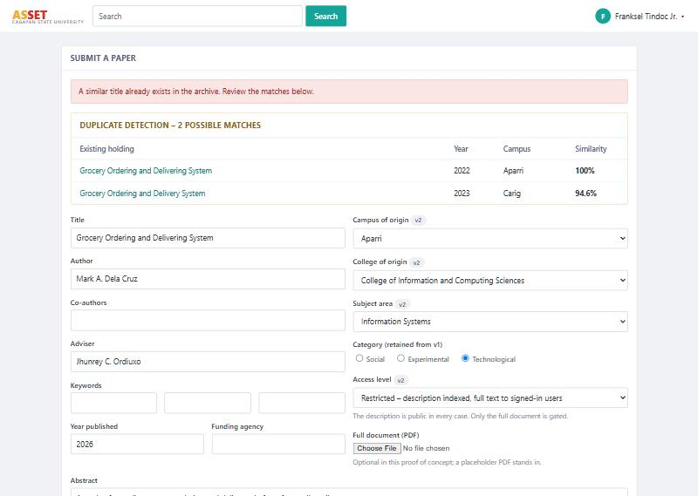
Figure
Duplicate detection at deposit, showing an exact and a near match with similarity scores

2.4 Objective 5 — Tiered Access and External Discoverability
ASSET v1 required an institutional account before any record could be viewed, which meant that research deposited within it could not be located from outside the campus network and could not be reached by an external academic search service. The objective requires that record descriptions be publicly viewable and reachable by such services, while full documents remain available only to authenticated institutional users or are withheld at the author’s or adviser’s instruction.
Access was accordingly separated into two tiers. The description of every approved holding — its title, authors, adviser, origin, year, keywords, and abstract — is readable without an account, and each record page emits twelve Dublin Core elements and a schema.org description of itself, which is what a harvester reads. A sitemap lists every approved record so that a crawler can find them all. The full document is separate: a visitor who is not signed in is sent to the sign-in page, an authenticated user receives the file, and a holding marked withheld releases its description but releases its document to no one. Every release is written to the system log, which is the audit trail on which the tiered access policy and the Republic Act No. 10173 commitment in Objective 8 rest. Table 6 reports the tests.
Table
Verification of Objective 5 — Tiered Access and External Discoverability
ID | Test performed | Expected result | Observed result | Verdict
TC-5.1 | Open a record description while not signed in. | The description is served in full. | HTTP 200; title, authors, adviser, origin, and abstract all present. | Pass
TC-5.2 | Request a full document while not signed in. | The visitor is sent to sign in, not refused outright. | HTTP 302 to login.php, returning to the record after sign-in. | Pass
TC-5.3 | Request the same document as a signed-in student. | The document is released. | HTTP 200, application/pdf, 610 bytes. | Pass
TC-5.4 | Request a withheld document as a signed-in student. | The document is refused while the description stays public. | HTTP 403; the description remained readable. | Pass
TC-5.5 | Request the same withheld document as the administrator. | Release is possible for the custodian of the archive. | HTTP 200, application/pdf. | Pass
TC-5.6 | Inspect the head of a record page. | Harvestable metadata is present. | 12 Dublin Core elements and 1 schema.org JSON-LD block. | Pass
TC-5.7 | Request the sitemap as an anonymous client. | Every approved record is listed for a crawler. | HTTP 200, application/xml, 14 record URLs — one per approved holding. | Pass
TC-5.8 | Open the administrative dashboard as a student. | The role boundary holds. | HTTP 403 — not permitted for your role. | Pass
TC-5.9 | Inspect the system log after the releases above. | Each release of a full document is recorded. | Both releases written to the log with user, action, and timestamp. | Pass
The objective is met. The description tier is open and carries the metadata an external service needs; the document tier is closed to anonymous visitors, open to authenticated institutional users, and closed to everyone where the author has withheld it. The role boundary holds and every release is auditable. Figure 4 shows a withheld holding: its description is public while its document is released to no one.
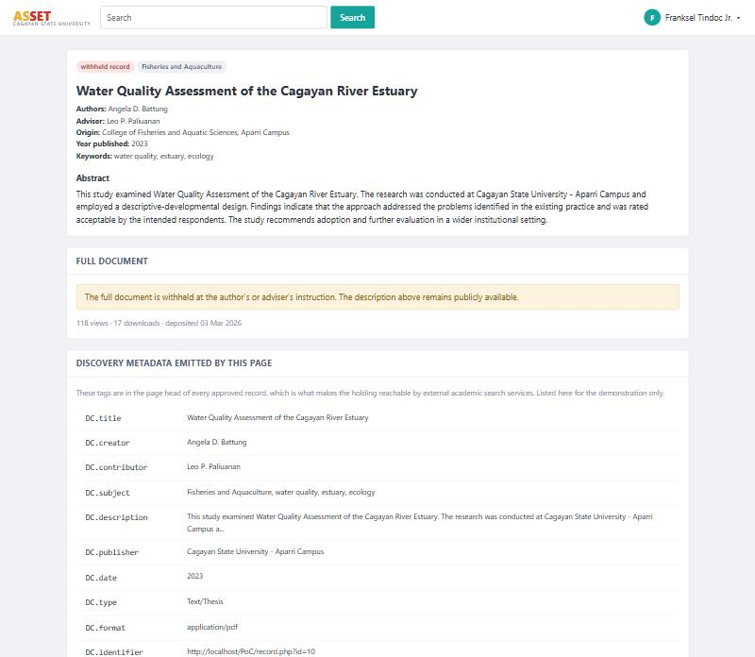
Figure
A withheld holding — the description is public and harvestable; the document is not released

2.5 Outcome 3 — Archive Composition Reporting
The logical framework carries archive composition reporting as Outcome 3, indicated by a report produced each quarter to the campus research office, and its stated risk is that the origin fields are not populated at deposit. It is verified here because it is the first thing Objective 4 makes possible: a report of this kind could not be produced under v1 at all, since the data it rests on was not recorded.
The report presents holdings by college, campus, subject area, year of publication, and access level, each with its share of the archive, the number publicly discoverable, and download activity. Deposit volume is also broken down by quarter, which is the cadence the logical framework reports on. Every dimension exports as a CSV file, which is the form in which a research office attaches evidence to an accreditation submission, and every export is written to the system log. Table 7 reports the tests.
Table
Verification of Outcome 3 — Archive Composition Reporting
ID | Test performed | Expected result | Observed result | Verdict
TC-6.1 | Open the composition report. | Holdings are broken down by every origin dimension. | Five breakdowns produced; the college dimension returned 7 rows totalling the 14 approved holdings. | Pass
TC-6.2 | Export the college breakdown. | A CSV file is served. | HTTP 200, text/csv, with a header row and one row per college. | Pass
TC-6.3 | Inspect the system log after the export. | The export is recorded. | Written to the log with user, action, and timestamp. | Pass
The outcome is demonstrable. Figure 5 shows the composition of the archive by college and by campus of origin, neither of which the original system could report.
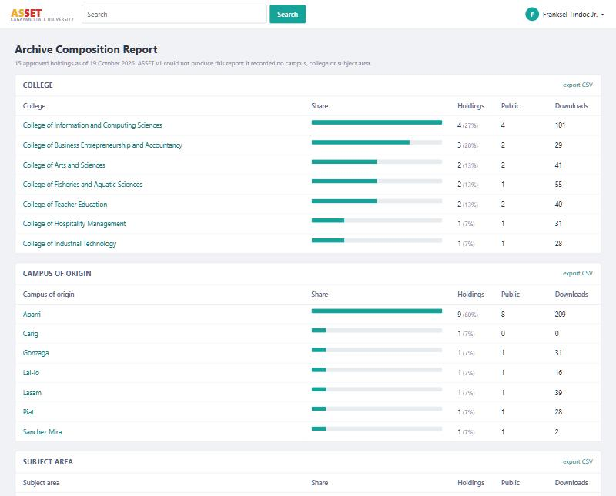
Figure
Archive composition by college and by campus of origin, with CSV export

CHAPTER 3

Summary and Limitations

3.1 Summary of Results
Thirty-four functional tests were executed against the running proof of concept across the four demonstrable objectives and the composition report. All thirty-four produced the expected result. Table 8 summarises the position of each specific objective in the proposal.
Table
Status of Each Specific Objective in the Proof of Concept
Objective | Nature | Status in the proof of concept
1. Establish a retrieval and discoverability baseline | Field measurement | Not demonstrable in software. The system reports retrieval time and the count of publicly discoverable records, which are the two measures the baseline will be taken against.
2. Backup with verified restoration | Function | Implemented and verified — 6 of 6 tests passed (Table 3).
3. Search filtering by year, adviser, college, subject area | Function | Implemented and verified — 10 of 10 tests passed (Table 4).
4. Record origin tracking and duplicate detection | Function | Implemented and verified — 6 of 6 tests passed (Table 5).
5. Tiered access and external discoverability | Function | Implemented and verified — 9 of 9 tests passed (Table 6).
6. Pilot deployment and training of personnel | Field activity | Not demonstrable in software. Requires institutional infrastructure and participants.
7. ISO/IEC 25010 and UTAUT evaluation against baseline | Field activity | Not demonstrable in software. Requires respondents and the endline instruments.
8. Compliance with Republic Act No. 10173 | Policy and function | Partially demonstrable. The system-side elements are in place: author consent is recorded at deposit, full documents are released only to authenticated users, every release is logged, and all data is held locally. The deposit licence and the approved access policy are documents, not software.
Outcome 3. Archive composition reporting | Function | Implemented and verified — 3 of 3 tests passed (Table 7).

3.2 Automated Self-Check
The tests in Chapter 2 exercise the system through its interface. Three areas of logic cannot be judged adequately that way, because a wrong answer still looks like an answer: title similarity, the access rule, and the backup cycle. These are covered by seventeen assertions in selfcheck.php, listed in Table 9, which can be run at any time from the command line and which leave the database as they found it. All seventeen pass. The three assertions covering alteration of a dump are the reason the corresponding control was removed from the backup screen: the behaviour is proved by the self-check, and an interface that damages data on purpose has no place in a system whose purpose is preservation.
Table
Assertions in the Automated Self-Check
Area | Assertion | Result
Duplicate detection | An exact existing title is flagged | Pass
 | Punctuation and case are ignored | Pass
 | An unrelated title is not flagged | Pass
 | The highest-similarity match is reported first | Pass
Tiered access | A guest cannot download a public holding | Pass
 | A guest cannot download a restricted holding | Pass
 | A signed-in user can download a public holding | Pass
 | A signed-in user can download a restricted holding | Pass
 | A student cannot download a withheld holding | Pass
 | An administrator can download a withheld holding | Pass
Backup cycle | The dump captured every row | Pass
 | A fresh dump verifies | Pass
 | A deletion takes effect | Pass
 | Restoration brings the holdings back | Pass
 | An altered dump fails verification | Pass
 | The failure names the checksum as the cause | Pass
 | A dump whose file is missing fails verification | Pass

3.3 Limitations of the Proof of Concept
What the proof of concept establishes is that each proposed function is buildable on the existing stack and behaves as its objective specifies. It does not establish that the enhancement has been deployed, and the following are stated so that nothing in this document is read as claiming more than it shows.
Scheduling. The backup mechanism is complete and verifiable, but it is invoked by a button rather than by a scheduler. The monthly verification rate the logical framework sets as a target is a property of the deployed schedule, not of the proof of concept.
External indexing. The metadata an academic search service harvests is emitted correctly and the sitemap is served, but the archive runs on a local host and is registered with no indexing service. Discoverability is therefore shown to be technically provided for, not shown to have occurred.
Framework. The proposal retains the deployed Laravel codebase and treats the enhancement as additive. The proof of concept is written in plain PHP so that it runs from a standard XAMPP installation. The functions and the schema changes transfer; the controllers and views would be rewritten in Laravel for deployment.
Similarity measure. Duplicate detection compares titles as strings. This catches the resubmitted and lightly retitled duplicates the proposal targets, as TC-4.3 shows, but it will not recognise two studies that describe the same work under genuinely different titles.
Scale. Sixteen holdings exercise every function but say nothing about behaviour at the scale of a full institutional archive. Retrieval time reported here is therefore a demonstration of the measure, not the baseline itself.

3.4 Conclusion
Every function the proposal commits to building has been built and exercised. The backup mechanism produces dumps whose integrity is proved before they are relied upon, and refuses a restoration it cannot verify. Search narrows by each of the four facets the objective names, and by campus besides. Origin is captured on every record, and duplicate detection catches both an exact and a lightly retitled resubmission from a different campus. Record descriptions are public and carry harvestable metadata while full documents remain gated, withheld where an author has so instructed, and logged on every release. The archive can describe its own composition, which the original system could not do at all.
The four objectives that define software to be built are therefore shown to be achievable, and the enhancement is confirmed as additive to the existing system rather than a replacement of it. What remains outstanding is not in doubt as to feasibility but as to execution: deployment on institutional infrastructure, the training of library personnel, baseline and endline measurement, and the policy instruments that accompany tiered access.

REFERENCES
Commission on Higher Education. (2016). CMO No. 52, s. 2016: Pathways to equity, relevance and advancement in research, innovation and extension in Philippine higher education. Commission on Higher Education.
Republic Act No. 10173. (2012). An Act Protecting Individual Personal Information in Information and Communications Systems in the Government and the Private Sector (Data Privacy Act of 2012). Congress of the Philippines.
Tindoc, F. P., Jr., Torres, R. G., Corpuz, K. A. C., Salem, J. T., & Paliuanan, L. P. (2023). Design and development of the ASSET: A web-based research archiving system. Journal of Pure and Applied Sciences, 1(2). https://doi.org/10.5281/zenodo.20724570

