2023-02-28

互联网应用开发技术-作业1

# 作业要求

## 安装配置开发环境：请你在这个文档中，逐项用文字和截图来说明你的安装开发运行环境的过程。要求包括：

### JDK 安装过程

Navigate to: <https://www.oracle.com/java/technologies/downloads/>

Click: x64 Installer

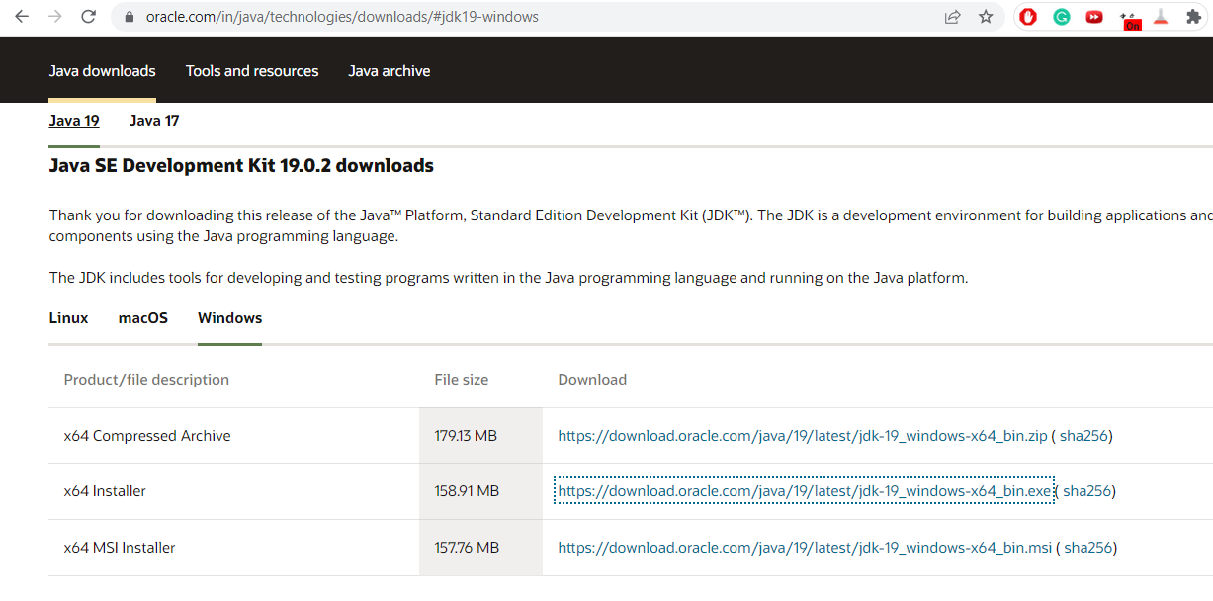

Install:

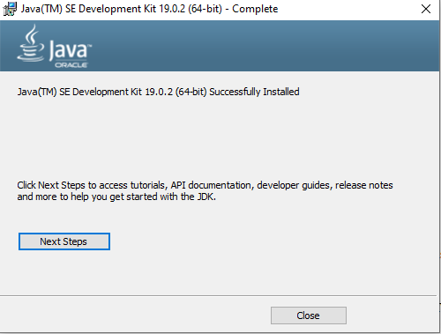

### IntelliJ IDEA安装与配置JDK过程

Navigate to : <https://www.jetbrains.com/idea/download/#section=windows>

Click to: Download

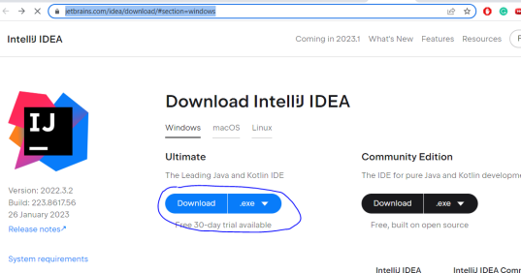

Install by clicking Next> :

Create new Project

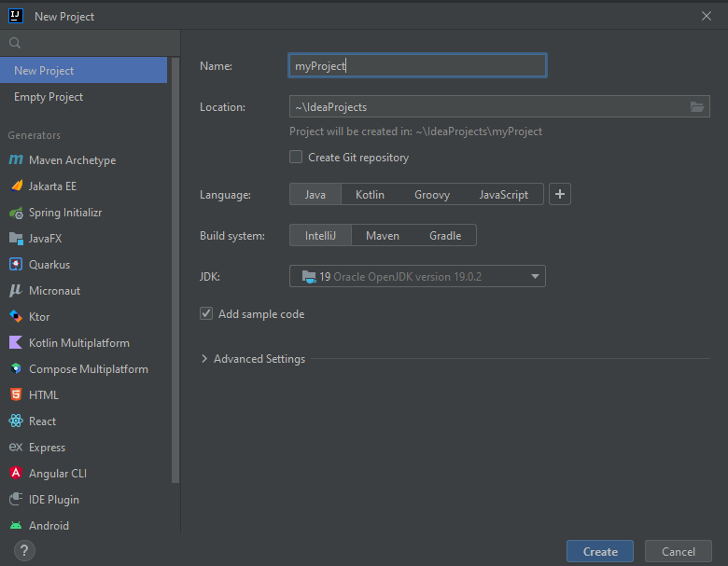

Build and run simple script

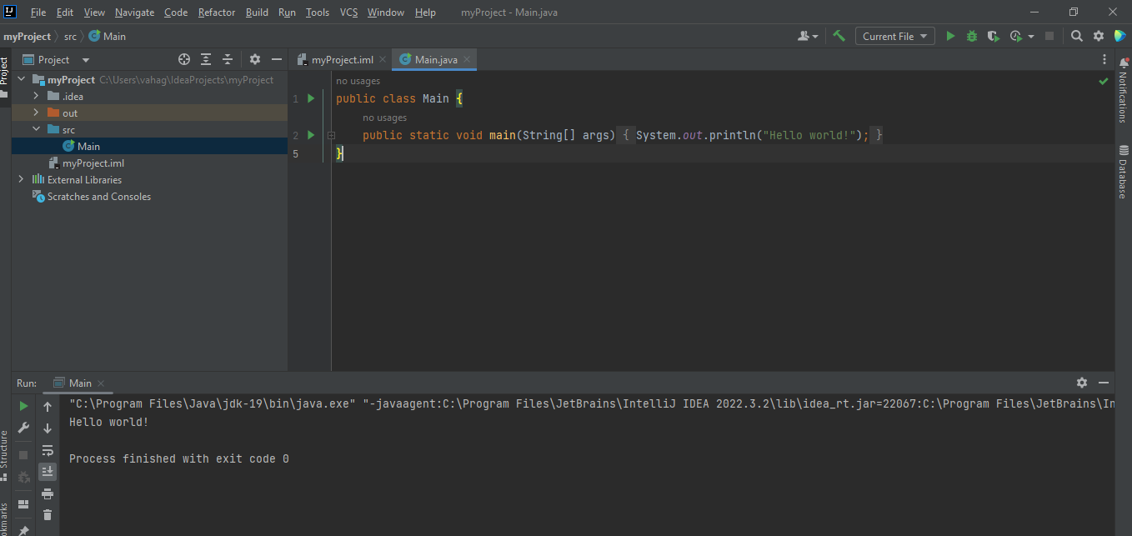

### Node.js安装过程

Navigate to :https://nodejs.org/en/download/

Click to: 64-bit Windows Installer

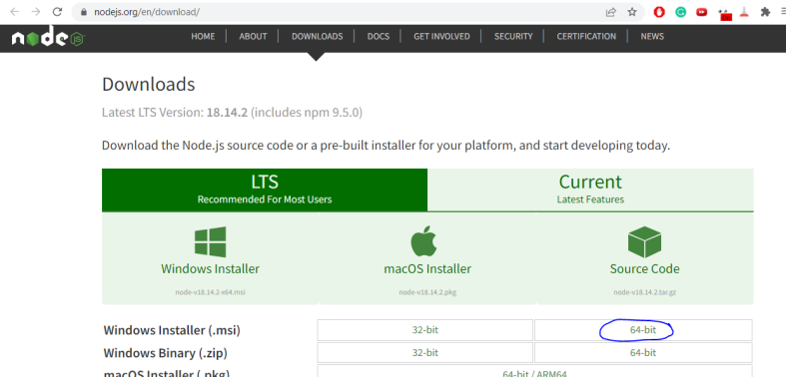

Click next

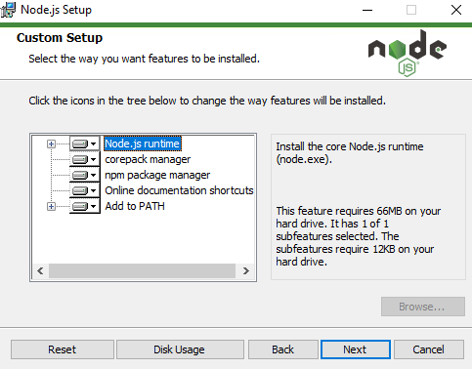

Install

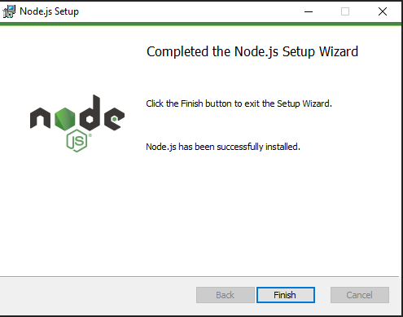

### MySQL Community Server安装过程

Navigate to : <https://dev.mysql.com/downloads/mysql/>

Click: Dowload

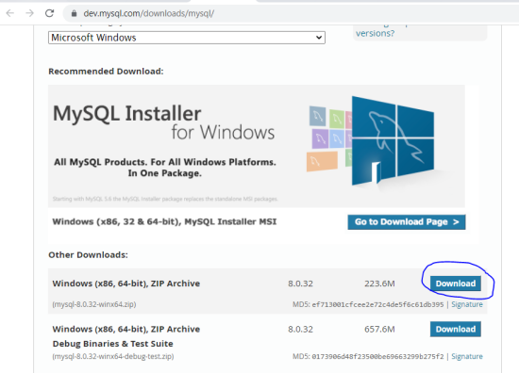

Install only SQL server

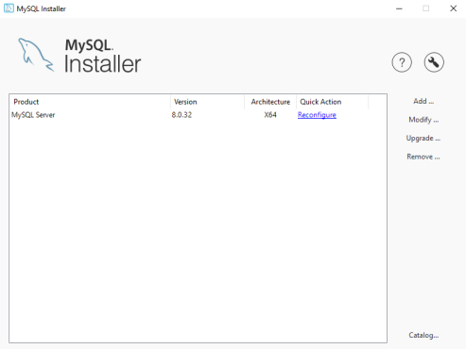

### MySQL WorkBench安装过程，如果你不想用MySQL WorkBench，而是选择用诸如NaviCat之类的其他工具，请说明它们的安装过程

I personally find DataGrip better then MySQL WorkBench, because it is a more powerful and versatile tool that supports a wide range of databases

Navigate to : <https://www.jetbrains.com/datagrip/>

Click Dowload：

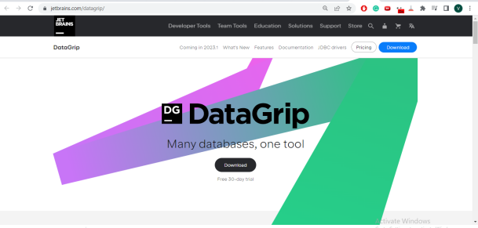

Install and activate license

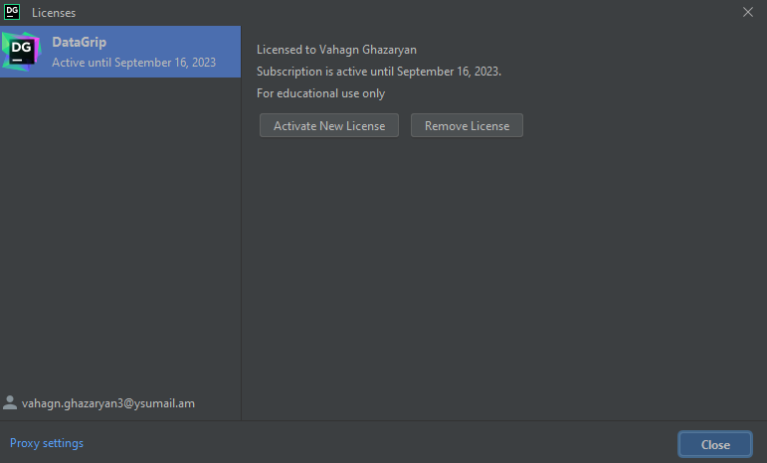

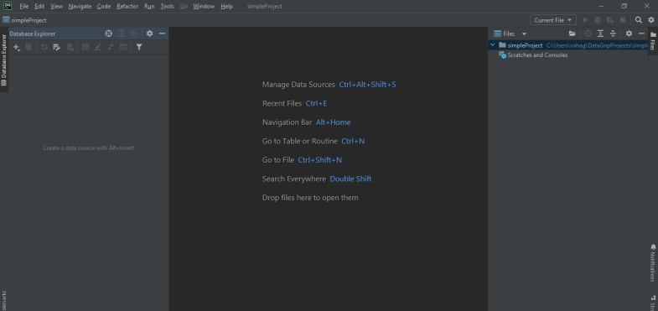

## 新建和运行React工程：在你安装好开发运行环境后，创建并运行一个新的React工程，将创建过程和运行结果贴图，并进行适当说明。

## Before starting I have **rebooted** my computer so all environment variables are properly setup.

## Check out the documentation:

## <https://www.jetbrains.com/help/idea/react.html#create_new_react_app>

Create React project

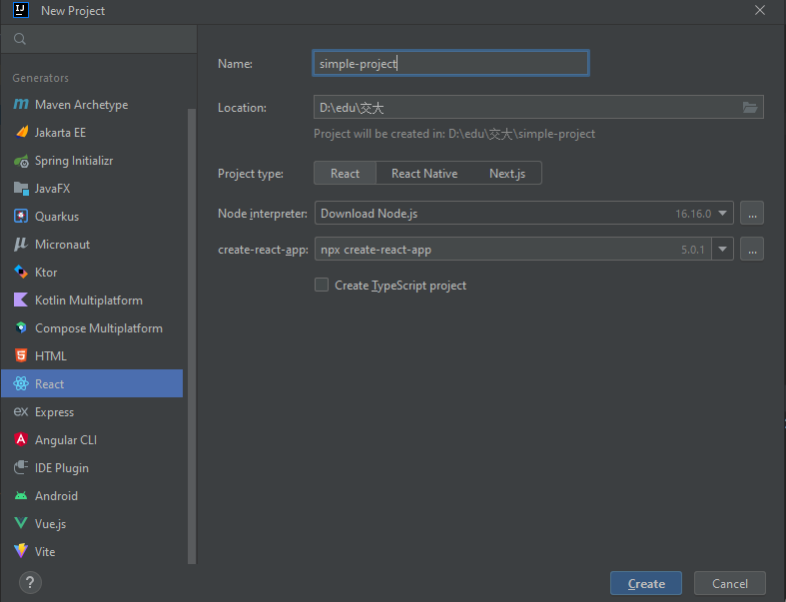

Make sure the project can find the node.js

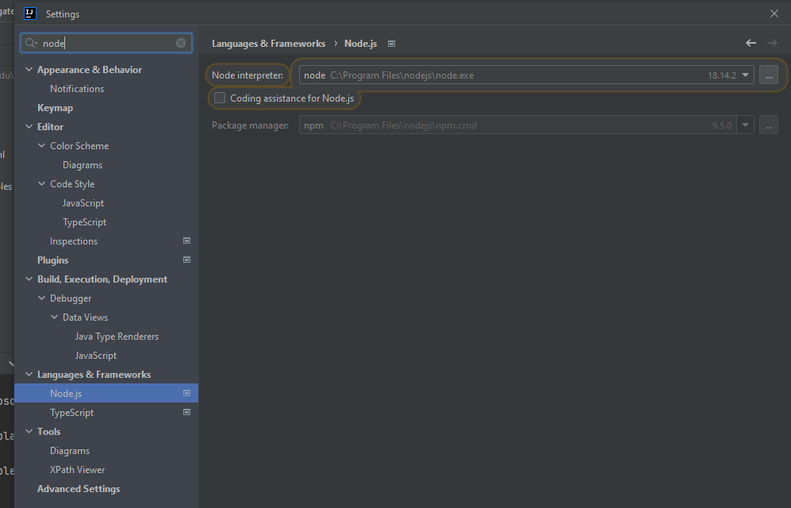

Open terminal and type:

**npm install --g create-react-app**  install the create-react-app package

**npx create-react-app <application-name>** to create an application.

**cd <application-name>** to switch to the application folder.

**npm start** to start the Node.js server.

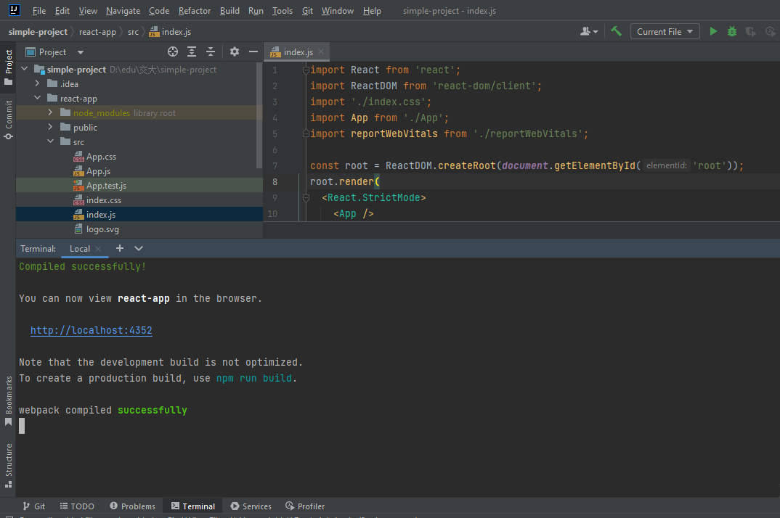

Go to: <http://localhost:4352/> (the port may differ)

